Supporting Information
Supramolecular Photodynamic Agents for Simultaneous Oxidation of NADH and Generation of Superoxide Radical
Kun-Xu Teng¹, Li-Ya Niu¹, Nan Xie² and Qing-Zheng Yang^{1,*}
¹Key Laboratory of Radiopharmaceuticals, Ministry of Education, College of Chemistry, Beijing Normal University, Beijing 100875, P. R. China.
²School of Pharmaceutical Sciences, Capital Medical University, Beijing 100069, P. R. China;
Email: qzyang@bnu.edu.cn
Table of Contents
1. General information S2
2. Synthesis of photosensitizer and electron acceptors. S5
3. The preparation and properties of supramolecular PS. S10
4. The evaluation of ROS generation ability. S14
7. Experimental data in vitro and in vivo S21
8. NMR spectra and HRMS S23
9. References S32

General information
- Materials and Instruments
Unless otherwise mentioned, materials were obtained from commercial suppliers and were used without further purification. All reactions were performed in dry glassware. 200-300 mesh silica gel was used to column chromatography purification. ¹H- and ¹³C-NMR spectra were recorded with JEOL-400, JEOL-600 spectrometers at 298 K. DOSY spectra were recorded with Bruker Avance Drx 500 spectrometer at 298 K. High-resolution mass spectrometry (HRMS) experiments were recorded by an Agilent Technologies 6224 Accurate-Mass time-of-flight spectrometer. Absorption spectra of liquid samples were determined on Hitachi UV-3900 spectrophotometer at room temperature. Fluorescence spectra of liquid samples were determined on Hitachi F-4600 spectrophotometer at room temperature. Cyclic voltammetry was carried out with CHI760E electrochemical workstation. Dynamic light scattering (DLS) investigations were recorded with a DynaPro NanoStar dynamic light scattering detector. Scanning electron microscope (SEM) images were obtained using a Hitachi SU-8010 instrument. The photostability was conducted under irradiation with a high-power LED light and monitored by using an UV-3900 spectrophotometer. Electron spin resonance was performed with Bruker E500. Confocal fluorescence imaging was performed with Nikon A1R microscopy. Cell viability test was obtained on a Thermo Scientific Multiskan. Irradiation was performed by using a LED light (660 nm, PLS-LED 100, Perfect Light, Beijing, China). In vivo imaging was recorded by an IVIS Spectrum imaging system (PerkinElmer, USA). All mouse models are provided by Beijing Vital River Laboratory Animal Technology Co., Ltd.
- Ethical statement
All animal experiments were performed following the protocols evaluated and approved by the Animal Ethics Committee of Capital Medical University (Ethics Approval Number: AEEI-2018-097).
- Detection of O₂^{−•} production with DHE in solution
We employed droethidium (DHE) as a specific O₂^{−•} probe to detect the generation of O₂^{−•} in solution. When O₂^{−•} is generated in the system, DHE can be oxidized to form ethidium which intercalates into DNA and emits bright fluorescence at ~580 nm. Specifically, 10 µM of photosensitizer was dissolved/dispersed in 2 mL PBS containing 40 µM of DHE and 500 μg/mL ctDNA. The mixture was then placed in a cuvette and irradiated with a 660 nm LED light at 20 mW cm⁻². The fluorescence change of sample was recorded by the fluorescence spectrometer.
- Detection of ¹O₂ production in solution
9,10-anthracenediyl-bis(methylene)-dimalonic acid (ABDA) as a singlet oxygen indicator was used to detect the generation of ¹O₂ in solution. When ¹O₂ is generated in the system, ABDA can react with ¹O₂ and the absorption at 378 nm is reduced. 10 µM of photosensitizer was dissolved in 2 mL PBS containing 30 µM of ABDA. The mixture was then placed in a cuvette and irradiated with a 660 nm LED light at 20 mW cm⁻². The absorption change of sample at 378 nm was recorded by the UV-Vis absorption spectrophotometer.
- Detection of O₂^{−•} production with ESR spectroscopy
Electron spin resonance (ESR) spectroscopy was employed to confirm the O₂^{−•} generation. BMPO (5-tert-butoxycarbonyl 5-methyl-1-pyrroline N-oxide) was used as a spin-trap agent for O₂^{−•} in water or DMSO. ESR spectroscopy was employed to detect the ESR signals of the following five groups of samples: i) 100 µM of DA1, DA2 or DA3 was dispersed in water containing 25 mM of BMPO and illuminated with a xenon lamp (500-1200 nm); ii) 100 µM of DA1 was dispersed in water containing 25 mM of BMPO without light; iii) 100 µM of D was dissolved in DMSO containing 25 mM of BMPO and illuminated with a xenon lamp; iv) 25 mM of BMPO was dissolved in DMSO and illuminated with a xenon lamp; v) 25 mM of BMPO was dispersed in water without light.
- Calculation of turnover frequency (TOF)
The TOF of photocatalytic oxidation of NADH was calculated from the difference in NADH concentration after 1 min irradiation divided by the concentration of photosensitizer. The concentration of NADH was calculated using the extinction coefficient ε₃₃₉ = 6220 M⁻¹cm⁻¹ in PBS buffer.
- Cyclic voltammetry measurement
Cyclic voltammograms experiment was conducted by using three-electrode system. A platinum-carbon compound electrode was used as working electrode, the Pt wire electrode and the Ag/Ag⁺ electrode were used as the auxiliary electrode and reference electrode, respectively. The measurement was conducted in dichloromethane containing 0.1 M tetrabutylammonium hexafluorophosphate. The scan rate was optimized as 100 mV/s. Fc/Fc⁺ was used as external reference.
- ROS generation in living cells
Human cervical cancer (HeLa) cells were seeded in 35 mm confocal dishes and incubated for 24 hours under normoxic (21% O₂) or hypoxic (2% O₂) environment. Specifically, the HeLa cells were incubated with 0.5 μM DA1 at 37 °C for 6 hours and then washed with PBS three times. The culture medium was replaced with DMEM containing 2 μM DCFH-DA and incubated for 30 min. After that, the DMEM was removed and washed three times with PBS buffer. The cells were then subjected to the photosensitization experiment with 660 nm LED irradiation (40 mW cm⁻²) for 5 min. Fluorescence images of DCFH-DA, staining on the cells were promptly captured by Nikon single-particle microscopy with a 40× objective lens.
- O₂^{−•} generation in living cells
HeLa cells were seeded in 35 mm confocal dishes and incubated for 24 h under normoxic (21% O₂) or hypoxic (2% O₂) conditions. Specifically, the HeLa cells were incubated with 0.5 μM DA1 at 37 °C for 6 hours and then washed three times with PBS buffer. The culture medium was replaced with DMEM containing 2 μM DHE and incubated for another 30 min. After that, the DMEM was removed and washed with PBS buffer three times. The cells were then subjected to the photosensitization experiment with 660 nm LED irradiation (40 mW cm⁻²) for 5 min. Fluorescent images of DHE, staining on the cells were promptly captured by Nikon single-particle microscopy with a 40× objective lens.
- Cellular NADH determination
Experiments to determine the NADH changes in Hela cells treated with different concentration of DA1 were performed using the NAD⁺/NADH assay kit with WST-8. In brief, Hela cells were seeded in six-well plates and incubated for 8 h. Then, the HeLa cells were exposed to different concentration of DA1, i.e., 0, 0.1, 0.2, 0.5, 1.0, 2.0 and 4.0 μM. After incubation for another 6 hours, the cells were washed with PBS buffer three times, infused with fresh DMEM, and illuminated by a 660 nm LED light (20 mW cm⁻²) for 10 min. After further incubation for 8 hours, the NADH concentration was examined by NAD⁺/NADH assay kit. For NAD⁺/NADH extraction, 200μL of NAD⁺/NADH extraction buffer was added and blow gently, followed by spinning at 10,000 rpm (5 min, 4 ℃) to get the supernatant as a test sample. After heating the collected supernatant at 60 ℃ for 0.5 h in a water bath, cellular NADH content was finally quantified according to the instructions.
- In vitro cytotoxicity
HeLa cells were seeded in 96-well plates (5×10³ cells well⁻¹) and incubated for 24 hours under normoxic (21% O₂) or hypoxic (2% O₂) conditions. Then, the medium was replaced with 100 μL of DMEM containing different concentrations of DA1. After incubation for another 6 hours, the cells were washed with PBS buffer three times, infused with fresh DMEM, and illuminated by a 660 nm LED light (50 mW cm⁻²) for 10 min. After further incubation for 12 hours, the cell viability was examined by cell counting kit-8 (CCK-8) assays. Moreover, the dark toxicity of DA1 was also analysed by the above procedure except the illumination was eliminated.
- Calcein AM/PI staining of HeLa cells in PDT experiments
HeLa cells were seeded on 35 mm confocal dishes and incubated for 24 hours. The medium was then replaced with fresh culture medium containing different concentrations of DA1 and incubated for 6 hours. Then, the culture medium was replaced with fresh DMEM containing 5 μM Calcein AM and 5 μM propidium iodide (PI). After further incubation for 20 min, the calcein Am and PI solution was removed and washed with PBS buffer three times. After that, the cells were irradiated with a LED light (50 mW cm⁻², 660 nm) for 5 min. Fluorescent images of Calcein AM and PI, staining on the cells, were promptly captured by Nikon single-particle microscopy with a 20× objective lens.
- In vivo imaging
Tumor imaging in vivo were studied with subcutaneous HeLa tumor model in the immunocompetent BALB/c mice. The tumor-bearing mice were intravenously injected of DA1 (400 μg/mL, 60 μL). Then, the fluorescence was recorded at different time points (1, 3, 6, 12 hours) with an IVIS Spectrum imaging system.
- Ex vivo biodistribution of DA1
The ex vivo biodistribution of DA1 was evaluated at 12 hours postinjection by IVIS Spectrum imaging. Mice were sacrificed and their major organs including heart, liver, spleen, lung, kidney, pancreas, and tumor were carefully removed for visualization under the imaging system.
- In vivo PDT experiment
Phototoxicity assay was performed by using HeLa tumor bearing mice. The mice were divided into three different groups for treatment: Group 1: PBS injection; Group 2: DA1 injection without irradiation; Group 3: DA1 injection with irradiation. Each group contained five mice. 9 hours after injection, LED light (120 mW cm⁻², 660 nm) treatment was performed on the Group 3 by irradiating the tumor region for 20 min. The effect of the different treatment groups was monitored by measuring tumor size (tumor size = width² × length/ 2.) and mice body weight for 14 days after PDT treatment. After 14 days, the tumors were dissected and weighed.

Synthesis of photosensitizer and electron acceptors.
Scheme S1. Synthesis of supramolecular assemble units of quadruple hydrogen bonds.
Synthesis of compound 4 is referred to previous literature.¹
Synthesis of compound 5: Compound 4 (3.03 g, 10.0 mmol) and mono-Propargylamine (0.66 g, 12.0 mmol) were mixed in 10 mL anhydrous dichloromethane and the resulting mixture was stirred at room temperature for 8 hours under N₂ atmosphere. After the reaction was completed, the resulting mixture was washed with 2M HCl, saturated aqueous NaHCO₃, brine and dried over anhydrous Na₂SO₄. Evaporation of the solvent under reduced pressure and the further purification was carried out by column chromatography using CH₂Cl₂/CH₃OH (100:1, v/v) as eluent to afford the product as colorless oil (2.73 g, 94 %). ¹H NMR (600 MHz, Chloroform-d) δ 13.01 (s, 1H), 12.11 (s, 1H), 10.83 (s, 0H), 5.85 (s, 1H), 4.06 (dd, J = 5.2, 2.5 Hz, 2H), 2.31 (ddd, J = 14.7, 9.2, 5.5 Hz, 1H), 2.25 (t, J = 2.5 Hz, 1H), 1.76 – 1.46 (m, 4H), 1.38 – 1.10 (m, 4H), 0.88 (m, 5H).
Scheme S2. Synthesis of compound D.
Synthesis of compound 6 is referred to previous literature.²
Synthesis of compound 8: Compound 6 (590.0 mg, 1.0 mmol) and compound 7 (448.0 mg, 2.5 mmol) were added into a two-neck vial. The Schlenk tube was capped with a rubber septum and then evacuated and backfilled with N₂ (this sequence was carried out three times). Glacial acetic acid (0.6 mL), piperidine (0.8 mL) and toluene (20 mL) were added via syringe through the septum, and the Schlenk tube was sealed. The reaction mixture was heated to 100 °C until 6 had been completely consumed by TLC analysis. After the reaction mixture was cooled to room temperature, 100 mL saturated brine were added to the mixture. The product was extracted with dichloromethane (3 × 100 ml) and the organic layers were combined. The organic solution was dried over anhydrous sodium sulfate and removed under reduced pressure. The residue was purified by column chromatography on silica gel with petroleum ether/ dichloromethane (80:20, v/v) as eluent to afford compound 8 as a fuchsia solid (524.4 mg, 56 %). ¹H NMR (600 MHz, Chloroform-d) δ 8.12 (d, J = 16.6 Hz, 1H), 7.72 – 7.54 (m, 6H), 7.32 (d, J = 7.7 Hz, 1H), 7.14 (d, J = 7.9 Hz, 2H), 6.96 (d, J = 8.7 Hz, 4H), 4.20 (t, J = 5.0 Hz, 4H), 3.63 (t, J = 5.0 Hz, 4H), 2.46 (s, 3H), 1.46 (s, 6H).
Synthesis of D: Compound 8 (300.0 mg, 0.32 mmol), compound 5 (185.8 mg, 0.64 mmol), CuSO₄•5H₂O (12.0 mg, 0.04 mmol) and sodium ascorbate (16.0 mg, 0.08 mmol) were dissolved in the mixture solution (THF/EtOH/H₂O, 60 mL, 40/10/10). The reaction mixture was stirred at room temperature for 24 hours under N₂ atmosphere. Then, the product was extracted into dichloromethane. The organic layer was dried over anhydrous Na₂SO₄ and evaporated under reduced pressure. The residue was purified by column chromatography on silica gel with CH₂Cl₂/MeOH (50:1, v/v) as eluent, and D was obtained as a purple dark solid (330.1 mg, 68 %). ¹H NMR (600 MHz, Chloroform-d) δ 13.08 (s, 2H), 12.19 (s, 2H), 10.90 (t, J = 5.7 Hz, 2H), 8.14 (d, J = 16.6 Hz, 2H), 7.85 (s, 2H), 7.63 – 7.50 (m, 6H), 7.33 (d, J = 7.7 Hz, 2H), 7.14 (d, J = 7.6 Hz, 2H), 6.92 (d, J = 8.3 Hz, 4H), 5.76 (s, 2H), 4.86 – 4.51 (m, 8H), 4.36 (t, J = 4.8 Hz, 4H), 2.47 (s, 3H), 2.33 – 2.15 (m, 2H), 1.77 – 1.38 (m, 14H), 1.34 – 1.15 (m, 8H), 0.91 (t, J = 7.3 Hz, 6H), 0.84 (t, J = 7.1 Hz, 6H). ¹³C NMR (150 MHz, Chloroform-d) δ 173.11, 159.10, 157.05, 155.88, 154.82, 150.36, 146.32, 146.14, 139.72, 139.43, 138.92, 133.21, 132.24, 130.42, 130.23, 129.32, 128.22, 122.89, 117.03, 114.93, 106.46, 82.92, 66.77, 49.88, 45.44, 36.08, 32.96, 29.36, 26.63, 22.50, 21.57, 17.78, 13.96, 11.80. HRMS: m/z; [M+H]⁺, calcd for C₆₈H₇₈BF₂I₂N₁₆O₆⁺: 1517.4441; found: 1517.4439.
Scheme S3. Synthesis of compound A1.
Synthesis of compound 10: To a 500 mL round-bottom flask were added compound 9 (720.0 mg, 3.0 mmol), 1-bromo-2-chloroethane (946.5 mg, 6.6 mmol), Cs₂CO₃ (2.93 g, 9.0 mmol) and acetonitrile (200 mL), and then the reaction mixture was refluxed for 24 hours. After the reaction mixture was cooled to room temperature, 200 mL saturated brine were added to the mixture. The product was extracted with ethyl acetate (3 × 200 ml) and the organic layers were combined. The organic solution was dried over anhydrous sodium sulfate and removed under reduced pressure. The residue was purified by column chromatography on silica gel with petroleum ether/ dichloromethane (30:70, v/v) as eluent to afford compound 10 as an orange solid (679.3 mg, 62 %). ¹H NMR (600 MHz, Chloroform-d) δ 8.08 (dd, J = 5.7, 3.3 Hz, 2H), 7.66 (dd, J = 5.8, 3.2 Hz, 2H), 7.29 (s, 2H), 4.30 (t, J = 6.0 Hz, 4H), 3.90 (t, J = 5.9 Hz, 4H).
Synthesis of compound 11: NaN₃ (247.0 mg, 3.8 mmol) was added to a solution of 10 mL of DMF of compound 10 (547.8 mg, 1.5 mmol). The reaction mixture was heated to 100 °C for 12 hours and then cooled to room temperature. 50 mL of ice water was added to the reaction mixture, and a large amount of yellow solid was precipitated. Compound 11 (556.2 mg, 98%) was obtained by filtration. ¹H NMR (600 MHz, Chloroform-d) δ 8.15 (dd, J = 5.8, 3.3 Hz, 2H), 7.71 (dd, J = 5.8, 3.3 Hz, 2H), 7.34 (s, 2H), 4.26 (t, J = 5.0 Hz, 4H), 3.76 (t, J = 5.0 Hz, 4H).
Synthesis of compound 12: Malononitrile (198.2 mg, 3.0 mmol) was added to 50 mL dichloromethane solution of compound 11 (378.3 mg, 1.0 mmol). TiCl₄ (0.6 mL, 5.5 mmol) was slowly added dropwise under N₂ atmosphere, and the solution changed from pale yellow to dark yellow. Then, pyridine (0.16 mL, 1.9 mmol) was added dropwise under an ice bath with the formation of a yellow solid. The mixture was heated to reflux for 24 hours. The mixture was poured into ice water and extracted with dichloromethane (3 × 100 mL). The combined organic layers were dried with anhydrous magnesium sulfate and concentrated in vacuo. The residue was purified by column chromatography on silica gel with dichloromethane as eluent to afford compound 12 as an orange solid (223.0 mg, 47 %). ¹H NMR (600 MHz, Chloroform-d) δ 8.07 – 8.19 (m, 2H), 7.80 – 7.57 (m, 2H), 7.42 – 7.08 (m, 2H), 4.70 – 4.15 (m, 4H), 4.08 – 3.41 (m, 4H).
Synthesis of compound A1: Compound 12 (237.2 mg, 0.5 mmol), compound 5 (290.3 mg, 1.0 mmol), CuSO₄•5H₂O (15.0 mg, 0.05 mmol) and sodium ascorbate (20.0 mg, 0.1 mmol) were dissolved in the mixture solution (THF/EtOH/H₂O, 60 mL, 40/10/10). The reaction mixture was stirred at room temperature for 24 hours under N₂ atmosphere. Then, the product was extracted into dichloromethane. The organic layer was dried over anhydrous Na₂SO₄ and evaporated under reduced pressure. The residue was purified by column chromatography on silica gel with CH₂Cl₂/MeOH (50:1, v/v) as eluent, and A1 was obtained as an orange solid (274.3 mg, 52 %). ¹H NMR (600 MHz, Chloroform-d) δ 13.09 (s, 2H), 12.10 (s, 2H), 10.83 (s, 2H), 8.26 (s, 2H), 8.11 – 7.99 (m, 2H), 7.62 (s, 2H), 7.17 – 6.96 (m, 2H), 5.90 – 5.65 (m, 2H), 4.88 – 4.23 (m, 14H), 2.25 (s, 2H), 1.37 – 1.66 (m, 6H), 1.04 – 1.32 (m, 8H), 0.69-0.89 (m, 12H). ¹³C NMR (150 MHz, Chloroform-d) δ 181.78, 173.07, 158.98, 157.06, 155.82, 154.79, 152.65, 149.04, 145.84, 145.50, 132.99, 132.58, 127.38, 126.23, 124.83, 124.35, 123.41, 121.44, 120.01, 119.06, 113.72, 113.46, 106.44, 86.14, 69.13, 66.79, 49.62, 49.28, 46.12, 35.65, 33.28, 31.66, 29.32, 27.12, 22.72, 22.53, 13.45, 11.74. HRMS: m/z; [M+H]⁺, calcd for C₅₄H₅₉N₁₈O₆⁺: 1055.4865; found: 1055.4869.
Scheme S4. Synthesis of compound A2.
Synthesis of compound 15: Compound 13 (100 mg, 0.15 mmol) and compound 14 (0.85 g, 4.5 mmol) were mixed in a 100 mL thick wall round-bottom flask. The temperature was raised to 120 °C, and the mixture gradually melted as the temperature increased. The reaction was carried out for 1 hour at 120 °C. After the reaction mixture was cooled to room temperature, 100 mL dichloromethane was added to dissolve and washed three times with saturated brine (3 × 100 mL). The organic phase was collected and dried over anhydrous sodium sulfate. After filtration, the dichloromethane was removed under reduced pressure. The obtained crude product was separated through a column chromatography CH₂Cl₂/MeOH (20:1, v/v) and purified to obtain product compound 15 as a purple solid (93.2 mg, 77%). ¹H NMR (600 MHz, Chloroform-d) δ 9.46 (s, 2H), 8.11 (s, 2H), 4.99 (s, 2H), 4.13 – 4.05 (m, 4H), 3.64 (s, 4H), 3.53 (s, 4H), 2.01 (s, 2H), 1.87 (s, 4H), 1.44 – 1.54 (m, 4H), 1.46 (s, 18H), 1.26 – 1.32 (m, 16H), 0.88 – 0.92 (m, 12H).
Synthesis of compound A2: Compound 15 (100.0 mg, 0.11 mmol) was dissolved in 95% TFA of dichloromethane solution, then stirred at room temperature for 4 hours and solvent was removed under reduced pressure. The product was used for the next step without puritification. Then to a solution of compound 15 in 5 mL anhydrous trichloromethane was added compound 4 (105.0 mg, 0.15 mmol), then the mixture was stirred at room temperature under N₂ atmosphere until compound 15 had been completely consumed by TLC analysis. After the reaction was completed, the resulting mixture was washed with 2 M HCl, saturated aqueous NaHCO₃, brine and dried over anhydrous Na₂SO₄. Evaporation of the solvent under reduced pressure and the further purification was carried out by column chromatography using CHCl₃/CH₃OH (100:5, v/v) as eluent to give a purple solid (79.4 mg, 67 %). ¹H NMR (600 MHz, Chloroform-d) δ 13.13 (s, 2H), 11.98 (s, 2H), 10.69 (s, 2H), 9.57 (s, 2H), 8.30 (s, 2H), 5.77 (s, 2H), 4.07 (dt, J = 35.1, 8.5 Hz, 4H), 3.80 (q, J = 6.6 Hz, 4H), 3.66 – 3.59 (m, 4H), 2.31 (q, J = 7.5 Hz, 2H), 1.95 – 1.87 (m, 2H), 1.53 – 1.70 (m, 12H), 1.24 – 1.34 (m, 20H), 0.84 – 0.92 (m, 24H). ¹³C NMR (100 MHz, Chloroform-d) δ 173.12, 166.59, 164.17, 157.90, 155.76, 154.77, 148.36, 127.02, 122.30, 118.71, 106.34, 103.06, 45.36, 44.11, 42.32, 39.75, 37.91, 32.85, 30.88, 29.42, 28.81, 26.59, 24.12, 23.23, 22.64, 14.23, 14.03, 11.84, 10.76. HRMS: m/z; [M+H]⁺, calcd for C₅₈H₈₅N₁₂O₈⁻: 1077.6613; found: 1077.6598.
Scheme S5. Synthesis of compound A3.
Synthesis of compound 17: Compound 16 (500.0 mg, 2.3 mmol), 4-bromobutan-1-amine (1.05 g, 6.9 mmol) and triethylamine (1 mL) were dissolved in 10 mL glacial acetic acid, and then the reaction mixture was refluxed for 12 hours. After the reaction mixture was cooled to room temperature, a large amount of solid was precipitated, which was filtered and washed with water and methanol to obtain an off-white compound 17 (1.05 g, 94%). ¹H NMR (600 MHz, Chloroform-d) δ 8.28 (s, 2H), 3.79 (t, J = 6.6 Hz, 4H), 3.45 (t, J = 6.1 Hz, 4H), 2.03 – 1.79 (m, 8H).
Synthesis of compound 18: NaN₃ (247.0 mg, 3.8 mmol) was added to a solution of 10 mL of DMF of compound 17 (729.2 mg, 1.5 mmol). The reaction mixture was heated to 100 °C for 12 hours and then cooled to room temperature. 50 mL of ice water was added to the reaction mixture, and a large amount of solid was precipitated. Compound 18 (591.0 mg, 96%) was obtained by filtration as a white solid. ¹H NMR (600 MHz, Chloroform-d) δ 8.27 (s, 2H), 3.78 (t, J = 7.1 Hz, 4H), 3.34 (t, J = 6.7 Hz, 4H), 1.90 – 1.75 (m, 4H), 1.73 – 1.54 (m, 4H).
Synthesis of compound A3: Compound 18 (205.2 mg, 0.5 mmol), compound 5 (290.3 mg, 1.0 mmol), CuSO₄•5H₂O (15.0 mg, 0.05 mmol) and sodium ascorbate (20.0 mg, 0.1 mmol) were dissolved in the mixture solution (THF/EtOH/H₂O, 60 mL, 40/10/10). The reaction mixture was stirred at room temperature for 24 hours under N₂ atmosphere. Then, the product was extracted into dichloromethane. The organic layer was dried over anhydrous Na₂SO₄ and evaporated under reduced pressure. The residue was purified by column chromatography on silica gel with CH₂Cl₂/MeOH (20:1, v/v) as eluent, and A3 was obtained as a white solid (232.9 mg, 47 %). ¹H NMR (600 MHz, Chloroform-d) δ 13.09 (s, 2H), 11.97 (d, J = 61.9 Hz, 2H), 10.73 (s, 2H), 7.73 (s, 2H), 5.78 (s, 2H), 4.09 – 4.64 (m, 8H), 3.49 – 3.84 (m, 6H), 2.30 (s, 2H), 1.95 (s, 2H), 1.47 – 1.78 (m, 12H), 1.21 – 1.30 (m, 8H), 0.88 – 0.81 (m, 12H). ¹³C NMR (100 MHz, CHLOROFORM-D) δ 172.99, 166.24, 166.02, 156.86, 155.85, 153.91, 136.07, 118.37, 118.13, 106.33, 49.37, 45.22, 37.44, 35.71, 32.88, 29.33, 26.98, 26.64, 25.07, 22.53, 13.95, 11.68. HRMS: m/z; [M+H]⁺, calcd for C₄₈H₆₂N₁₆O₈⁺: 991.5015; found: 991.5005.

The preparation and properties of supramolecular PS.
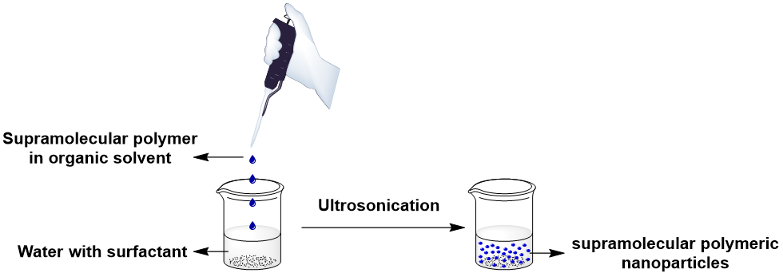
Figure S1. The scheme of the preparation of supramolecular photodynamic agents.
The preparation of the quadruple hydrogen bonded supramolecular polymeric photosensitizers (Figure S1): A mixture of D and the electron acceptor (2 mg, molar ratio 4:6) in 200 μL chloroform was quickly added into deionized water with 1 mg/mL Pluronic F127 as surfactant (5 mL). The resulting mixture was sonicated for 35 min by ultrasonic cell disruptor. After centrifuge-washing with deionized water three times, the water-dispersible nanoparticles were obtained.
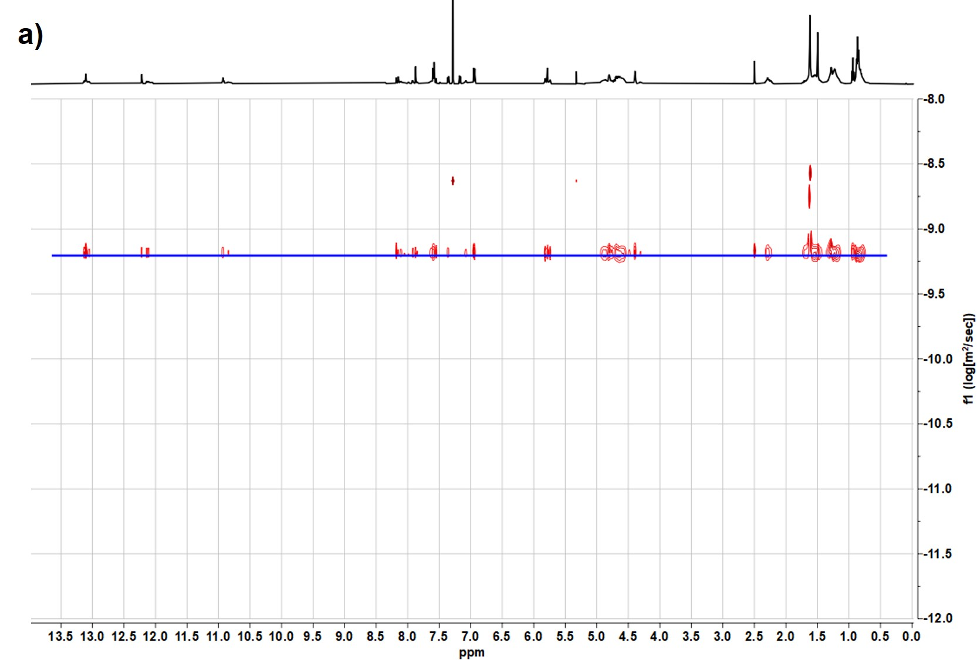
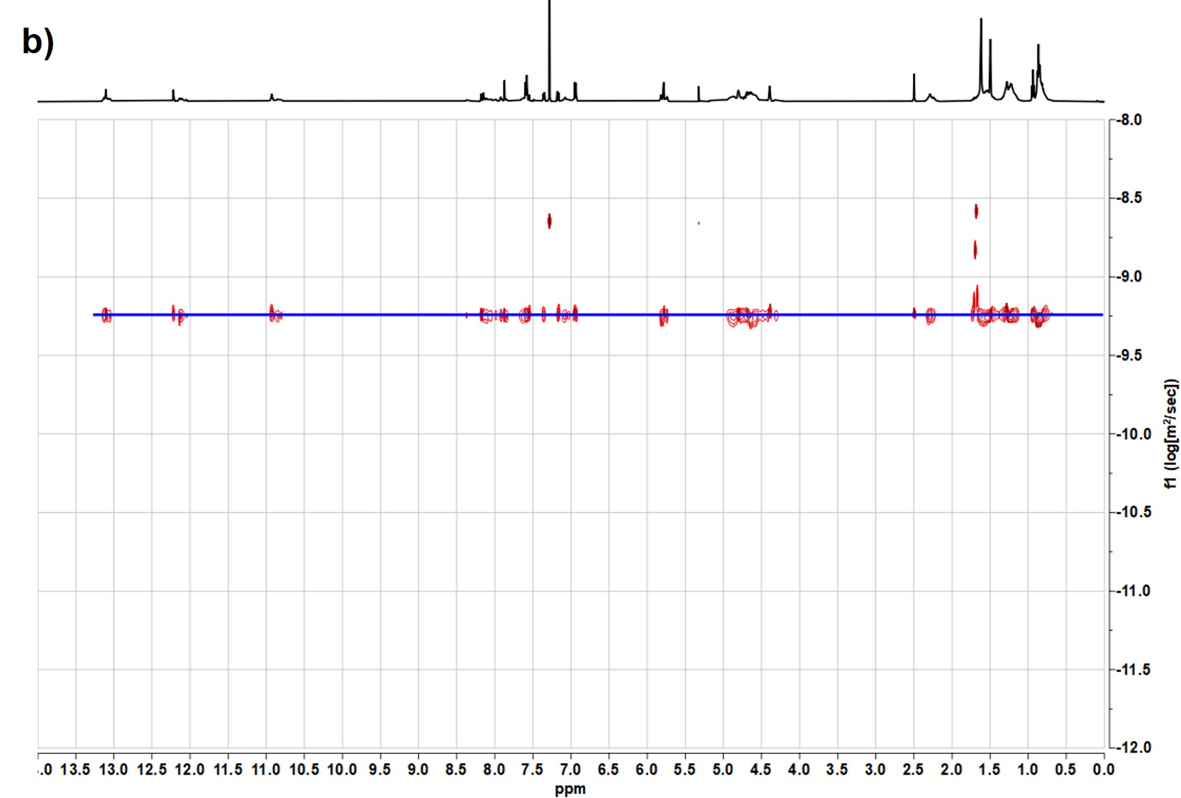
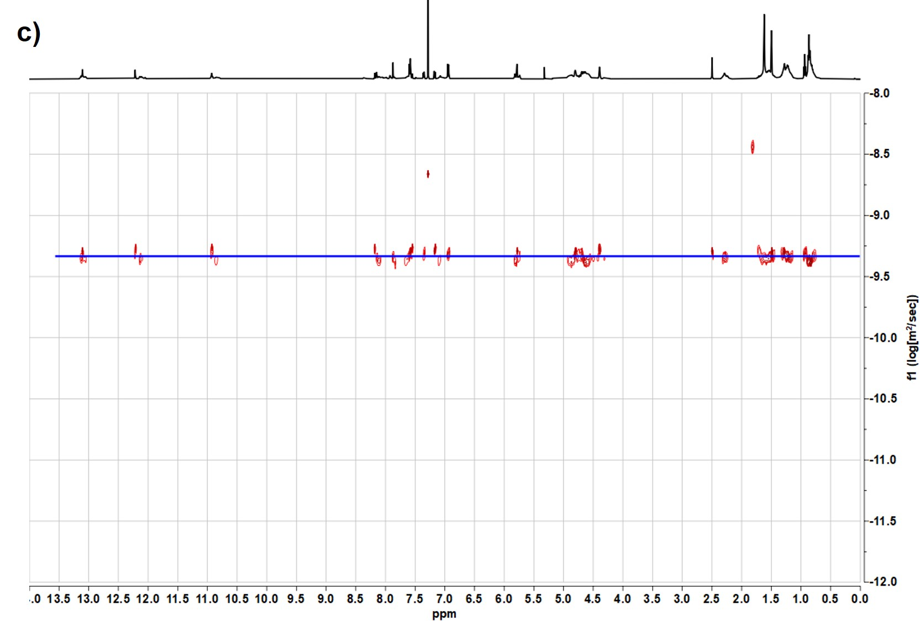
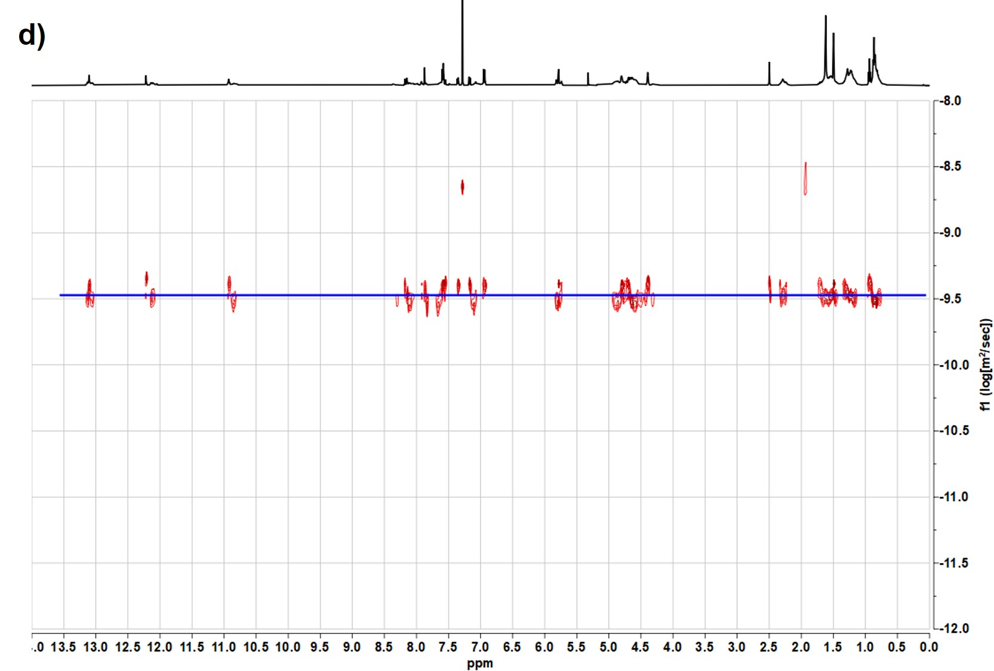
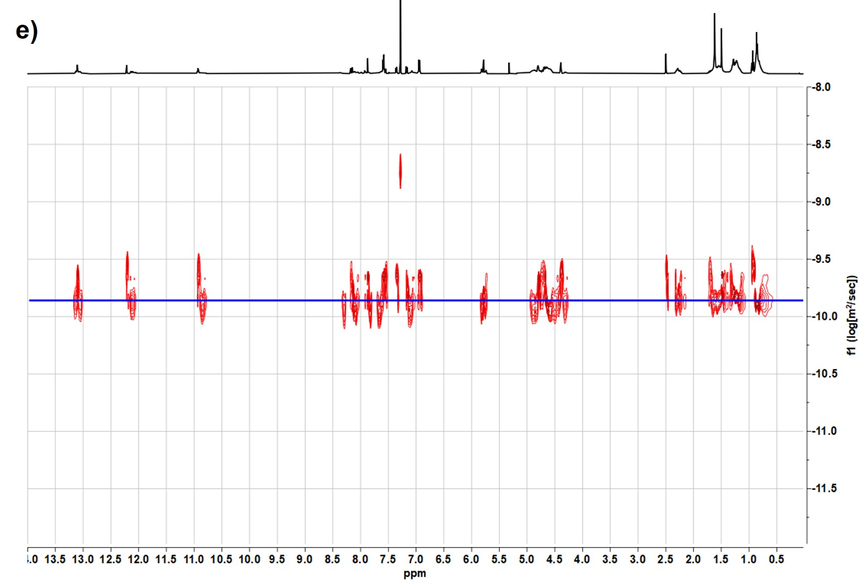
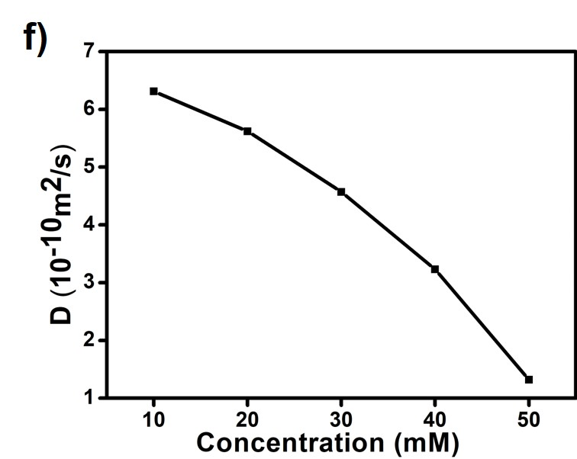
Figure S2. DOSY NMR (700 MHz, 298 K) spectra of mixture of D and A1 (molar ratio 4:6) at a) 10 mM; b) 20 mM; c) 30 mM; d) 40 mM; e) 50 mM. f) DOSY (500 MHz, 298 K) plots of solutions in CDCl₃ of mixture of D and A1 at various concentrations.
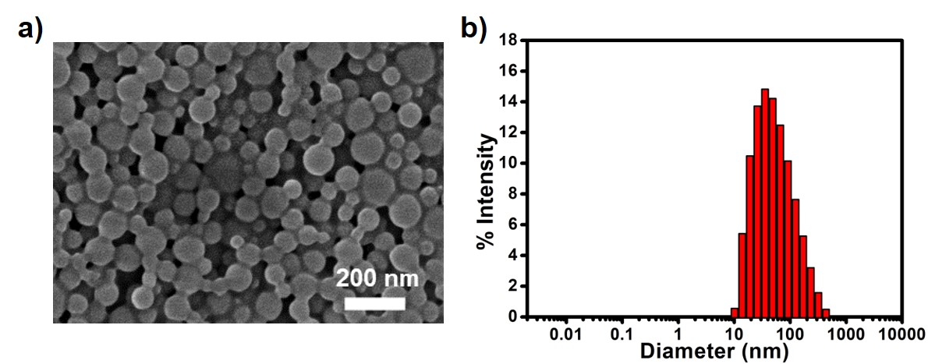
Figure S3. a) SEM image of DA1. b) The particle size distribution plots of DA1 from DLS.
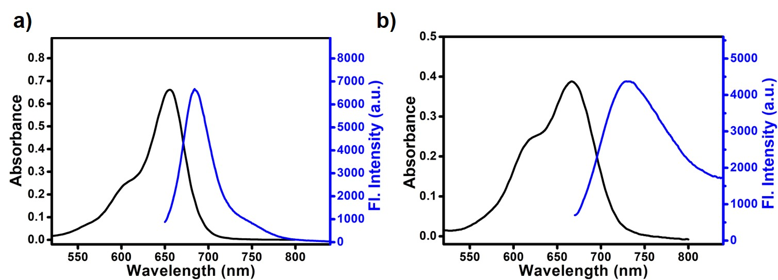
Figure S4. The absorption and fluorescence spectra of a) D (10 μM) in DCM and b) DA1 (10 μM) dispersed in water.
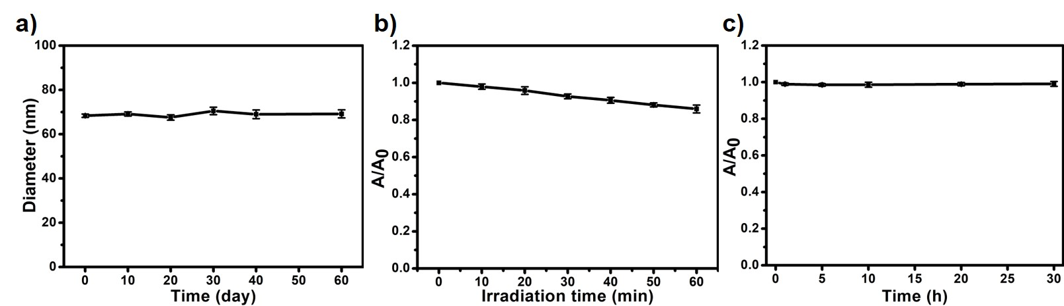
Figure S5. a) Hydrodynamic diameter of DA1 in PBS buffer in different days. b) The A/A₀ at 665 nm of DA1 at different times under the illumination of LED light (660 nm, 40 mW/cm²). c) The A/A₀ at 665 nm of HG in complete medium at different times.

The evaluation of ROS generation ability.
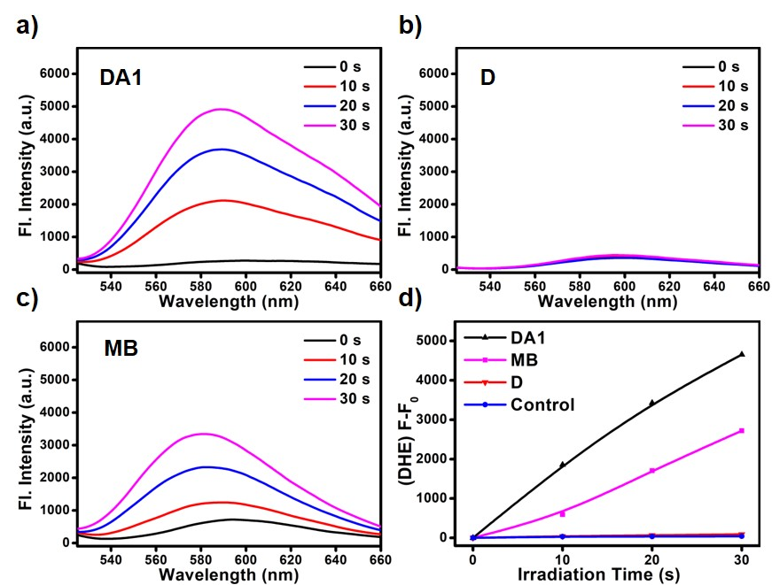
Figure S6. The fluorescence spectra of DHE (40 μM, excitation at 510 nm, detection from 525 nm to 660 nm) containing 500 μg/mL ctDNA after irradiation (660 nm, 20 mW/cm²) for different time in the presence of a) DA1 (10 μM) dispersed in PBS; b) D (10 μM) in PBS containing 20% DMF and c) MB in PBS. d) Plots of ΔFl. (F-F₀) of DHE at 580 nm upon light irradiation (660 nm, 20 mW/cm²) for different time intervals in the presence of DA1, MB or D.

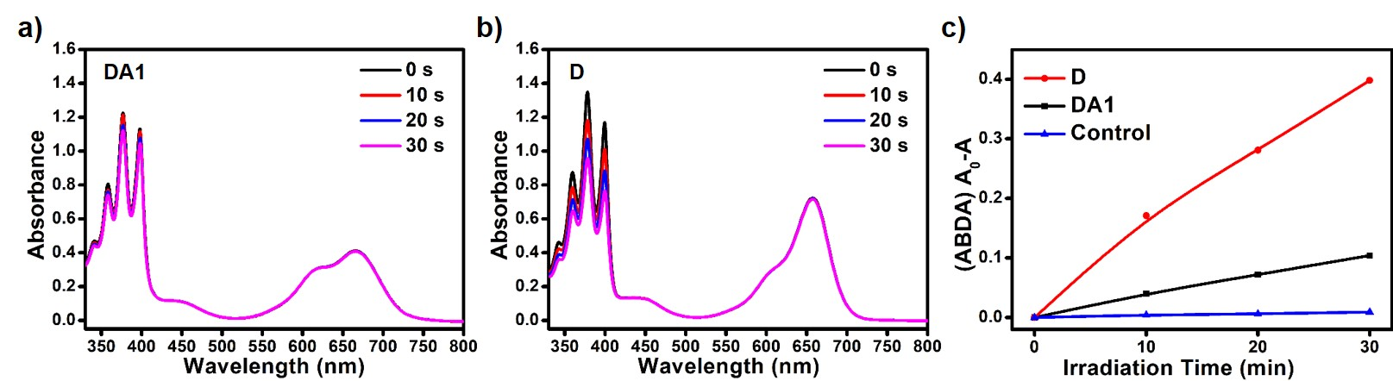
Figure S7. The absorption spectra of ABDA (30 μM) after irradiation (660 nm, 20 mW/cm²) for different time in the presence of a) DA1 (10 μM) dispersed in PBS and b) D (10 μM) in PBS containing 20% DMF. c) Plots of ΔAbs (A₀-A) of ABDA at 378 nm upon light irradiation (660 nm, 20 mW/cm²) for different time intervals in the presence of D or DA1.
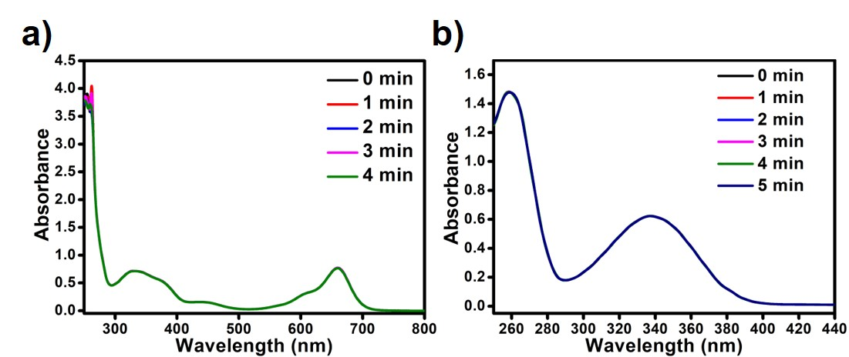
Figure S8. a) The absorption spectra of NADH (100 μM) after irradiation (660 nm, 20 mW/cm²) for different time in the presence of D (10 μM) in PBS containing 20% DMF. b) The absorption spectra of NADH (100 μM) after irradiation (660 nm, 20 mW/cm²) for different time in PBS.
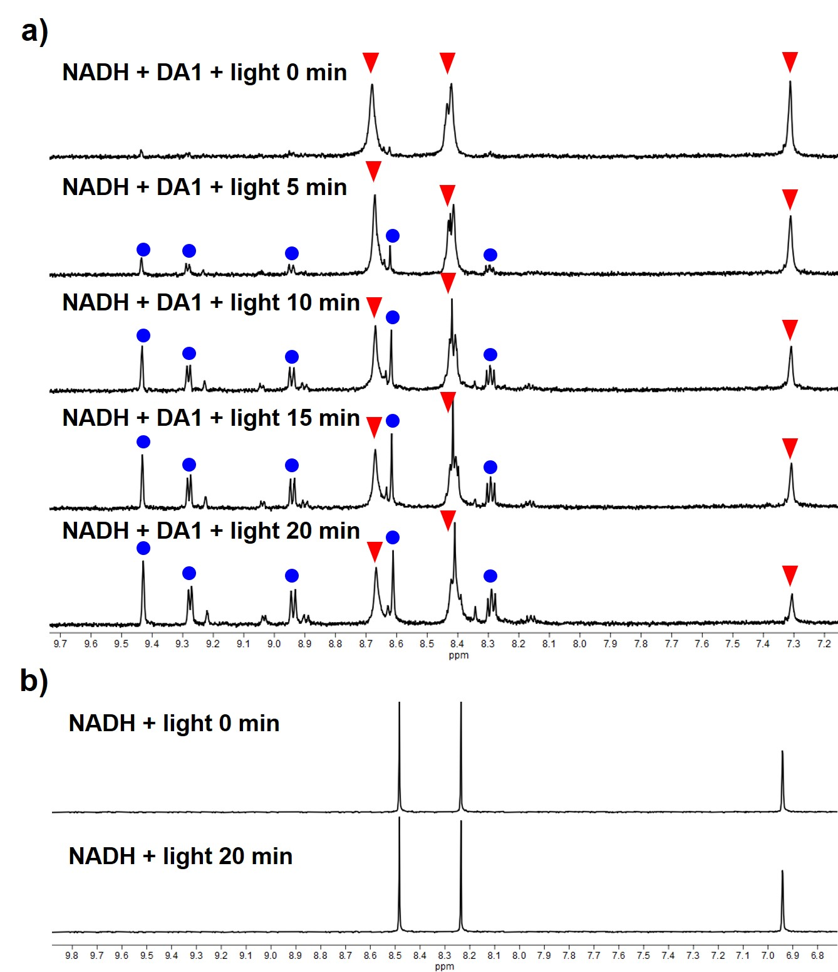
Figure S9. a) ¹H NMR of NADH (2.0 mM) in D₂O containing DA1 (0.1 mM) after irradiating for different time (660 nm, 20 mW/cm²). Peaks labeled with red triangles represent NADH and peaks labeled with blue circles represent NAD⁺. b) ¹H NMR of NADH (2.0 mM) in D₂O after irradiating for different time (660 nm, 20 mW/cm²).

- The study of photoinduced electron transfer between D and A1.
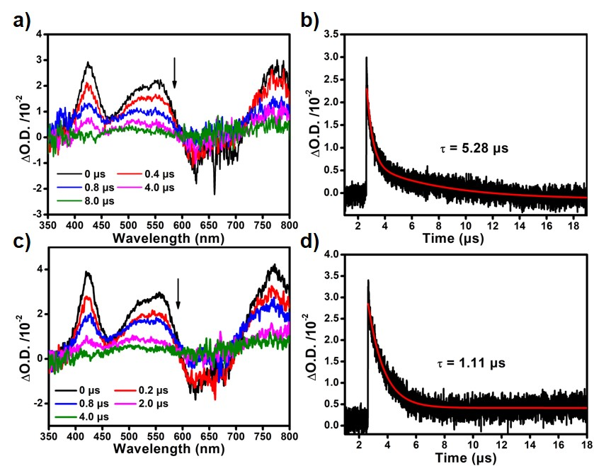
Figure S10. Time-resolved transient difference absorption of D in the a) supramolecular polymer without electron acceptor and c) DA1 dispersed in water (20 mM). Decay trace of D in the b) supramolecular polymer without electron acceptor and d) DA1 dispersed in water (20 mM).
$$ΔG=e\left[E_{{D^{+•}}/D}-E_{A/{A^{-•}}}-E_{00}\right]-\frac{e^{2}}{4πε_{s}ε_{0}R_{cc}}-\frac{e^{2}}{8πε_{0}}\left(\frac{1}{r^{+}}+\frac{1}{r^{-}}\right)\left(\frac{1}{ε_{ref}}-\frac{1}{ε_{s}}\right)$$
$≈e\left[E_{{D^{+•}}/D}-E_{A/{A^{-•}}}-E_{00}\right]$ (1)
Gibbs-free energy changes of the electron transfer from D to A1 can be calculated using Weller eqs (1), where E_{D+•/D} is onset potential for one electron oxidation in the electron donor unit; E_{A/A-•} is the onset potential for one electron reduction of the electron acceptor unit; E₀₀ can be estimated at the intersection between the normalized absorbance and emission spectra of D after converting the wavelength axis to an energy scale.³⁻⁴
Electrochemical measurements show that D has oxidation potentials of +0.440 V vs Fc/Fc⁺ (Figure S11a), and the A1 has reduction potentials of -1.183 V vs Fc/Fc⁺ (Figure S11b). The excited state energy E₀₀ is estimated to be 1.85 eV (Figure S11c). Rehm−Weller theory calculations show that the ΔG is -22.2 KJ/mol, which indicates photoinduced electron transfer between excited-state D to A1 is thermodynamically feasible.
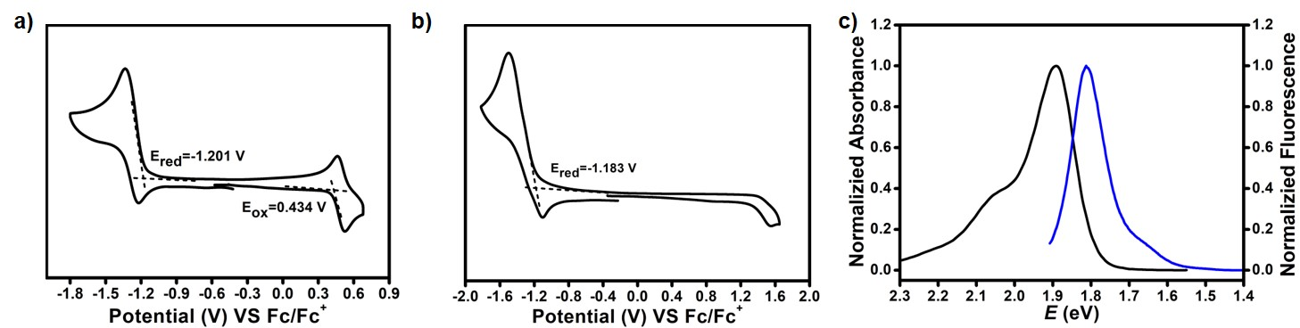
Figure S11. Cyclic voltammogram of a) D and b) A1 in DCM with 0.1 M (n-Bu)₄N⁺PF₆⁻ as a supporting electrolyte, Ag/Ag⁺ as a reference electrode, platinum-carbon electrode as a working electrode and Pt wire as a counter electrode; scan rate, 100 mVs⁻¹; Fc/Fc⁺ was used as an external reference. c) Normalized absorbance and emission spectra of D in DCM after converting the wavelength axis to an energy scale.
- The expansion of electron acceptors.
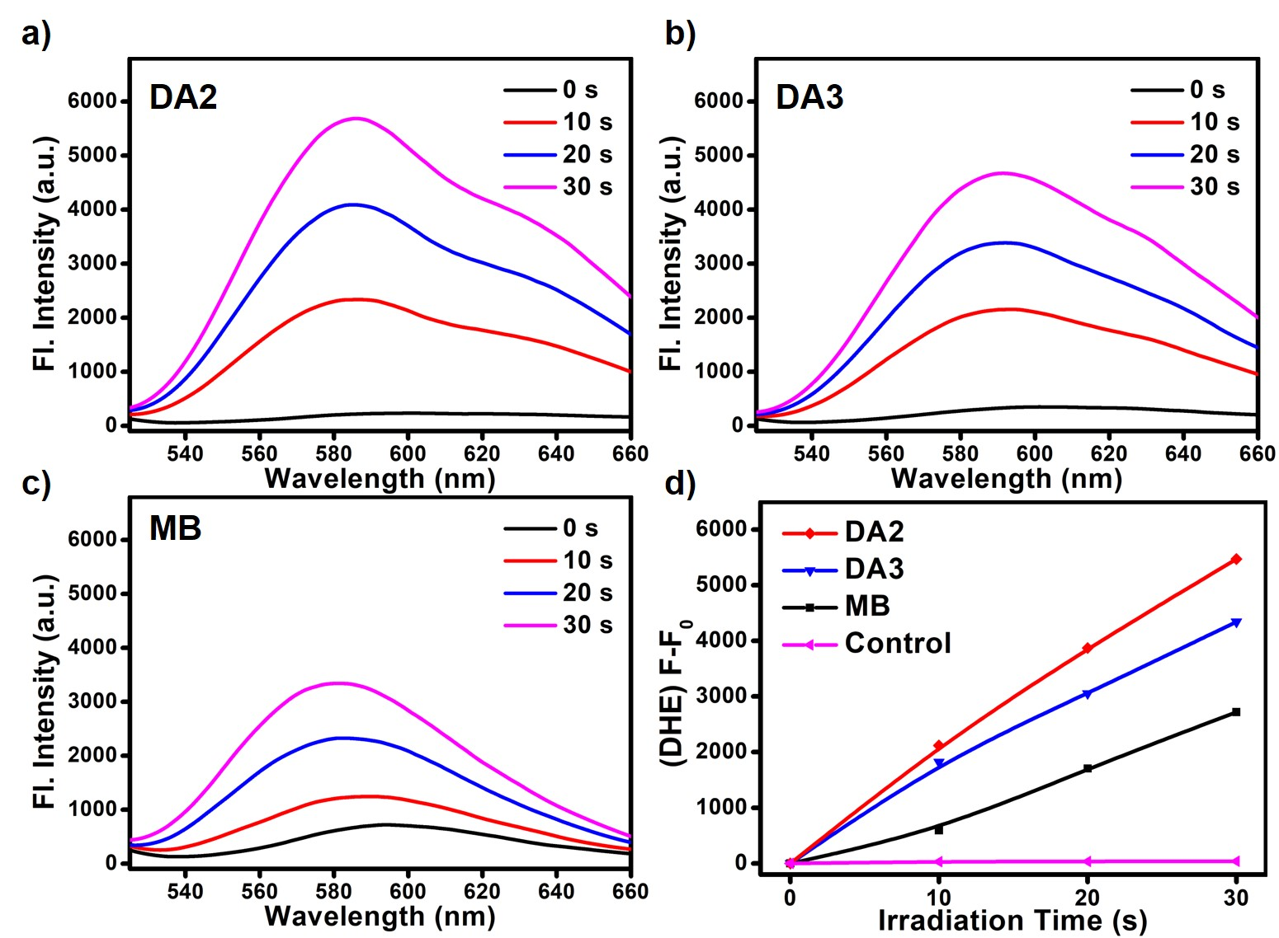
Figure S12. The fluorescence spectra of DHE (40 μM, excitation at 510 nm, detection from 525 nm to 660 nm) containing 500 μg/mL ctDNA after irradiation (660 nm, 20 mW/cm²) for different time in the presence of 10 μM a) DA2; b) DA3 and c) MB in PBS. d) Plots of ΔFl. (F-F₀) of DHE at 580 nm upon light irradiation (660 nm, 20 mW/cm²) for different time intervals in the presence of DA2, DA3 or MB.
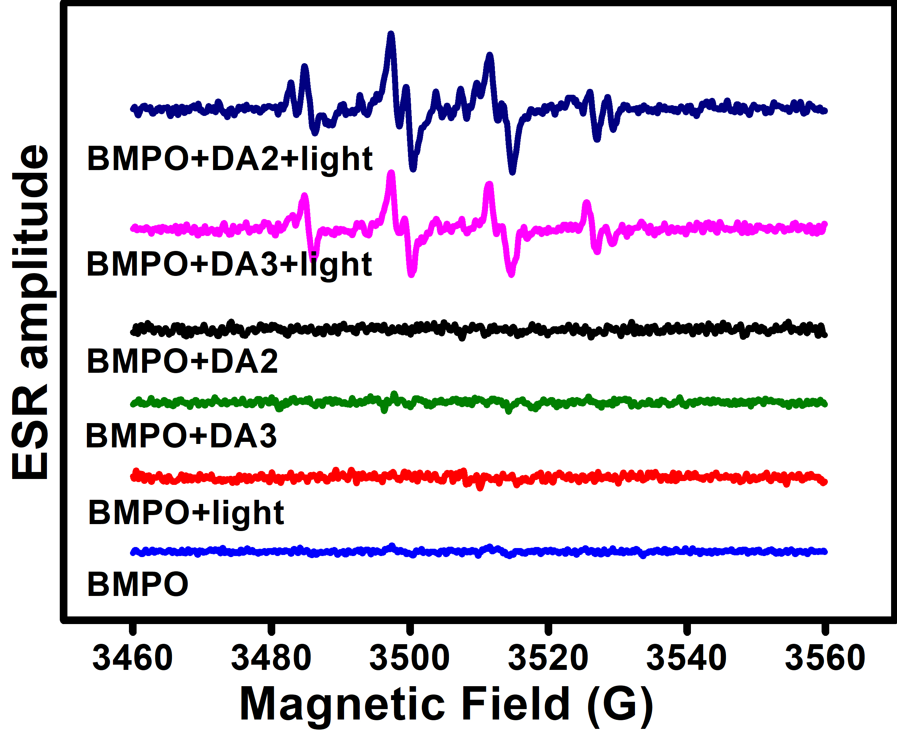
Figure S13. ESR spectra to detect O₂^{−•} generated by DA2 and DA3 (0.5 mM) under illumination, using BMPO (25 mM) as a spin trap.
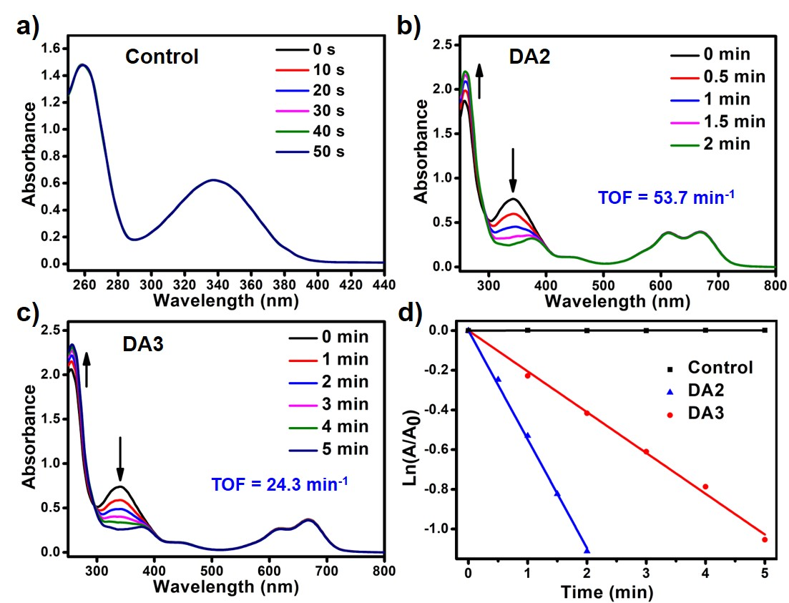
Figure S14. a) The absorption spectra of NADH (100 μM) after irradiation (660 nm, 20 mW/cm²) for different time in PBS. b) The absorption spectra of NADH (100 μM) after irradiation (660 nm, 20 mW/cm²) for different time in the presence of 10 μM b) DA2; c) DA3 dispersed in PBS. d) Plots of lnA/A₀ of NADH at 339 nm for different time intervals.
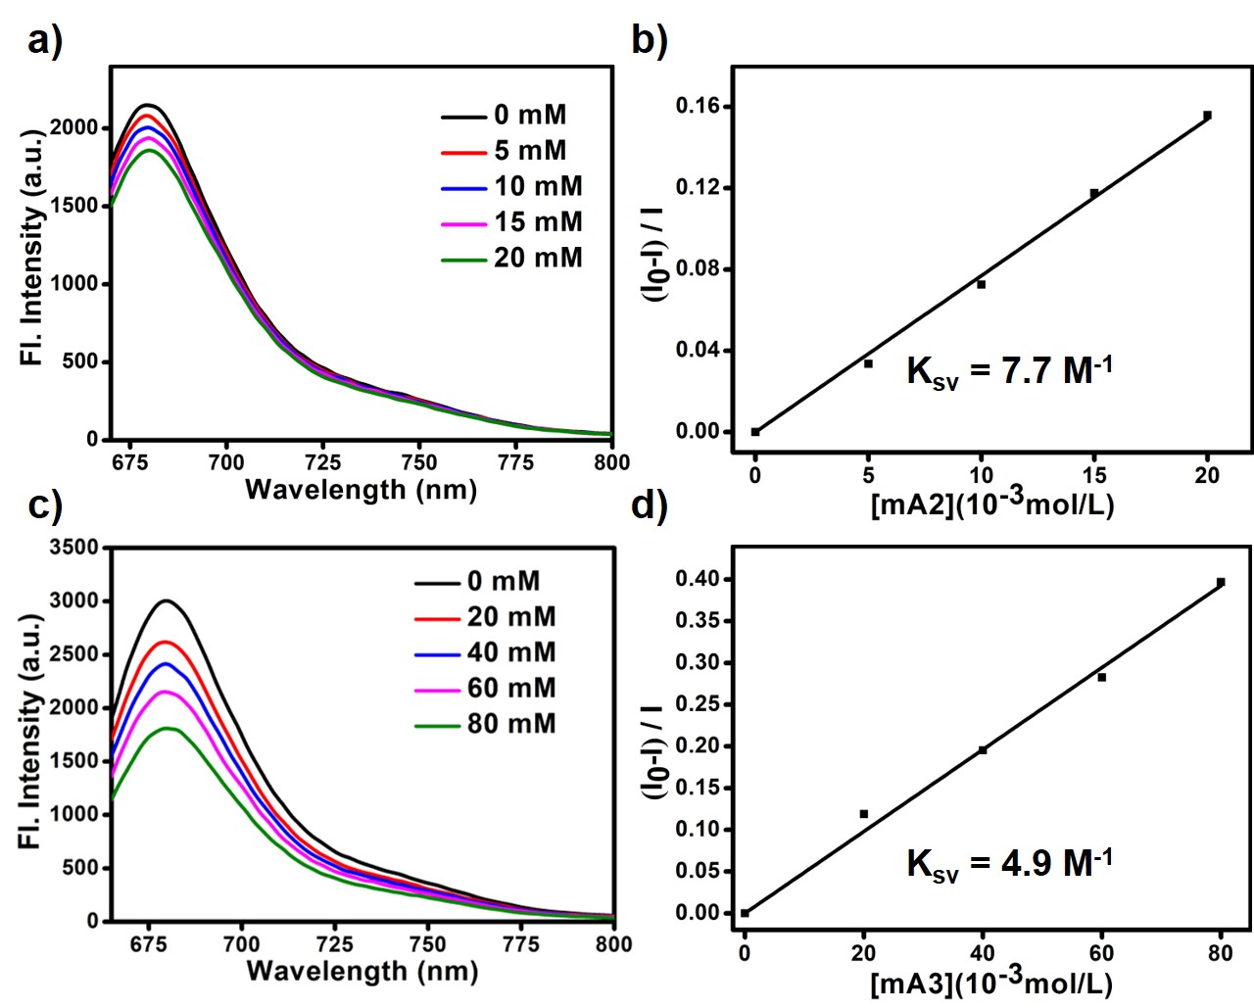
Figure S15. The emission spectra of D (1.0 × 10⁻⁵ M) at 25 ℃ in DMF with increasing amounts of a) A2 (0 – 20 mM) and c) A3 (0 – 80 mM) under excitation at 650 nm. The Stern–Volmer plots for the fluorescence quenching of D by b) A2 and d) A3 in acetonitrile at 25 ℃ (I₀ is the fluorescence intensity of D in the absence of electron acceptor, I is the fluorescence intensity in the presence of electron acceptor at the different concentrations).
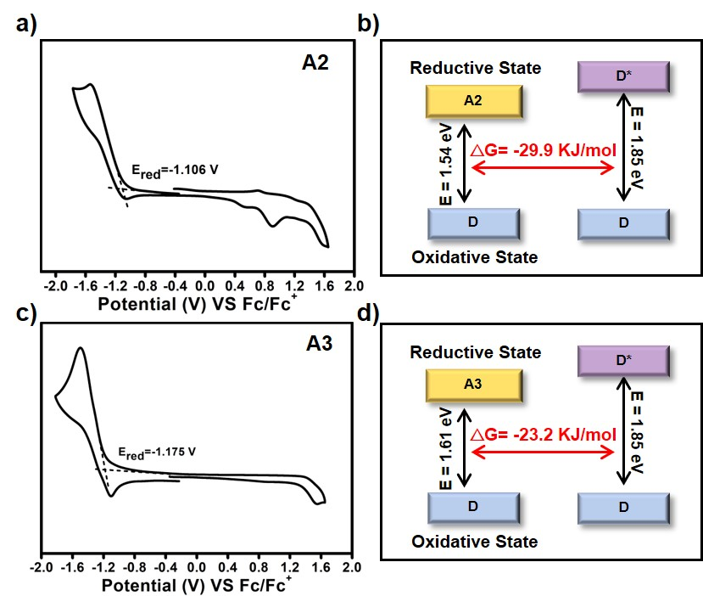
Figure S16. Cyclic voltammogram of a) A2 and c) A3 in DCM with 0.1 M (n-Bu)₄N⁺PF₆⁻ as a supporting electrolyte, Ag/Ag⁺ as a reference electrode, platinum-carbon electrode as a working electrode and Pt wire as a counter electrode; scan rate, 100 mVs⁻¹; Fc/Fc⁺ was used as an external reference. Gibbs free energy of electron transfer from D to b) A2 and d) A3.
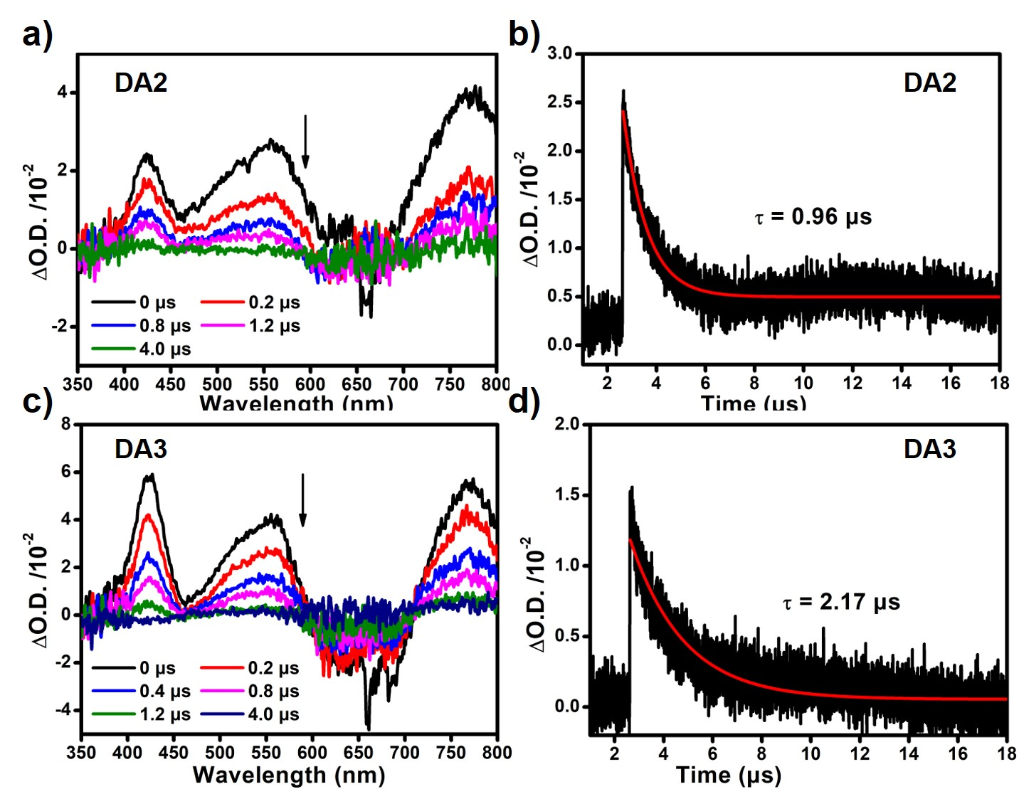
Figure S17. Time-resolved transient difference absorption of D in the a) DA2 and c) DA3 dispersed in water (20 mM). Decay trace of D in the b) DA2 and d) DA3 dispersed in water (20 mM).

Experimental data in vitro and in vivo
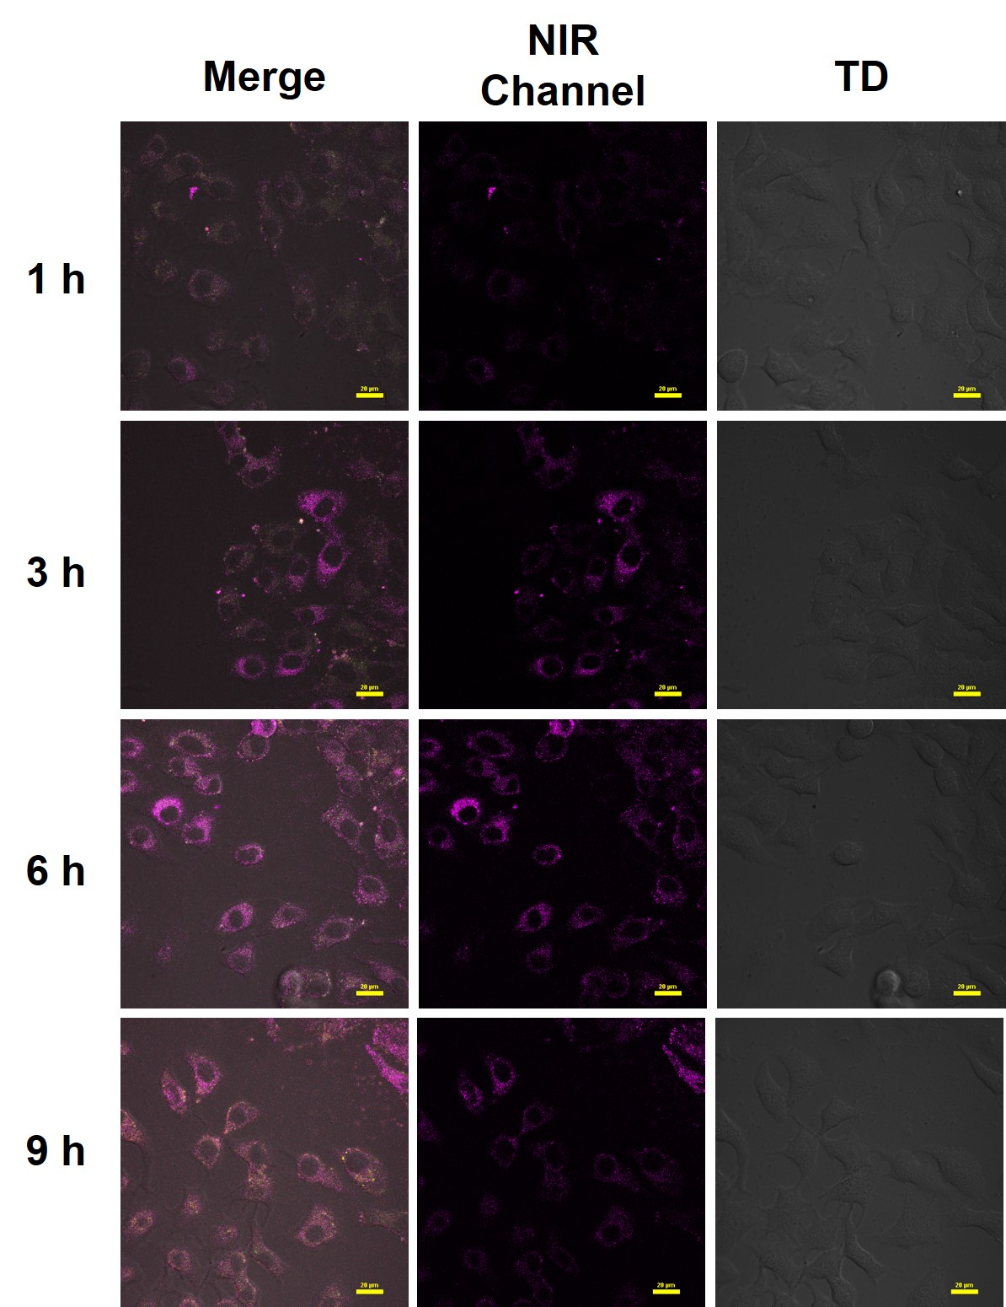
Figure S18. CLSM images of HeLa cells incubated with DA1 (1.0 μM) at different time points. The scale bar represents 20 μm.
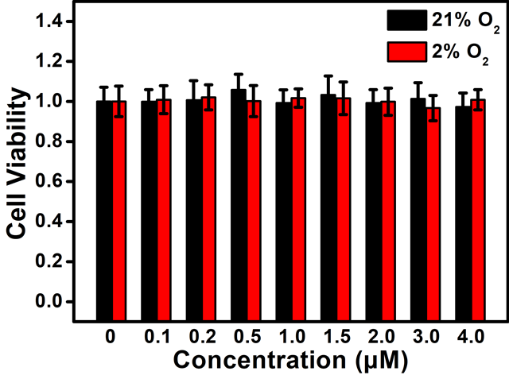
Figure S19. Cell viability of HeLa cells subjected to a range of DA1 concentrations in the dark under normoxic or hypoxic conditions.
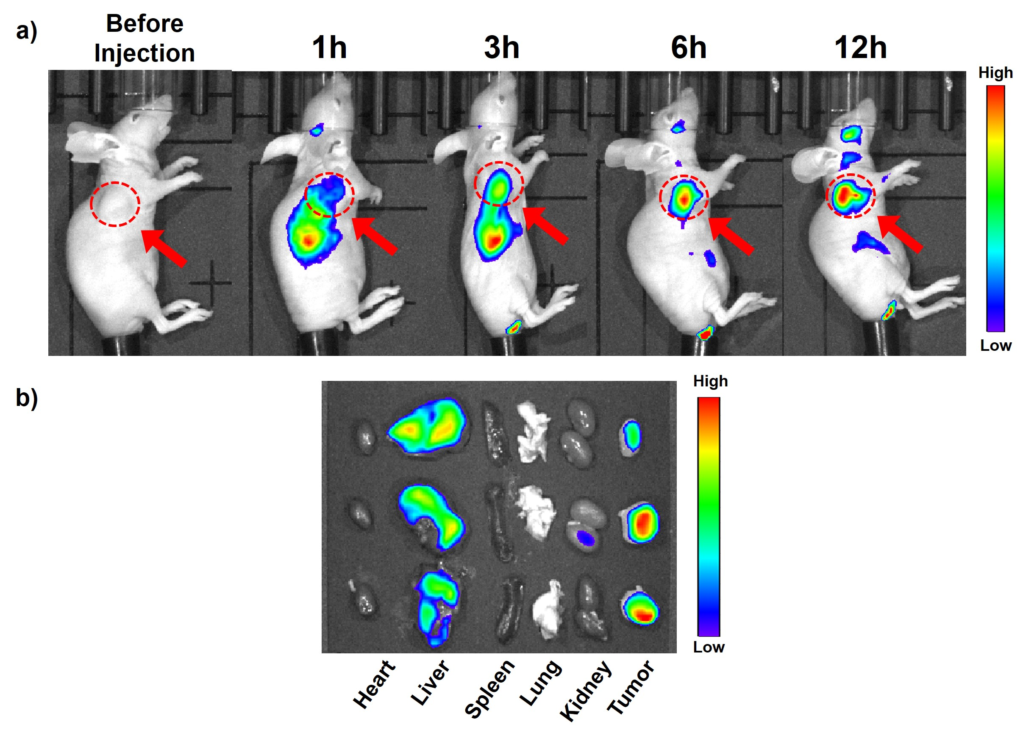
Figure S20. a) In vivo fluorescence imaging of HeLa tumor-bearing BALB/c mice after intravenous injection of DA1. b) Fluorescence images of ex vivo organs harvested at 12 hours postinjection.

NMR spectra and HRMS
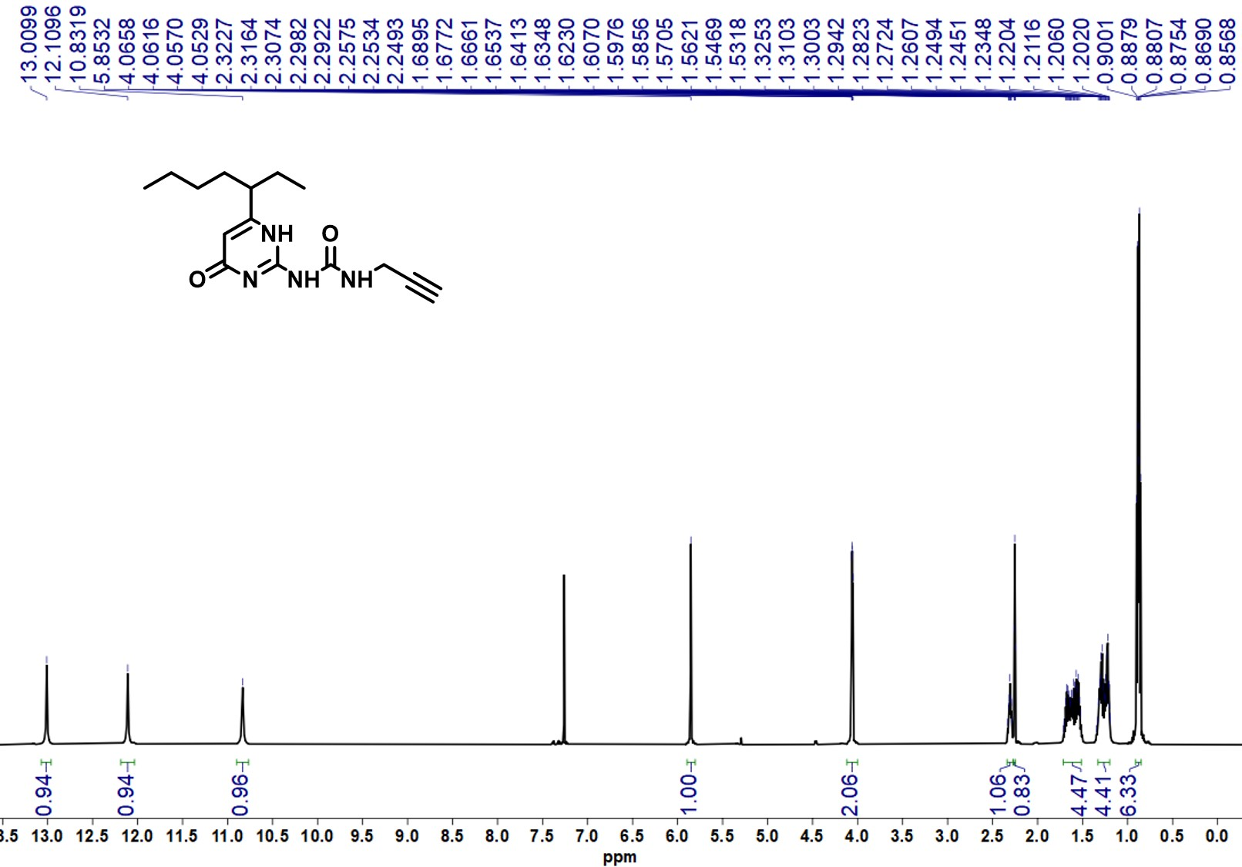
Figure S21. The ¹H NMR of compound 5 in CDCl₃.
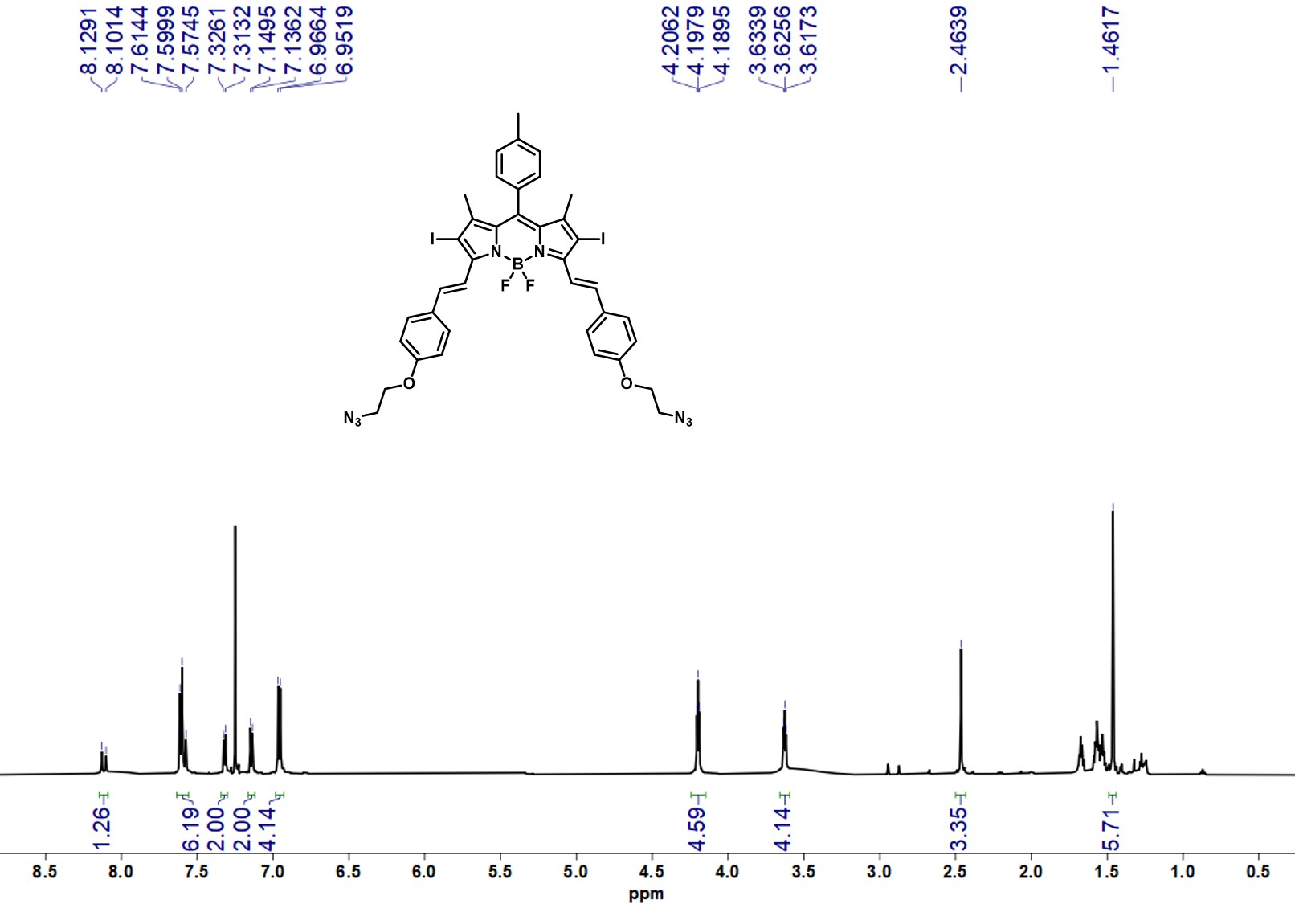
Figure S22. The ¹H NMR of compound 8 in CDCl₃.
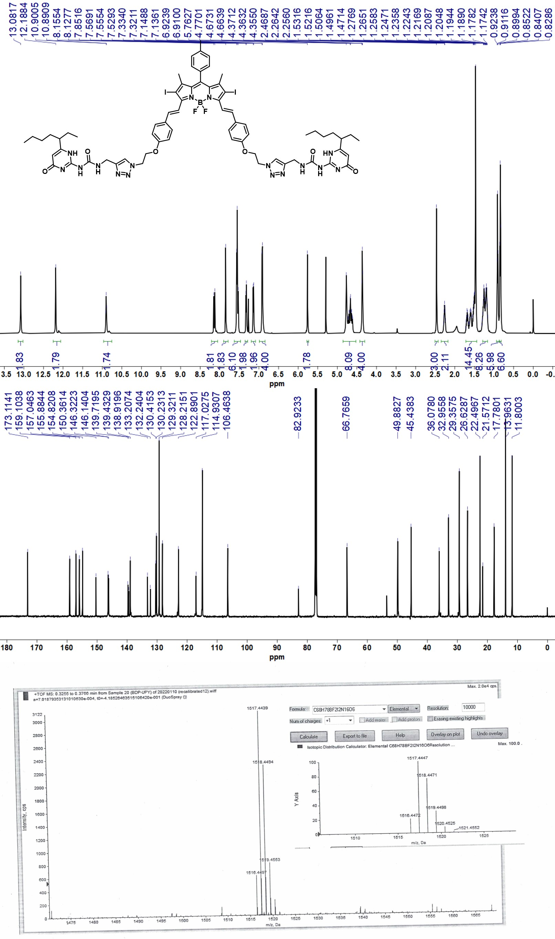
Figure S23. The ¹H NMR ,¹³C NMR in CDCl₃ and HRMS of D.
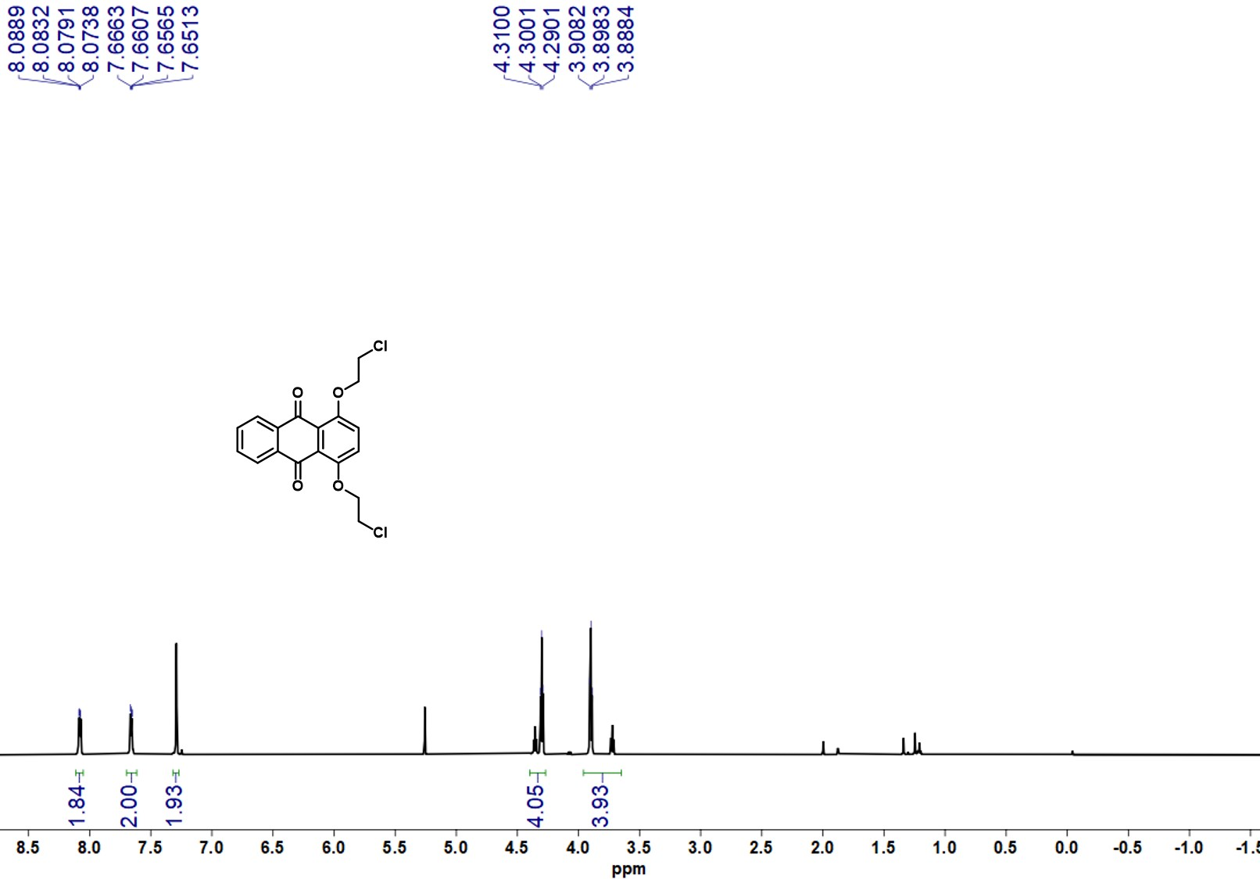
Figure S24. The ¹H NMR of compound 10 in CDCl₃.
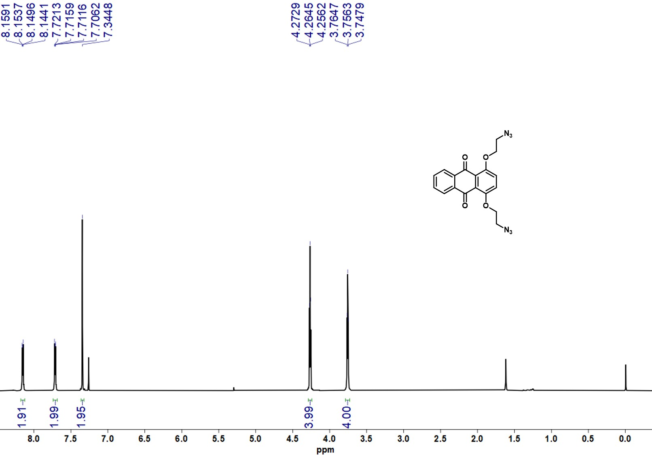
Figure S25. The ¹H NMR of compound 11 in CDCl₃.
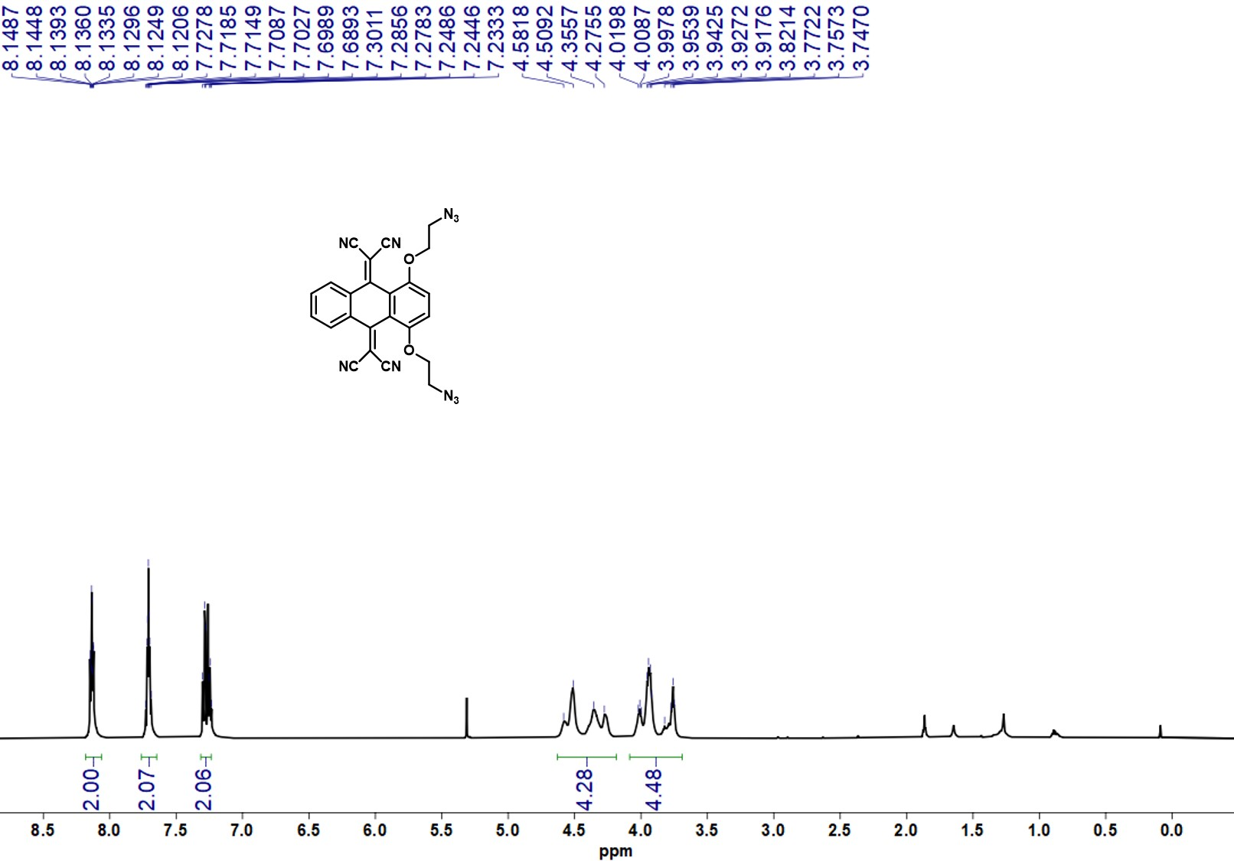
Figure S26. The ¹H NMR of compound 12 in CDCl₃.
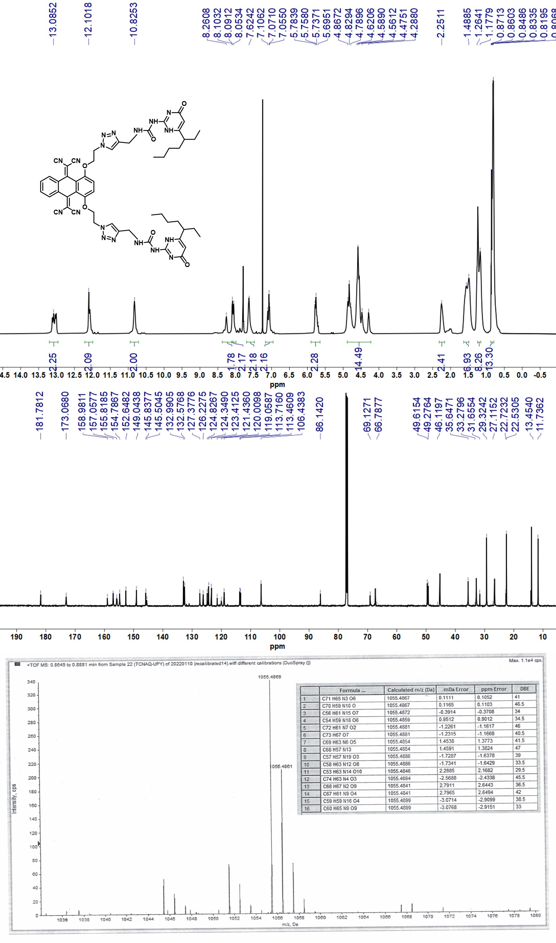
Figure S27. The ¹H NMR ,¹³C NMR in CDCl₃ and HRMS of A1.
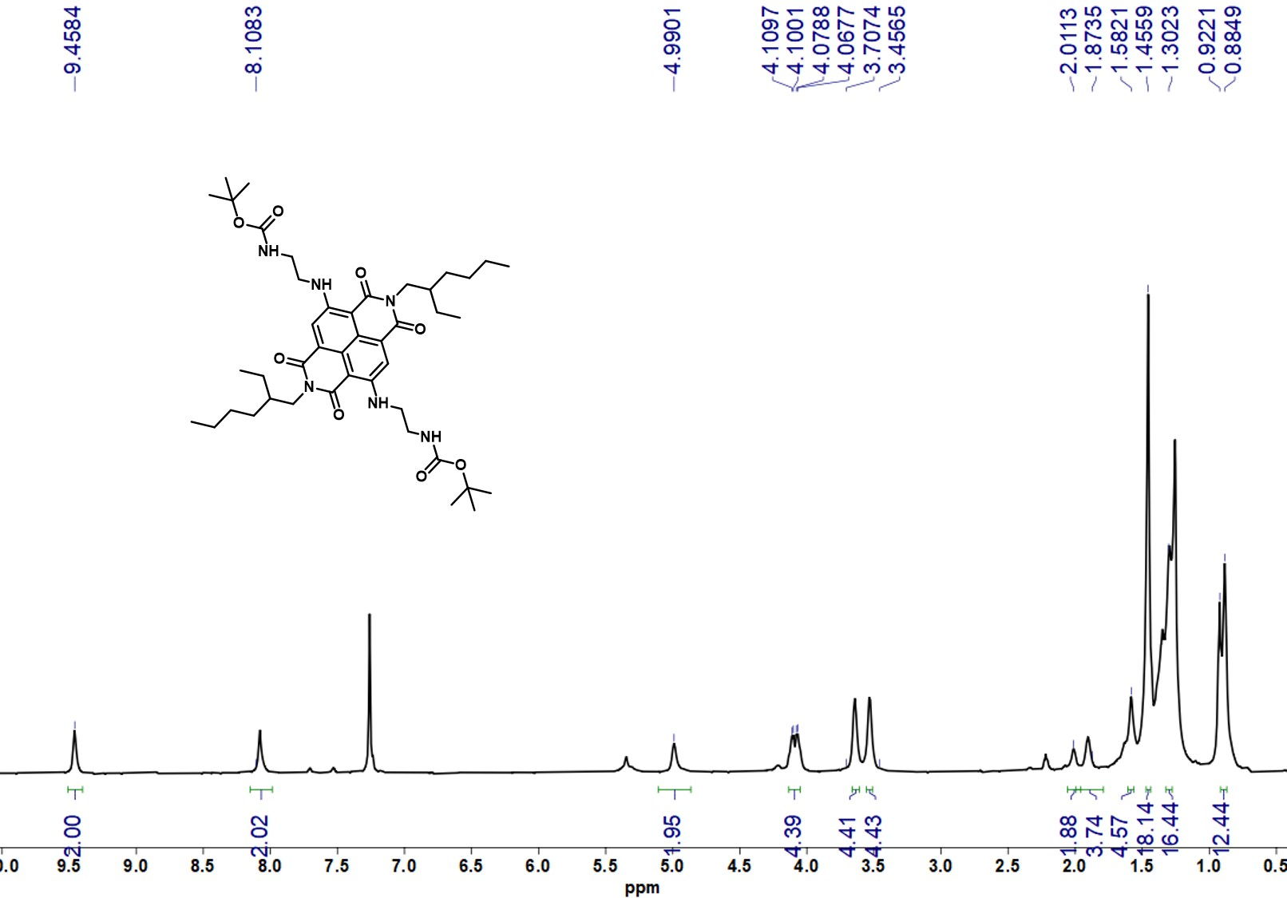
Figure S28. The ¹H NMR of compound 15 in CDCl₃.
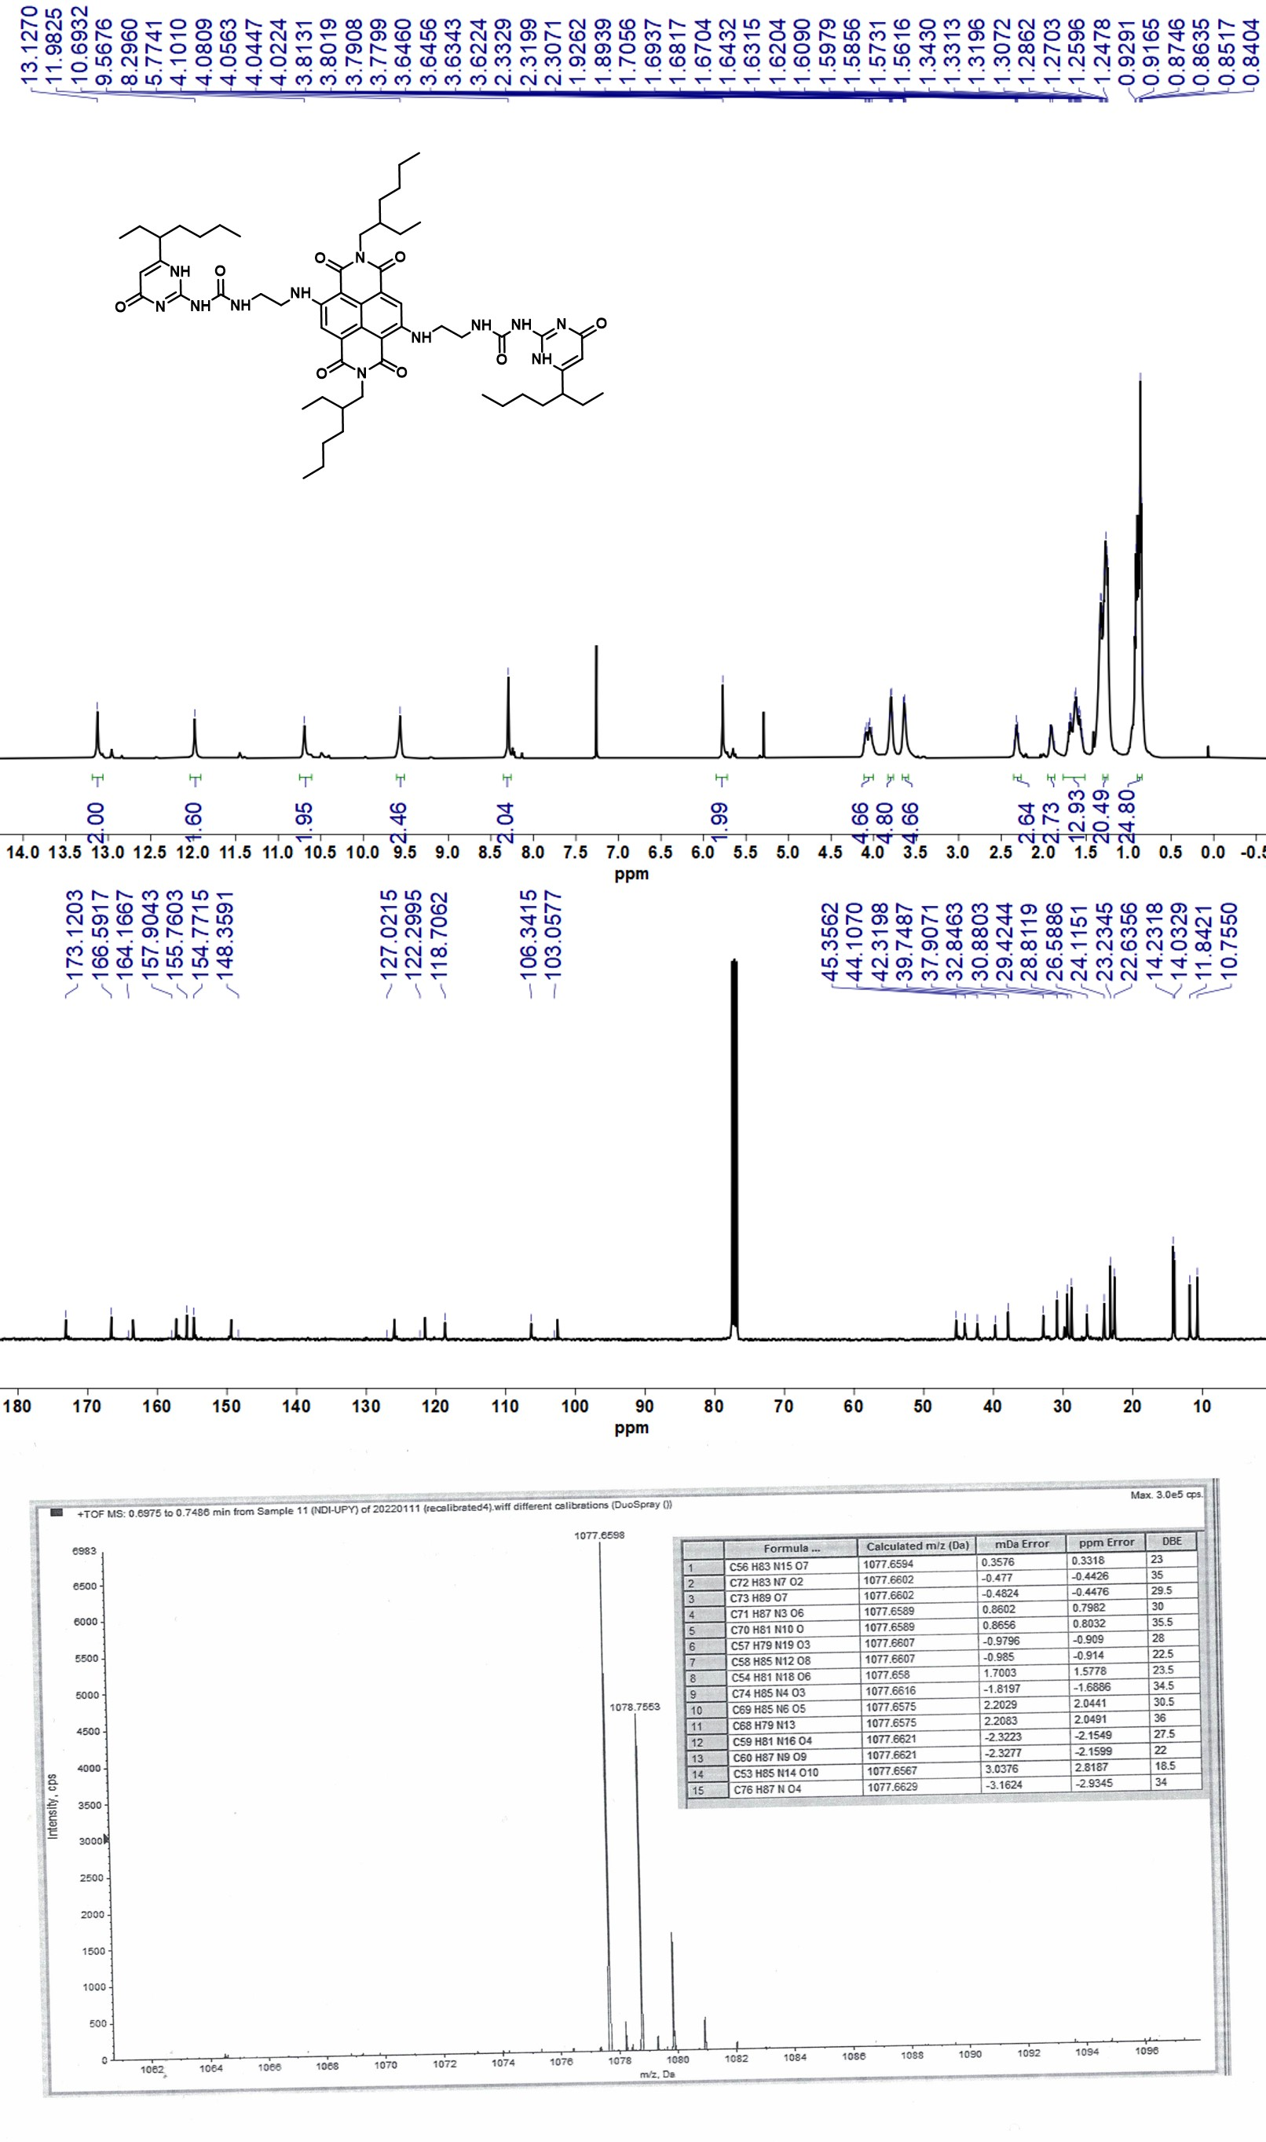
Figure S29. The ¹H NMR ,¹³C NMR in CDCl₃ and HRMS of A2.
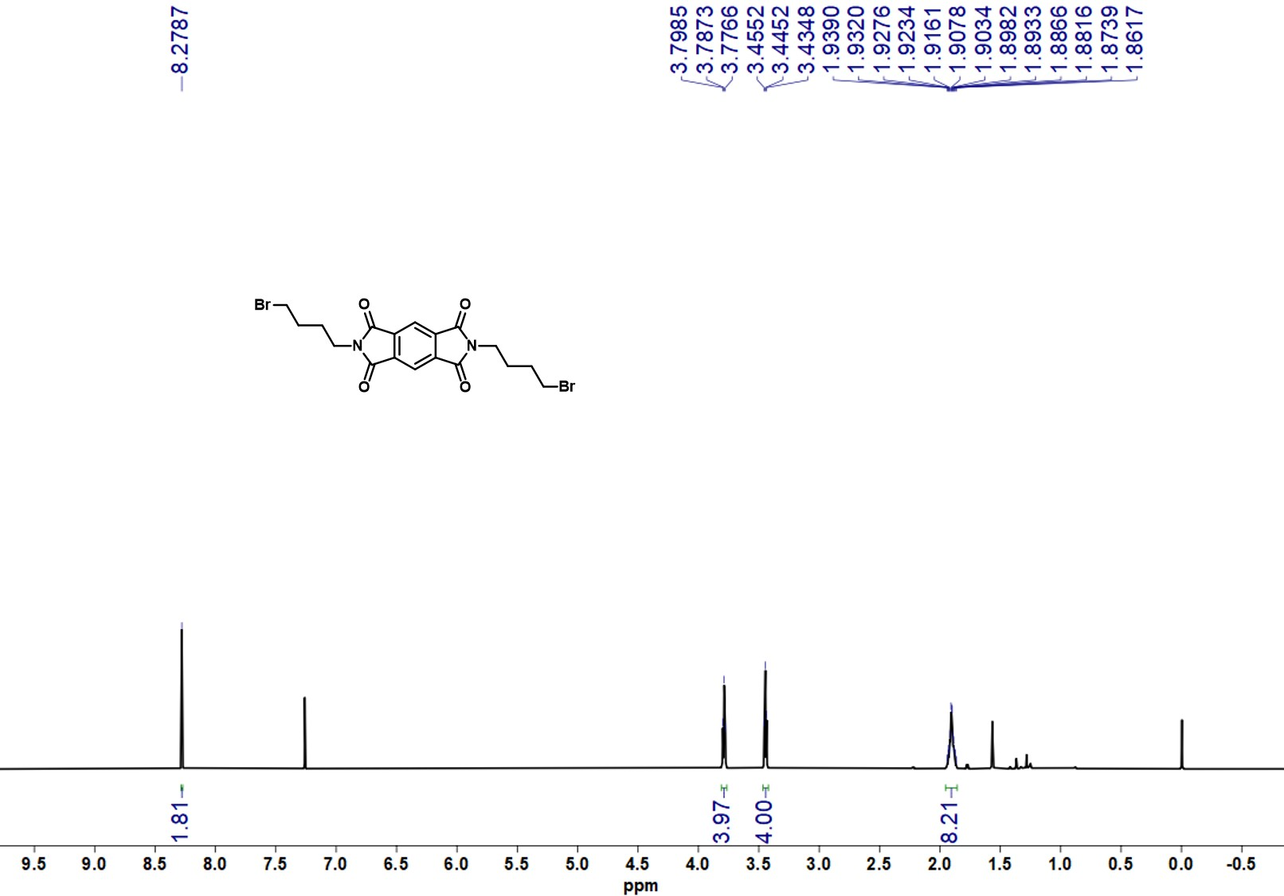
Figure S30. The ¹H NMR of compound 17 in CDCl₃.
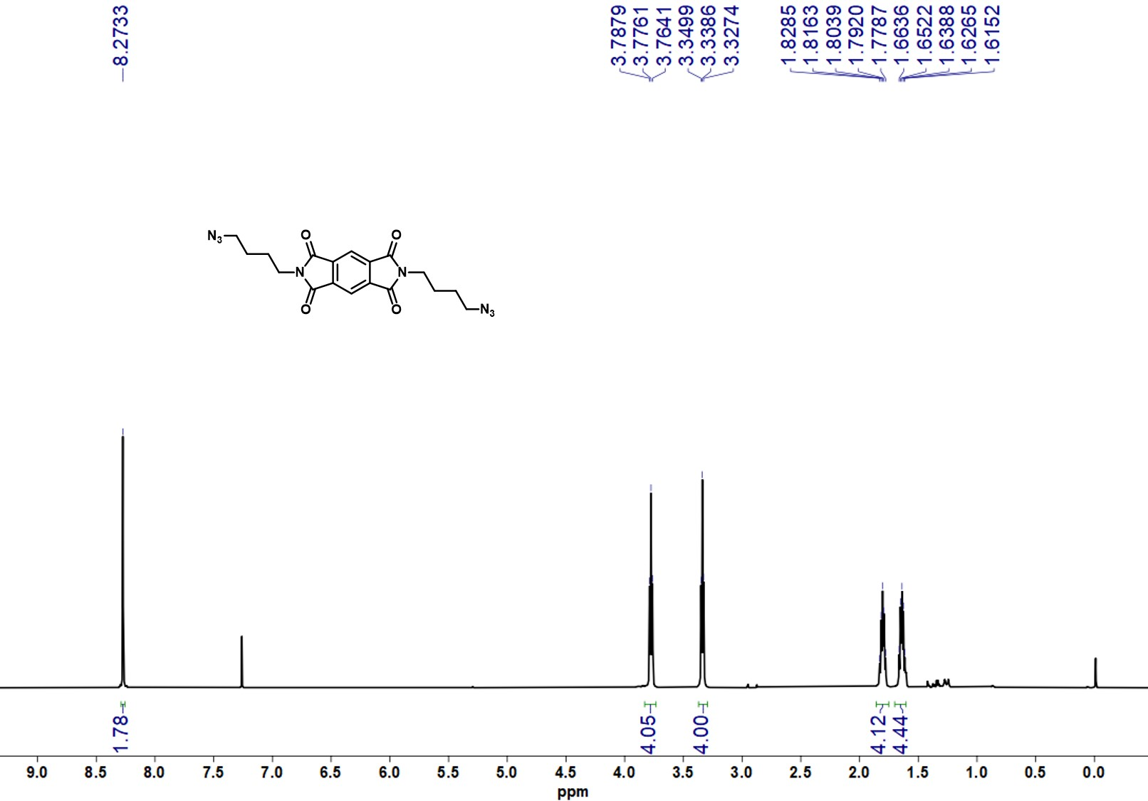
Figure S31. The ¹H NMR of compound 18 in CDCl₃.
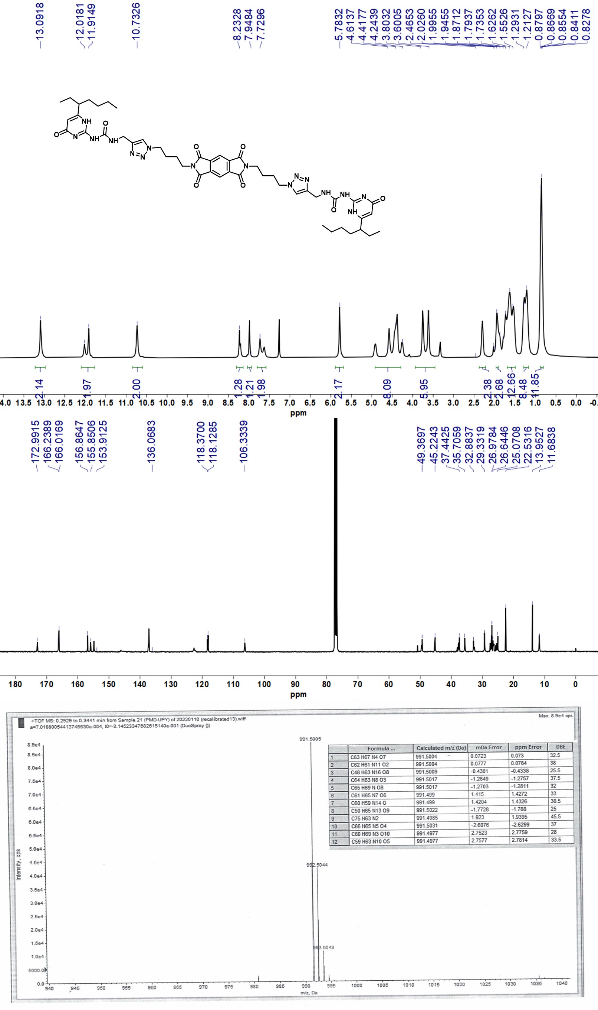
Figure S32. The ¹H NMR ,¹³C NMR in CDCl₃ and HRMS of A3.

References
1. Peng, H.-Q.; Chen, Y.-Z.; Zhao, Y.; Yang, Q.-Z.; Wu, L.-Z.; Tung, C.-H.; Zhang, L.-P.; Tong, Q.-X., Artificial light-harvesting system based on multifunctional surface-cross-linked micelles. Angew. Chem. Int. Ed. 2012, 51, 2088-2092.
2. Teng, K.-X.; Niu, L.-Y.; Kang, Y.-F.; Yang, Q.-Z., Rational design of a “dual lock-and-key” supramolecular photosensitizer based on aromatic nucleophilic substitution for specific and enhanced photodynamic therapy. Chem. Sci. 2020, 11, 9703-9711.
3. Li, Z.-J.; Li, S.; Hofman, E.; Hunter Davis, A.; Leem, G.; Zheng, W., Visible-light induced disproportionation of pyrrole derivatives for photocatalyst-free aryl halides reduction. Green Chem. 2020, 22, 1911-1918.
4. Rehm, D.; Weller, A., Kinetics of fluorescence quenching by electron and H-atom transfer. Isr. J. Chem. 1970, 8, 259-271.

