Table 1: Chemical structure and pIC₅₀ data of CPT derivatives
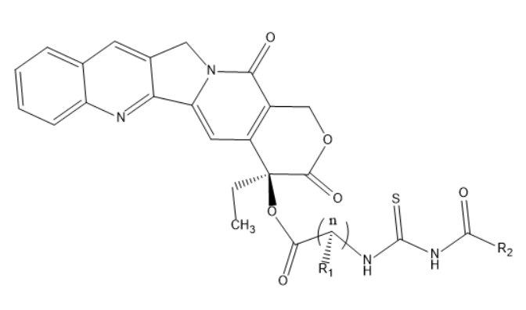
Entry | n | R₁ | R₂ | Hep3b | MCF7 | MDA-  MB-231 | KB-vin
 |  |  |  | Values in pIC₅₀
C1 | 1 | H |  | 0.18 | 2.60 | 2.58 | 1.65
C2 | 1 | H |  | 0.11 | 2.16 | 2.53 | 1.68
C3 | 1 | H |  | 1.08 | 2.37 | 2.52 | 1.53
C4 | 1 | H |  | 1.12 | 2.25 | 2.60 | 1.63
C5 | 1 | H |  | 1.05 | 2.34 | 2.67 | 2.26
C6 | 1 | H |  | 0.61 | 2.72 | 2.31 | 1.67
C7 | 1 | H |  | 1.25 | 2.30 | 2.30 | 1.62
C8 | 1 | H |  | 0.18 | 2.44 | 2.65 | 2.22
C9 | 1 | H |  | 0.28 | 2.41 | 2.98 | 2.69
C10 | 1 | H |  | 2.02 | 2.80 | 2.87 | 2.46
C11 | 1 | H |  | 0.83 | 2.00 | 1.98 | 1.57
C12 | 1 | H |  | 1.42 | 2.91 | 2.88 | 2.59
C13 | 1 | H |  | 1.09 | 2.23 | 2.50 | 2.00
C14 | 1 | H |  | 1.95 | 2.32 | 2.26 | 1.69
C15 | 1 | H |  | 0.28 | 2.09 | 2.52 | 2.05
C16 | 1 | H |  | 0.72 | 1.94 | 2.46 | 2.02
C17 | 1 | H |  | 1.71 | 1.71 | 2.14 | 1.70
C18 | 1 | CH₃ |  | 2.14 | 2.14 | 2.34 | 1.74
C19 | 1 | CH₃ |  | 2.17 | 2.15 | 2.63 | 2.25
C20 | 1 | CH₃ |  | 0.36 | 1.62 | 1.98 | 1.68
C21 | 1 | (CH₃)₂CH |  | 0.32 | 2.50 | 2.58 | 1.65
C22 | 1 | (CH₃)CH |  | 0.62 | 2.60 | 2.64 | 2.32
C23 | 1 |  |  | 1.14 | 2.94 | 2.81 | 2.35
C24 | 1 |  |  | 1.26 | 2.97 | 2.85 | 2.37
C25 | 1 |  |  | 1.54 | - | 2.80 | 1.98
C26 | 1 |  |  | 1.11 | - | 2.80 | 1.96
C27 | 1 |  |  | 1.66 | 2.88 | 2.59 | 1.90
C28 | 1 |  |  | 0.76 | 2.95 | 2.30 | 1.61
C29 | 1 |  |  | 0.89 | 2.97 | 2.84 | 2.27
C30 | 1 |  |  | 0.87 | 2.79 | 2.75 | 2.00
C31 | 1 |  |  | 0.32 | 2.87 | 2.94 | 1.89
C32 | 1 |  |  | - | 2.25 | 2.81 | 2.27
C33 | 1 |  |  | 0.22 | 2.77 | 2.10 | 1.64
C34 | 1 |  |  | 0.65 | 2.90 | 2.17 | 1.73
C35 | 1 |  |  | 1.71 | 2.79 | 2.74 | 1.83
C36 | 1 |  |  | 1.71 | - | 2.33 | 1.77
C37 | 1 |  |  | 1.77 | 2.91 | 2.91 | 2.33
C38 | 1 |  |  | 1.33 | 2.73 | 2.71 | 1.67
C39 | 2 | H |  | 2.06 | - | 2.69 | 1.95
C40 | 2 | H |  | 1.90 | - | - | -
C41 | 2 | H |  | 1.34 | 1.85 | - | 2.66
C42 | 2 | H |  | 2.25 | - | - | 2.98
C43 | 3 | H |  | 1.90 | - | - | 2.19
C44 | 3 | H |  | 1.72 | 2.89 | 2.84 | 2.55
C45 | 4 | H |  | 2.78 | - | - | 2.86
C46 | 4 | H |  | 1.98 | - | - | -

