Supplementary information

High Proton Conduction in Ba₂LuAlO₅ with Highly Oxygen Deficient Layers
Riho Morikawa¹, Taito Murakami¹, Kotaro Fujii¹, Maxim Avdeev^{2,3}, and Masatomo Yashima^{1,*}

¹ Department of Chemistry, School of Science, Tokyo Institute of Technology, 2-12-1 W4-17 Ookayama, Meguro-ku, Tokyo 152-8551, Japan
² Australian Centre for Neutron Scattering, Australian Nuclear Science and Technology Organization (ANSTO), Locked Bag 2001, Kirrawee DC, NSW, 2232, Australia
³ School of Chemistry, The University of Sydney, Sydney 2006, Australia

* Correspondence to Masatomo Yashima (yashima@cms.titech.ac.jp).

Supplementary Figures

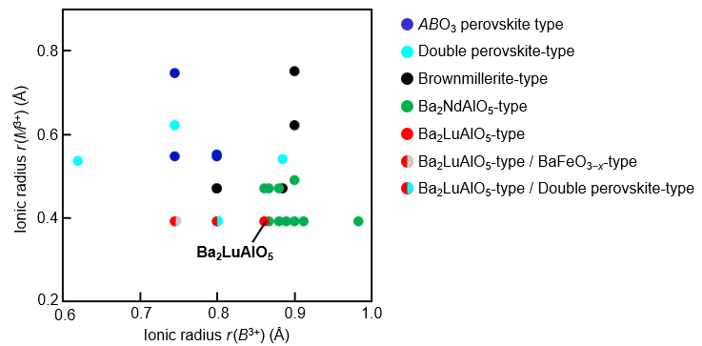

Fig. S1. Structure field map of Ba₂BMO₅ oxides (B, M: trivalent cations, r(M) ≤ r(B)). r(B) and r(M) denote the ionic radius of B cation and M cation, respectively. The ionic radius of B cation is the value of the coordination number CN = 6. The ionic radius of M cation is the value of CN = 6 for ABO₃ perovskite-type^{1–4}, double perovskite-type⁵, and BaFeO_{3−x}-type and CN =4 for Brownmillerite-type, Ba₂NdAlO₅-type^{6–11}, and Ba₂LuAlO₅-type^{12,13}. Note that this figure includes the new composition Ba₂LuAlO₅.

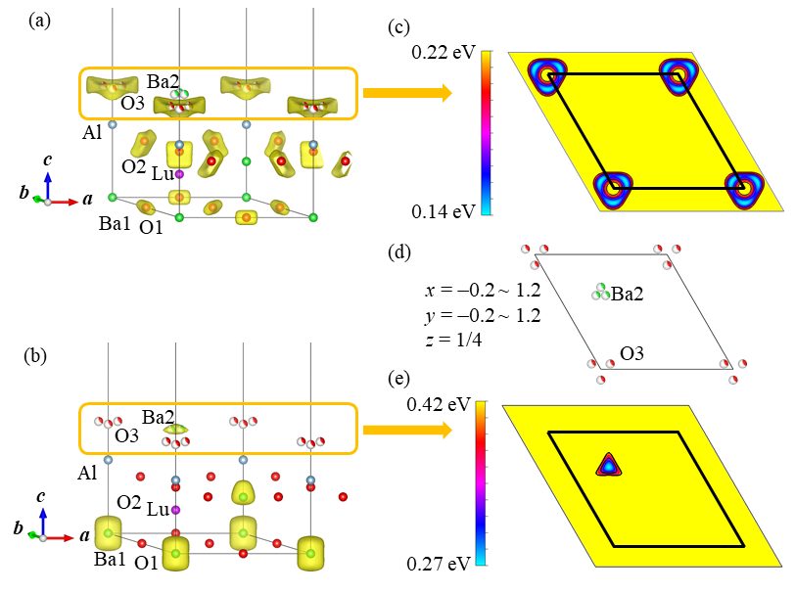
Fig. S2. (a, b) Refined crystal structure of Ba₂LuAlO₅ at 20 °C with yellow isosurfaces of the BVELs for (a) an oxide ion at 0.5 eV and (b) Ba²⁺ at 0.7 eV. (c‒e) BVELs for (c) an oxide ion and (e) Ba²⁺ at z = 0.25 and (d) corresponding atomic arrangements on the ab plane (‒0.2 ≤ x, y ≤ 1.2, z = 1/4). Contour lines are (c) from 0.14 to 0.22 eV with 0.008 eV interval and (e) from 0.27 to 0.42 eV with 0.005 eV interval.

Table S1: Comparison of the crystal parameters optimized by the DFT calculations and those refined by single-crystal X-ray structure analyses of Ba₂LuAlO₅.
Crystal symmetry: hexagonal, space group: P6₃/mmc
(a) Optimized lattice parameters
 | Optimized lattice parameter / Å | Difference / %
 | a = 5.97112 | 0.86
 | c = 20.05432 | 1.57

(b) Optimized atomic coordinates
Atomic coordinates |  |  |  | Difference / %
Atom | x | y | z | Δx | Δy | Δz
Ba1 | 0 | 0 | 0 | 0 | 0 | 0
Ba2 | 1/3 | 2/3 | 1/4 | 0.010 | ‒0.004 | 0
Ba3 | 2/3 | 1/3 | 0.10599 | 0.000 | ‒0.001 | ‒5.273
Lu | 1/3 | 2/3 | 0.0665 | ‒0.001 | 0.000 | ‒1.874
Al | 0 | 0 | 0.16361 | 0 | 0 | ‒1.082
O1 | 1/2 | 0 | 0 | 0 | 0 | 0
O2 | 0.16163 | 0.32326 | 0.36641 | 1.209 | 1.335 | 0.414
O3 | 0 | 0 | 1/4 | 0 | 0 | 0

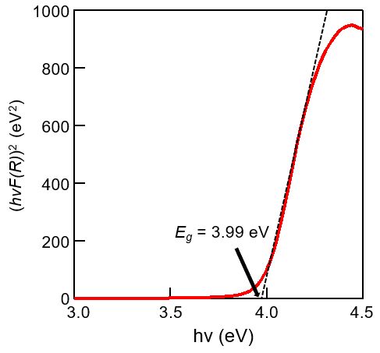
Fig. S3. Tauc plot of the UV−Vis diffuse reflectance spectrum of Ba₂LuAlO₅ at room temperature.

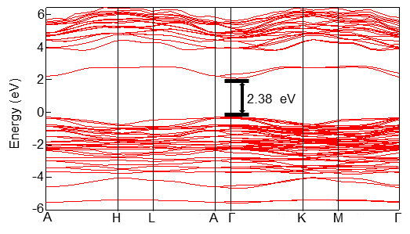

Fig. S4. Band structure of Ba₂LuAlO₅ obtained by DFT calculations, where Γ = (0,0,0), M = (1/2,0,0), A = (0,0,1/2)，H = (1/3,1/3,1/2), K = (1/3,1/3,0), L = (1/2,0,1/2). Fermi level is set to 0 eV.

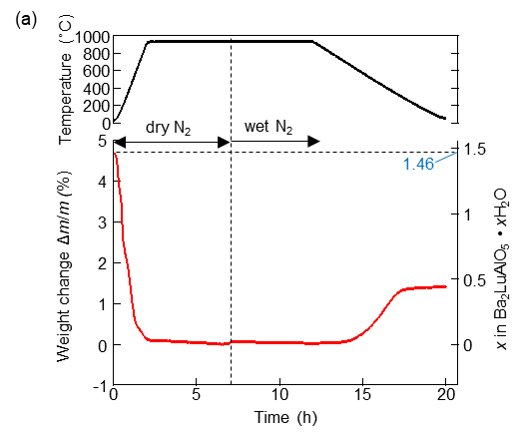

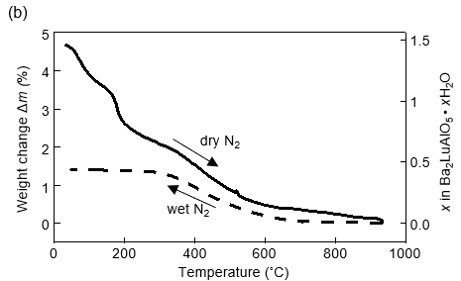
Fig. S5. Thermogravimetric curves of Ba₂LuAlO₅ during heating (solid line) in dry N₂ and cooling (dashed line) in wet N₂ as functions of (a) time and (b) temperature. The sample was kept in dry N₂ flow for 2 hours at 900 °C in order to remove water, and the weight was saturated to a value of m₀. Then, the atmosphere was switched to wet N₂. After that, the sample was annealed at 900 °C for 2 hours and cooled to 50 °C in wet N₂ flow. The weight change Δm/m₀ (%) is calculated by the equation 100(m − m₀)/m₀ where m is the sample weight. The water amount was estimated assuming that the sample just after the annealing at 900 ºC in dry N₂ for 2 hours contains no water (x = 0). The loaded water amount during cooling in wet N₂ from 900 to 50 °C is x = 0.44 in Ba₂LuAlO₅·x H₂O. The water amount in as-prepared sample was x = 1.47.

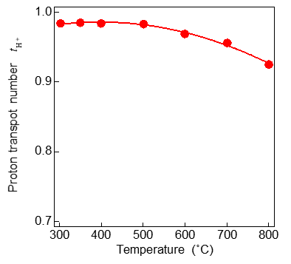
Fig. S6. Temperature dependence of the transport number t_{H}⁺, where t_{H}⁺ = (σ(H₂O) – σ(dry)) / σ(H₂O).

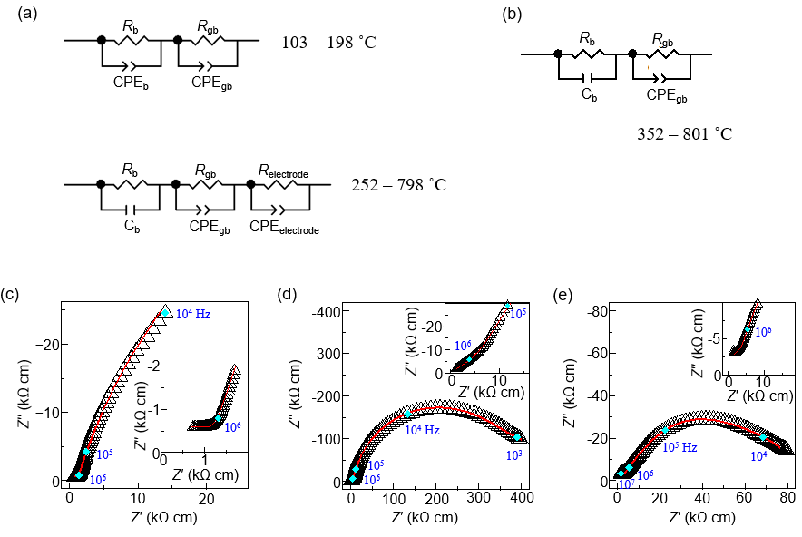
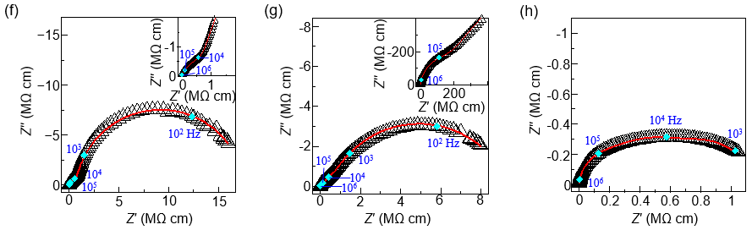
Fig. S7. Impedance analysis of Ba₂LuAlO₅. (a) Equivalent circuits for data analysis of wet sample. (b) Equivalent circuits for data analysis of dry sample. (c−e) Complex impedance plots of Ba₂LuAl₅ measured at (c) 200, (d) 450, and (e) 700 ºC in H₂O saturated N₂ + H₂. (f−i) Complex impedance plots of Ba₂LuAl₅ measured at (f) 350, (g) 500 and (h) 800 ºC in dry N₂.

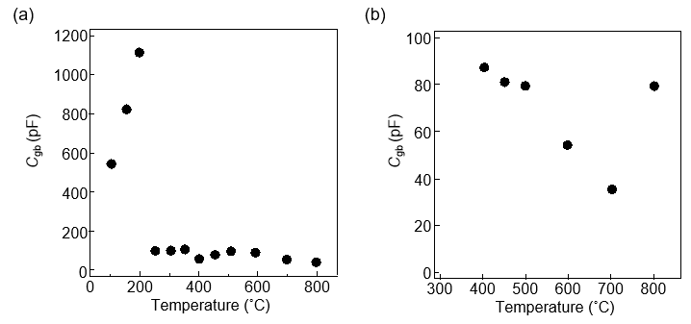
Fig. S8. Temperature dependencies of grain-boundary capacitance C_{gb} of (a) wet Ba₂LuAlO₅ and (b) dry Ba₂LuAlO₅.

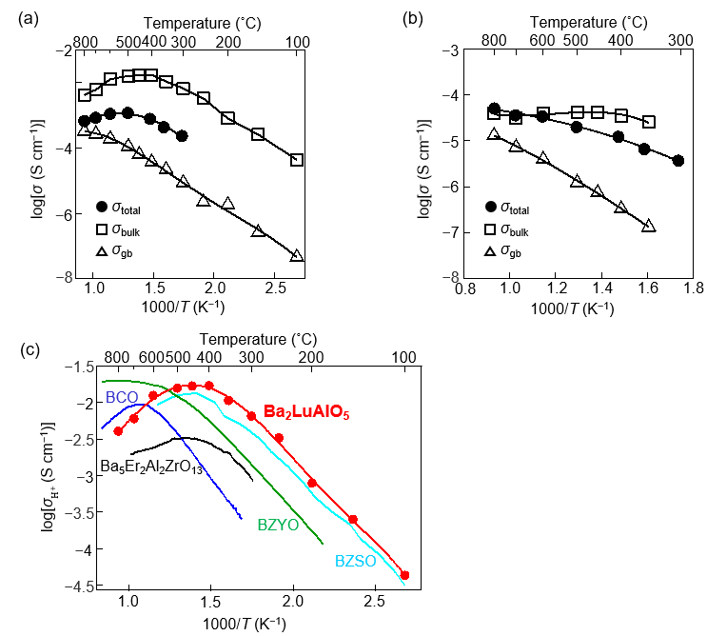
Fig. S9. (a-b) Arrhenius plots of bulk (σ_{bulk}) and grain-boundary (σ_{gb}) conductivities of Ba₂LuAlO₅ measured in (a) H₂O saturated N₂ and H₂ and (b) dry N₂. (c) Comparison of proton conductivity of Ba₂LuAlO₅ and other proton conductors.

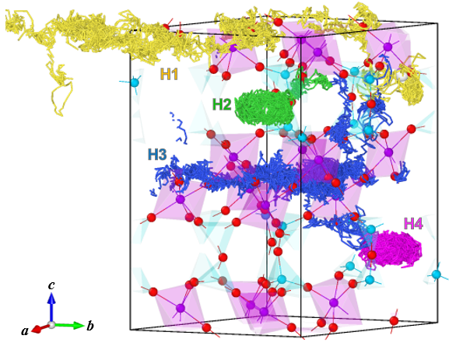

Fig. S10. The trajectory of four protons in AIMD simulation at 1473 K in the first 5ps. Color coding is used to display each trajectory.

Supplementary note 1: Exploration of Ba₂BMO₅ oxides (B, M: cations)
We prepared seven compositions of Ba₂BMO₅ oxides in order to explore a new hexagonal perovskite-related material with highly oxygen-deficient layers.
Two aluminates Ba₂TbAlO₅ and Ba₂TmAlO₅ samples prepared were found to adopt Ba₂NdAlO₅-type structure without any oxygen vacancies, consistent with the literature.⁶ We also prepared new materials Ba₂YbGaO₅, Ba₂LuGaO₅ and Ba₂TmGaO₅. The X-ray powder diffraction patterns of these materials are similar with those of Ba₂NdAlO₅-type oxides, which suggests that the main phases of the Ba₂YbGaO₅, Ba₂LuGaO₅ and Ba₂TmGaO₅ samples prepared have Ba₂NdAlO₅-type structure without oxygen vacancies. Total DC conductivity of Ba₂YbGaO₅ was too low to be measured and less than 10⁻⁶ S cm⁻¹, probably due to the absence of oxygen vacancies. Total DC conductivity of Ba₂DyAlO₅ was also quite low (6.84×10⁻⁷ S cm⁻¹ at 500 °C)¹⁴. Therefore, we did not examine the structural and transport properties of the Ba₂NdAlO₅-type oxides (Ba₂YbGaO₅, Ba₂LuGaO₅ and Ba₂TmGaO₅) in more detail.
Figure S1 shows the structure-field map of Ba₂BMO₅ oxides (B, M: cations). Only three aluminates Ba₂BAlO₅ (B = Lu, In, and Sc) crystallize into hexagonal perovskite-related oxides with oxygen-deficient BaO h′ layers. In these compositions, the ionic radius of M cation is relatively small (ionic radius of M = Al³⁺ for coordination number CN of 4, r(Al; 4) is 0.39 Å), and the ionic radius of B cation for CN = 6 is ranged from 0.745 to 0.861 Å.
In the literature¹², Ba₂InAlO₅ prepared by the flux method is reported to have the Ba₂LuAlO₅-type structure, although the Ba₂InAlO₅ sample prepared by us adopts a new double perovskite-type structure. In addition, the Ba₂InAlO₅ sample exhibited a lower total DC conductivity (4.8×10⁻⁵ S cm⁻¹) at 500 °C in wet air than Ba₂LuAlO₅ (2.75×10⁻³ S cm⁻¹). Ba₂ScAlO₅ crystallizes into either Ba₂LuAlO₅-type structure (Sc/Al-ordered β-phase) or BaFeO_{3−x}-type structure (partially Sc/Al-disordered α-phase) depending on temperature. In contrast, Ba₂LuAlO₅ adopts only the Ba₂LuAlO₅-type structure (Lu/Al-ordered phase). Since the size mismatch between Lu and Al cations [r(Lu; 6) − r(Al; 4) = 0.471 Å] is larger than that between Sc and Al cations [r(Sc; 6) − r(Al; 4) = 0.355 Å], the Lu/Al-ordered Ba₂LuAlO₅-type Ba₂LuAlO₅ should be more stable than the partially Lu/Al-disordered phase.

Supplementary References
1. Lozano Gorrín, A. D., Núñez, P., De La López Torre, M. A., De Romero Paz, J. & Sáez Puche, R. Spin glass behavior of new perovskites Ba₂In_{2-x}Co_{x}O₅ (0.5 ≤x≤1.70). J. Solid State Chem. 165, 254–260 (2002).
2. Omata, T., Fuke, T. & Otsuka-Yao-Matsuo, S. Hydration behavior of Ba₂Sc₂O₅ with an oxygen-deficient perovskite structure. Solid State Ionics 177, 2447–2451 (2006).
3. Luo, K., Tran, T. T., Halasyamani, P. S. & Hayward, M. A. Synthesis and selective topochemical fluorination of the cation and anion-vacancy ordered phases Ba₂YCoO₅ and Ba₃YCo₂O_{7.5}. Inorg. Chem. 52, 13762–13769 (2013).
4. Kameneva, M. Y. et al. Preparation and Investigation of Compounds with the 114-Type Structure in the Y-Sc-Ba-Co-O System. J. Struct. Chem. 61, 29–43 (2020).
5. Matheis, D. P. & Snyder, R. L. The crystal structures and powder diffraction patterns of the bismuth and thallium Ruddlesden-Popper copper oxide superconductors. Powder Diffr. 5, 8–24 (1990).
6. Antipov, E.V., Lykova, L.N., Korba, L. M. Crystal structure of Ba ₂NdAlO₅. Koord. Khimiya 11, 1151–1153 (1985).
7. Wan, C., Qu, Z., He, Y., Luan, D. & Pan, W. Ultralow thermal conductivity in highly anion-defective aluminates. Phys. Rev. Lett. 101, 3–6 (2008).
8. Liu, L., Wang, Y., Ma, Z., Wang, F. & Zhu, M. Preparation and thermophysical properties of Yb-doped Ba₂DyAlO₅ ceramics. Mater. Lett. 144, 33–35 (2015).
9. von Schenk, R. & Mueller Buschbaum, H. Representation and crystal structure of Ba₂Tl₂O₅. Zeitschrift fuer Anorg. und Allg. Chemie 405, 197–201 (1974).
10. Gregory, D. H. xCuxO. & Weller, M. T. Phases in the system Ba₂M_{2-x}Cu_{x}O_{4+δ}, M = In, Sc: Structure and Oxygen Stoichiometry. J. Solid State Chem. 107, 134–148 (1993).
11. Didier, C., Claridge, J. & Rosseinsky, M. Crystal structure of brownmillerite Ba₂InGaO₅. J. Solid State Chem. 218, 38–43 (2014).
12. Mueller Buschbaum, H., Abed, M. Ba₂InAlO₅: Ein weiterer Strukturtyp bei Oxometallaten der Formel A₂M₂O₅. Zeitschrift fuer Anorg. und Allg. Chemie 174–180 (1990).
13. Shpanchenko, R. V; Antipov, E. V; Lykova, L. N.; Kovba, L. M. Crystal-Structure of Beta-Ba₂ScAlO₅. Vestn. Mosk. Univ. SERIYA 2 KHIMIYA 31, 555–558 (1990).
14. Zhang, Z. W., Liu, L., Zhu, M. M., Zhu, S. Z. & Ma, Z. Chemical compatibility and oxygen-ion conductivity of Ba₂DyAlO₅ ceramic for thermal barrier coatings. Mater. Res. Innov. 19, S20–S23 (2015).

