Appendix
A1 Weights
Table A1: Odds ratios of being included in study sample, based on all eligible ambulance call outs during the study period
Characteristic | Odds ratio (95% Confidence Interval)
Age (ref: 50-54)
55-59 | 1.11 | (0.86-1.45)
60-64 | 1.56 | (1.23-1.98)
65-69 | 1.77 | (1.40-2.24)
70-74 | 1.95 | (1.56-2.44)
75-79 | 2.34 | (1.88-2.90)
80-84 | 2.70 | (2.19-3.34)
85-89 | 2.98 | (2.41-3.67)
≥90 | 3.26 | (2.63-4.04)
Female | 1.08 | (1.00-1.16)
Deprivation quintile (ref: 1, Most)

2 | 1.12 | (1.02-1.24)
3 | 1.13 | (1.00-1.27)
4 | 1.04 | (0.91-1.17)
5 (Least) | 1.09 | (0.96-1.24)
NEWS2 ≥ 5 | 0.74 | (0.64-0.86)
Rural | 1.11 | (1.01-1.22)
Care home resident | 1.10 | (0.99-1.23)
Ambulance priority category (ref: 2)
3 | 1.52 | (1.40-1.65)
4 | 0.71 | (0.59-0.85)
Baseline | 0.01 | (0.01-0.02)

Survey weights were generated with inverse probability weighting. We used data from all eligible ambulance calls (patient aged ≥50, Glasgow Coma Scale score = 15 and not ‘category 1’ 999 calls) in the North East Ambulance Service region during the survey period (n=86,311) to produce a population dataset to generate weights. The population dataset was sourced from electronic emergency call logs.
Weights accounted for age, gender, Index of Multiple Deprivation quintile, rurality, NEWS2 of patients, whether the patient was located at a care home and the ambulance priority category of the call. Ambulance priority categories are assigned by means of a uniform approach nationally in England and specify the urgency of a patient’s condition [https://www.england.nhs.uk/wp-content/uploads/2018/10/ambulance-response-programme-review.pdf].
Table A1 shows the odds ratio of patients in the population data set being included in the study data set. Older and female patients were more likely to be included, while those with NEWS ≥ 5 had lower odds. Deprivation did not appear to have a significant effect on inclusion in the study.
A small number of patients in our study were not included in the population dataset due to the patient’s age not being recorded in the electronic emergency call logs (45), or the patient being initially classified as category 1 (175). This is because some patients whose urgency category was downgraded from category 1 once a study paramedic arrived on scene were included in our study. Patients in the study dataset, but not included in the population dataset, were retained in our analysis but assigned a neutral weighting of 1.

A2 Area Deprivation
Table A2: Percentage of small areas (Lower Super Output Areas) in the North East of England in each deprivation quintile. Deprivation measured by English Index of Multiple Deprivation (2019).
Deprivation quintile | Percentage of small areas (LSOAs) in the North East of England in each deprivation quintile | Number (percentage) of calls to each deprivation quintile (unweighted).
1 (Most) | 35 | 1068 (34.9)
2 | 22 | 792 (25.9)
3 | 14 | 467 (15.3)
4 | 15 | 390 (12.8)
5 (Least) | 14 | 339 (11.1)

A3 Conveyance with increased frailty score
Table A3: Odds ratios of a patient being conveyed to hospital conveyance, if their Clinical Frailty Score increased in the two weeks prior to their ambulance call.
Characteristic | Odds ratio
Frailty score increased | 2.16 | (1.48-3.15)
NEWS2 ≥ 5 | 5.24 | (2.54-10.79)
Deprivation (ref: 1, Most)
2 | 1.09 | (0.77-1.54)
3 | 1.32 | (0.89-1.96)
4 | 1.19 | (0.79-1.78)
5 (Least) | 1.38 | (0.90-2.13)
Age (ref: 50-54)
55-59 | 0.88 | (0.38-2.03)
60-64 | 0.76 | (0.37-1.56)
65-69 | 0.94 | (0.45-1.97)
70-74 | 0.62 | (0.31-1.22)
75-79 | 0.59 | (0.30-1.16)
80-84 | 0.54 | (0.28-1.03)
85-89 | 0.66 | (0.34-1.28)
90+ | 0.56 | (0.29-1.10)
Male | 1.14 | (0.87-1.50)
Rural | 0.94 | (0.69-1.30)
Constant | 2.82 | (1.71-4.63)

A4 Study month
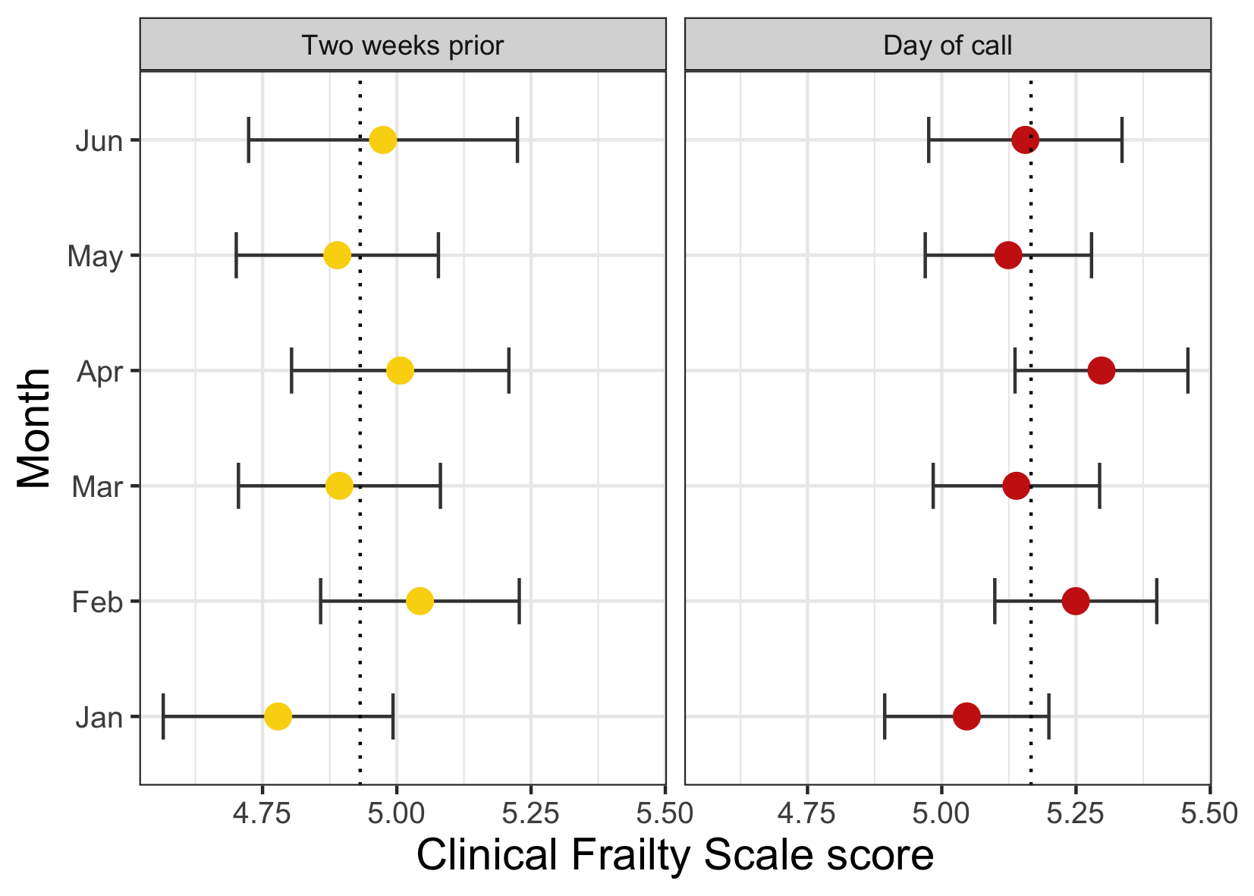
Figure A4: Patient Clinical Frailty Scale scores (mean and 95% confidence intervals) for each month of the study. CFS scores on the day of ambulance call and the estimate of patients’ score two weeks prior to the call are shown. Dashed line indicates the mean CFS score over the six-month period.

CFS scores did not vary significantly over the course of the study (Figure A4). Large changes in the NEAS region’s COVID-19 case rate over the study period did not appear to be associated with patient CFS scores; the seven-day rolling case rate per 100,000 people in the North East of England dropped from 494.4 (4 January 2021) to 19.3 (16 May 2021) before increasing to 495.6 (30 June 2021) over the study period [https://coronavirus.data.gov.uk].

