Supporting Information for Non-invasive and minute-frequency 3D tomographic imaging enabling long-term spatiotemporal observation of single cell fate

Fei Liang, Junwen Zhu, Huichai Chai, Yongxiang Feng, Peng Zhao, Shaofeng Liu, Yuanmu Yang, Linhan Lin, Liangcai Cao, Wenhui Wang*
State Key Laboratory of Precision Measurement Technology and Instrument, Department of Precision Instrument, Tsinghua University, Beijing 100084, China

Numerical simulation and performance evaluation of phase unwrapping algorithms
In order to select an effective unwrapping algorithms for 2D quantitative phase measurement of cells, we evaluated six commonly used unwrapping algorithms, including path-following methods such as Goldstein’s branch cut (BC) algorithm, quality-guided path following (QGPF) algorithm, Flynn’s minimum discontinuity approach (MDA) algorithm, and minimum-norm methods such as discrete cosine transform (DCT) algorithm, Fourier transform (FT) algorithm, unweighted least squares iteration (LSI) algorithm. These algorithms can be obtained from the GitHub website.
Fig. S1 shows the unwrapping results of different algorithms for the simulated step phase module. We assume that a uniform square micropillar quartz wafer (height: 500 nm, width: 20 μm, RI: 1.45) is imaged and reconstructed by QPI, and the true phase distribution is shown in Fig. S1a. Note that the above assumptions are set to keep the numerical simulation parameters consistent with the parameters of the wDPM optical settings in Methods. By adding the phase slope error in the inverse Fourier transform process, the Gaussian white noise error (σ = 25) and impulse noise (ρ = 0.001) during camera imaging, we get the simulated phase map with noise in Fig. S1b and the wrapped phase map with noise in Fig. S1c. Then we apply the above algorithms to unwrap the wrapped phase map (Fig. S1c) respectively, and compare with the real phase distribution (Fig. S1a) to obtain the phase error histogram shown in Fig. S1d-i. Furthermore, we count the mean square error (MSE), mean error, variance and running time of different algorithms, as shown in Table S1. Results show that the BC method, QGPF method and LSI method can all achieve accurate reconstruction for the step phase module. However, Fig. S1d shows that the BC method is unstable as the errors may be transferred to the phase unwrapping process. Although the QGPF method has high accuracy, the program execution time is too long (908 seconds). Therefore, the LSI algorithm is recommended to reconstruct the phase step for better accuracy and time consuming.
Then we perform unwrapping evaluation on the wrapped phase map of the simulated cell to ensure the high phase measurement accuracy in 3D RI reconstruction. We assume that the cells are spheres with a diameter of 20 μm and the RI distribution is divided into three layers along the radius from the center of the sphere to the outer contour (RI=1.40 for radius 0-4 μm, RI=1.37 for radius 4-6.5 μm, RI=1.35 for radius 6.5-10 μm). Then the same parameter settings are used to simulate the true phase projection, the phase distribution with noise and wrapping phase distribution with noise in Fig. S2a-c. Comparison of the results and performance of six algorithms are shown in Fig. S2d-i and Table S2. Results show that for relatively continuously distributed phase objects, except the DCT method, the other five algorithms all have high measurement accuracy. Finally, we perform the evaluations on the wrapped cell phase map angle stack collected in our experiment (supplementary video clip 1), respectively, to evaluate the stability of the algorithm. Results show that the MDA and DCT method cannot be accurately unwrapped for some frames as sudden phase change occurs. Although the BC and QGPF method show high accuracy and stability of phase unwrapping, the program execution (590s for BC method and 41210s for QGPF method with 600 frames) takes too long. Considering accuracy, stability and time-consuming, the FT method and LSI method are recommended to deal with cells based on our results.
Fig. S1. Comparison of six algorithms for phase unwrapping of simulated step phase module. (a) Real phase map. (b) Simulated step phase with noise. (c)Wrapped phase map of (b). (d)-(i) The unwrapped phase map and phase error histogram obtained by using BC method (d), QGPF method (e), MDA method (f), DCT method (g), FT method (h), LSI method. (i) for the wrapped phase step with noise in (c).
Table S1. Comparison of the error and time of six algorithms for phase unwrapping (phase step simulation)
Unwrapping algorithm | MSE | Mean | Variance | Time (s)
BC method | 2.3472 | 1.2168 | 4.5474 | 13.11
QGPF method | 0.8485 | 0.5825 | 0.6407 | 908.47
MDA method | 5.2980 | 2.6325 | 22.8211 | 0.9590
DCT method | 8.9334 | 6.6474 | 45.9038 | 0.12
FT method | 0.9890 | 0.8149 | 0.9497 | 0.12
LSI method | 0.6517 | 0.5183 | 0.4230 | 0.29

Fig. S2. Comparison of six algorithms for phase unwrapping of simulated cell phase map. (a) Real phase map. (b) Simulated cell phase with noise. (c)Wrapped phase map of (b). (d)-(i) The unwrapped phase map and phase error histogram obtained by using BC method (d), QGPF method (e), MDA method (f), DCT method (g), FT method (h), LSI method (i) for the wrapped cell phase with noise in (c).

Table S2. Comparison of the error and time of six algorithms for phase unwrapping (cell phase simulation)
Unwrapping algorithm | MSE | Mean | Variance | Time (s)
BC method | 0.2279 | 0.2006 | 0.0128 | 12.87
QGPF method | 0.2279 | 0.2006 | 0.0129 | 926.02
MDA method | 0.1831 | 0.1522 | 0.0126 | 0.90
DCT method | 3.3668 | 3.0998 | 1.7472 | 0.11
FT method | 0.1509 | 0.1243 | 0.0110 | 0.10
LSI method | 0.1831 | 0.1522 | 0.0126 | 0.18

Processing result of cell phase reconstruction
Fig. S3 shows the complete data processing result of a HeLa cell to obtain a 2D phase map without halo. Fig. S3a shows an example interferogram image for cell and its corresponding background recorded using our setup (Fig. 1ab), and Fig. S3b is the amplitude of the Fourier transform on a logarithmic scale of Fig. S3a. Due to the interference pattern in the off-axis geometry, the region in the black circle that contains the information about the specimen is shifted away from the unscattered light (origin peak in Fourier space). By selecting the black circle region, moving it to the center, and taking the inverse Fourier transform, we retrieve the complex angular spectra. Respectively, the wrapped phase of specimen and background is acquired by calculating the angle of the complex field (Fig. S3c). The filter width of the black circle and the positions of the filter center can be calculated according to the design parameter of wDPM.
Note that if the filtered region in Fourier space is not shifted to the exact center before Fourier inversion, the phase image will be superimposed by a linear ramp. Since the shift is discrete, the ramp cannot be fully removed as shown in Fig. S3c, and a background-subtraction correction is necessary. By subtracting the object image from the background image, we get the wrapped phase map without ramp in Fig. S3d.
As can be seen in Fig. S3cd, the phase map only contains values between -π and π, while the real phase shift of the cell may contain values outside this range. The phase map should be resolved through unwrapping using the unweighted least squares phase unwrapping algorithm, and the representative image of the unwrapped phase is shown in Fig. S3e.
Fig. S3f shows the result of halo correction using the method described in Methods, the cell outline is clearly visible and can be accurately extracted, which improves the accuracy of reconstruction. The phase value of AA section in Fig. S3ef are compared in Fig. S3g, and the result shows that the halo effect is eliminated very well.
Fig. S3. Data processing to determine the phase of a HeLa cell from a wDPM image. (a) Raw interferogram of a HeLa cell and its background. (b) Logarithm of absolute value of Fourier transform of (a). The zero-frequency component lies in the center of the shown Fourier space image. The white circle indicates the position of the Gaussian filter. (c) Wrapped phase image of object and background. (d) Wrapped phase with background correction. (e) Unwrapped phase image. (f) Unwrapped phase image with halo correction. (g) Phase value comparison of AA section between (e) and (f).

Working principle of OPT method
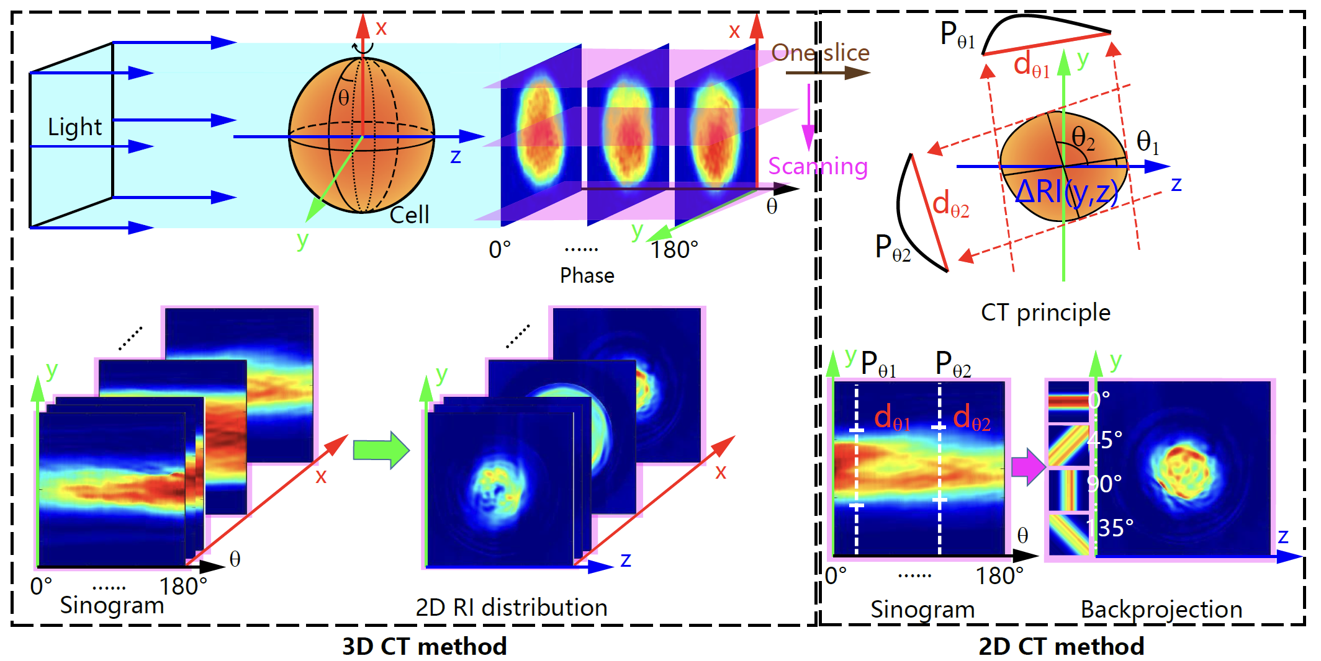
Fig. S4. Sketch of the working principle of OPT method.

Noise stability valuation
The spatiotemporal phase noise is defined as
, (1)
where OPD(x,y,t) is the OPD of the background at certain time being, OPD₀ (x,y) is the initial OPD background for the same scene.
Fig. S5a is one frame of such phase map noise image corresponding to a certain time being. There are totally 2546 frames during the 10 s period of investigation. We then plot the histogram, i.e., the number of pixels with respect to their phase noise, in Fig. S5b. The histogram standing for the overall spatiotemporal noise has a standard deviation of 0.9 nm, which is slightly better than but at the same order of magnitude as other wDPM systems ^{[1]}. Besides, the best temporal noise is measured as 0.33 nm, which is at least 3 times improvement compared with the Mach–Zehnder configuration ^{[2]} (1.10 nm). The best spatial noise is measured as 0.46 nm, while the corresponding data for the Mach-Zednder configuration was not available for comparison. From the spatiotemporal noise perspective, the wDPM configuration can obtain phase distribution with high stability and sensitivity.
To demonstrate the accuracy of the reconstructed 2D phase, we imaged a φ3 ± 0.2 μm polymethyl methacrylate (PMMA) bead (RI = 1.49) in the index-matching paraffin oil (RI = 1.46). Fig. S5c shows the PMMA bead phase image, where the maximum measured phase value is 0.830 rad. The nominal phase value of the bead was calculated to be 0.857 rad according to the definition of phase. Here, the deviation is just 0.057 rad, or 6.6%, showing excellent accuracy.
Fig. S5. Noise stability of wDPM. (a) Spatial pathlength noise distribution of background at first frame; (b) Spatiotemporal pathlength noise histogram 2546 frames in 10s time-series; (c)Phase distribution of a 3 μm diameter PMMA bead imaged by wDPM.

Transverse and axial resolution calculation
For a standard wide-field microscope operating in transmission mode, according to the Rayleigh criterion, the diffraction spot radius or the distance from the center of the PSF to the first transverse minimum and the first axial minimum (the first zero of the Airy pattern) is defined as its transverse and axial resolution. Respectively, the transverse resolution (r_{xy}) and axial resolution (r_{z}) are given by Abbe’s formula:
(2)
(3)
where NA_{obj} is the numerical aperture of the objective lens, λ is the mean wavelength of the illumination, n stands for the refractive index of the medium where the objective lens is located.
The mean wavelength of our SCL is 660 nm, the objective lens (40×, 0.6 NA) in our wDPM system is used in the air. Theoretically, the resolution of our system can be reached as 0.71 μm and 3.67 μm in the lateral and axial directions. To get better resolution at a given wavelength of illumination, a higher NA is required.

3D imaging of confocal microscope and wDPM for same cell
To compare the results between fluorescence and tomography imaging, we use a rolling HeLa cell pre-treated with fluorescent staining to realize the 3D RI reconstruction in Fig. S6 a-d. Detailed information can be found in Methods. Note that the nucleus (red dotted line in Fig. S6a) under the bright field cannot be directly obtained from the phase image (red dotted line in Fig. S6c) at the corresponding angle. This is because even if the RI of the nucleus is higher than that of the cytoplasm, the OPD integral cannot directly reflect the cell attributes due to the various thickness of the cells at different positions.
Next, we switch the optical path to confocal microscope (Ti2 R1, Nikon, Japan) to acquire 3D fluorescence images of the same HeLa cell. Basically, the HeLa cell was stained in red using RedDot 1 (Biotium, USA) for nucleus and in green using CMFDA (Yeasen, China) for cytoplasm. In order to prolong the photobleaching time, we change the cell culture medium to an isotonic solution containing glutamate in 2h before the experiment. Then to excite fluorescence probes inside a sample, a multi-wavelength laser source (center wavelength: λG = 488 nm, λR = 561 nm) was coupled to the optical setup using a dichroic mirror. During the fluorescence image acquisition, the DMD (Digtial Micromirror Devices) was turned off to avoid camera saturation and potential photobleaching by the laser beam. The stage was scanned along the axial direction with a step size of 0.6 μm and a scanning distance of 25.8 μm. At each axial position (FOV: 30.72 μm × 30.72 μm, resolution: 1024 × 1024), the light source switched the excitation wavelength of the light, and received the green cytoplasmic emission signal with a central wavelength of 517 nm and the red nuclear emission signal with a central wavelength of 660 nm, respectively. Typically, the camera was exposed for 2 s to acquire a single-channel fluorescence image at one axial position and it took about 176 s totally to complete the scanning. In order to ensure the image quality, we added oil with a refractive index of 1.515 to the objective lens (NA 1.3, 100×). Fig. S6e shows some special 2D fluorescence images of the sample at the focal position of z = -6 μm, 0 μm, and 6 μm during 3D multichannel scanning.
3D deconvolution was performed using commercial software (Bitplane Imaris 9.5, Oxford Instruments, England), which exploits the iterative classic maximum likelihood estimation. The measured axial stacks of each fluorescence channel were deconvoluted using theoretical 3D point spread functions (PSF) of the optical setup, which were calculated from optical parameters including the wavelength of the emission signals and the numerical aperture of the objective lens. As shown in Fig. S6f, the deconvoluted fluorescence images show high image contrast compared to the raw epi-fluorescence images in Fig. S6e. Then, the obtained fluorescence images of the sample in two channels were then merged into a single fluorescence image (Fig. S6g). In order to further compare with the reconstructed refractive index map (Fig. S6d), we fit the contour of the nucleus and cytoplasm separately through threshold selection in Fig. S6h.
Fig. S6. A schematic diagram of the OPT reconstruction (a-d) and correlative confocal microscopy with 3D fluorescence imaging (e-h). (a) A HeLa cell in bright field, the red dotted line is the nucleus compared to (e, z = 0 μm). (b) Raw holograms of the same HeLa cell obtained with various illumination angles. (c) Phase map extracted from (b). (d) the 3D rendered map of the reconstructed 3D RI distribution. (e) Axially stacked two-channel and its mixed channel epi-fluorescence images of the same HeLa cell. (f) Deconvolution fluorescence images of (e). (g) 3D fluorescence image merged with two-channel deconvoluted fluorescence images. (h) 3D contour shape of cytoplasm and nucleus extracted from (g)

Tables S3. Geometric and biochemical parameters measurement results for five types of cells.
Cell type | RI | Volume (fL) | Surface area (μm²) | Sphericity index | Dry mass density (g/L) | Dry mass (pg)
MCF-10A | 1.3806 ± 0.0065 | 1046.2 ± 261.9 | 834.1 ± 146.2 | 0.59 ± 0.02 | 248.95 ± 34.28 | 260.45 ± 39.58
MCF-7 | 1.3771 ± 0.0043 | 2600.9 ± 663.6 | 1516.1 ± 262.0 | 0.60 ± 0.01 | 230.64 ± 22.68 | 591.51 ± 126.03
HL60 | 1.3797 ± 0.0080 | 904.9 ± 191.6 | 761.9 ± 110.8 | 0.59 ± 0.02 | 244.71 ± 42.26 | 217.08 ± 37.60
HeLa | 1.3761 ± 0.0095 | 1955.2 ± 489.4 | 1269.5 ± 218.1 | 0.59 ± 0.02 | 225.29 ± 50.09 | 420.63 ± 53.89
A549 | 1.3768 ± 0.0043 | 2369.7 ± 716.5 | 1447.1 ± 357.1 | 0.59 ± 0.03 | 228.88 ± 22.62 | 533.64 ± 131.55

Chip-compatible cell culture chamber
To ensure the normal growth of cells for long-term observation, we designed a live cell culture chamber to maintain the temperature, and pH value required by the cells. Fig. S7a shows the schematic of device which includes a temperature control system, a gas control system, and a three-layered closed chamber structure. To ensure uniform temperature distribution in the chamber, we adopt a multi-point heating configuration with four PTC (positive temperature coefficient) heaters symmetrically placed in the middle layer. To keep the temperature and carbon dioxide gas concentration constant, we fixed the sensors in Fig. S7b and performed feedback control using a microcontroller unit (stm32f103r6) to maintain the temperature at 37 ℃ and the carbon dioxide concentration in the closed chamber at 5%. To satisfy the pH value requirement for cell growth, we controlled the humidity in the closed chamber to reduce the evaporation of the medium as much as possible. For this reason, we added a water tank in the chamber to increase the ambient humidity. In addition, we also placed the microfluidic chip in a closed Petri dish full of culture medium to further reduce the evaporation of liquid from the external environment in the microfluidic chip. The whole device is shown in Fig. S7c. In order to prevent the condensation water on the upper and lower covers due to the temperature difference around glass that obstructs the imaging observation, we used ITO (Indium-Tin Oxide) glass and heated it at about 37℃. Also, this arrangement can further ensure uniform temperature distribution in the chamber.
We verified the feasibility of our home-made chip-compatible cell culture chamber. We injected the HeLa cell suspension into the microfluidic chip to observe the cells clearly up to 12 h in Fig. S7d. All HeLa cells were all suspended at 0 h and then, after 6 h, more than 50% cells begun to adhere to the wall. Finally, most of the HeLa cells spread and divided (green arrow) at 12h. Note that small numbers of non-adherent cells may die due to trypsinization during sample processing. In general, our chip-compatible cell culture chamber ensures the long-term live cell growth.
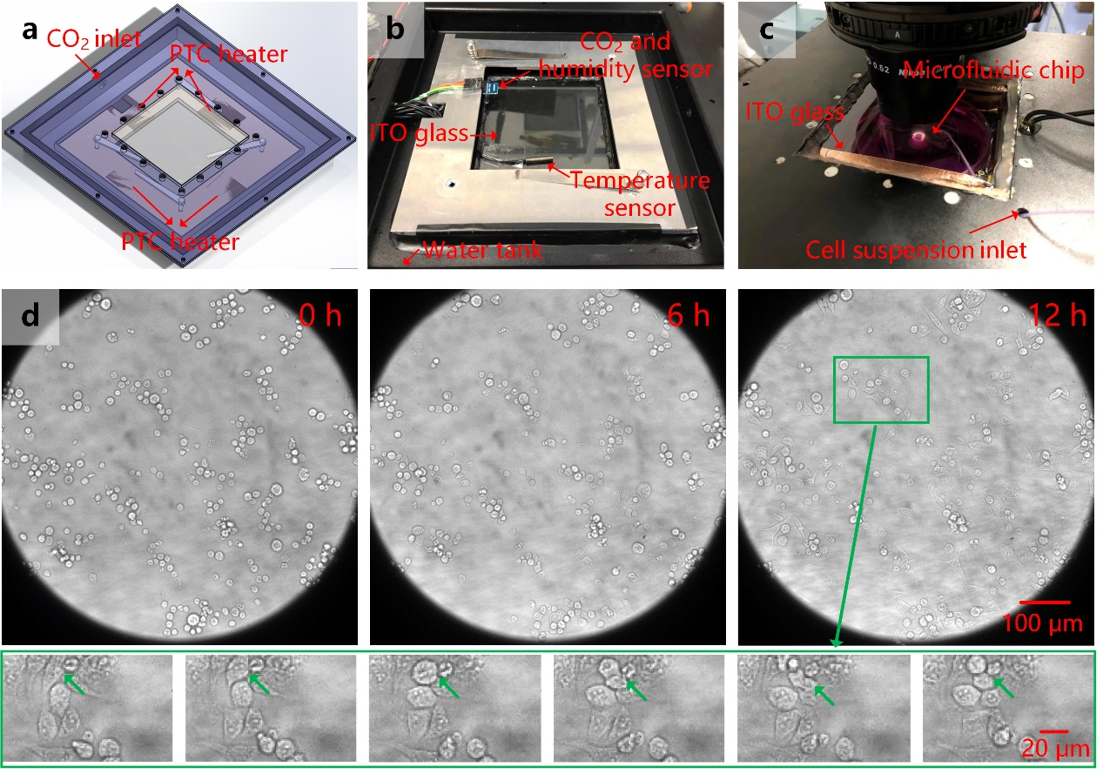
Fig. S7. Cell culture chamber setup and verification. (a) Schematic diagram. (b) Internal structure of the device with mounted sensors. (c) Working diagram of cell culture chamber fixed with microfluidic chip under microscope. (d) Long time observation with HeLa cells grow for 12 h. (Green box shows the cell division process for a particular cell)

RI threshold selection for K562 cell to differentiate nucleus and cytoplasm
In order to more clearly show the structural details changes in the cells, we first performed the histogram statistics of the RI distribution of K562 cells in Fig. S8a. It shows that the RI distribution of the K562 cell resembles a binormal distribution. For the normal distribution in the high-end, it is most likely to be nucleus. By error and trial, we found that by using the mean of the normal distribution in the high-end as the threshold, the nucleus has a volume ratio similar to the result given by confocal microscopy. Fig. S8b shows the nuclear region extracted by wDPM and confocal. The 64.05% proportion of nucleus of wDPM result shows highly consistent with confocal method (65.91%). We thus use the mean of the normal distribution in the high-end as the threshold throughout the study.
Fig. S8. Threshold selection to differentiate nucleus and cytoplasm in RI image. (a) Histogram of RI distribution of a K562 cell. (b) Nuclear extraction results by wDPM and confocal for the same K562 cell.

Voxel matching to compensate for the rotation axis misalignment
In order to compensate for the rotation axis misalignment caused by microfluidic disturbance during the ten-minute period, we performed voxel matching for any two adjacent reconstructed 3D RI maps. In voxel matching, the two maps can be represented by two parameters relevant with the rotation axis, and rotation angle. By varying the two parameters, the two maps are correlated voxel-wise to calculate the correlation coefficients. For the maximum coefficient, the corresponding two parameters are used to compensate for the relative orientation of the two RI maps.

Supplementary video：
Video 1: Performance comparison for the six unwrapping algorithms.
Video 2: Cells rolling in a large scale under the array arrangement.
Video 3: 3D RI reconstruction process for a HeLa cell.
Video 4: Comparison of 3D fluorescence imaging and 3D RI imaging for the same HeLa cell.
Video 5: 3D RI distribution for MCF-7 and MCF-10A.
Video 6: 3D RI time-varying distributions for K562 cell growth during 5 hours.
Video 7: Long-term observation of MCF-7 cell apoptosis.
Video 8: Long-term observation of MCF-7 cell necrosis.

Reference
[1] Bhaduri, B.; Pham, H.; Mir, M.; Popescu, G., Diffraction phase microscopy with white light. Opt Lett 2012, 37 (6), 1094-1096.
[2] Hsu, W. C.; Su, J. W.; Tseng, T. Y.; Sung, K. B., Tomographic diffractive microscopy of living cells based on a common-path configuration. Opt Lett 2014, 39 (7), 2210-2213.

