Graphical Abstract

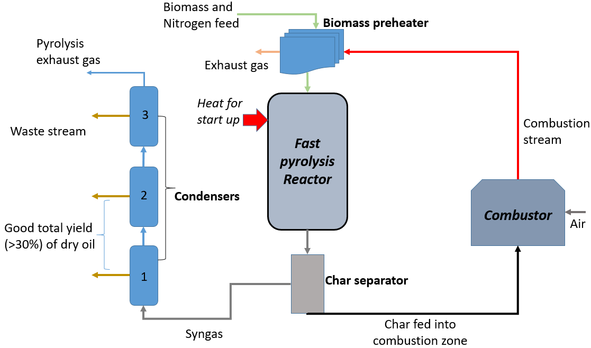
A sustainable model for the pyrolysis of Acacia tortilis

