Appendix 1 Internal validation
For internal validity, we compared the EC incidence for both-sex that was simulated by the model with the estimates that were predicted by the National Office for Cancer Prevention and Control from which the input EC incidence for males and females were drawn. And the calculation of the estimates used the EC incidence rates in 2012 combined with the value of the average annual percent change (-0.9%) that was predicted by the National Office for Cancer Prevention and Control.
Table S1 displayed the predicted EC incidence per 100 000 from both methods. According to tableS1, linear regression without intercept was conducted, and the linear curve was plotted using the model predictions versus the estimates predicted by the National Office for Cancer Prevention and Control. The regression slop was 1.01, and the R² was 0.99, which demonstrated a good model of internal validation.

Table S1 The predicted incidence per 100 000 of esophageal cancer from model simulation
and model inputs
Year | Model prediction | Publised estimates*
2013 | 20.84 | 20.98
2014 | 20.69 | 20.79
2015 | 20.54 | 20.60
2016 | 20.40 | 20.42
2017 | 20.26 | 20.23
2018 | 20.12 | 20.05
2019 | 19.98 | 19.87
2020 | 19.85 | 19.69
2021 | 19.71 | 19.52
2022 | 19.58 | 19.34
2023 | 19.46 | 19.17
2024 | 19.34 | 18.99
2025 | 19.22 | 18.82
2026 | 19.08 | 18.65
2027 | 18.97 | 18.49
2028 | 18.85 | 18.32
2029 | 18.74 | 18.15
2030 | 18.63 | 17.99
Note: * predicted by the published data of National Office for Cancer Prevention and Control
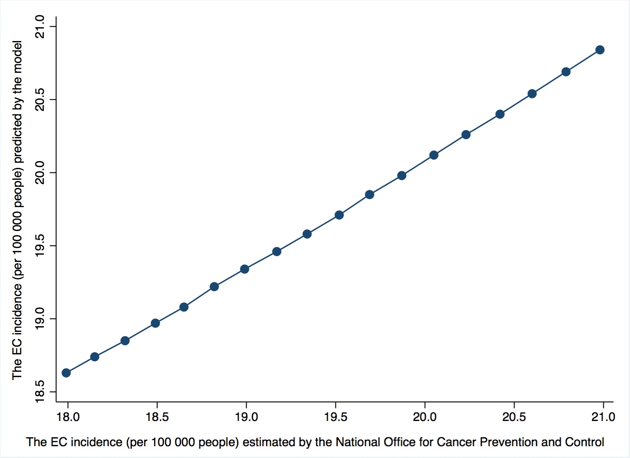
Figure S1 Model internal validation by Goodness-of-fit test

Appendix 2
The proportions of the medical direct expenditure on EC in the total health expenses and the personal cash health expenses from 2013 to 2018 were addressed in figure S1. The total health expenses and the personal cash health expenses were obtained from the National Bureau of Statistics of China.
According to figure S2, the proportions of the medical direct expenditure on EC in the total health expenses and the personal cash health expenses addressed decreasing trends over time. Compared to 2013, the proportion of the medical direct expenditure in the total health expenses decreased by 23.4% (0.47% vs. 0.36%) in 2017, while it decreased by 10.8% (1.39% vs. 1.24%) in the personal cash health expenses.
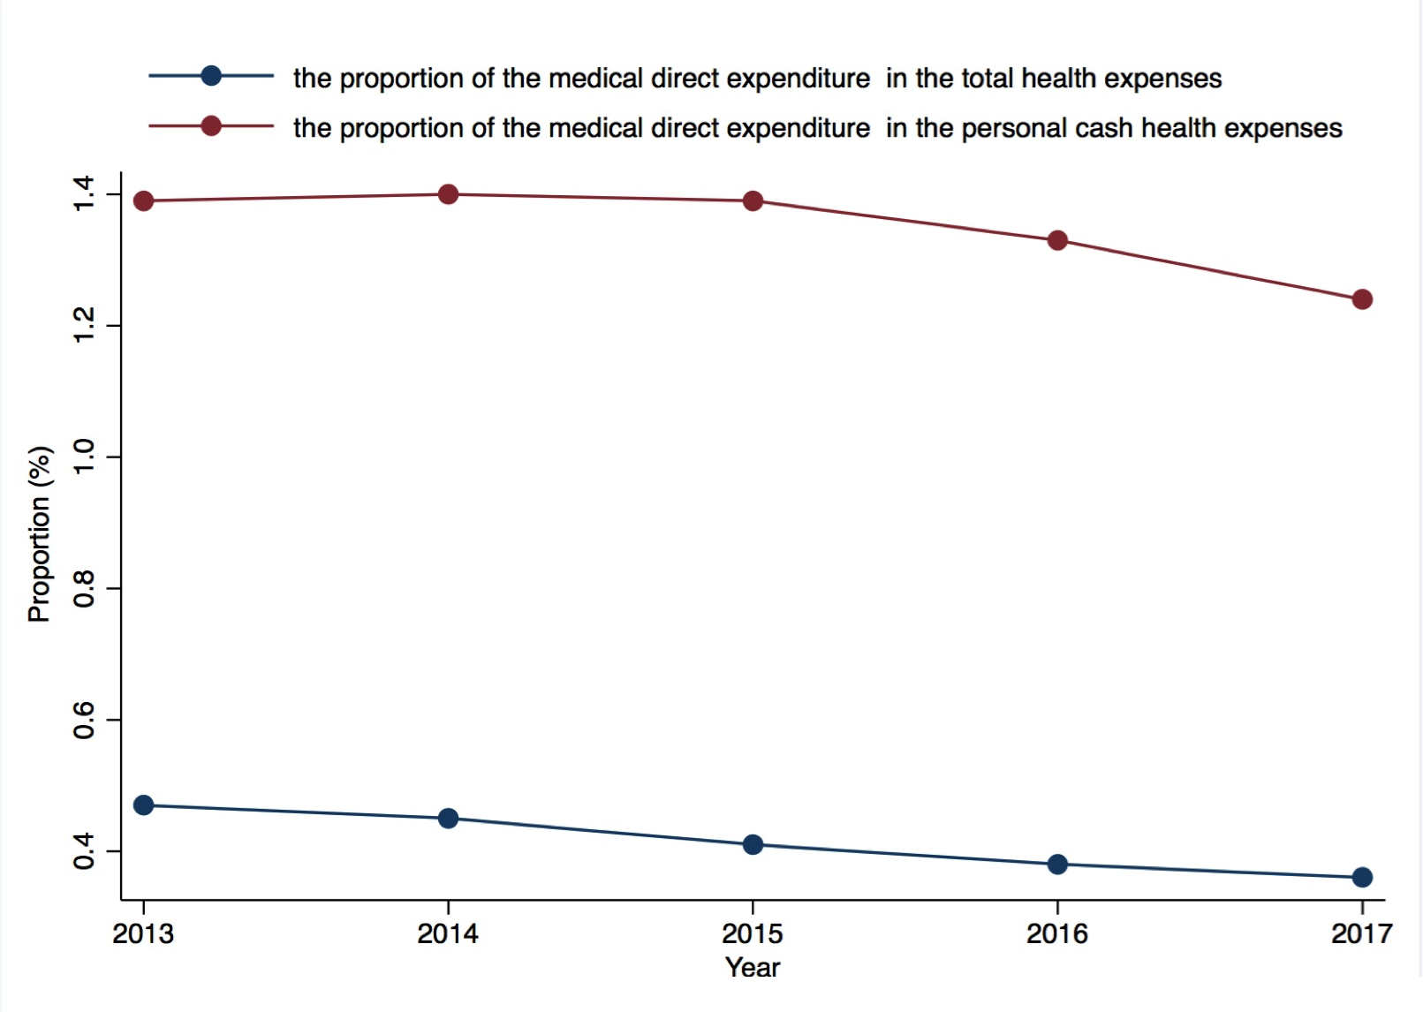
Figure S2 The proportion of the medical direct expenditure in the total health expenses and
the personal cash health expense

