Supplementary material

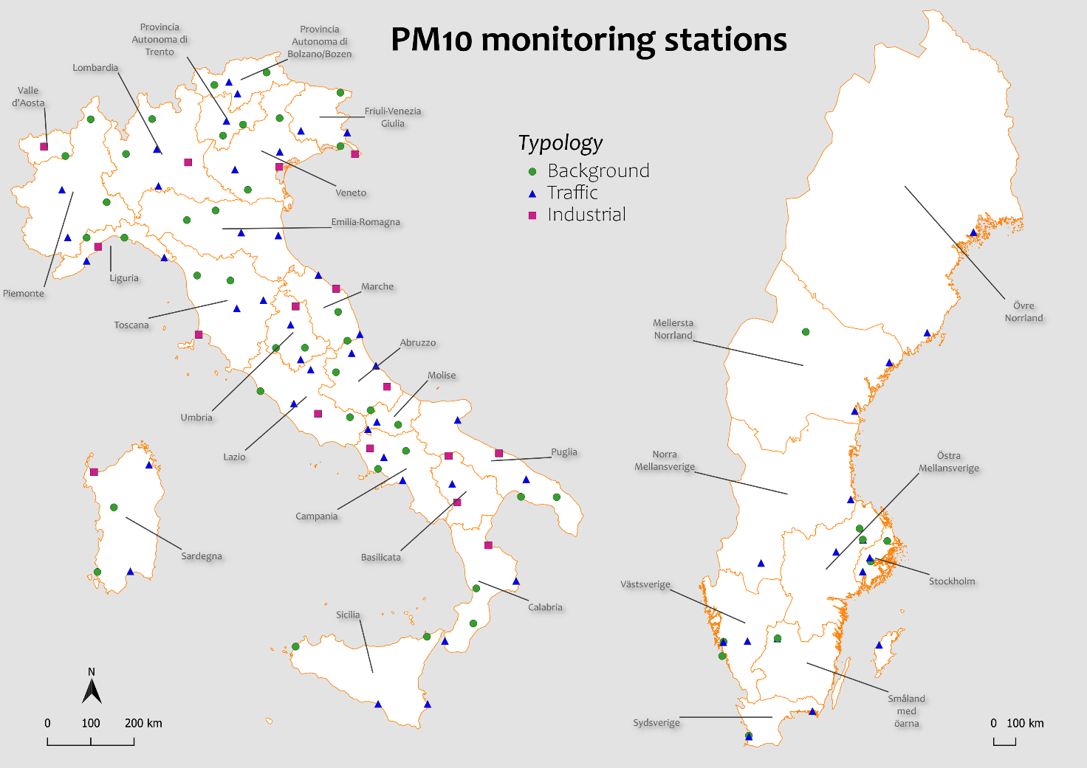
Fig. S1: Geographical distribution of PM10 ground monitoring stations defined by typology in each region of Italy and Sweden.

