Supplementary Materials

eTable 1. Study characteristics. ¥ Information not specified. SS = single shot. RS = read-out-segment
Study | Country | Make &  Model (T) | TE (TR) in ms | EPI type | Subject position (coil [Transmit/Receive T/R or Receive only, R], channels) | Parallel Imaging (partial Fourier) | Resolution (In plane x Slice Thickness, mm) | Number of Signals | b-values (directions) | Number of raters | Subjects (limbs) M:F | Mean Age (SD) [Range]
Bäumer 2014³⁷ | Germany | Siemens  TIM-TRIO (3T) | 99 (3800) | SS | Superman (Knee [T/R], 15) | ¥ (¥) | 1.17x1.17x4 | 2 | 1200 (19) | 2 | 30 (30) 13:17 | 39.3 (11.38) [25-68]
Ohana 2012²⁷ | France | GE  Signa (3T) | 105 (5200) | ¥ | Superman (Wrist [R], 8) | ¥ (¥) | 1.09x1.09x4 | 3 | 1000 (15, 20, 30) | 2 | 14 (14) 11:3 | 27.5 (1.76) [20-32]
Jengojan 2015⁴⁶ | Austria | Philips  Achieva (3T) | 78 (6433) | SS | Supine, arm by side (Flexible [R], ¥) | ¥ (¥) | 1.5x1.5x ¥ | 5 | 700 (16) | 2 | 13 (13) 8:5 | 24.3(1.94) [22-28]
Ho 2021⁵³ | Switzerland | Siemens  Skyra (3T) | 77 (4400) | SS | Superman (Flexible, 4) | ¥ (¥) | 1.2x1.2x2 | 1 | 1000 (20) | 2 | 10 (20) 5:5 | 32.1 (4.45) [¥-¥]
Ho 2018³⁸ | Switzerland | Siemens  Skyra (3T) | 77 (4400) | SS and RS | Superman (Flexible, 4) | GRAPPA (6/8) | 1.2x1.2x4 | 2 | 1000 (20) | 2 | 10 (10) 5:5 | 30.4 (4.01) [25-36]
Park 2020⁴⁸ | Korea | Philips  Achieva (3T) | 91 (7049) | SS | Superman (¥, ¥) | SENSE (¥) | 1.1x1.1x3  1.3x1.3x3  1.5x1.5x3  1.3x1.3x4  1.3x1.3x5 | 5 | 1200 (15) | 2 | 15 (15) 9:6 | 30 (6.8) [22-42]
Breckwoldt 2015³⁹ | Germany | Siemens  TIM-TRIO and Vario (3T) | 94 (3800) | ¥ | Supine arm overhead (¥, ¥) | GRAPPA (7/8) | 1.14x1.14x4 | 2 | 1200 (19) | 2 | 30 (30) 16:14 | 40.67 (13.07) [20-70]
Kabakci 2007⁴⁷ | Turkey | Philips  Achieva (3T) | 90 (4600) | SS | Superman (head [T/R], 8] | ¥ (¥) | 1.09375x1.09375x4 | 3 | 1000 (32) | ¥ | 20 (20) 6:14 | 27.5 (1.85) [21-35]
Kronlage 2017⁴¹ | Germany | Siemens  TIM-TRIO (3T) | 92.8 (4000) | SS | Superman (Flexible [R], 16) | GRAPPA (¥) | 1.25x1.25x4 | 3 | 1000 (20) | 1 | 18 (18) 11:7 | 54.9 (13.3) [¥-¥]
Zhou 2012⁴⁹ | USA | Philips  Achieva (3T) | 65 (7200) | SS | Superman (Knee [T/R], 8) | SENSE (¥) | 1.8x1.8x3 | 2 | 1000 (21) | ¥ | 10 (20) 5:5 | 26.5 (3.23) [22-32]
Jambawalikar 2010⁴⁵ | USA | Philips  ¥ (3T) | 69 (5300) | SS | Superman (Knee [T/R], 8) | ¥ (¥) | 1.25x1.25x4 | 2 | 1000 (6) | ¥ | 10 (10) 8:2 | 30.3 (4.85) [24-39]
Stein 2009⁵² | Israel | GE Signa | 81 (10,000) | SS | ¥ (¥,¥) | ¥ (¥) | ¥ x1.09x3 | 2 | 1000 (6) | ¥ | 17 (17) 7:10 | 26 (2.78) [24-34]
Zhou 2014⁵⁰ | USA | Philips  ¥ (3T) | 65 (7200) | SS | Superman (Flexible [R], 8) | SENSE (6/8) | 1x1x3 | 2 | 1000 (42) | 1 | 10 (10) 5:5 | 27 (3.88) [22-34]
Breitenseher 2015⁴³ | Austria | Philips  Achieva (3T) | 100 (3964) | SS | Supine, arm by side (Flexible [R], 2) | ¥ (¥) | 1.18x1.16x4 | 2 | 700 (16) | 2 | 20 (20) 14:6 | 40 (8.56) [28-60]
Haakma 2017²⁸ | Netherlands | Philips  Achieva (3T) | 66 (6340) | SS | Superman (Flexible [R], 32) | SENSE (¥) | 1.5x1.5x4 | 1 | 800 (15) | ¥ | 10 (20) 8:2 | 54 (12.28) [29-67]
Kronlage 2018⁴² | Germany | Siemens  TIM-TRIO (3T) | 92.8 (4000) | SS | Superman (Flexible [R], 16) | GRAPPA (¥) | 1.25x1.25x4 | 3 | 1000 (20) | 2 | 60 (60) 30:30 | 50.1 (17. 3) [25-80]
Raval 2017³⁰ | USA | Siemens  TIM-TRIO (7T) | 83 (7000) | ¥ | Superman (Flexible [R], 8) | Used but ¥ (¥) | 0.14x0.14x3 | 5 | 1300 (64) | 2 | 3 (3) ¥:¥ | ¥ (¥) [¥-¥]
Griffiths 2021⁴⁰ | UK | Siemens  Prisma (3T) | 74 (7800) | SS | Superman (Flexible [R], 4) | GRAPPA (6/8) | 1.5x1.5x3 | 4 | 800 (30) | 2 | 13 (13) 8:5 | 28 (6) [21-40]
D'Souza 2021⁵¹ | Australia | GE  MR750 (3T) | 72 (3900) | SS | Superman (Knee [T/R], 8) | ASSET (Not used) | 0.625x0.625x3 | 2 | 300, 450, 600, 750 and 900 (24) | ¥ | 8 (8) 5:3 | 30 (8) [¥-¥]
Edward 2020⁴⁴ | Egypt | Philips  Sense (1.5T) | ¥ (¥) | SS | Superman (Wrist, ¥) | ¥ (¥) | ¥ | ¥ | 2000 (32) | ¥ | 15 (30) 10:5 | 45.67 (7.77) [¥-¥]

eFigure 1. The directed acyclic graph designed to define confounders (red coloured nodes, with red arrows) which must be adjusted for when exploring the relationship between b-value (the exposure) and fractional anisotropy (the outcome). Open causal pathways have green arrows.
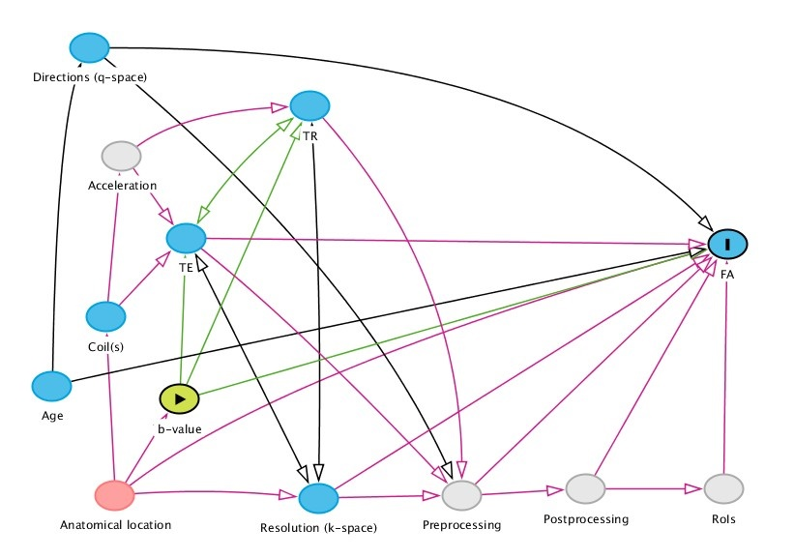
eFigure 2. The directed acyclic graph designed to define confounders (red coloured nodes, with red arrows) which must be adjusted for when exploring the relationship between TE (the exposure) and fractional anisotropy (the outcome). Open causal pathways have green arrows.
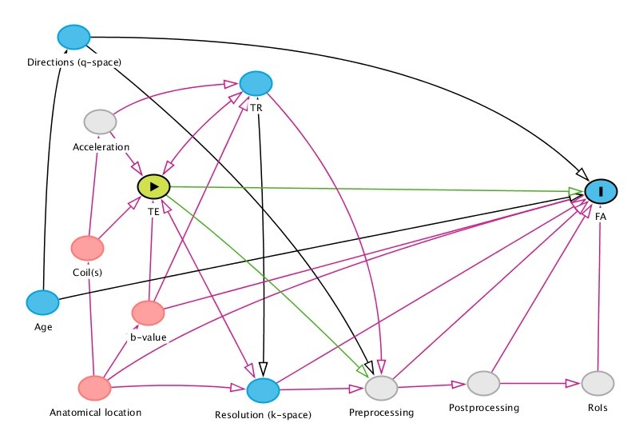
eFigure 3. The directed acyclic graph designed to define confounders (of which there are none in this network) which must be adjusted for when exploring the relationship between age (the exposure) and fractional anisotropy (the outcome). Open causal pathways have green arrows.
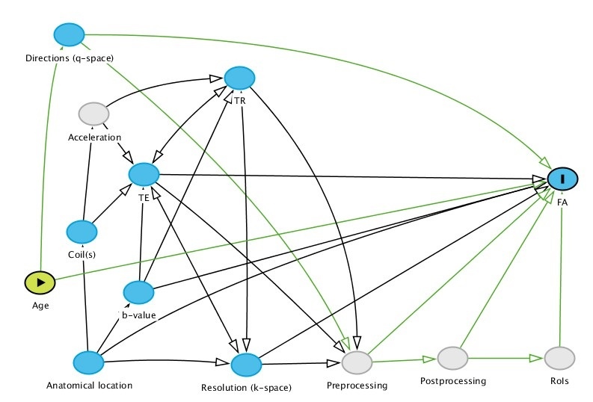
eFigure 4. The directed acyclic graph designed to define confounders (of which there are none) which must be adjusted for when exploring the relationship between anatomical location (the exposure) and fractional anisotropy (the outcome). Open causal pathways have green arrows.
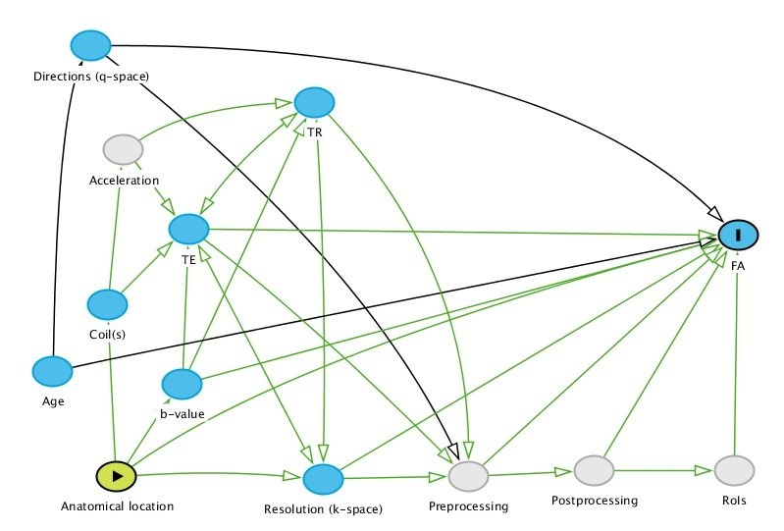
eFigure 5. The directed acyclic graph designed to define confounders (red coloured nodes, with red arrows) which must be adjusted for when exploring the relationship between TR (the exposure) and fractional anisotropy (the outcome). Open causal pathways have green arrows.
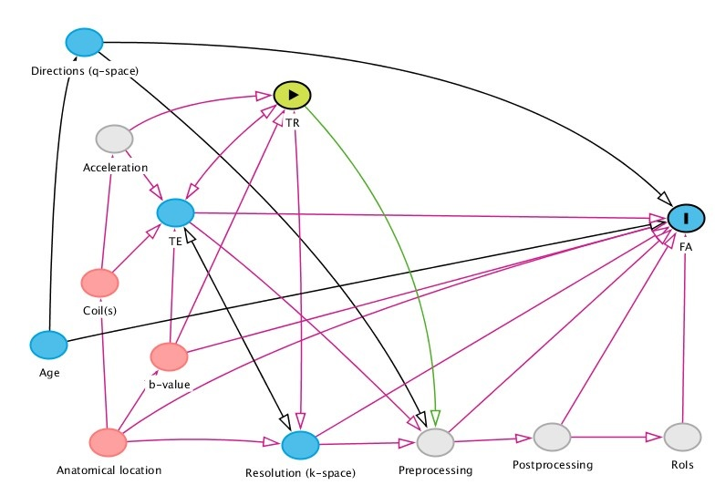
eFigure 6. The directed acyclic graph designed to define confounders (red coloured nodes, with red arrows) which must be adjusted for when exploring the relationship between spatial resolution (the exposure) and fractional anisotropy (the outcome). Open causal pathways have green arrows.
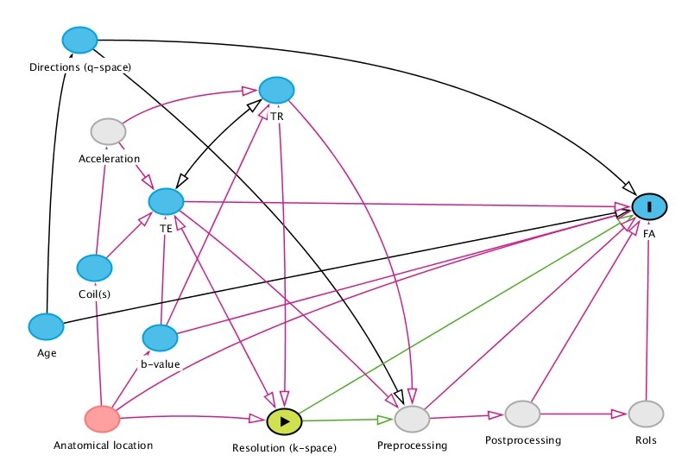
eFigure 7. The directed acyclic graph designed to define confounders (red coloured nodes, with red arrows) which must be adjusted for when exploring the relationship between N_{D} (the exposure) and fractional anisotropy (the outcome). Open causal pathways have green arrows.
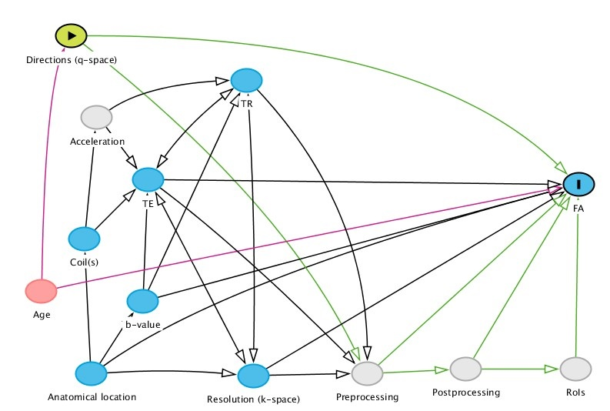
eFigure 8. PRISMA flow diagram

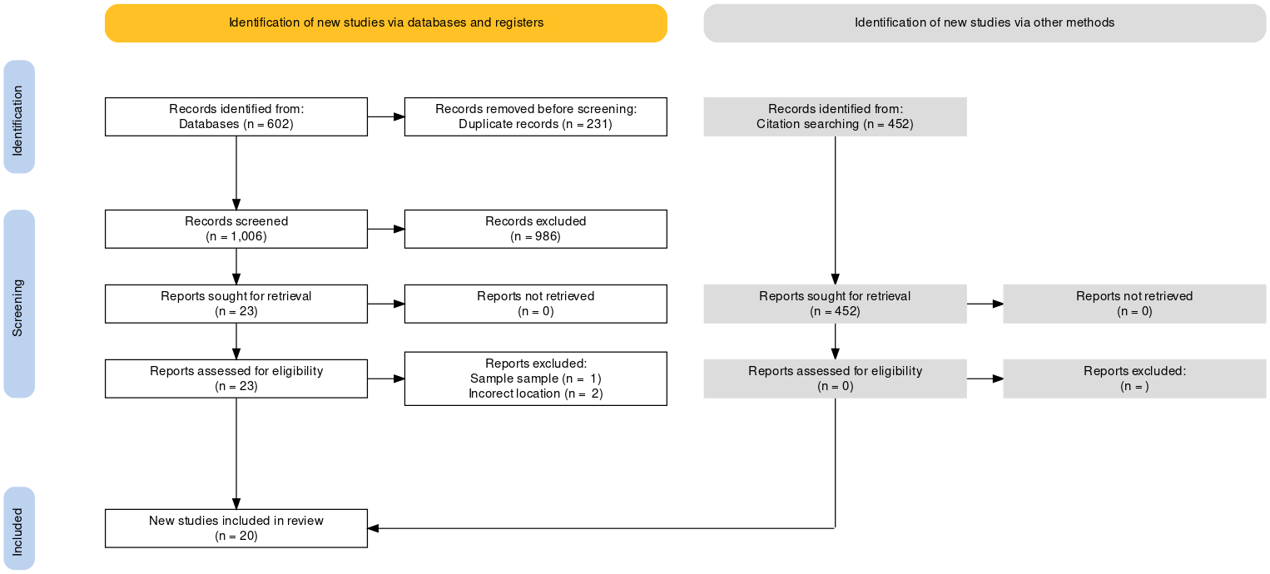

eFigure 9. Forest plot of the normal MD of the median, ulnar and radial nerves in the arm, sorted by the echo time and b-value.

eFigure 10. Forest plot of the normal RD of the median, ulnar and radial nerves in the arm, sorted by the echo time and b-value.

eFigure 11. Forest plot of the normal AD of the median, ulnar and radial nerves in the arm, sorted by the echo time and b-value.

eFigure 12. Forest plot of the normal MD of the median, ulnar and radial nerves around the elbow, sorted by the echo time and b-value.

eFigure 13. Forest plot of the normal RD of the median, ulnar and radial nerves around the elbow, sorted by the echo time and b-value.

eFigure 14. Forest plot of the normal AD of the median, ulnar and radial nerves around the elbow, sorted by the echo time and b-value.

eFigure 15. Forest plot of the normal MD of the median, ulnar and radial nerves in the forearm, sorted by the echo time and b-value.

eFigure 16. Forest plot of the normal RD of the median, ulnar and radial nerves in the forearm, sorted by the echo time and b-value.

eFigure 17. Forest plot of the normal AD of the median, ulnar and radial nerves in the forearm, sorted by the echo time and b-value.

Appendix 1. Search strategy

- Median
- Pronator
- Ulnar
- Cubital
- Radial
- Forearm
- Arm
- Upper limb
- Elbow
- Diffusion?tensor
- DTI
- Diffusion MRI
- Diffusion magnetic resonance imaging
- Q?space
- Diffusion?weighted
- DWI
- Anisotropic diffusion
- 1 OR 2 OR 3 OR 4 OR 5 OR 6 OR 7 OR 8 OR 9
- 10 OR 11 OR 12 OR 13 OR 14 OR 15 OR 16 OR 17
- 18 AND 19

