Review on the strategies for enhancing mechanical properties of bacterial cellulose
Journal: CELLULOSE
Yun-Ya Wang ^{a,b}, Xue-Qing Zhao ^{a,b}, Dong-Mei Li ^{a,b}, Ya-Mei Wu ^{a,b}, Fazli Wahid ^{c}, Yan-Yan Xie ^{a,b}*, Cheng Zhong ^{a,b}*
ª State Key Laboratory of Food Nutrition & Safety, Tianjin University of Science and Technology, Tianjin, PR China
^{b} Key Laboratory of Industrial Fermentation Microbiology, (Ministry of Education), Tianjin University of Science and Technology, Tianjin, PR China
*Corresponding author:Yan-Yan Xie, Cheng Zhong
E-mail: yyxie0220@tust.edu.cn, czhong@tust.edu.cn

[1] L. Wang, L. Mao, F. Qi, X. Li, G. Yang, Synergistic effect of highly aligned bacterial cellulose/gelatin membranes and electrical stimulation on directional cell migration for accelerated wound healing, Chemical Engineering Journal 424 (2021). (Figures. 1, Figures. 2, Figures. 3)
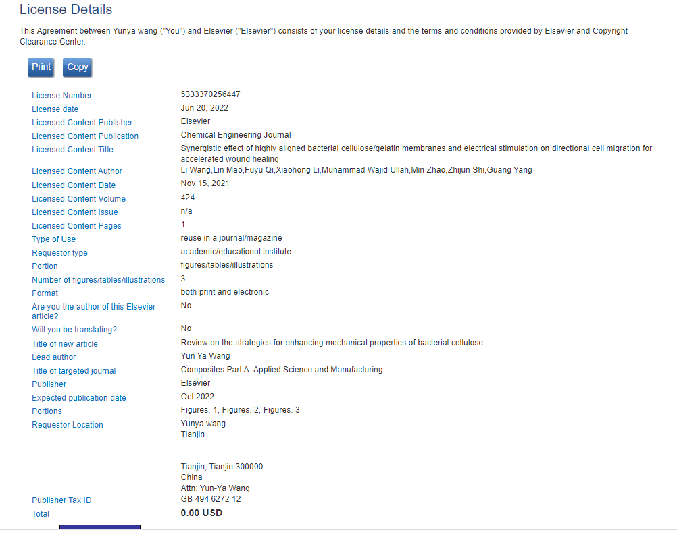

[2] Lin S, Tao W, Lei Y, Chuntao C, Ran D, Xiaoli Y, Bianjing S, Baojing Z, Lei Z, D. S., Enhanced mechanical properties and biocompatibility on BC/HAp composite through calcium gluconate fortified bacterial, Carbohydrate Polymers 281 (2022). (Figures. 1, Figures. 2, Figures. 5)

[3] P. Cazon, M. Vazquez, Improving bacterial cellulose films by ex-situ and in-situ modifications: A review Food Hydrocolloids 113 (2020). (Figures. 2)
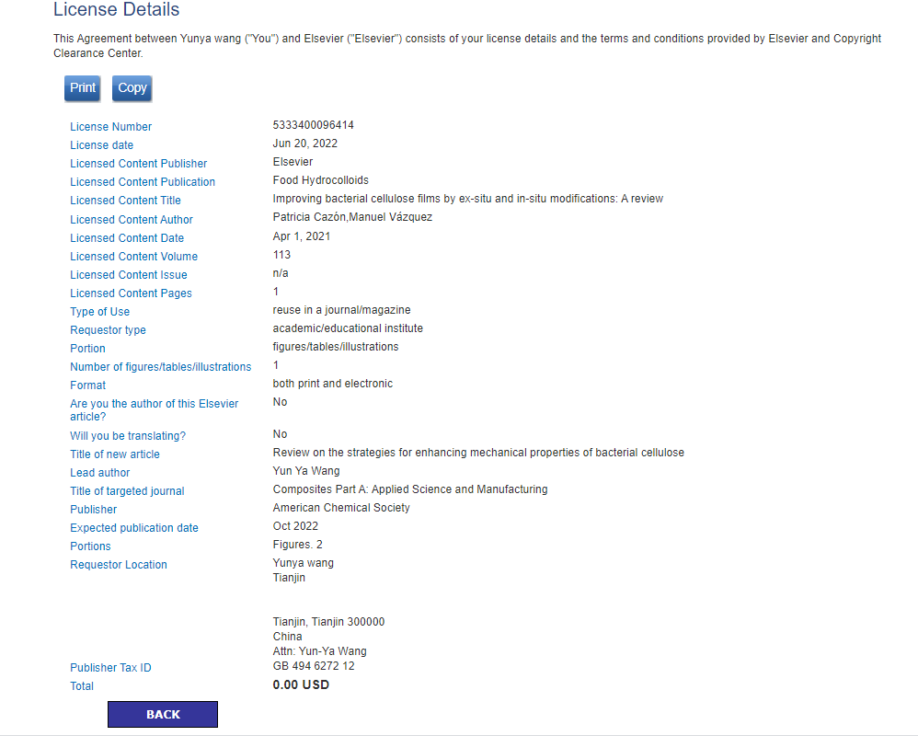

[4] H. Luo, J. Dong, X. Xu, J. Wang, Z. Yang, Y. Wan, Exploring excellent dispersion of graphene nanosheets in three-dimensional bacterial cellulose for ultra-strong nanocomposite hydrogels, Composites Part A: Applied Science Manufacturing (2018) 290-297. (Figures. 1, Figures. 10)

