Supplementary Materials
A
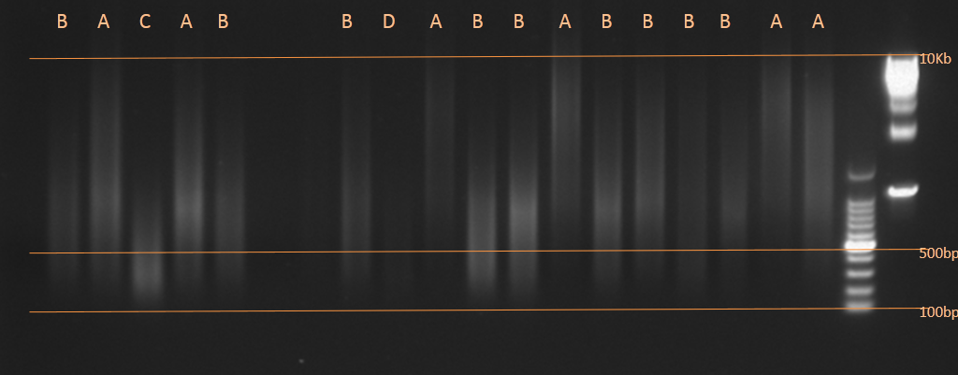
B
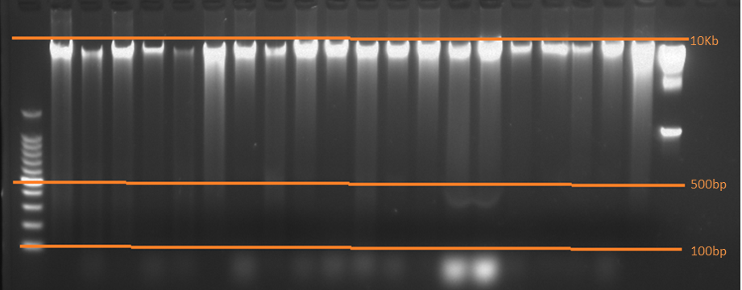
Figure S1. DNA samples were controlled by agarose gel electrophoresis. A. Level A:Qualified DNA samples demand the extracted DNA concentration was >10ng/ul, and the main band of agarose gel was evenly distributed between 500bp-10KB; Level B: Partial degradation of DNA: Although the DNA concentration was more than 10ng/ul and most of the main bands of agarose gel were distributed over 500bp, a few main bands were still distributed below 500bp. Level C: Unqualified DNA samples: Although THE DNA concentration was more than 10ng/ul, the main bands of agarose gel are distributed around 500bp, and more than half of the main bands are below 500bp; B.The main bands of all DNA samples were more than 500bp, and most were distributed around 10Kb.
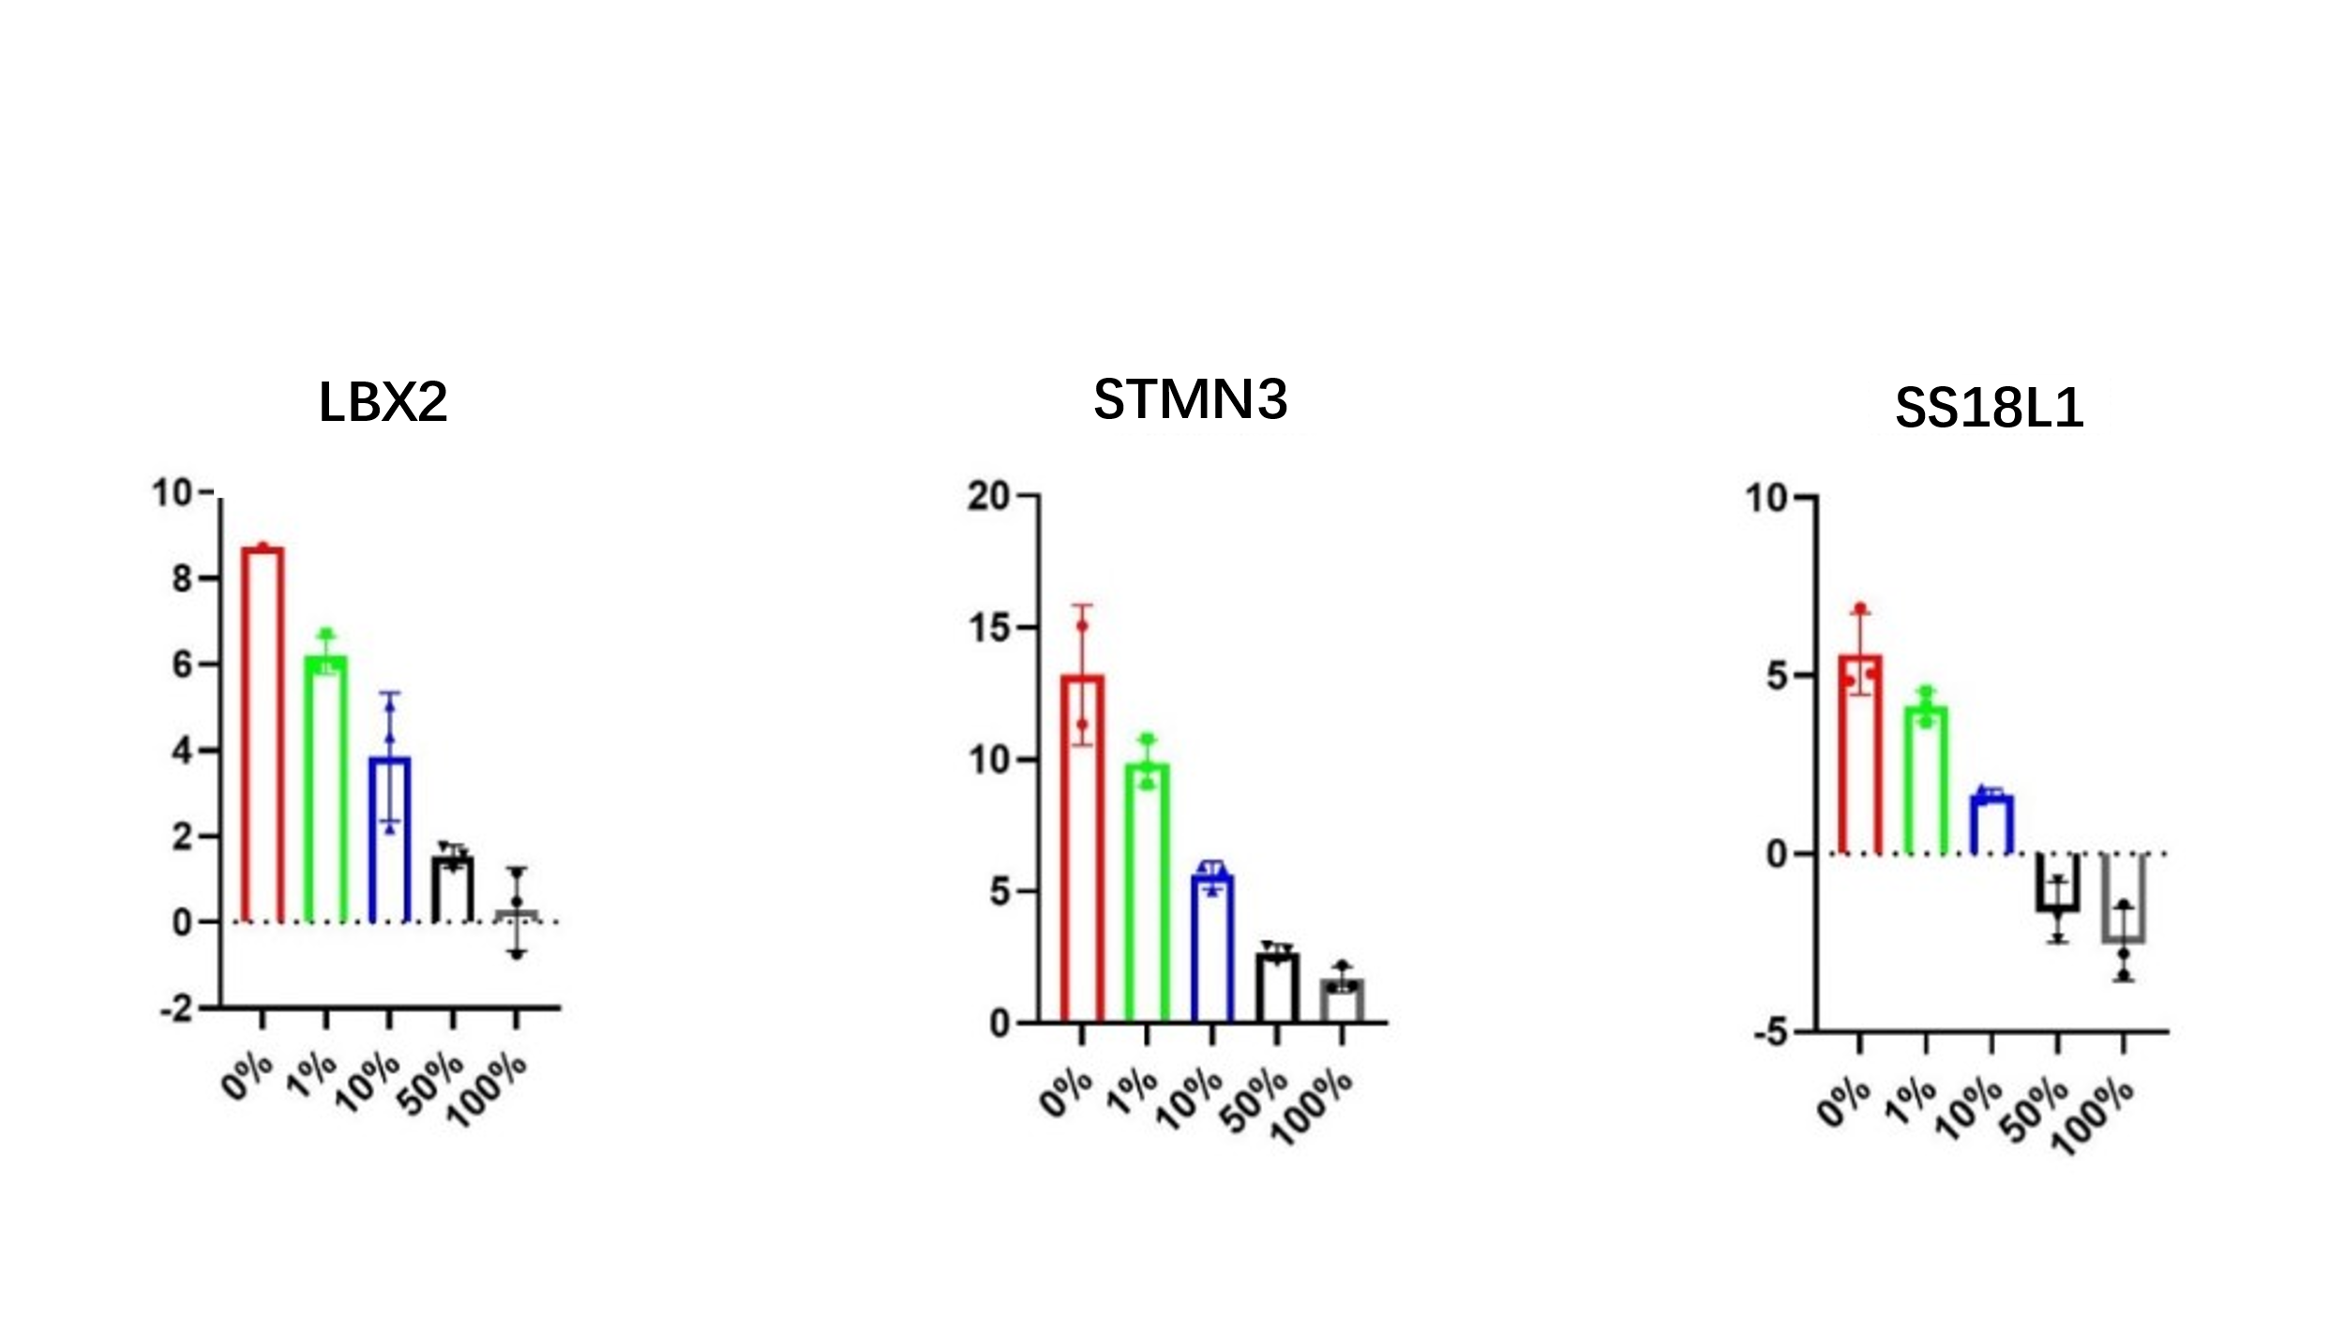

Figure S2. Primer/ probes of LBX2, STMN3 and SS18L1 in different gradients concentrations could distinguish methylation levels. Methylight qPCR was used to verify the methylation degree of the three primers in five different methylation gradients (0%, 1%, 10%, 50%, 100%) of genomic DNA standard samples. The degree of methylation was inversely proportional to the respective PCR detla CT, and the concentration of methylated standard samples in five gradients was detla CT values showed a gradient decline, which indicatd that qPCR method could accurately reflect the methylation level of candidate markers.

A B
C D
E F
G H
Figure S3. Relationship between clinicopathologic feature and LNM. A. Relationship between gender and LNM.B. Relationship between age and LNM. C. Relationship between t-staging and LNM. D. Relationship between tumor size and LNM. E. Relationship between ulceration and LNM.F. Relationship between Lymp-vessel invasion and LNM.G. Relationship between vascular invasion and LNM. H. Relationship between Nerve invasion and LNM.

A B
C D

E F
G H
Figure S4. LBX2 has a good discriminative effect in each clinicopathological classification. A. Performance of LBX2 in the male and female groups.B. Performance of LBX2 in age less than 55 years and age more than 55 years groups.C. Performance of LBX2 in t₁, t₂, t₃, t₄-staging. D. Performance of LBX2 in tumor size less than 5cm and tumor size more than 5cm groups.E. Performance of LBX2 in ulcerative and non- ulcerative groups.F. Performance of LBX2 in lymph-vessel invasion and non-lymph-vessel invasion groups.G. Performance of LBX2 in vascular invasion and non- vascular invasion groups. H. Performance of LBX2 in nerve invasion and non-nerve invasion. *p < 0.05, **p < 0.01, and***p < 0.001，****p<0.0001.

Table S1. The information of EPIC database construction samples
Library numbers | Sex |  | Age |  | Tunor size  (cm) | Ulceration | Lymph-vessel invasion | Blood vessel invasion | Nerve invasion | T-stage | LNM(-/+)
EPIC-CRC-001-FR-IRM |  | Male |  | 78 | 2.0*1.2*0.4 | （+） | （+） | （-） | （-） | 3 | LNM+
EPIC-CRC-014-FR-IRM |  | Female |  | 67 | 3.2*2.8*0.6 | （+） | （-） | （-） | （+） | 3 | LNM+
EPIC-CRC-015-FR-IRM |  | Female |  | 61 | 3.0*2.3*0.4 | （+） | （-） | （-） | （+） | 4a | LNM+
EPIC-CRC-019-FR-IRM |  | Male |  | 61 | 6.0*3.0*1.5 | （-） | （-） | （-） | （+） | 3 | LNM+
EPIC-CRC-024-FR-IRM |  | Female |  | 69 | 6.0*5.5*3.0 | （+） | （-） | （-） | （-） | 3 | LNM+
EPIC-CRC-030-FR-IRM |  | Male |  | 56 | 4.5*4.0*0.7 | （+） | （+） | （+） | （+） | 3 | LNM+
EPIC-CRC-031-FR-IRM |  | Male |  | 70 | 2.0*2.0*1.5 | （-） | （-） | （-） | （-） | 3 | LNM+
EPIC-CRC-041-FR-IRM |  | Female |  | 64 | 6.5*6.0*5.0 | （-） | （+） | （+） | （+） | 4a | LNM+
EPIC-CRC-051-FR-IRM |  | Female |  | 55 | 4.0*3.0*2.0 | （-） | （-） | （-） | （-） | 3 | LNM+
EPIC-CRC-053-FR-IRM |  | Male |  | 80 | 10.0*3.5*2.5 | （-） | （-） | （-） | （-） | 4 | LNM+
EPIC-CRC-054-FR-IRM |  | Female |  | 65 | 3.5*2.0*1.0 | （+） | （-） | （-） | （+） | 3 | LNM+
EPIC-CRC-058-FR-IRM |  | Male |  | 63 | 7.0*3.0*1.5 | （+） | （+） | （+） | （+） | 3 | LNM+
EPIC-CRC-061-FR-IRM |  | Male |  | 55 | 4.5*2.5*1.2 | （-） | （+） | （+） | （+） | 3 | LNM+
EPIC-CRC-063-FR-IRM |  | Female |  | 46 | 3.5*5.0*0.5 | （-） | （-） | （-） | （-） | 3 | LNM+
EPIC-CRC-069-FR-IRM |  | Male |  | 64 | 3.0*2.5*1.0 | （+） | （-） | （-） | （+） | 3 | LNM+
EPIC-CRC-082-FR-IRM |  | Male |  | 77 | 3.0*2.0*1.2 | （+） | （-） | （-） | （-） | 4a | LNM+
EPIC-CRC-086-FR-IRM |  | Female |  | 64 | 3.0*2.0*1.0 | （+） | （-） | （-） | （-） | 3 | LNM+
EPIC-CRC-087-FR-IRM |  | Male |  | 57 | 4.0*3.0*2.0 | （-） | （-） | （-） | （） | 4b | LNM+
EPIC-CRC-100-FR-IRM |  | Male |  | 68 | 7.0*6.5*0.5 | （-） | （-） | （-） | （+） | 3 | LNM+
EPIC-CRC-018-FR-IRM |  | Female |  | 67 | 3.5*2.5*0.7 | （-） | （-） | （-） | （-） | 3 | LNM-
EPIC-CRC-023-FR-IRM |  | Male |  | 57 | 2.8*2.8*0.8 | （-） | （-） | （-） | （-） | 3 | LNM-
EPIC-CRC-012-FR-IRM |  | Male |  | 51 | 4.0*3.0*2.5 | （+） | （-） | （-） | （+） | 4a | LNM-
EPIC-CRC-052-FR-IRM |  | Female |  | 66 | 3.0*2.0*0.5 | （+） | （-） | （-） | （-） | 3 | LNM-
EPIC-CRC-066-FR-IRM |  | Female |  | 78 | 4.0*2.5*2.0 | （+） | （-） | （-） | （+） | 3 | LNM-
EPIC-CRC-067-FR-IRM |  | Female |  | 56 | 4.0*2.0*1.0 | （-） | （-） | （-） | （+） | 4a | LNM-
EPIC-CRC-071-FR-IRM |  | Male |  | 76 | 5.0*4.3*0.5 | （+） | （+） | （+） | （+） | 3 | LNM-
EPIC-CRC-078-FR-IRM |  | Male |  | 61 | 4.5*3.5*1.5 | （-） | （-） | （-） | （+） | 3 | LNM-
EPIC-CRC-081-FR-IRM |  | Male |  | 85 | 5.0*4.0*2.5 | （-） | （-） | （-） | （+） | 3 | LNM-
EPIC-CRC-098-FR-IRM |  | Male |  | 65 | 5.0*4.0*2.0 | （+） | （-） | （-） | （+） | 3 | LNM-
EPIC-CRC-099-FR-IRM |  | Female |  | 66 | 3.0*3.0*1.5 | （+） | （-） | （-） | （-） | 3 | LNM-

Table S2. Quality inspection results after library sequencing
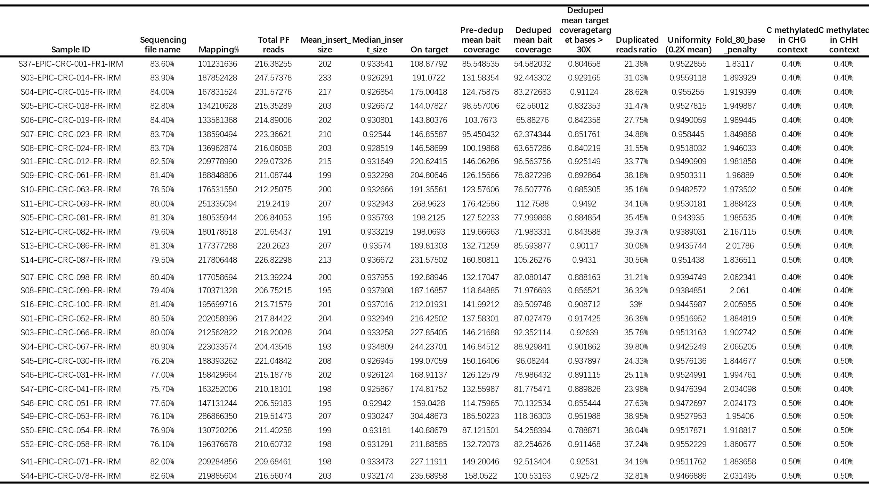
Table S3. The information of target genes
Chromosome | Start location | Terminal location |  | Gene |  | Length | nCG | Mean methylation level in LNM+ | Mean methylation level in LNM- |  | Methylation difference
chr2 | 74725882 |  | 74726332 |  | LBX2 | 451 | 34 | 0.09 |  | 0.36 | -0.27
chr20 | 62272293 |  | 62272494 |  | STMN3 | 202 | 20 | 0.33 |  | 0.1 | 0.23
chr20 | 60745185 |  | 60745246 |  | SS18L1 | 62 | 5 | 0.79 |  | 0.97 | -0.18

Table S4. Performance of three genes in the identification LNM of CRC
Gene | Threshold value(qPCR) | Specificity | Sensitivity | Accuracy | PPV | NPV | AUC
LBX2 | 6.770 | 0.873 | 0.757 | 0.819 | 0.839 | 0.805 | 0.870
STMN3 | 1.208 | 0.856 | 0.262 | 0.579 | 0.614 | 0.571 | 0.540
SS18L1 | 2.011 | 0.814 | 0.388 | 0.615 | 0.645 | 0.604 | 0.555
Table S5. Performance of traditional indicators and LBX2 in the identification LNM of CRC
Methods | AUC | 95%CI | Specificity | Sensitivity | Accuracy | PPV | NPV
CA199 | 0.58 | 0.51-0.66 | 0.49 | 0.71 | 0.59 | 0.56 | 0.65
CEA | 0.56 | 0.48-0.64 | 0.43 | 0.72 | 0.57 | 0.54 | 0.63
Image | 0.52 | 0.45-0.59 | 0.46 | 0.58 | 0.52 | 0.48 | 0.56
LBX2 | 0.87 | 0.82-0.92 | 0.87 | 0.76 | 0.82 | 0.84 | 0.80

