Supplementary Information

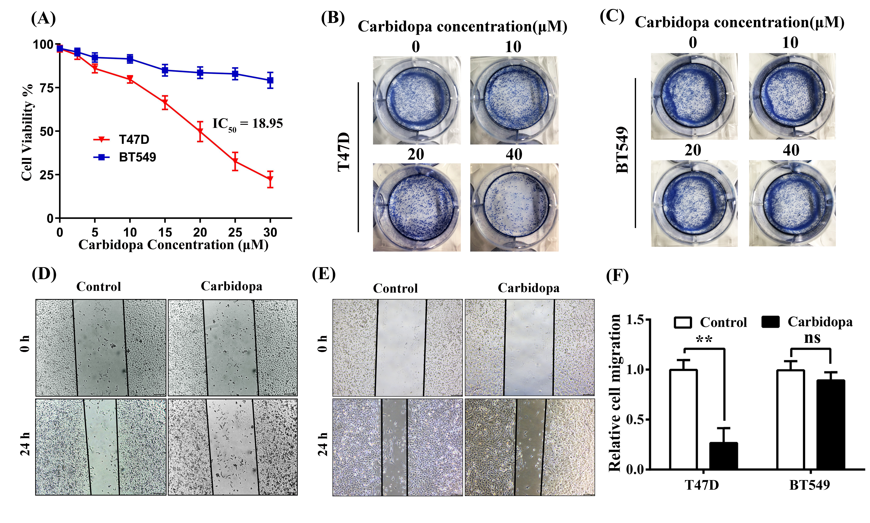
Fig. S1. Carbidopa inhibits T47D cell (ER-positive) proliferation and migration, but has no effect on BT549 cells (ER-negative). (A) T47D and BT549 cells were treated with increasing doses of carbidopa for 24 h, and the cell viability was then examined by MTT assay. Data are given as means ± SD of 3 independent experiments. (B and C) Colony-formation assay: T47D (B) and BT549 (C) cells were cultured in the presence of increasing doses of carbidopa for 2 weeks and then stained with 0.1% crystal violet. Stained colonies in a representative experiment are shown. The experiment was repeated thrice. (D and E) Migration assay (wound healing): T47D (D) and BT549 (E) cells were subjected to wound healing assay with carbidopa and vehicle alone (control) treatment. (F) Quantitative analysis of cell migration in 3 separate fields; data are given as means ± SD. **, p < 0.01 versus control. ns, non-significant.

Fig. S2. Carbidopa induces apoptosis in T47D cells but has no effect on MB231 and BT549 cells. Flow cytometry analysis of apoptosis in MB231 (A), T47D (B), and BT549 (C) cells with increasing doses of carbidopa. Apoptotic cells were detected with their characteristic high signals for propidium iodide and FITC-Annexin V (top right quadrant).

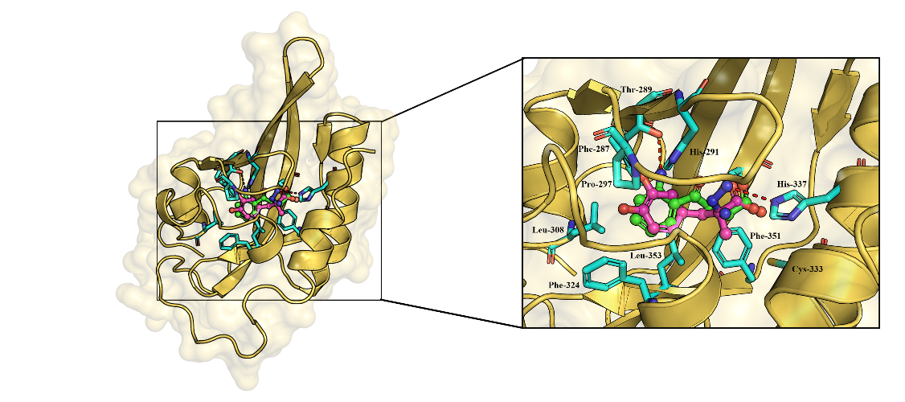

Fig.S3. Molecular docking modeling for the interaction of carbidopa and L-kynurenine with the ligand-binding site of AhR. Carbidopa is in magenta and L-kynurenine in green. Hydrogen bonding is colored red. The amino acid residues in the ligand-binding pocket involved in the interaction of these two agonists are indicated.

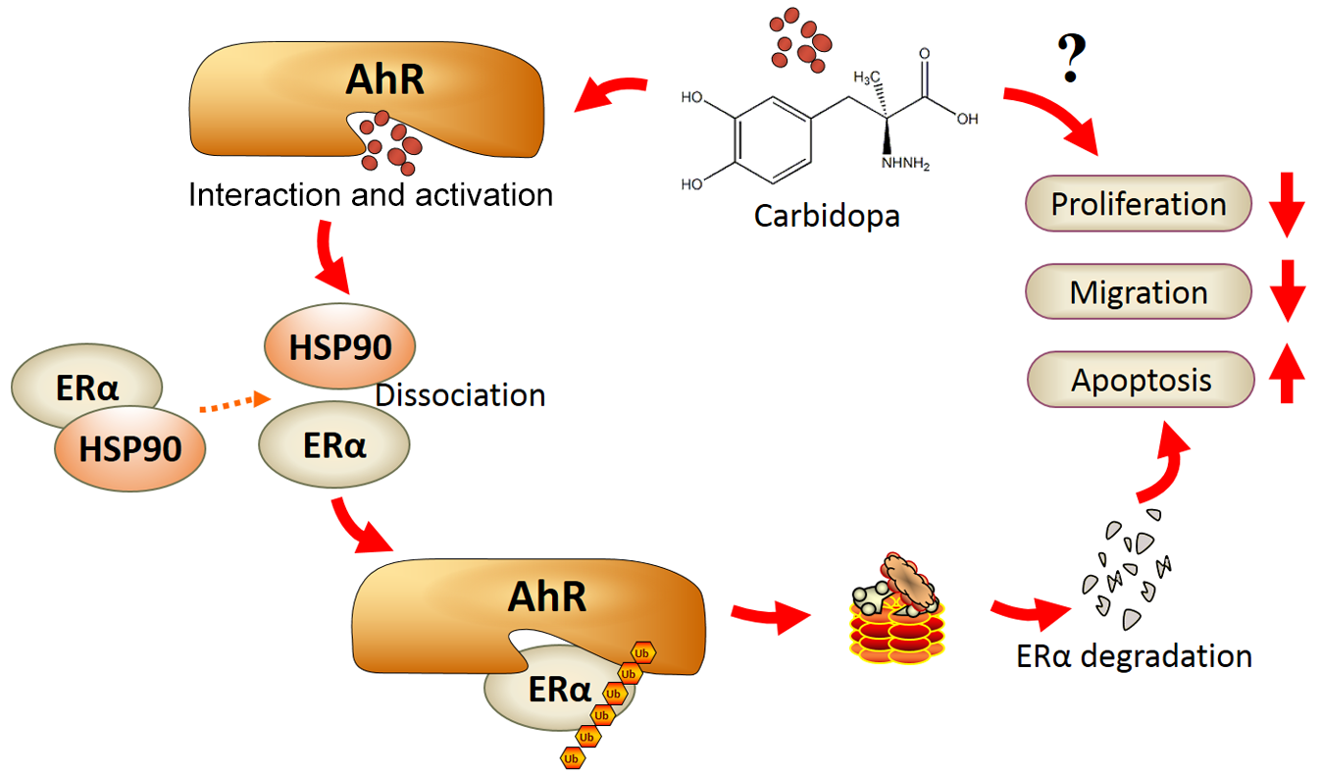
Fig. S4. Schematic showing the proposed mechanism of carbidopa in suppressing the growth and proliferation of ERα-dependent breast cancer cells. Carbidopa acts as an agonist for AhR, which promotes its AhR translocation into nucleus and hence expression of AhR target genes (not indicated in the scheme). The binding of the agonist to AhR also promotes its involvement in the E3 ubiquitin ligase complex to facilitate ubiquitination of ERα for subsequent proteasomal degradation. With the resultant decrease in the cellular levels of ERα, ER-positive breast cancer cells undergo apoptosis and also decreased proliferation and migration. There may also be other molecular mechanisms not yet uncovered for the anticancer effects of carbidopa.

