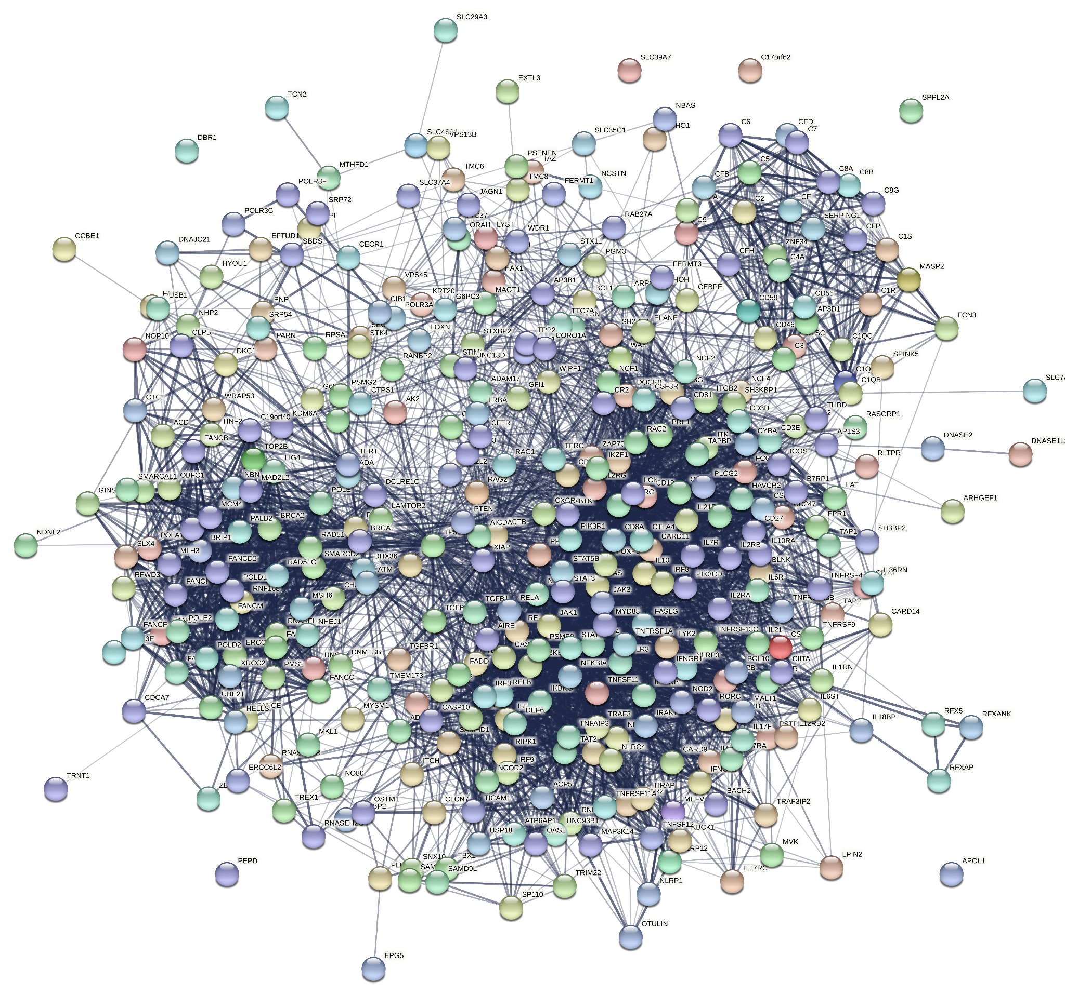

Supplementary figure 1. STRING graph of known PID genes.

Supplementary figure 2 (A-J). Graphs of PPI of 10 random groups with genes causing congenital neutropenia. Graphs were obtained from Cytoscape.

A B
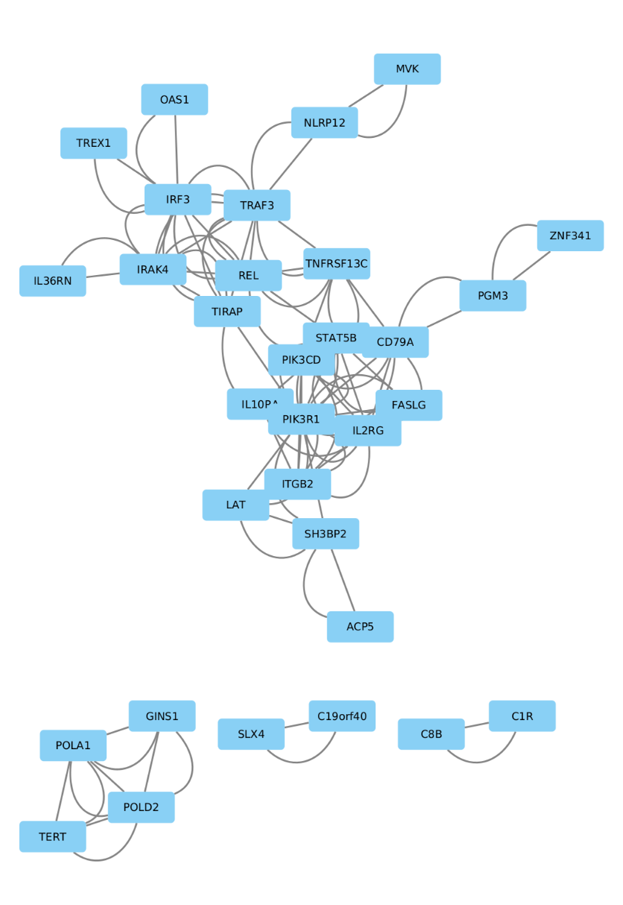
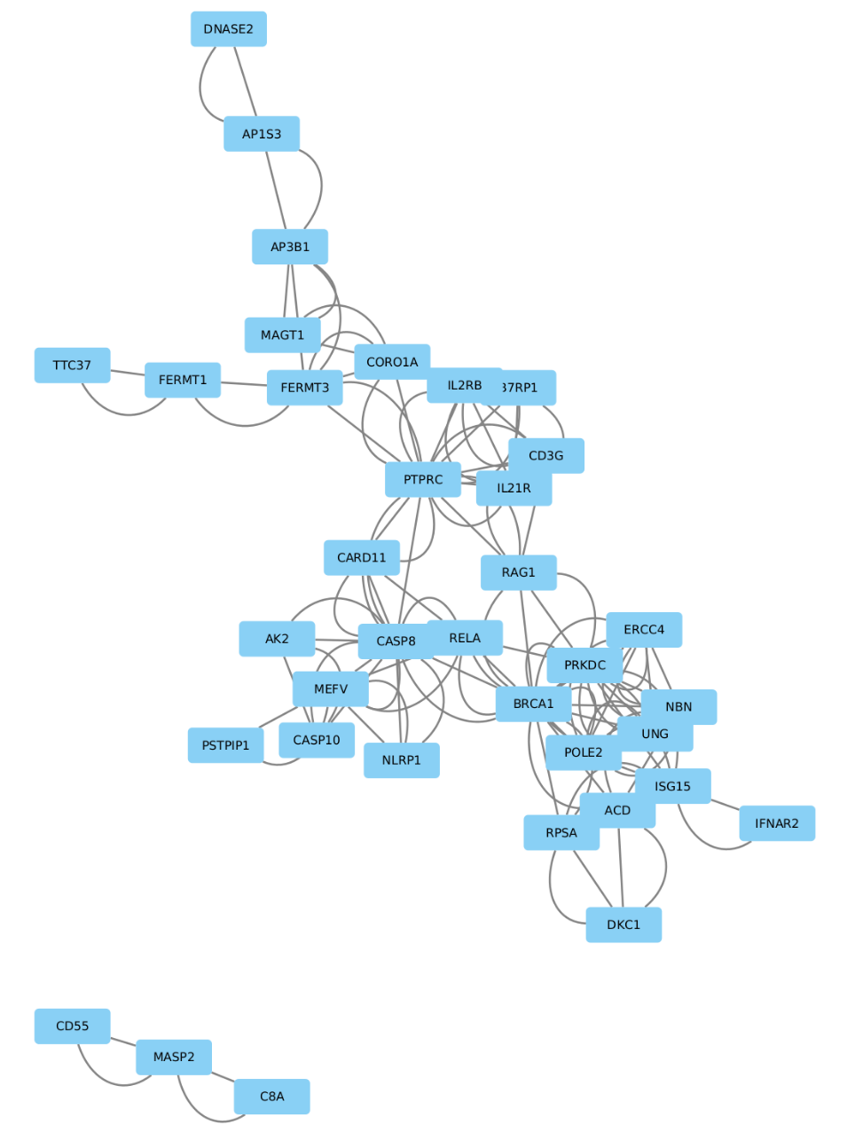

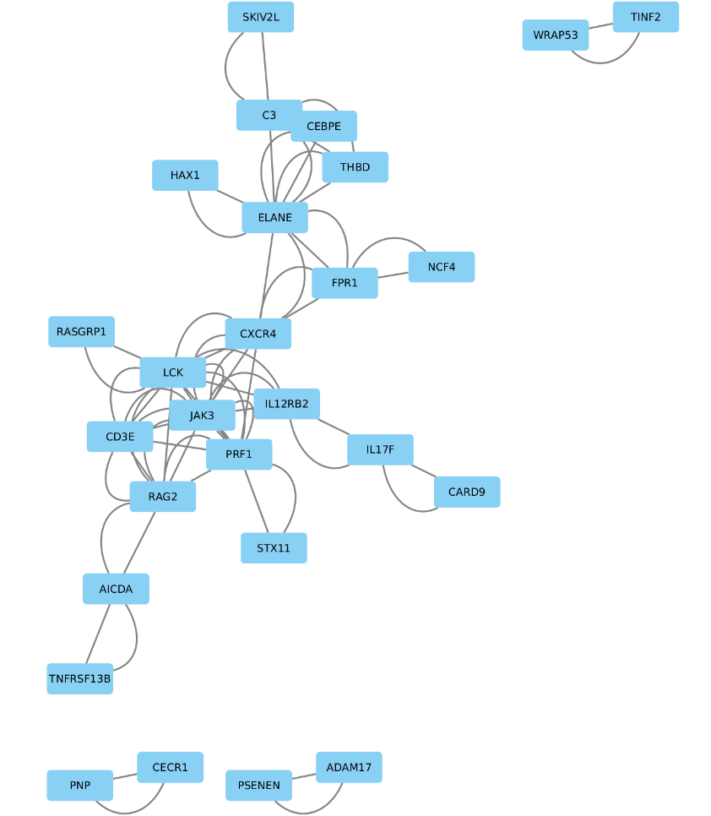
C D
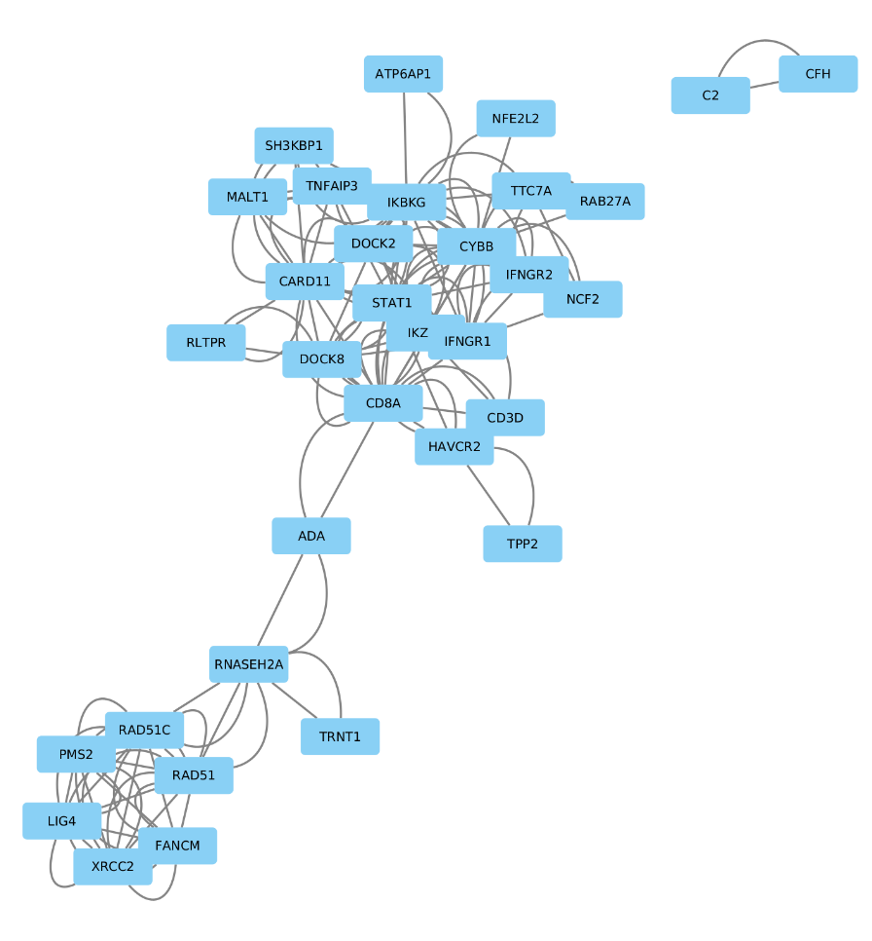

E F
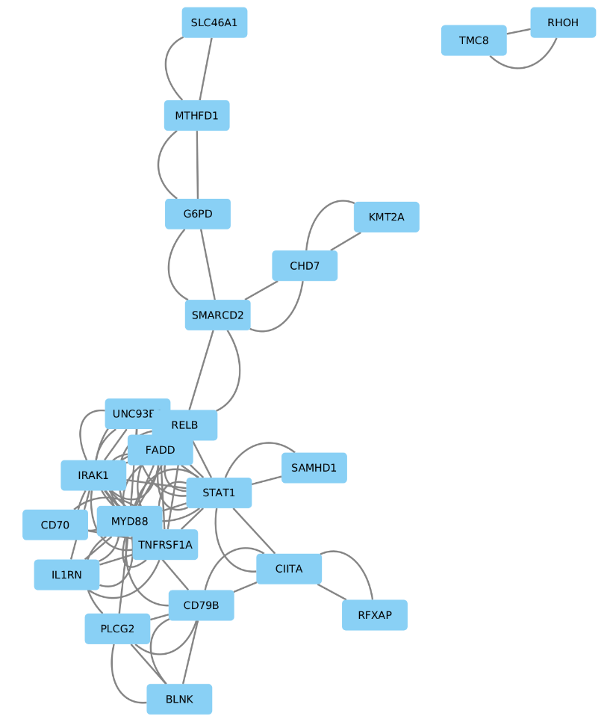
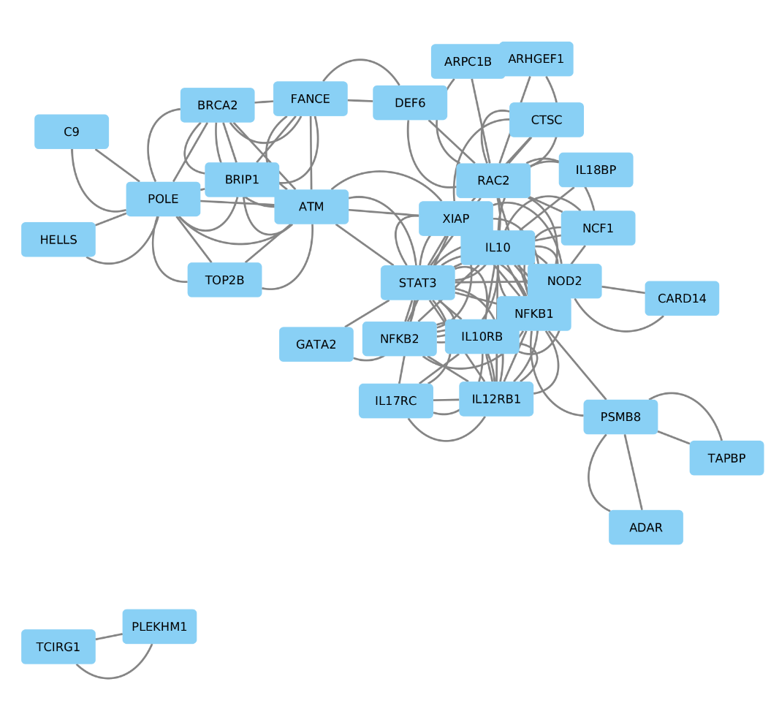

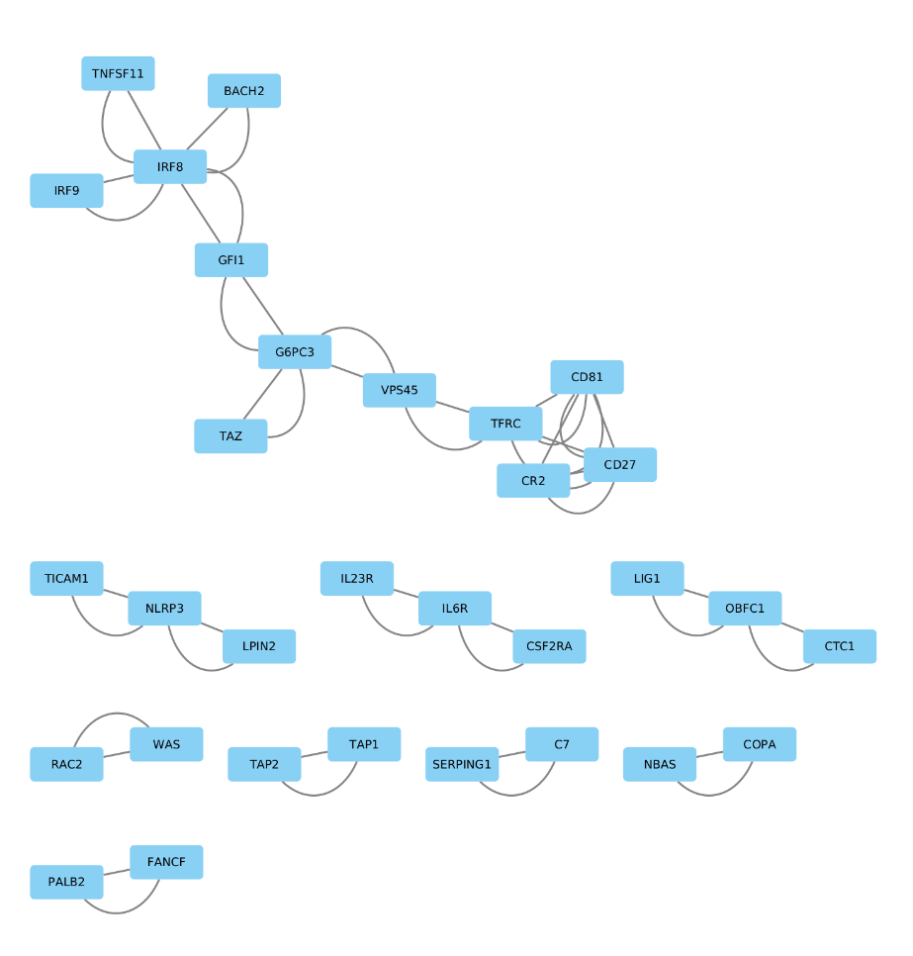
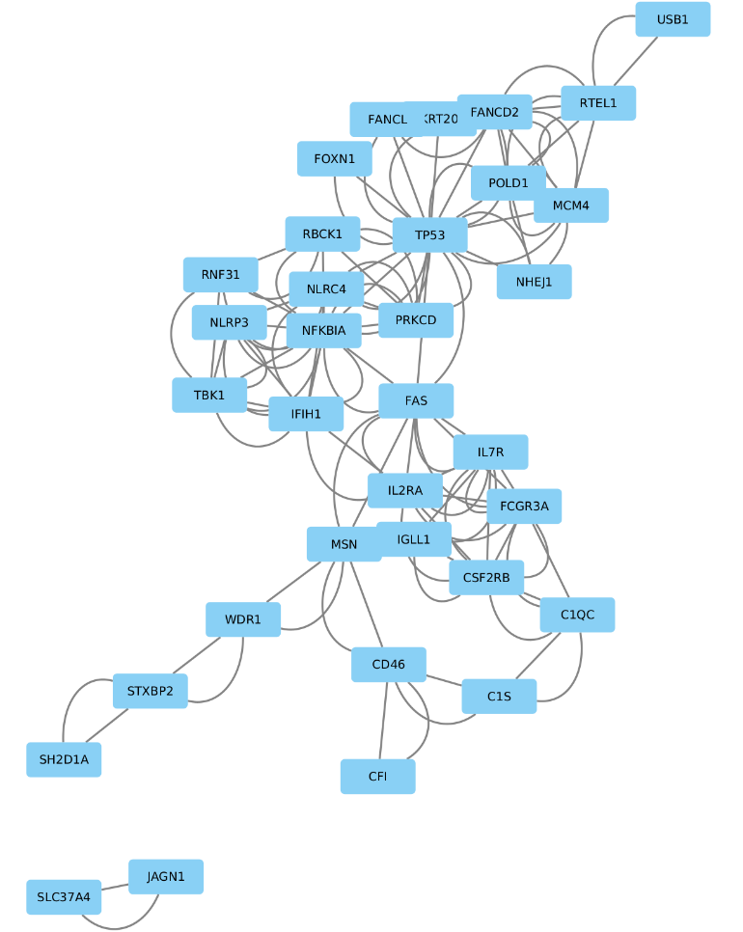
G H
I J
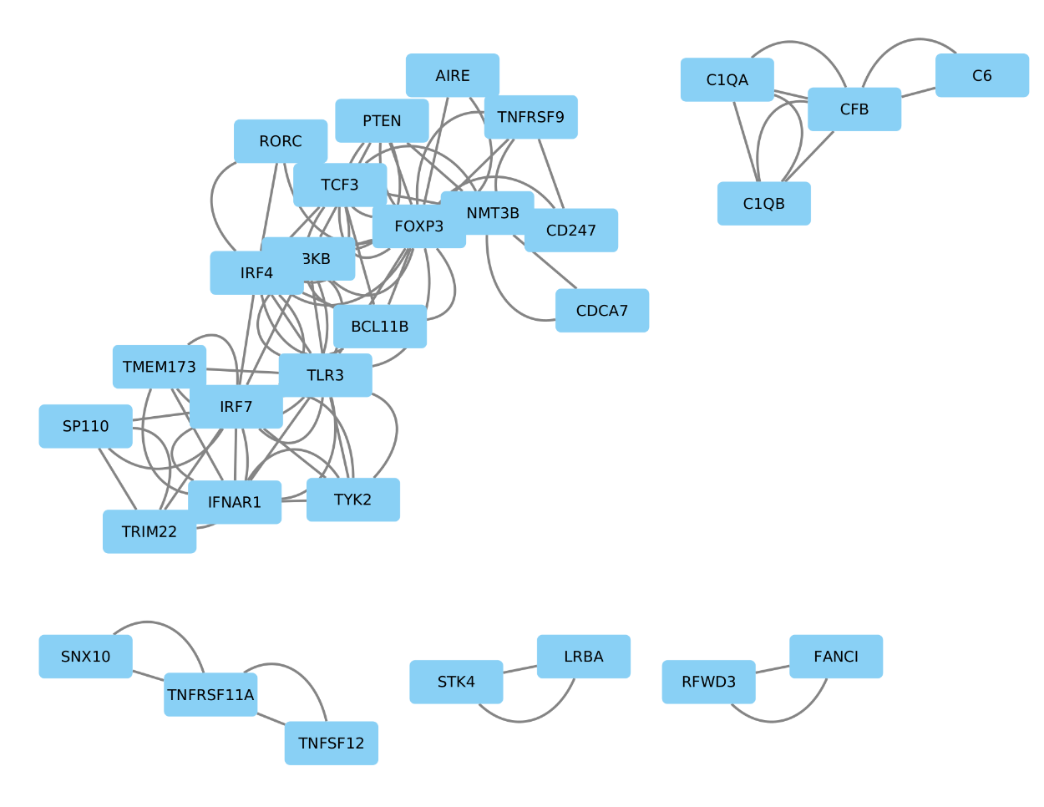
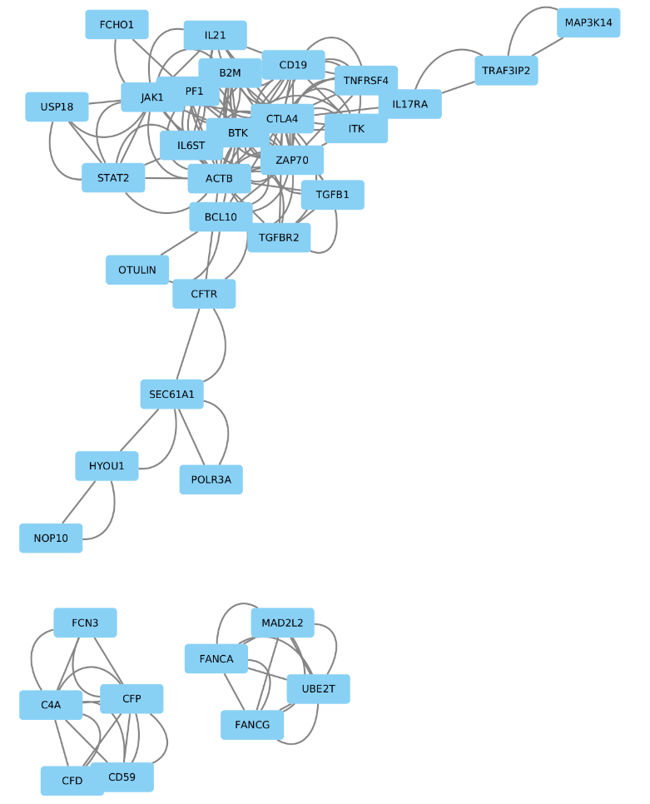

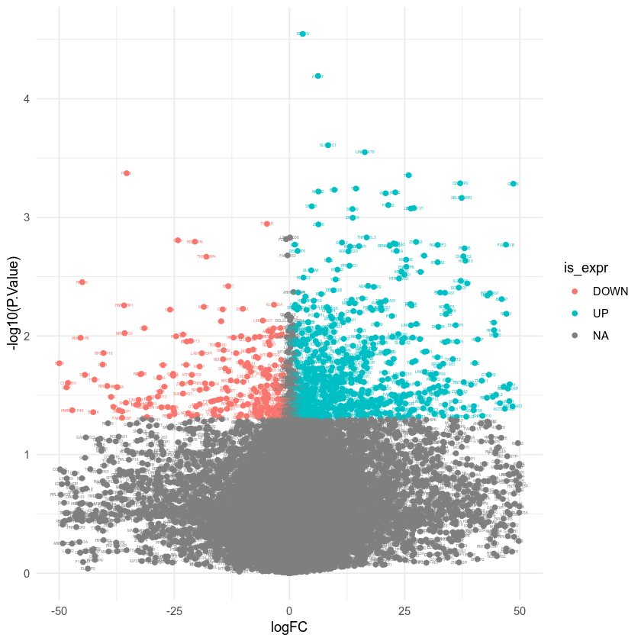
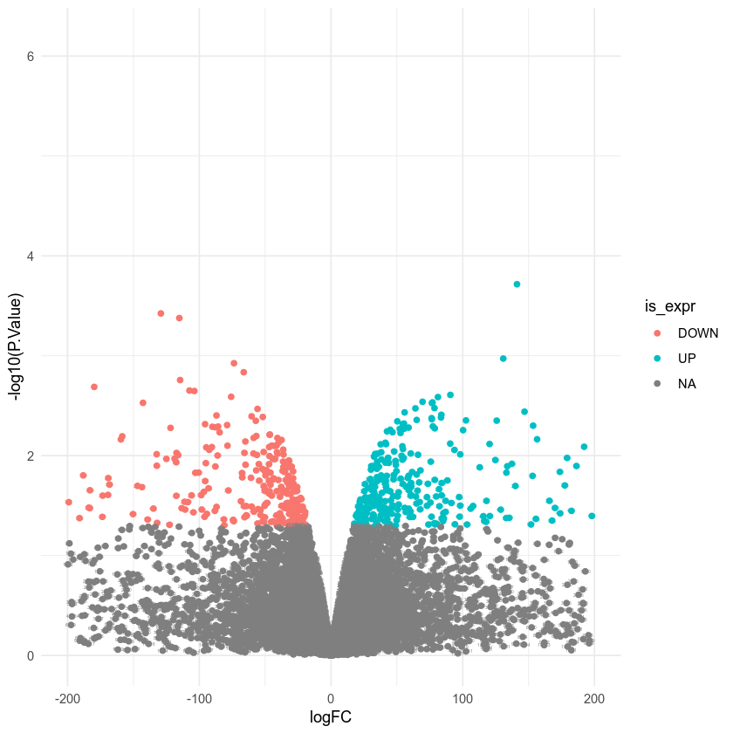
A B

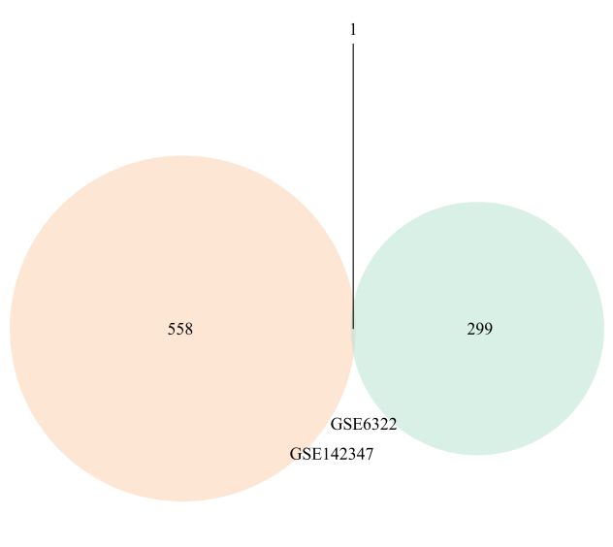
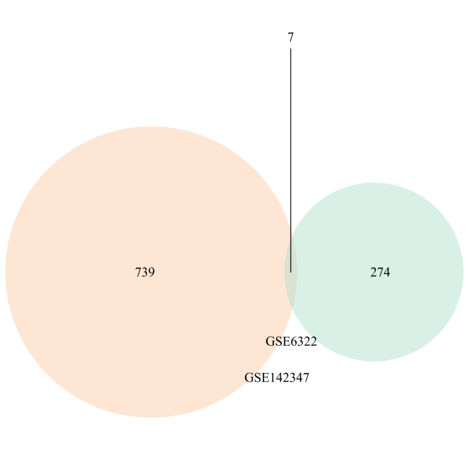
C D

Up-regulated Down-regulated

Supplementary figure 3. The volcano plots of DEGs and Venn diagrams. (A-B) The plot represents gene expression data distribution in samples in the GSE6322 (A) and GSE142347 (B) datasets. Differentially expressed genes are colored in red and blue. own-regulated genes are red, up-regulated genes are blue. Venn diagram of overlapping up-regulated (C) and down-regulated (D) DEGs. The shaded areas denote
overlapping DEGs.

