Supplemental Material

Table
Table S1 Training and test data selection.
Test data | 2018 |  | 2019 |  | 2020
Training data | 2012–17 |  | 2012–18 |  | 2012–19
Training data | # of used years | # of combinations | # of used years | # of combinations | # of used years | # of combinations
Training data | 6 | 1 | 7 | 1 | 8 | 1
Training data | 5 | 6 | 6 | 7 | 7 | 8
Training data | 4 | 15 | 5 | 21 | 6 | 28
Training data | 3 | 20 | 4 | 35 | 5 | 56
Training data | 2 | 15 | 3 | 35 | 4 | 70
Training data | 1 | 6 | 2 | 21 | 3 | 56
Training data |  |  | 1 | 7 | 2 | 28
Training data |  |  |  |  | 1 | 8
Training data | Sum | 63 | Sum | 127 | Sum | 255

Table S2 Accuracy of top five models for 2020 by multiple regression.
Training data (year) | RMSE | MAE | Chosen prediction variables
2019 | 25.54 | 24.05 | Jun, Jul, Aug, Mon, Tue, Thu
2018, 19 | 26.92 | 24.05 | Jun, Jul, Aug, Thu
2015, 19 | 27.43 | 24.06 | Jun, Jul, Aug
2014, 19 | 29.9 | 24.13 | Jun, Jul, Aug, Sat
2015, 18, 19 | 30.67 | 24.17 | Jun, Jul, Aug, Mon, Thu

Table S3 Accuracy of top five models for 2020 by GAM.
Training data (year) | RMSE | MAE | Chosen prediction variables
2014, 18, 19 | 27.66 | 18.78 | Jun, Jul, Aug, Mon, Tue, Thu
2014, 17, 18, 19 | 27.66 | 17.77 | Jun, Jul, Aug, Thu
2015, 17, 18, 19 | 28.13 | 19.02 | Jun, Jul, Aug
2014, 15, 18, 19 | 28.13 | 18.47 | Jun, Jul, Aug, Sat
2017, 18, 19 | 28.29 | 20.01 | Jun, Jul, Aug, Mon, Thu
Table S4 Accuracy of top five models for 2020 by time-stratified case-crossover analysis.
Training data (year) | RMSE | MAE | Odds ratio  (95%CI) (/°C) | $$β$$(/°C)
2013, 16, 17, 18, 19 | 25.51 | 15.48 | 1.41 (1.40, 1.42) | 0.35
2013, 14, 16, 17, 19 | 25.51 | 15.48 | 1.41 (1.40, 1.42) | 0.35
2012, 14, 15 | 25.51 | 15.49 | 1.41 (1.40, 1.43) | 0.35
2013, 14, 15 | 25.51 | 15.49 | 1.41 (1.40, 1.43) | 0.35
2013, 15, 16, 18, 19 | 25.51 | 15.5 | 1.41 (1.41, 1.42) | 0.35

Table S5 Accuracy of top five models for predicting 2019 by multiple regression.
Training data (year) | RMSE | MAE | Chosen prediction variables
2018 | 52.69 | 23.87 | Jun, Jul, Aug
2015, 18 | 52.97 | 22.73 | Jun, Jul, Aug
2015 | 53.93 | 22.94 | Jun, Jul, Aug
2014, 15, 18 | 54.6 | 23.07 | Jun, Jul, Aug, Sat
2014, 18 | 54.93 | 23.21 | Jun, Jul, Aug, Sat

Table S6 Accuracy of top five models for predicting 2019 by GAM.
Training data (year) | RMSE | MAE | Chosen prediction variables
2015,2018 | 47.02 | 26.24 | Jun, Jul, Aug
2015,2016,2018 | 47.03 | 24.82 | Jun, Jul, Aug
2016,2018 | 47.04 | 26.11 | Jun, Jul, Aug
2015 | 47.33 | 23.03 | Jun, Jul, Aug, Sat
2014,2015,2018 | 47.42 | 24.6 | Jun, Jul, Aug, Sat

Table S7 Accuracy of top five models for predicting 2019 by the time-stratified case-crossover analysis.
Training data (year) | RMSE | MAE | Odds ratio  (95%CI) (/°C) | $β$(/°C)
2015 | 46.75 | 22.18 | 1.43 (1.42, 1.47) | 0.36
2014, 15 | 46.75 | 22.18 | 1.43 (1.42, 1.46) | 0.36
2014 | 46.76 | 22.18 | 1.44 (1.41, 1.47) | 0.36
2013, 14 | 46.79 | 22.15 | 1.42 (1.42, 1.46) | 0.35
2013 | 46.81 | 22.13 | 1.44 (1.42, 1.46) | 0.36
Table S8 Accuracy of top five models for predicting 2018 by multiple regression.
Training data (year) | RMSE | MAE | Chosen prediction variables
2015 | 50.53 | 25.12 | Jun, Jul, Aug
2015, 16 | 53.51 | 26.51 | Jun, Jul, Aug, Mon
2013, 15 | 54.15 | 26.75 | Jun, Jul, Aug
2013, 15, 16 | 54.97 | 27.35 | Jun, Jul, Aug, Mon, Thu
2015, 17 | 55.07 | 26.63 | Jun, Jul, Aug

Table S9 Accuracy of top five models for predicting 2018 by GAM.
Training data (year) | RMSE | MAE | Chosen prediction variables
2015 | 47.25 | 27.17 | Jun, Jul, Aug
2013, 15 | 50.73 | 27.33 | Jun, Jul, Aug, Mon
2015, 17 | 51.37 | 26.85 | Jun, Jul, Aug
2014, 15 | 52.03 | 27.74 | Jun, Jul, Aug, Mon, Thu
2013, 15, 17 | 52.69 | 27.38 | Jun, Jul, Aug

Table S10 Accuracy of top five models for predicting 2018 by time-stratified case-crossover analysis.
Training data (year) | RMSE | MAE | Odds ratio  (95%CI) (/°C) | $β$ (/°C)
2012,13 | 53.61 | 29.51 | 1.43 (1.42, 1.45) | 0.36
2012,15 | 53.64 | 29.55 | 1.43 (1.42, 1.45) | 0.36
2012 | 53.71 | 29.21 | 1.42 (1.39, 1.46) | 0.35
2013 | 53.77 | 29.7 | 1.42 (1.42, 1.46) | 0.35
2013,14 | 53.82 | 29.74 | 1.44 (1.42, 1.46) | 0.36

Table S11 Investigating the determinants of RMSE in time-stratified case-crossover analysis.
 | Coefficient | Standard deviation | t-value | p-value | Lower 95% | Upper 95%
Intercept | -1710 | 3406.85 | -0.5 | 0.62 | -8932.2 | 5512.21
Year | 0.87 | 1.69 | 0.52 | 0.61 | -2.71 | 4.46
The end of rainy season day | 1.4 | 7.49 | 0.19 | 0.85 | -14.48 | 17.28
Extremely hot days | 1.01 | 0.92 | 1.1 | 0.29 | -0.94 | 2.97
Tropical nights | -0.46 | 0.42 | -1.1 | 0.29 | -1.36 | 0.43

Table S12 Examination of the determinants of RMSE for mean temperatures after the end of the rainy season.
Method |  | Coefficient | Standard deviation | t-value | p-value | Lower 95% | Upper 95%
MR | Intercept | 40.53 | 5.82 | 6.97 | 1.23E-06 | 28.35 | 52.71
MR | Difference in average temperature after the end of the rainy season | 15.02 | 6.33 | 2.37 | 0.028 | 1.76 | 28.27
GAM | Intercept | 45.45 | 6 | 7.57 | 3.76E-07 | 32.89 | 58.02
GAM | Difference in average temperature after the end of the rainy season | 8.28 | 6.54 | 1.27 | 0.22 | -5.4 | 21.95
TC | Intercept | 46.49 | 8.68 | 5.36 | 3.61E-05 | 28.33 | 64.66
TC | Difference in average temperature after the end of the rainy season | 3.39 | 9.45 | 0.36 | 0.72 | -16.39 | 23.17
Table S13 Accuracy of models for 2018 by three methods when training data was decreased by one year from 2012 to 2017.
Training data (year) | MR | GAM | TC | MR, GAM | TC
Training data (year) | RMSE |  |  | Chosen prediction variables | Odds ratio  (95%CI) (/°C) | $β$ (/°C)
2012–17 | 60.79 | 57.58 | 57.9 | Jun, Jul, Aug, Mon, Sat | 1.39  (1.38, 1.40) | 0.33
2013–17 | 57.91 | 55.6 | 56.87 | Jun, Jul, Aug, Mon, Wed, Thu | 1.39  (1.38, 1.41) | 0.33
2014–17 | 57.94 | 57.14 | 56.08 | Jun, Jul, Aug, Mon, Sat | 1.4  (1.39, 1.41) | 0.34
2015–17 | 56.31 | 55.49 | 58.18 | Jun, Jul, Aug, Mon, Wed | 1.39  (1.37, 1.40) | 0.33
2016–17 | 61.2 | 66.89 | 65.97 | Jun, Jul, Aug, Mon, Wed, Thu | 1.35  (1.33, 1.37) | 0.3
2017 | 63.11 | 64.83 | 68.93 | Jun, Jul, Aug, Wed | 1.34  (1.31, 1.36) | 0.29

Table S14 Accuracy of models for 2018 by time-stratified case-crossover analysis when training data was decreased by one year from 2012 to 2017.
Training data (year) | RMSE | MAE | Odds (95%CI) (/℃) | $β$ (/℃)
2012–17 | 57.9 | 29.68 | 1.39  (1.38, 1.40) | 0.33
2013–17 | 56.87 | 29.49 | 1.39  (1.38, 1.41) | 0.33
2014–17 | 56.08 | 29.4 | 1.4  (1.39, 1.41) | 0.34
2015–17 | 58.18 | 29.72 | 1.39  (1.37, 1.40) | 0.33
2016–17 | 65.97 | 34.11 | 1.35  (1.33, 1.37) | 0.3
2017 | 68.93 | 35.79 | 1.34  (1.31, 1.36) | 0.29

Table S15 Accuracy of models for 2018 by multiple regression when training data was decreased by one year from 2012 to 2017.
Training data (year) | RMSE | MAE | Chosen prediction variables
2012–17 | 60.79 | 30.16 | Jun, Jul, Aug, Mon, Sat
2013–17 | 57.91 | 28.63 | Jun, Jul, Aug, Mon, Wed, Thu
2014–17 | 57.94 | 28.47 | Jun, Jul, Aug, Mon, Sat
2015–17 | 56.31 | 27.77 | Jun, Jul, Aug, Mon, Wed
2016–17 | 61.2 | 30.45 | Jun, Jul, Aug, Mon, Wed, Thu
2017 | 63.11 | 31.19 | Jun, Jul, Aug, Wed

Table S16 Accuracy of models for 2018 by GAM when training data was decreased by one year from 2012 to 2017.
Training data (year) | RMSE | MAE | Chosen prediction variables
2012–17 | 57.58 | 30.16 | Jun, Jul, Aug, Mon, Sat
2013–17 | 55.6 | 28.63 | Jun, Jul, Aug, Mon, Wed, Thu
2014–17 | 57.14 | 28.47 | Jun, Jul, Aug, Mon, Sat
2015–17 | 55.49 | 27.77 | Jun, Jul, Aug, Mon, Wed
2016–17 | 66.89 | 30.45 | Jun, Jul, Aug, Mon, Wed, Thu
2017 | 64.83 | 31.19 | Jun, Jul, Aug, Wed

Table S17 Accuracy of models for 2020 by three methods when training data was decreased by one year from 2012 to 2019.
Training data (year) | MR | GAM | TC | MR, GAM | TC
Training data (year) | RMSE |  |  | Chosen prediction variables | Odds ratio (95%CI) (/°C) | $β$ (/°C)
2012–19 | 41.46 | 32.36 | 27.03 | Jun, Jul, Aug, Mon, Wed, Thu | 1.39  (1.39, 1.40) | 0.33
2013–19 | 40.05 | 30.67 | 26.24 | Jun, Jul, Aug, Mon, Wed, Thu | 1.4  (1.39, 1.40) | 0.34
2014–19 | 38.39 | 29.49 | 25.91 | Jun, Jul, Aug, Mon, Sat | 1.4  (1.40, 1.41) | 0.34
2015–19 | 37.91 | 29.03 | 25.51 | Jun, Jul, Aug, Mon, Tue, Wed, Thu | 1.41  (1.40, 1.42) | 0.35
2016–19 | 37.82 | 28.91 | 25.68 | Jun, Jul, Aug, Mon, Thu | 1.41  (1.40, 1.42) | 0.34
2017–19 | 32.83 | 28.29 | 25.53 | Jun, Jul, Aug, Mon, Thu | 1.42  (1.40,1.43) | 0.35
2018–19 | 26.92 | 29.78 | 26.95 | Jun, Jul, Aug, Thu | 1.43  (1.42, 1.45) | 0.36
2019 | 25.54 | 49.46 | 60.06 | Jun, Jul, Aug, Mon, Tue, Thu | 1.51  (1.48, 1.53) | 0.41
Table S18 Accuracy of models for 2019 by three methods when training data was decreased by one year from 2012 to 2018.
Training data (year) | MR | GAM | TC | MR, GAM | TC
Training data (year) | RMSE |  |  | Chosen prediction variables | Odds ratio  (95%CI) (/°C) | $β$ (/°C)
2012–18 | 59.55 | 52.1 | 51.21 | Jun, Jul, Aug, Mon, Wed, Thu | 1.39  (1.38, 1.40) | 0.33
2013–18 | 58.62 | 50.11 | 50.69 | Jun, Jul, Aug, Mon, Wed, Thu | 1.39  (1.38, 1.40) | 0.33
2014–18 | 57.57 | 48.76 | 50.44 | Jun, Jul, Aug, Mon, Sat | 1.39  (1.38, 1.40) | 0.33
2015–18 | 57.76 | 47.92 | 51.49 | Jun, Jul, Aug, Mon, Wed, Thu | 1.38  (1.37, 1.40) | 0.33
2016–18 | 59.24 | 48.21 | 53.8 | Jun, Jul, Aug, Mon, Wed, Thu | 1.37  (1.36, 1.38) | 0.31
2017–18 | 57.15 | 48.6 | 53.54 | Jun, Jul, Aug, Mon, Wed, Thu | 1.37  (1.36, 1.39) | 0.31
2018 | 52.69 | 50.28 | 51.92 | Jun, Jul, Aug | 1.38  (1.37, 1.40) | 0.32

Table S19 Accuracy of models for 2020 by time-stratified case-crossover analysis when training data was decreased by one year from 2012 to 2019.
Training data (year) | RMSE | MAE | Odds (95%CI) (/℃) | $β$ (/℃)
2012–19 | 27.03 | 14.98 | 1.39  (1.39, 1.40) | 0.33
2013–19 | 26.24 | 15.04 | 1.4  (1.39, 1.41) | 0.34
2014–19 | 25.91 | 15.15 | 1.4  (1.40, 1.41) | 0.34
2015–19 | 25.51 | 15.46 | 1.41  (1.40, 1.42) | 0.35
2016–19 | 25.68 | 15.25 | 1.41  (1.40, 1.42) | 0.34
2017–19 | 25.53 | 15.57 | 1.42  (1.40, 1.43) | 0.35
2018–19 | 26.95 | 16.53 | 1.43  (1.42, 1.45) | 0.36
2019 | 60.06 | 30.23 | 1.51  (1.48, 1.53) | 0.41

Table S20 Accuracy of models for 2020 by multiple regression when training data was decreased by one year from 2012 to 2019.
Training data | RMSE | MAE | Chosen prediction variables
2012–19 | 41.46 | 21.33 | Jun, Jul, Aug, Mon, Wed, Thu
2013–19 | 40.05 | 20.65 | Jun, Jul, Aug, Mon, Wed, Thu
2014–19 | 38.39 | 19.55 | Jun, Jul, Aug, Mon, Sat
2015–19 | 37.91 | 19.53 | Jun, Jul, Aug, Mon, Tue, Wed, Thu
2016–19 | 37.82 | 19.29 | Jun, Jul, Aug, Mon, Thu
2017–19 | 32.83 | 16.92 | Jun, Jul, Aug, Mon, Thu
2018–19 | 26.92 | 14.48 | Jun, Jul, Aug, Thu
2019 | 25.54 | 13.97 | Jun, Jul, Aug, Mon, Tue, Thu

Table S21 Accuracy of models for 2020 by GAM when training data was decreased by one year from 2012 to 2019.
Training data | RMSE | MAE | Chosen prediction variables
2012–19 | 32.36 | 19.11 | Jun, Jul, Aug, Mon, Wed, Thu
2013–19 | 30.67 | 18.31 | Jun, Jul, Aug, Mon, Wed, Thu
2014–19 | 29.49 | 18.07 | Jun, Jul, Aug, Mon, Sat
2015–19 | 29.03 | 18.81 | Jun, Jul, Aug, Mon, Tue, Wed, Thu
2016–19 | 28.91 | 19.35 | Jun, Jul, Aug, Mon, Thu
2017–19 | 28.29 | 20.01 | Jun, Jul, Aug, Mon, Thu
2018–19 | 29.78 | 21.87 | Jun, Jul, Aug, Thu
2019 | 49.46 | 27.09 | Jun, Jul, Aug, Mon, Tue, Thu

Table S22 Accuracy of models for 2019 by time-stratified case-crossover analysis when training data was decreased by one year from 2012 to 2018.
Training data (year) | RMSE | MAE | Odds (95%CI) (/℃) | $β$ (/℃)
2012–18 | 51.21 | 23.09 | 1.39  (1.38, 1.40) | 0.33
2013–18 | 50.69 | 22.98 | 1.39  (1.38, 1.40) | 0.33
2014–18 | 50.44 | 22.93 | 1.39  (1.38, 1.40) | 0.33
2015–18 | 51.49 | 23.15 | 1.38  (1.37, 1.40) | 0.33
2016–18 | 53.8 | 23.86 | 1.37  (1.36, 1.38) | 0.31
2017–18 | 53.54 | 23.78 | 1.37  (1.36, 1.38) | 0.31
2018 | 51.92 | 23.26 | 1.38  (1.37, 1.40) | 0.32

Table S23 Accuracy of models for 2019 by multiple regression when training data was decreased by one year from 2012 to 2018.
Training data (year) | RMSE | MAE | Chosen prediction variables
2012–18 | 59.55 | 25.38 | Jun, Jul, Aug, Mon, Wed, Thu
2013–18 | 58.62 | 24.97 | Jun, Jul, Aug, Mon, Wed, Thu
2014–18 | 57.57 | 24.45 | Jun, Jul, Aug, Mon, Sat
2015–18 | 57.76 | 24.53 | Jun, Jul, Aug, Mon, Wed, Thu
2016–18 | 59.24 | 25.24 | Jun, Jul, Aug, Mon, Wed, Thu
2017–18 | 57.15 | 24.73 | Jun, Jul, Aug, Mon, Wed, Thu
2018 | 52.69 | 23.87 | Jun, Jul, Aug

Table S24 Accuracy of models for 2019 by GAM when training data was decreased by one year from 2012 to 2018.
Training data (year) | RMSE | MAE | Chosen prediction variables
2012–18 | 52.1 | 25.42 | Jun, Jul, Aug, Mon, Wed, Thu
2013–18 | 50.11 | 24.43 | Jun, Jul, Aug, Mon, Wed, Thu
2014–18 | 48.76 | 23.93 | Jun, Jul, Aug, Mon, Sat
2015–18 | 47.92 | 24.48 | Jun, Jul, Aug, Mon, Wed, Thu
2016–18 | 48.21 | 25.39 | Jun, Jul, Aug, Mon, Wed, Thu
2017–18 | 48.6 | 26.97 | Jun, Jul, Aug, Mon, Wed, Thu
2018 | 50.28 | 31.2 | Jun, Jul, Aug

Figure

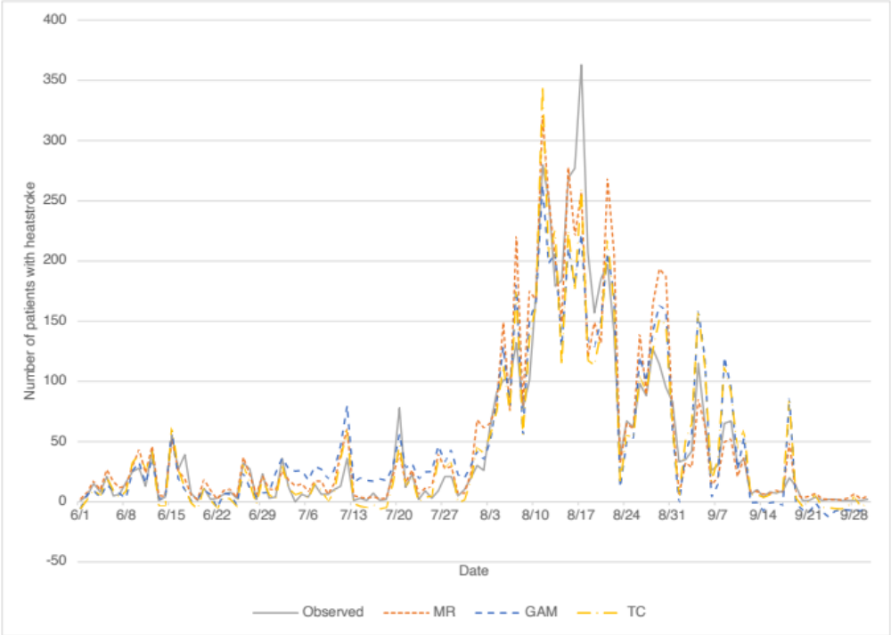
Fig. S1 Number of predicted and observed patients with heatstroke in 2020 / The most accurate model for each of the three methods was used to predict the number of each day.

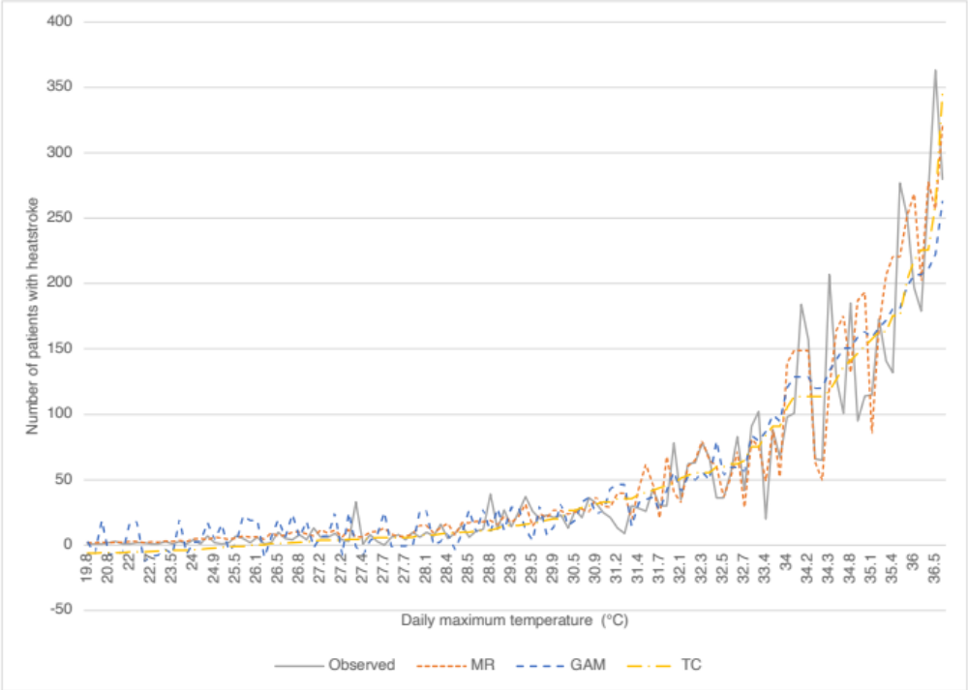
Fig. S2 Number of predicted and observed patients with heatstroke in 2020 / The most accurate model for each of the three methods was used to predict the number at that daily maximum temperature.
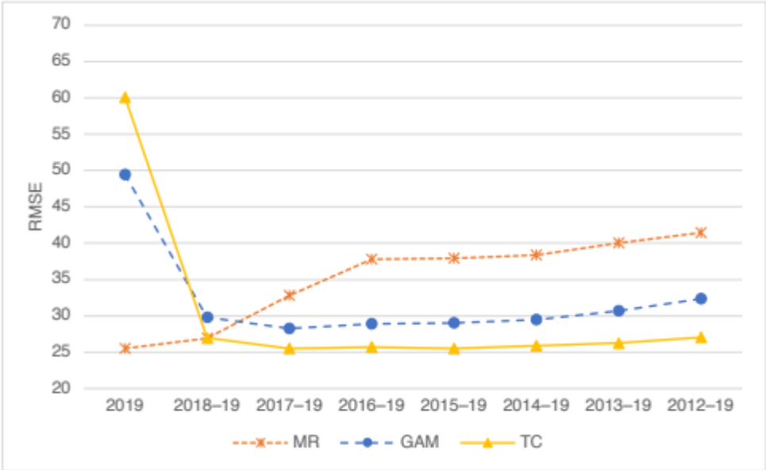
Fig. S3 Comparison of the RMSE of the three methods predicting for 2020 / When training data was added by one year from 2012 to 2019.
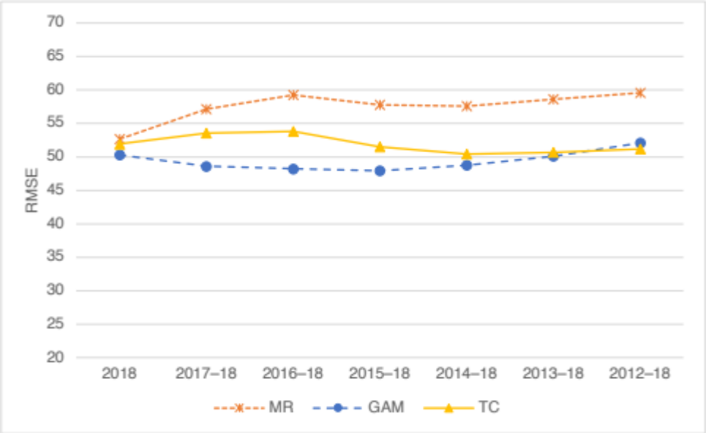
Fig. S4 Comparison of the RMSE of the three methods predicting for 2019 / When training data was added by one year from 2012 to 2018.

