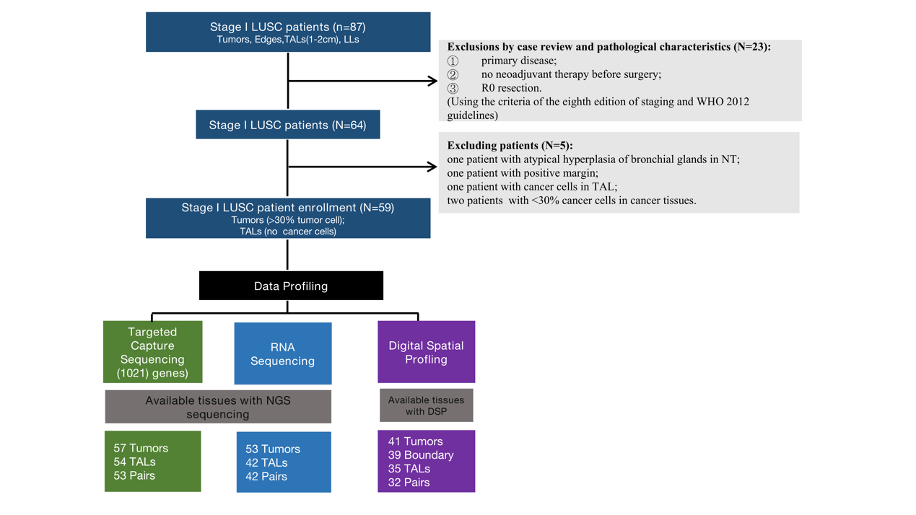
Supplementary

Fig. S1. Study overview. NGS strategies included target sequencing and RNA sequencing which were boxed in green and light blue, respectively. All results were validated by DSP data. Tumors represented for tumor tissues, Edges for tumor edge tissues, TALs for tumor-adjacent tissues, LLs for leukocyte layers.

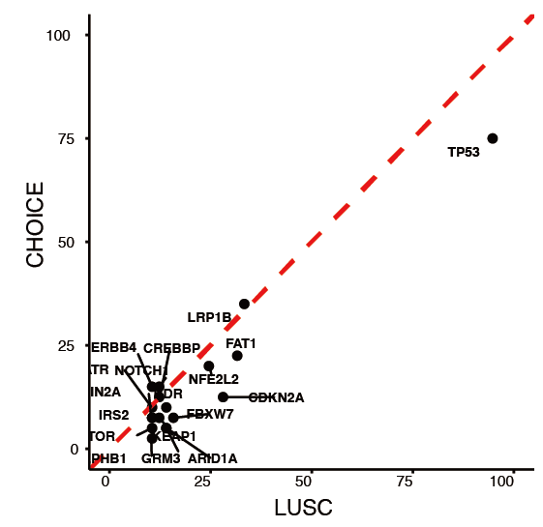

Fig. S2. The consistency of CHOICE study and our study. Mutation ratio of top20 cancer-related genes in CHOICE stage I LUSC cohort and our cohort (x axis for our cohort, y axis for CHOICE study).

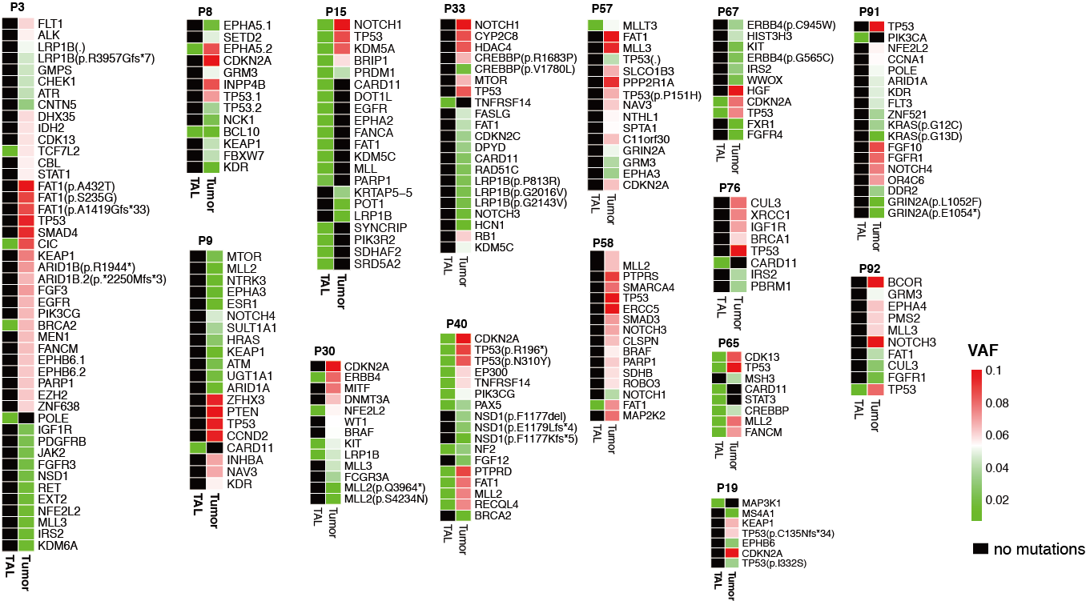
Fig. S3. The detail of mutations in tumors and paired TALs. 15 paired tissues were shown for mutation detection.

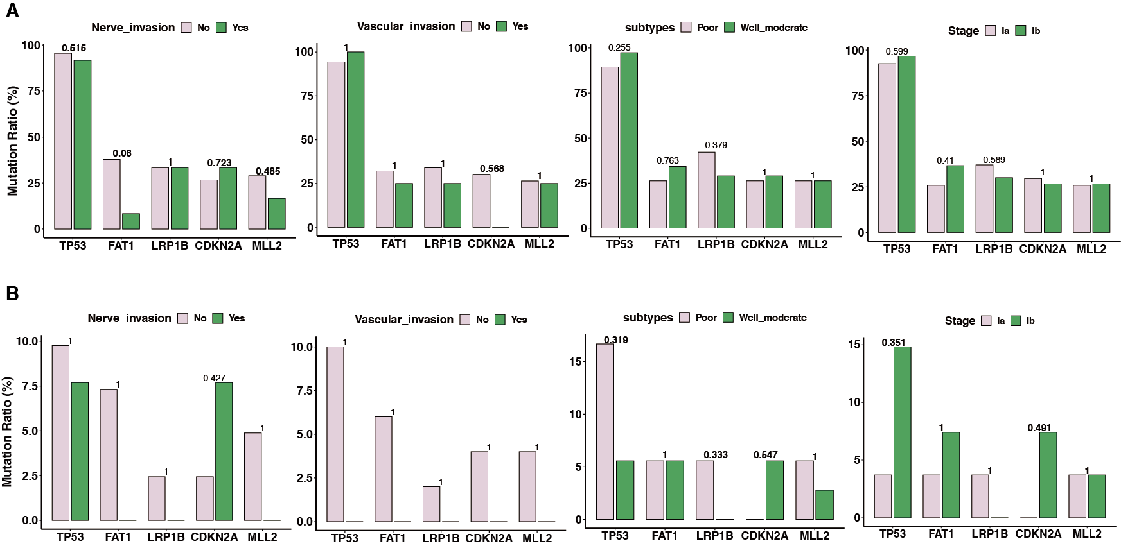
Fig. S4. Association between clinical characteristics and cancer genes in tumors (A) and TALs (B). The number on the top of bar was p value test by Fisher. exact. test.

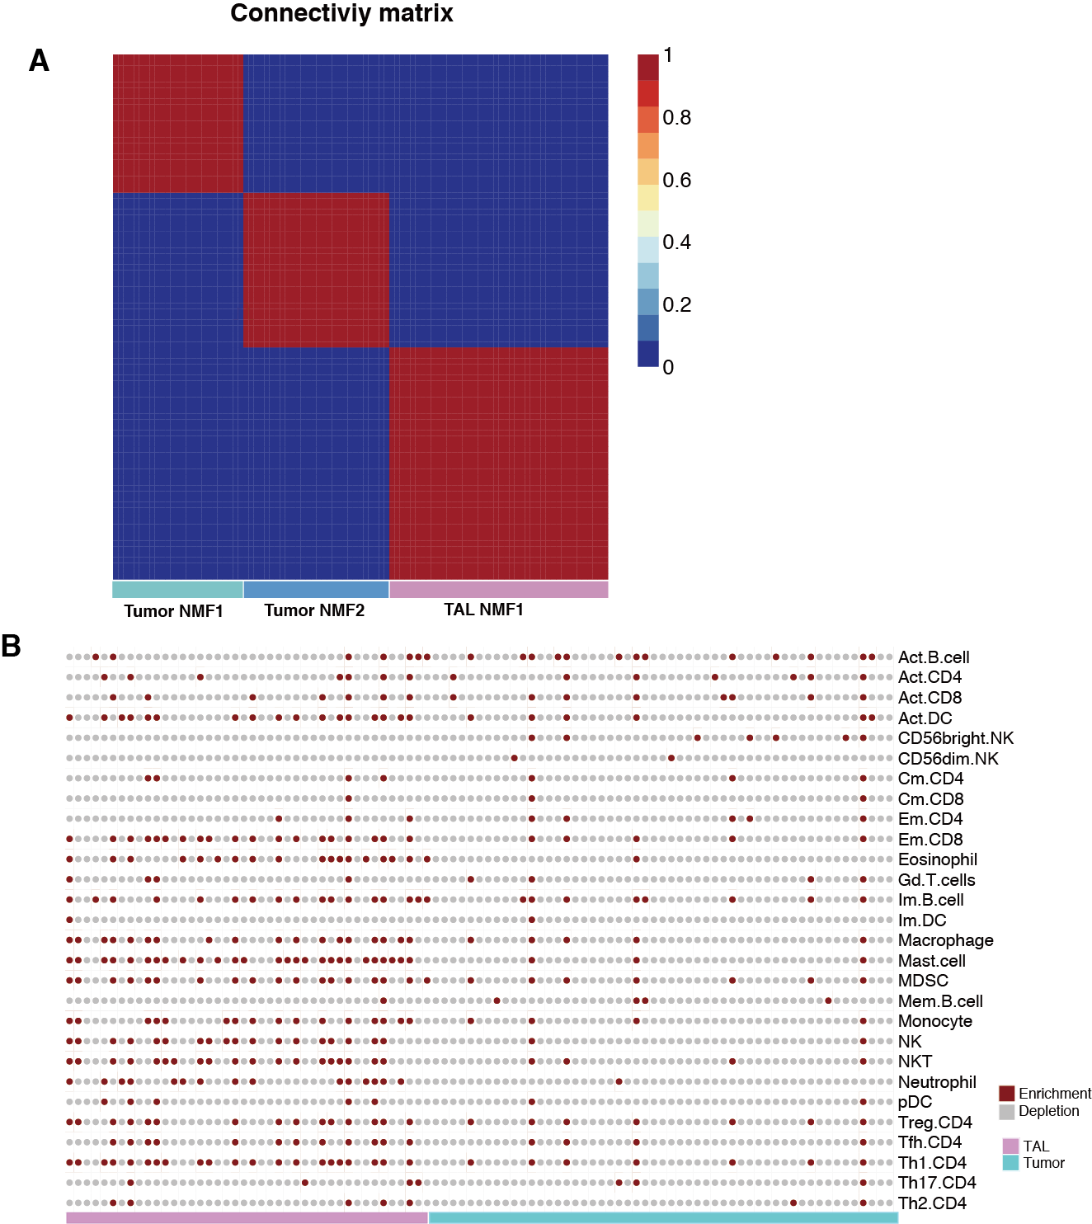
Fig. S5. Immune cell infiltration. A. Unsupervised NMF clustering heatmap of the 22,737 gene expression levels in tumors and TALs. B. Immune cell enrichment (red) and depletion (grey) in tumors and TALs.

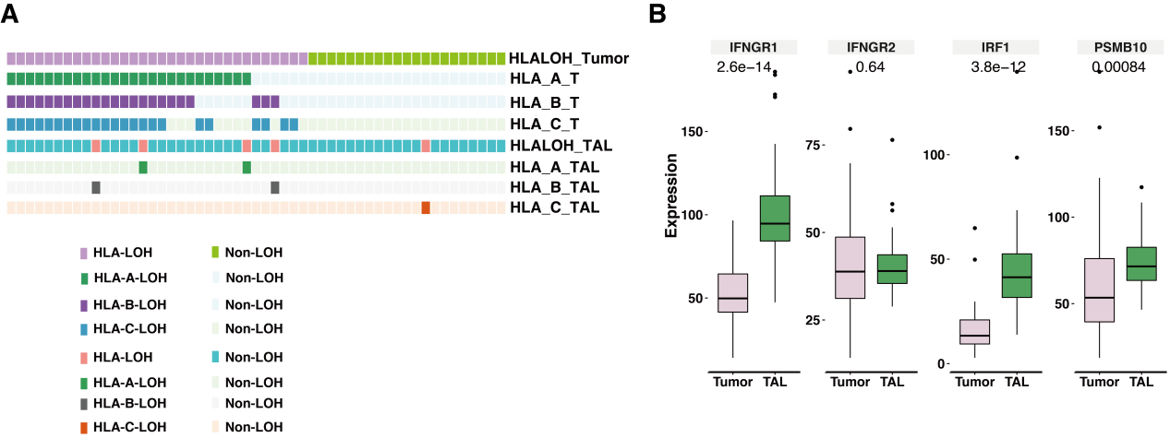

Fig. S6. HLA Loss of heterozygosity (LOH) event and the expression of IFN-γ-related genes in tumors and TALs, respectively. A. LOH in HLA class I genes including HLA-A, HLA-B, HLA-C in tumors and TALs. B. Comparison of IFN-γ-associated genes between tumors and TALs (Wilcoxon test).

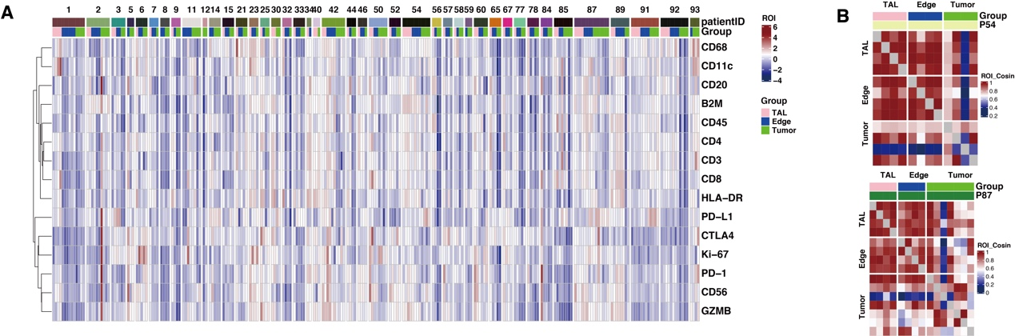
Fig. S7. Immune heterogeneity of DSP ROIs across tumors, tumor edge and TALs. A. ﻿Inter- and intratumor variability of DSP protein expression in tumors, tumor edges and TALs of stage I LUSC. B. Inter-ROI Cosin similarity in two representative patients of P54 and P87.

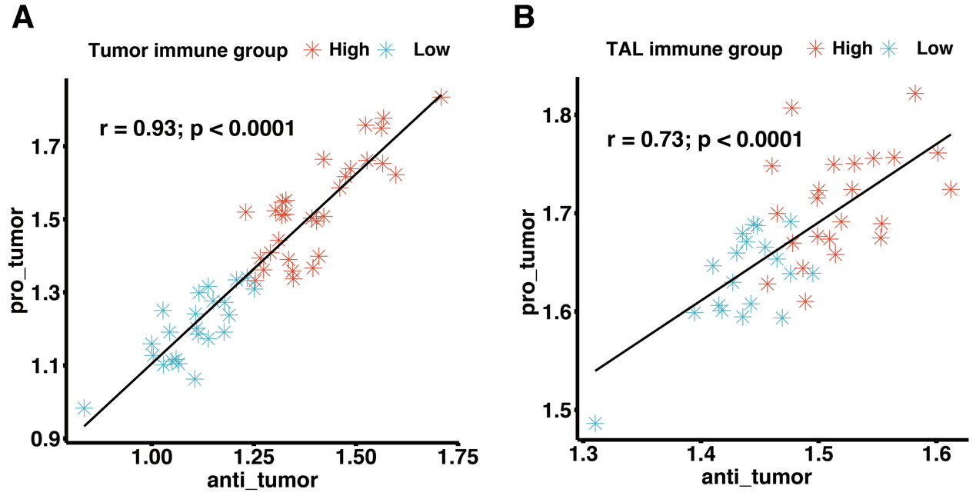
Fig. S8. Correlation between infiltration of cell types executing anti-tumor immunity and cell types executing pro-tumor. A for tumor. B for TALs, the red was high immune group, the green was low immune group.

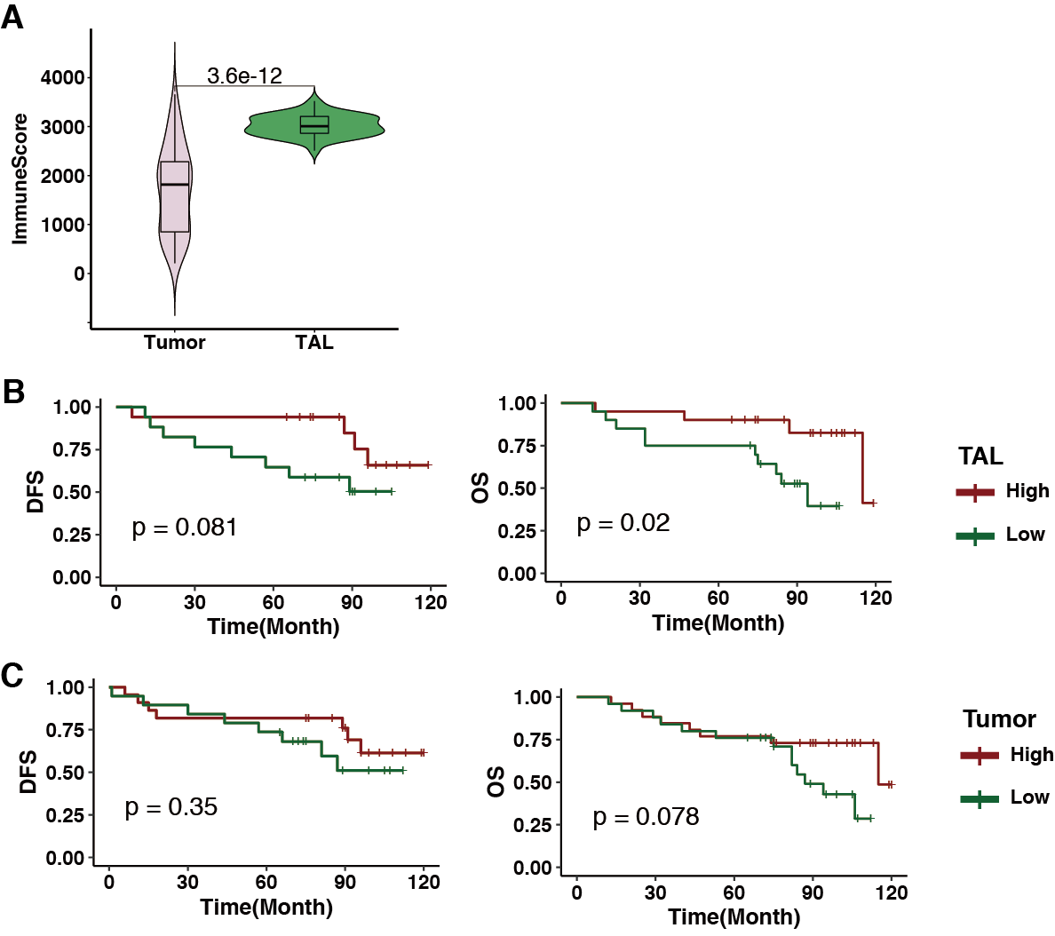

Fig. S9. The immune score evaluated by Estimate was consistent with the result of ssGSEA. A. Higher immune score was shown in TALs. B. Two groups were identified by immune score according to the median of immune score. And higher immune score was associated with more favorable survival in TALs, left for DFS, right for OS. C. There was no significant association between immune score and survival in tumors, left for DFS and right for OS.

