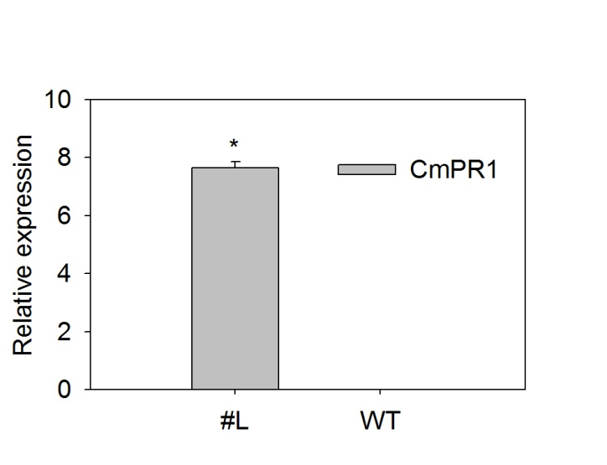
Supplementary Fig. 2 The expression of CmPR1 in tobacco plants under normal growth conditions. #L represents the equally-mixed samples of three independent CmPR1-overexpressed transgenic lines. asterisks denote statistical significance between both materials at p < 0.05.

