Appendix 1

Yodzis and Innes (1992) estimated the ecological scope as 1⁓1.6 for homoeothermic animals, 1⁓3.9 for poikilothermic vertebrates, and 1⁓19.4 for invertebrates. Based on these estimates McCann and Yodzis (1994) criticized the parameterization by Hasting and Powell (1991) setting y₃=5, y₂=2.01⁓6.25 as merely representative of limited conditions where the top predator needed to be an invertebrate and the prey could be from a part of vertebrates. Another line of argument also casted a concern on the parameterization by Hasting and Powell (1991). According to the allometric scaling, the body mass ratio of the predator to the prey, m₃/m₂, is inferred from ${\left({α_{3}}/{α_{2}}\right)}^{4}{\left({x_{2}}/{x_{3}}\right)}^{4}$, in which α_{i} and x_{i} is the allometric coefficient and the metabolic rate of the i-th species, respectively. Since the allometry coefficient for invertebrates is about 2.3 and that for vertebrates are 0.5, the body mass ratio was estimated as ${\left(\frac{0.5}{2.3}\right)}^{4}{\left(\frac{0.4}{0.01}\right)}^{4}≅5.7×{10}^{3}$ for cases where the prey was vertebrate and the predator was invertebrate, ${\left(\frac{0.5}{0.5}\right)}^{4}{\left(\frac{0.4}{0.01}\right)}^{4}≅2.6×{10}^{6}$ for cases where the predator and the prey were both invertebrates if the metabolic rate is 0.4 for the prey and 0.01 for the predator. The former case is ecologically rare, and the latter case must be related to an extremely large body mass ratio because the body mass ratio between adjacent trophic levels is typically within the range between 10 and 10³ (McCann and Yodzis 1994).
In our simulations we postulated vertebrate predator like fish then should set even a lower value for the metabolic rate (the mortality) of the prey, d₃=0.1⁓0.3, whereby fixing the ecological scope for the prey and the predator (equivalent to $\frac{c_{2}}{d_{2}h_{2}}$ and $\frac{c_{3}}{d_{3}h_{3}}$) as 2 and 5. Using these metabolic rate values and the above allometry coefficients for an invertebrate prey and a vertebrate predator, we infer the body mass ratio between the prey and the predator as ranging between 4.5×10⁶ and 3.6×10⁸. These values may be realistic for grazer zooplankton as prey and teleost fish as predator (e.g., Daphnia spp have wet body weight in the order of 1 mg while Crucian carp Carassius carassius weighs more than 1 kilogram, the ratio is about 10⁶) or mysids as prey and sea mammals as predator in aquatic environment while not for herbivorous insects and avian or other small vertebrate predators in terrestrial ecosystems.
Regarding the ratio of allometry coefficients, Brown et al. (2004) stated that the coefficient ratio (α₃⁄α₂) is 0.2227 for invertebrates in all of the basal, intermediate and top species. If we use this value with the above-mentioned metabolic rates, the body mass ratio is estimated to be less constrained values ranging from 2.5×10 to 2.0×10³.
Regarding the ecological scope, $\frac{c_{2}}{d_{2}h_{2}}$, as a constant value implicitly assumes that the mortality or the metabolic rate d₂ and the maximum consumption rate factored by the conversion coefficient c₂/h₂ covary proportionately among species or populations. Although not comprehensively validated for many taxa, this assumption has some biological relevance at least for the typical cladoceran zooplankton, Daphnia species, which are important herbivores in freshwater ecosystems: species which have consumption rates (grazing capacity) higher than other species tend to have higher mortalities due to higher metabolic rates (Gliwicz 1990; Kreutzer and Lampert 1999).

Appendix 2

Table A1. Equilibria and local stabilities of corresponding ecological subsystem defined by specific trait values in the entire eco-evolutionary dynamics
Time  Trait | Equilibria | Eigenvalues | 3-species dynamics  Population size | Adaptive landscape
t = 91000  z = 1.999  a₃=0.0368 | n₁ = 0.200  n₂ = 0.800  n₃ = 0 | 0.10 ± 0.27i  0.0083 | 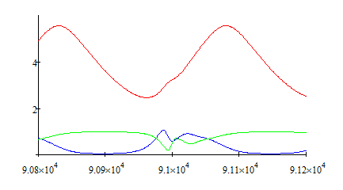  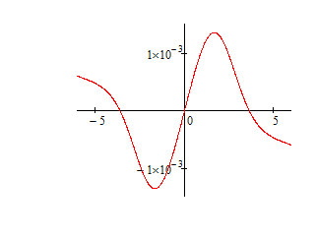 | z  dz/dt
t = 91000  z = 1.999  a₃=0.0368 | n₁ = 0.874  n₂ = 0.339  n₃ = 4.26 | -0.76  0.0077±0.031i |  | z  dz/dt
t = 92000  z = 2.79  a₃=0.0142 | n₁ = 0.200  n₂ = 0.800  n₃ = 0 | 0.10 ± 0.27i  -0.00074 | 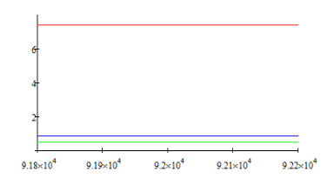 | 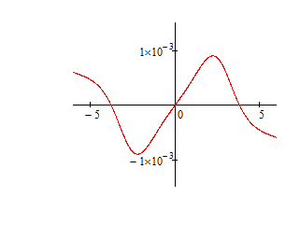
t = 92000  z = 2.79  a₃=0.0142 | n₁ = 0.311  n₂ = 0.880  n₃ = 3.81 | 0.059 ± 0.25i  0.00056
t = 92000  z = 2.79  a₃=0.0142 | n₁ = 0.489  n₂ = 0.880  n₃ = 7.39 | -0.054 ± 0.19i  -0.0021
t = 92500  z = 3.02  a₃=0.0103 | n₁ = 0.200  n₂ = 0.800  n₃ = 0 | 0.10 ± 0.27i  -0.0030 | 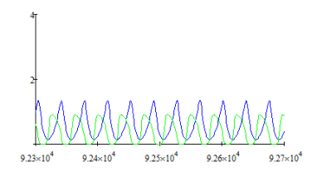 | 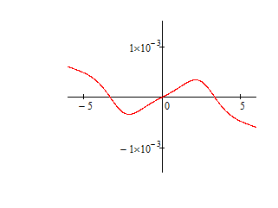
t = 93000  z = 2.982  a₃=0.0108 | n₁ = 0.200  n₂ = 0.800  n₃ = 0 | 0.10 ± 0.27i  -0.0026 | 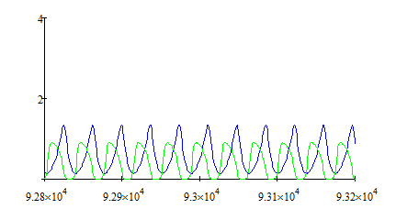 | 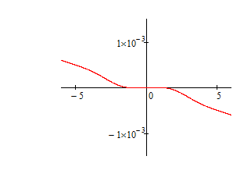
t = 95000  z = 2.458  a₃=0.0221 | n₁ = 0.200  n₂ = 0.800  n₃ = 0 | 0.10 ± 0.27i  0.0031 | 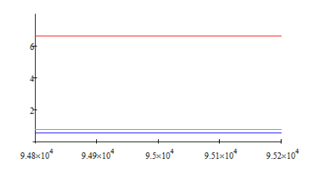  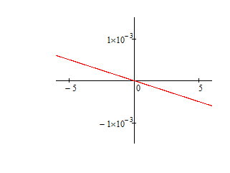
t = 95000  z = 2.458  a₃=0.0221 | n₁ = 0.765  n₂ = 0.566  n₃ = 6.63 | -0.55  -0.0016±0.031i
t = 97000  z = 2.016  a₃=0.0362 | n₁ = 0.200  n₂ = 0.800  n₃ = 0 | 0.10 ± 0.265i  0.00834 | 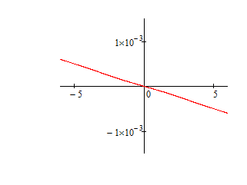  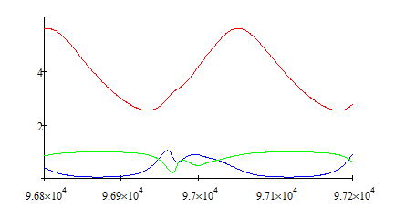
t = 97000  z = 2.016  a₃=0.0362 | n₁ = 0.871  n₂ = 0.345  n₃ = 4.33 | -0.756  0.00753 ± 0.031i
t = 98000  z = 2.015  a₃=0.0362 | n₁ = 0.200  n₂ = 0.800  n₃ = 0 | 0.10 ± 0.265i  0.00835 | 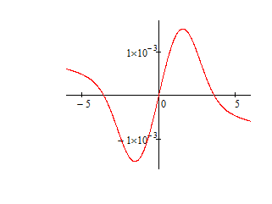  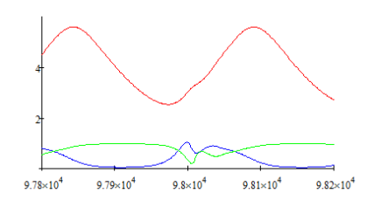
t = 98000  z = 2.015  a₃=0.0362 | n₁ = 871  n₂ = 0.345  n₃ = 4.32 | -0.756  0.00753 ± 0.031i
Adaptive landscape: the potential evolutionary rate, depicted along the trait axis, with selection pressure determined by the ecological subsystem.

