Association between depressive symptoms and all-cause mortality in Chilean adult population: prospective results from the National Health Survey.
Journal of Social psychiatry and psychiatric epidemiology
Authors: Eliazar Luna¹, Hynek Pikhart¹, Anne Peasey¹
¹Department of Epidemiology and Public Health, University College London, 1-19 Torrington Place, London, UK.
Address correspondence to: Eliazar Luna, eliazar.luna.16@ucl.ac.uk, +44 (0) 020 7679 8252

Supplementary material

Supplementary Table 1. Number of deaths by covariate in the analytical sample of the 2003 and 2010 cohort.
 | 2003 ENS  n=3,151 |  | 2010 ENS  n=3,749
Variable | n | % | n | %
Depressive symptoms
Yes | 55 | 10.72 | 52 | 8.48
No | 260 | 9.86 | 266 | 8.48
Sex
Females | 160 | 9.3 | 173 | 7.77
Males | 155 | 10.84 | 145 | 9.53
Age groups
18-44 years | 9 | 0.67 | 13 | 0.75
45-64 years | 47 | 4.59 | 72 | 5.62
65+ years | 259 | 33.08 | 233 | 32.14
Marital Status
No Partner | 31 | 4.1 | 36 | 4.32
Widowed/Divorced | 135 | 25.52 | 134 | 18.82
With Partner | 149 | 7.98 | 148 | 6.72
Working Status
Employed+Student | 32 | 2.29 | 63 | 3.08
Homemaker | 83 | 8.88 | 46 | 5.04
Retired | 153 | 35.33 | 176 | 30.45
Unemployed | 47 | 12.14 | 33 | 15.49
Years of Education
12+ | 8 | 2.06 | 22 | 2.98
8-12 | 49 | 4.28 | 98 | 4.87
Less than 8 | 258 | 15.95 | 198 | 19.82
Cntd. Supplementary Table 1. Mortality by covariate in the analytical sample of the 2003 and 2010 cohort.
Variable | 2003 ENS  N=3,151 |  | 2010 ENS  N=3,749
Variable | N | % | N | %
Physical activity
3+ times weekly | 8 | 3.05 | 5 | 1.82
1-2 times weekly | 14 | 4.59 | 2 | 0.71
<4 times monthly | 3 | 2.29 | 6 | 3.49
No sport | 290 | 11.82 | 305 | 10.09
Smoking
No | 271 | 13.21 | 260 | 10.86
Yes | 44 | 4 | 58 | 4.28
High Blood Pressure
Yes | 190 | 17.54 | 199 | 18.86
No | 125 | 6.04 | 119 | 4.42
Diabetes
Yes | 84 | 26.33 | 78 | 21.85
No | 231 | 8.16 | 240 | 7.08

Supplementary Figure 1. Kaplan Meier plots of the bivariate association between covariates and mortality by ENS.
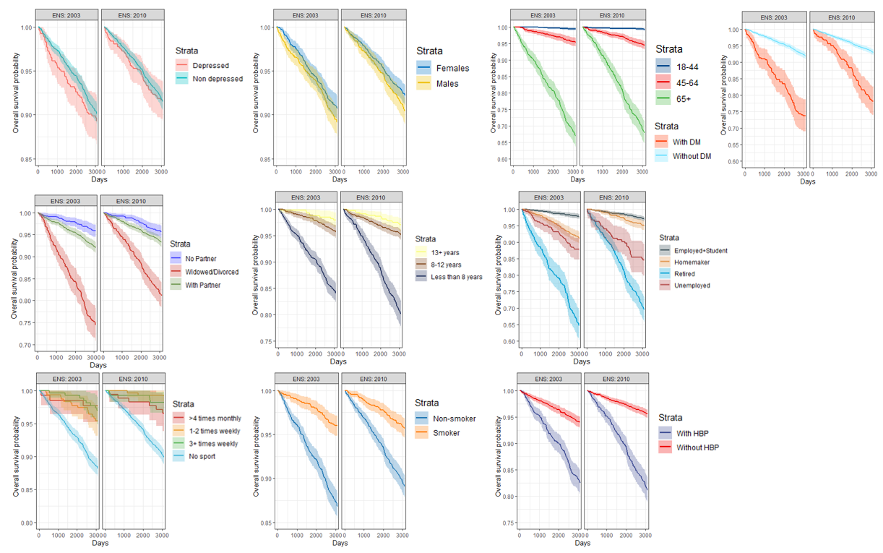

Supplementary Table 2. Fully adjusted Cox model of the association between depressive symptoms and mortality in the Chilean population using an 8.5-year follow-up.
Characteristic | 2003 Cohort  n=3,151 |  |  | 2010 Cohort  n=3,749
Characteristic | HR | 95% CI | P-value | HR | 95% CI | P-value
Depressive Symptoms
(CIDI-SF≥5)
Non depressed | 1 |  |  | 1
Depressed | 1.38 | 1.02, 1.86 | 0.038 | 1.38 | 1.02, 1.88 | 0.039
Sex
Females | 1 |  |  | 1
Males | 1.53 | 1.12, 2.08 | 0.007 | 1.49 | 1.16, 1.92 | 0.002
Age groups
18-44 years | 1 |  |  | 1
45-64 years | 5.27 | 2.52, 11.0 | <0.001 | 5.66 | 3.07, 10.4 | <0.001
65+ years | 25.4 | 12.1, 53.1 | <0.001 | 24.8 | 13.0, 47.4 | <0.001
Marital Status
No Partner | 1 |  |  | 1
Widowed/Divorced | 1.21 | 0.81, 1.82 | 0.4 | 1.13 | 0.77, 1.66 | 0.5
With Partner | 0.78 | 0.52, 1.17 | 0.2 | 0.86 | 0.59, 1.25 | 0.4
Years of Education
12+ | 1 |  |  | 1
8-12 | 1.33 | 0.63, 2.85 | 0.5 | 1.14 | 0.71, 1.81 | 0.6
Less than 8 | 1.64 | 0.80, 3.40 | 0.2 | 1.45 | 0.91, 2.29 | 0.12

Cntd. Supplementary Table 2. Fully adjusted Cox model of the association between depressive symptoms and mortality in the Chilean population using an 8.5-year follow-up.
Characteristic | 2003 Cohort  n=3,151 |  |  | 2010 Cohort  n=3,749
Characteristic | HR 95% CI P-value |  |  | HR 95% CI P-value
Working Status
Employed + Student | 1 |  |  | 1
Homemaker | 1.80 | 1.12, 2.90 | 0.016 | 1.07 | 0.70, 1.63 | 0.8
Retired | 2.89 | 1.89, 4.41 | <0.001 | 1.72 | 1.22, 2.44 | 0.002
Unemployed | 2.33 | 1.45, 3.74 | <0.001 | 4.09 | 2.63, 6.36 | <0.001
Physical activity
3+ times weekly | 1 |  |  | 1
1-2 times weekly | 1.47 | 0.61, 3.52 | 0.4 | 0.61 | 0.12, 3.15 | 0.6
>4 times monthly | 0.96 | 0.25, 3.65 | >0.9 | 3.11 | 0.94, 10.3 | 0.062
No sport | 1.85 | 0.91, 3.75 | 0.089 | 3.09 | 1.27, 7.53 | 0.013
Smoking
Non-smoker | 1 |  |  | 1
Smoker | 1.00 | 0.71, 1.41 | >0.9 | 1.07 | 0.79, 1.44 | 0.7
High Blood Pressure
Yes | 1 |  |  | 1
No | 1.04 | 0.82, 1.33 | 0.7 | 0.82 | 0.64, 1.04 | 0.11
Diabetes
Yes | 1 |  |  | 1
No | 0.57 | 0.44, 0.74 | <0.001 | 0.69 | 0.53, 0.90 | 0.006

Supplementary Table 3. Sensitivity analyses comparing the assessment between depressive symptoms and mortality adjusted by age and sex, excluding those who died in first 6 months of follow-up by cohort.

Variable | 2003 Cohort  n=3,355 |  |  | 2003 Cohort  with exclusions  n= 3,341 |  |  | 2010 Cohort  n= 4425 |  |  | 2010 Cohort  with exclusions  n= 4404
Variable | HR | 95% CI | P-value | HR | 95% CI | P-value | HR | 95% CI | P-value | HR | 95% CI | P-value
Depressive symptoms
(CIDI-SF≥5)
Non-depressed | 1 |  |  | 1 |  |  | 1 |  |  | 1
Depressed | 1.49 | 1.12, 1.98 | 0.007 | 1.42 | 1.05, 1.90 | 0.021 | 1.50 | 1.14, 1.98 | 0.004 | 1.38 | 1.03, 1.85 | 0.029
Sex
Males | 1 |  |  | 1 |  |  | 1 |  |  | 1
Females | 0.68 | 0.55, 0.84 | <0.001 | 0.72 | 0.57, 0.89 | 0.003 | 0.72 | 0.59, 0.89 | 0.002 | 0.74 | 0.60, 0.91 | 0.005
Age groups
18-44 years | 1 |  |  | 1 |  |  | 1 |  |  | 1
45-64 years | 6.37 | 3.32, 12.2 | <0.001 | 6.34 | 3.31, 12.2 | <0.001 | 7.78 | 4.49, 13.5 | <0.001 | 7.33 | 4.22, 12.7 | <0.001
65+ years | 55.7 | 30.5, 102 | <0.001 | 52.9 | 28.9, 96.7 | <0.001 | 55.4 | 32.9, 93.1 | <0.001 | 52.5 | 31.2, 88.3 | <0.001

