Supplementary Information
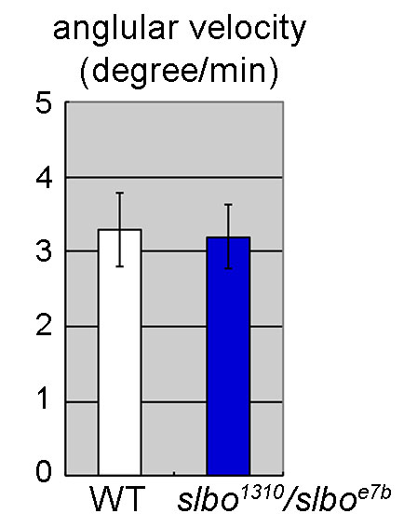
Fig. S1
The angular velocity of wild-type (WT) and slbo¹³¹⁰/slbo^{e7b} border cells. Angular velocities were comparable in these conditions. n=10, N=5. Error bars indicate SEM.

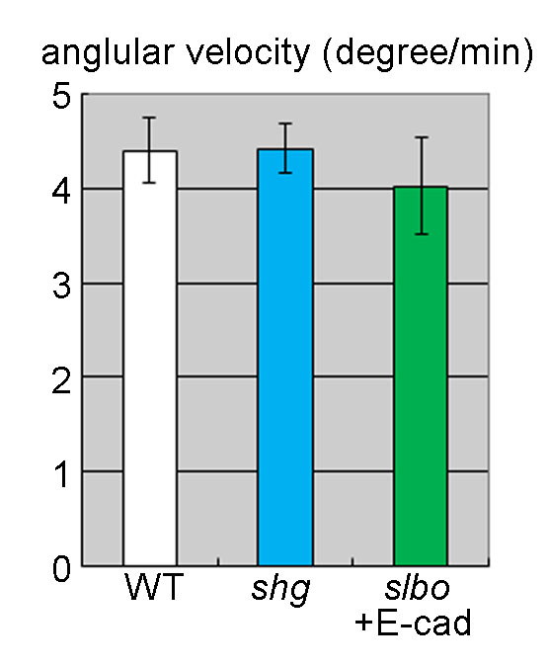
Fig. S2
Angular velocity for the following border cells: wild-type (WT), shg-mutant (shg), and slbo-mutant with E-cad expression (slbo+E-cad). Angular velocities were comparable in these conditions. 10≦n≦26, 5≦N≦13. Error bars indicate SEM.

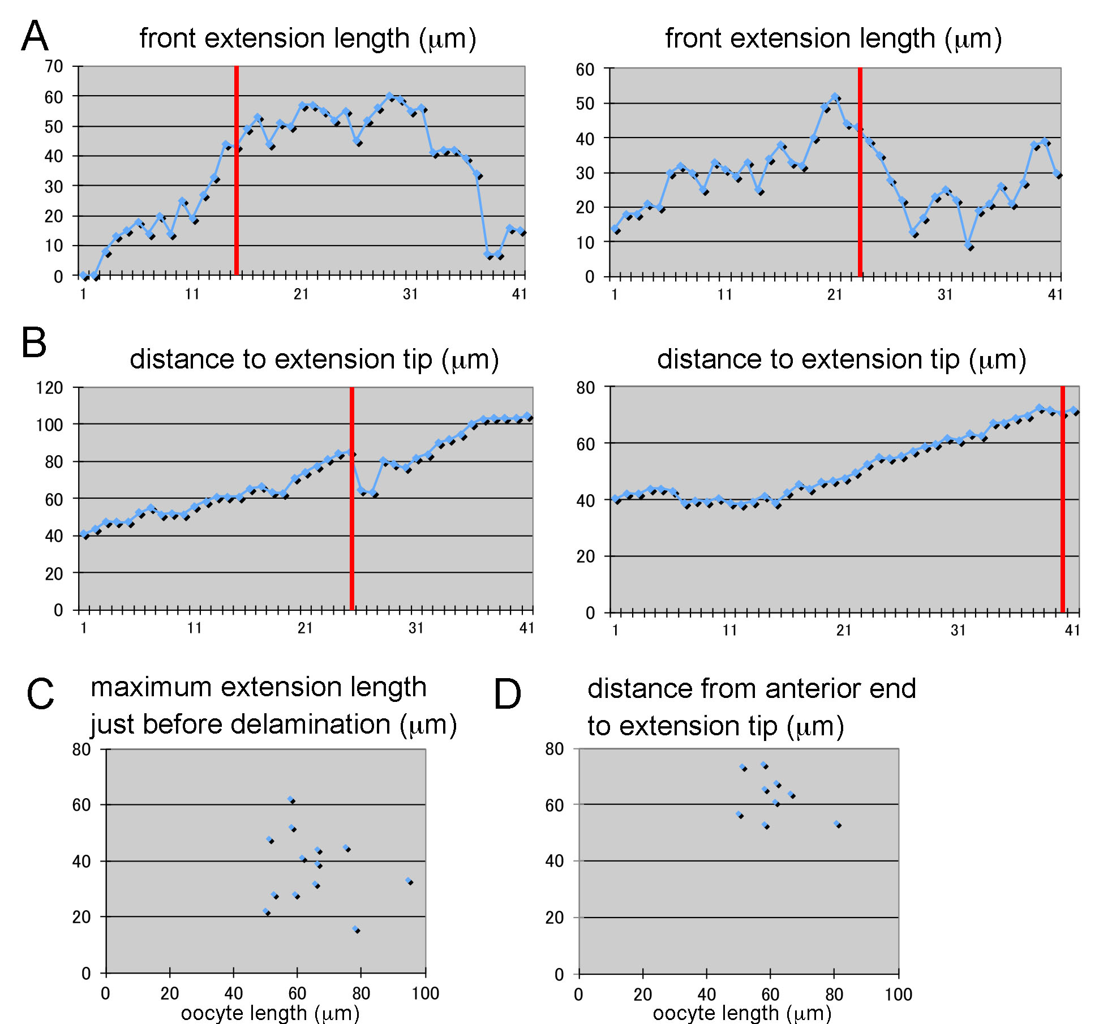
Fig. S3
(A,B) Examples of changes in front extension length (A) and in cluster reach (the distance between the anterior end of the egg-chamber and the extension tip) (B) during delamination. X axis: time frame. Red lines: delamination point. Front extension length varied quite a bit, while cluster reach tended to increase over time. The maximum extension length did not correlate with the delamination point. (C,D) The maximum extension length (C) and the cluster reach (D) just before delamination. Length varied more than reach.

Movies

Movie 1
Delaminating wild-type Drosophila border cells form a cluster of jiggling cells. The cluster extends a protrusion in the direction of future migration, and the tip finds an attachment point. The cell cluster detaches from the epithelial layer and follows the protrusion as it contracts. Elapsed time (minutes) shows at lower right.

Movie 2
JAK/STAT-inhibited follicle cells failed to differentiate into border cells, move into clusters, or extend protrusions in the period corresponding to wild-type delamination. JAK/STAT signaling was inhibited with DOME lacking a cytoplasmic domain. Elapsed time shows at the lower right.

Movie 3
slbo-mutant border cells formed clusters and moved within the clusters, but did not form protrusions or delaminate during the period when wild-type cells would delaminate. Elapsed time shows at the lower right.

Movie 4
slbo-mutant border cells formed clusters but lost motility when treated with CytochalasinD, which inhibits actin polymerization, and failed to delaminate during the period of wild-type delamination period. Elapsed time shows at the lower right.

Movie 5
shg-mutant border cells formed clusters of motile cells and sent out short extensions, but did not delaminate during the wild-type delamination period. Elapsed time shows at the lower right.

Movie 6
slbo-mutant border cells with E-cad expression formed front extensions but did not delaminate during the wild-type delamination period. Elapsed time shows at the lower right.

Movie 7
Guidance-deficient border cells had normal motion but formed front extensions that were shorter and less persistent than wild-type extensions.

Movie 8
Guidance-deficient border cells delaminated successfully. Elapsed time shows at the lower right.

Movie 9
E-cad expression did rescued invasive extensions in JAK/STAT-inhibited border cells did not rescue cell movement. Elapsed time shows at the lower right.

Movie 10
Slbo overexpression induced front extensions in JAK/STAT-inhibited follicle-like cells, but the cells failed to delaminate. Elapsed time shows at the lower right.

