Appendix A:
Appendix Fig A1. Pay-it-forward model overview

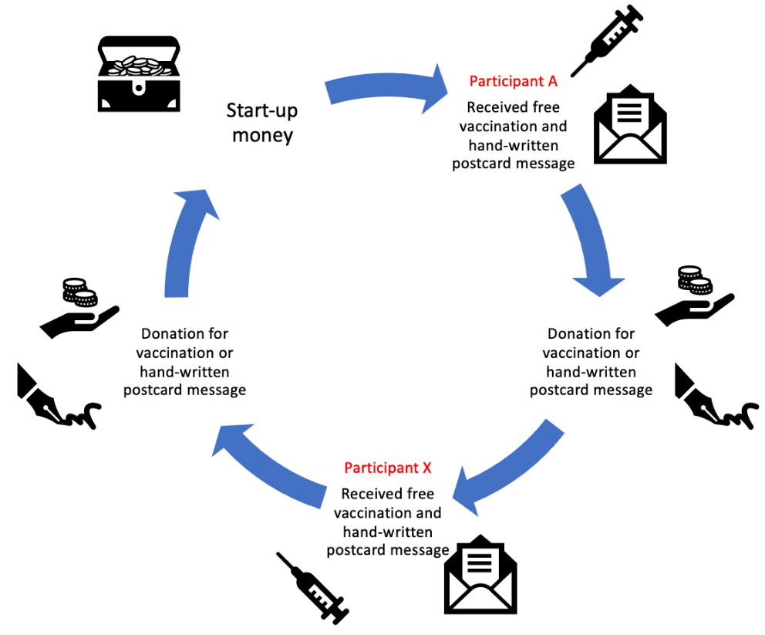
Appendix Fig A2: Quasi-experimental study flow chart of the three arms
in each site
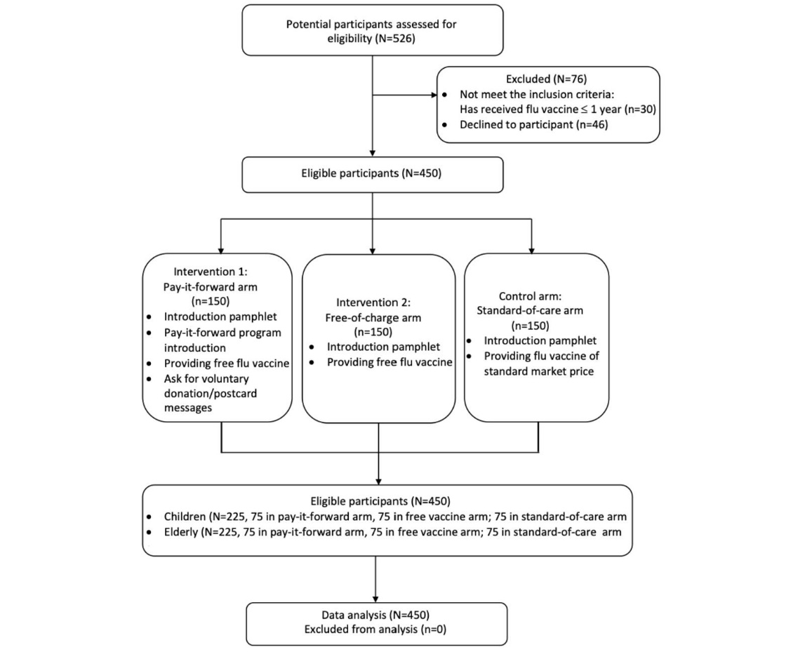

Appendix A3: Detailed treatments of participants in the three original arm:
1) Standard of care arm (i.e., control group): Participants in this study arm were exposed to the typical standard of care for that clinic. They were provided with a brief introduction to the influenza vaccine using a pamphlet (Appendix B2) and then asked if they were willing to pay out of pocket at the standard market price patient prices CN¥55-153) of an influenza vaccine.
2) Pay-it-forward arm: participants recruited in pay-it-forward group where the same introductory pamphlet was provided. Project staff also explained the pay-it-forward program with the PIF pamphlet (Appendix B3), including the purpose, the opportunity to receive one dose of influenza vaccination for free, and the decisions to vaccinate and donate money. Participants were told that the patient prices of an influenza vaccine including administration fees for children were CN¥65 and for adults ranged from CN¥82-153 respectively (the vaccines used in different sites are different, affected by the local availability), while former families had donated money to cover the costs and also created handwritten postcards. If they decided to accept a vaccination, they were then asked whether they were willing to donate any amount of money to support more future participants to receive the same vaccination service, they were also invited to write anonymous postcard messages for future users. It is assured that the donation was completely voluntary, and any donation amount was acceptable.
3) Free-of-charge arm: participants in the free-of-charge condition were invited using the same pamphlet and were provided with free influenza vaccination, but they did not receive any community created messages about the pay-it-forward program.

Appendix B: Supplementary marterials used in primary study

Appendix B1: Online questionnaire example
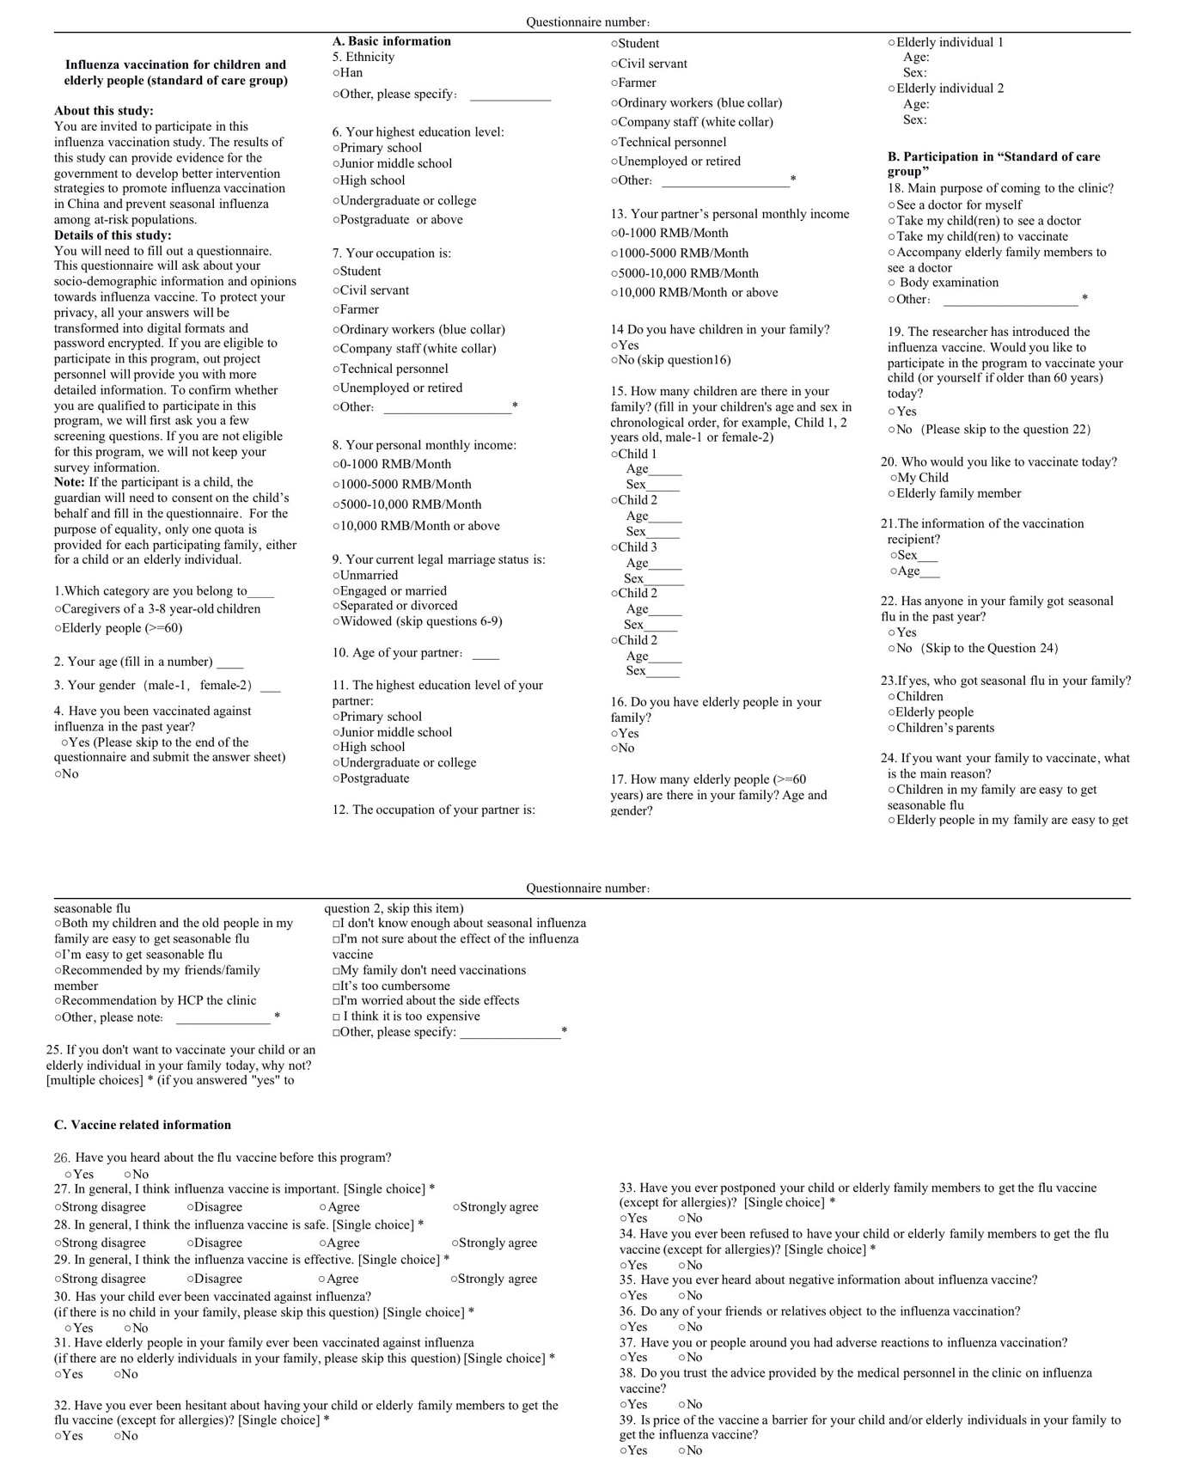

Appendix B2: Influenza and influenza vaccine introduction pamphlet

in English
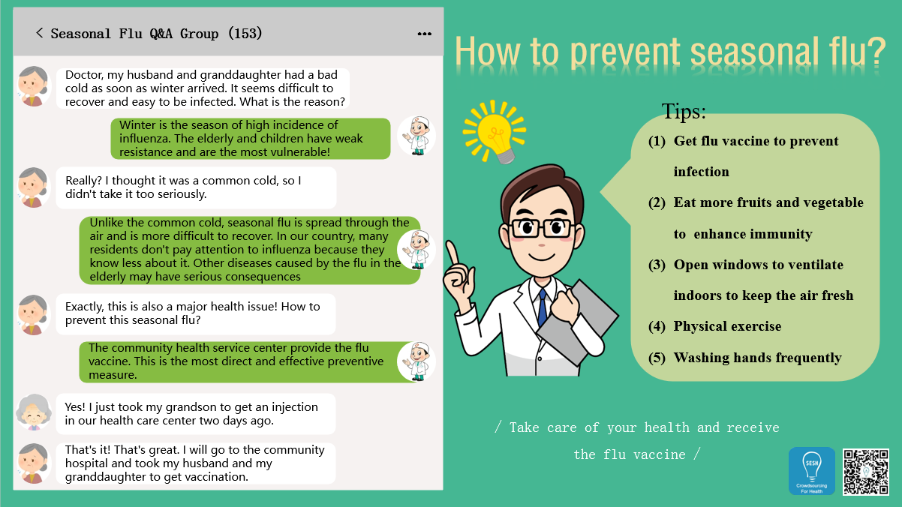

Appendix B3: Pay-it-forward project introduction pamphlet in English
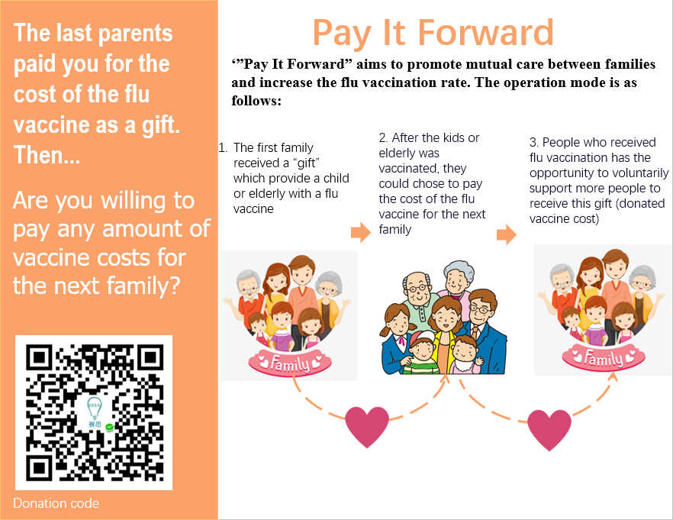

Appendix C: Supplementary results

Figure C1. Influenza vaccine uptake rates in self-paid and subsidized groups by participant types in Guangdong Province, China, 2020-2021 (N=450)

Appendix Table C2. Missing value of different intervention arms in Guangdong Province, China, 2020-2021 (N=450)

Characteristics | No. of missing values* (%)
Characteristics | Total  (N=450) | Standard-of-care group  (N=150) | Pay-it-forward  group  (N=150) | Free-of-charge  group  (N=150)
Sociodemographic factors
Participant type | 0 | 0 | 0 | 0
Age (years) | 0 | 0 | 0 | 0
Sex | 0 | 0 | 0 | 0
Ethnicity | 0 | 0 | 0 | 0
Completed highest education level | 0 | 0 | 0 | 0
Occupation | 0 | 0 | 0 | 0
Marital status | 0 | 0 | 0 | 0
Belief factors
I think influenza vaccine is important | 15 (3.0%) | 2 (1.3%) | 6 (4.0%) | 7 (4.7%)
I think the influenza vaccine is safe | 15 (3.0%) | 9 (6.0%) | 6 (4.0%) | 0 (0.0%)
I think the influenza vaccine is effective | 15 (3.0%) | 9 (6.0%) | 6 (4.0%) | 0 (0.0%)
Trust the advice from medical personnel on influenza vaccine | 0 | 0 | 0 | 0
View the price of vaccines as barriers | 0 | 0 | 0 | 0
Enabling factors
Annual income  (USD) | 0 | 0 | 0 | 0
Community resources | 0 | 0 | 0 | 0
Needs factors
Experienced influenza-like illnesses among family members in the past year | 0 | 0 | 0 | 0
Adverse reactions to influenza vaccination of family members | 0 | 0 | 0 | 0
Behaviour factors
Influenza vaccine history of children in the family | 45 (10.0%) | 27 (18.0%) | 9 (6.0%) | 9 (6.0%)
Influenza vaccine history of older adults in the family | 30 (6.7%) | 15 (10.0%) | 4 (2.7%) | 11 (7.3%)
External environmental factors
Have ever heard about negative information about influenza vaccine | 0 | 0 | 0 | 0
Have friends/relatives object to the influenza vaccination | 0 | 0 | 0 | 0
* Missing values indicates the missing data caused by the participants who did not answer the question

Appendix Table C3. Descriptive analysis of sociodemographic characteristics
within the subsidized arm in Guangdong Province,
China, 2020-2021 (N=300)

Sociodemographic factors | Total of subsidized group  (N=300)  (%) | Subsidized group |  | P value*
Sociodemographic factors | Total of subsidized group  (N=300)  (%) | Pay-it-forward  arm  (N=150) | Free-of-charge  arm  (N=150) | P value*
Participant type
Children’s caregiver | 150 (50.0%) | 75 (50.0%) | 75 (50.0%) | 1.000
Older adults | 150 (50.0%) | 75 (50.0%) | 75 (50.0%) | 1.000
Age, Mean (SD) | 52 (17.7) | 52 (17.1) | 53 (17.6) | 0.717
Sex
Male | 83 (27.7%) | 43 (28.7%) | 40 (26.7%) | 0.699
Female | 217 (72.3%) | 107 (71.3%) | 110 (73.3%) | 0.699
Completed highest education level
Primary school | 63 (21.0%) | 30 (20.0%) | 33 (22.0%) | 0.809
Middle school | 138 (46.0%) | 68 (45.3%) | 70 (46.7%) | 0.809
Undergraduate or above | 132 (29.3%) | 52 (34.7%) | 47 (31.3%) | 0.809
Occupation
Unemployed/retired | 234 (52.0%) | 79 (52.7%) | 82 (54.7%) | 0.814
Peasant | 54 (12.0%) | 16 (10.7%) | 18 (12.0%) | 0.814
Employed | 99 (33.0%) | 55 (36.7%) | 50 (33.3%) | 0.814
Marital status
Single | 37 (12.3%) | 24 (16.0%) | 13 (8.7%) | 0.053
Married or living with a partner | 263 (87.7%) | 126 (84.0%) | 137 (91.3%) | 0.053
*P-value from chi-square test for comparison of proportion and t test for comparison of mean.

Appendix Table C4. Univariate analysis of associated factors for influenza vaccine uptake in pay-it-forward and free-of-charge arm in Guangdong Province,
China, 2020-2021 (N=300)

 | Pay-it-forward arm (N=150) |  | Free-of-charge arm (N=150) |  | P-value of  Heterogeneity of OR†
Explanatory variables | Crude OR  (95% CI) | P-value of LRT* | Crude OR (95% CI) | P-value of LRT* | P-value of  Heterogeneity of OR†
Sociodemographic factors
Participant type
Children’s care giver | Ref. | <0.0001 | Ref. | 0.009 | 0.398
Older adults | 0.20 (0.09,0.47) | <0.0001 | 0.34 (0.15, 0.76) | 0.009 | 0.398
Age | 0.97 (0.94, 0.99) | 0.003 | 0.96 (0.94, 0.98) | <0.0001 | 0.908
Sex
male | Ref. | 0.371 | Ref. | 0.600 | 0.288
female | 0.68 (0.29, 1.59) | 0.371 | 1.29 (0.57, 2.94) | 0.600 | 0.288
Education
primary school | Ref. | 0.007 | Ref. | 0.106 | 0.834
middle school | 0.40 (0.15, 1.12) | 0.007 | 2.76 (1.08, 7.09) | 0.106 | 0.834
Undergraduate/above | 1.61 (0.49, 5.32) | 0.007 | 6.67 (0.63, 4.38) | 0.106 | 0.834
Occupation
Unemployed/retired | Ref. | 0.037 | Ref. | 0.052  (Fisher) | 0.843
peasant | 1.56 (0.46, 5.29) | 0.037 | 3.71(0.79,17.36) | 0.052  (Fisher) | 0.843
employed | 3.05 (1.26, 7.37) | 0.037 | 2.43 (1.00, 5.92) | 0.052  (Fisher) | 0.843
Marital status
Single | Ref. | 0.190 | Ref. | 0.381 | 0.226
Married or living with a partner | 0.52 (0.17, 1.63) | 0.190 | 1.46 (0.42, 5.05) | 0.381 | 0.226
Belief factors
I think influenza vaccine is important
Disagree | Ref. | 0.969 | Ref. | 0.548 | 0.632
Agree | 1.02 (0.41, 2.53) | 0.969 | 0.72 (0.25, 2.09) | 0.548 | 0.632
I think the influenza vaccine is safe
Disagree | Ref. | <0.0001 | Ref. | 0.031 | 0.108
Agree | 8.33(3.20, 21.67) | <0.0001 | 2.82 (1.24, 6.40) | 0.031 | 0.108
I think the influenza vaccine is effective
Disagree | Ref. | <0.0001 | Ref. | <0.0001 | 0.446
Agree | 10.92(3.95,30.22) | <0.0001 | 6.26(2.75,14.21) | <0.0001 | 0.446
Trust the advice from medical personnel on influenza vaccine
No | Ref. | <0.0001 | Ref. | 0.001 | 0.270
Yes | 12.17(4.30,34.48) | <0.0001 | 5.13(1.92,13.72) | 0.001 | 0.270
View the price of vaccines as barriers
No | Ref. | 0.978 | Ref. | 0.184 | 0.325
Yes | 1.01 (0.41, 2.50) | 0.978 | 2.02 (0.72, 5.69) | 0.184 | 0.325
Enabling factors
Annual income
(USD)
<1860 | Ref. | 0.079 | Ref. | 0.781 | 0.649
1860~9300 | 0.66 (0.29, 1.55) | 0.079 | 1.29 (0.53, 3.12) | 0.781 | 0.649
9300~1,8600 | 0.92 (0.24, 1.99) | 0.079 | 1.63 (0.51, 5.22) | 0.781 | 0.649
≥1,8600 | - | 0.079 | 0.89 (0.26, 3.03) | 0.781 | 0.649
Community resources
Yangshan (rural) | Ref. | 0.003 | Ref. | 0.021 | 0.058
Zengcheng (suburban) | 1.15 (0.41, 3.18) | 0.003 | 0.31 (0.12, 0.80) | 0.021 | 0.058
Tianhe (urban) | 0.28 (0.11, 0.70) | 0.003 | 0.86 (0.31, 2.46) | 0.021 | 0.058
Needs factors
Experienced influenza-like illnesses among family members in the past year
No | Ref. | 0.416 | Ref. | § | 0.081
Yes | 2.17 (0.25,18.63) | 0.416 | § | § | 0.081
Adverse reactions to influenza vaccination of family members
No | Ref. | 0.111 | Ref. | 0.446 | 0.311
Yes | 0.22 (0.04, 1.37) | 0.111 | 0.72 (0.18, 2.94) | 0.446 | 0.311
Behavior factors
Influenza vaccine history of children in the family
No | Ref. | 0.059 | Ref. | 0.729 | 0.111
Yes | 2.15 (0.97, 4.78) | 0.059 | 0.87 (0.40, 1.89) | 0.729 | 0.111
Influenza vaccine history of older adults in the family
No | Ref. | 0.081 | Ref. | 0.236 | 0.988
Yes | 2.30 (0.82, 6.46) | 0.081 | 2.26(0.48,10.57) | 0.236 | 0.988
External context factors
Have ever heard about negative information about influenza vaccine
No | Ref. | 0.887 | Ref. | 0.259 | 0.493
Yes | 0.94 (0.42, 2.13) | 0.887 | 0.63 (0.28, 1.40) | 0.259 | 0.493
Have friends/relatives object to the influenza vaccination
No | Ref. | 0.213 | Ref. | 0.195 | 0.088
Yes | 3.35 (0.41, 27.36) | 0.213 | 0.44 (0.12, 1.67) | 0.195 | 0.088
*P-value of Likelihood ratio test in logistic regression
† P-value of odds ratio heterogeneity in Mantel-Haenszel analysis
§Values removed by logistic model in Stata for too few observations in subgroups

Appendix Table C5. Collinearity diagnosis of self-paid group in Guangdong Province,
China, 2020-2021 (N=150)

Explanatory variables* | VIF | SQRT  VIF | Tolerance | R-Squared
Sociodemographic factors
Age | 5.83 | 2.41 | 0.17 | 0.83
Participants type | 5.64 | 2.37 | 0.18 | 0.82
Sex | 1.11 | 1.05 | 0.90 | 0.10
Belief factors
I think the influenza vaccine is safe | 1.26 | 1.12 | 0.79 | 0.21
I think the influenza vaccine is effective | 1.41 | 1.19 | 0.71 | 0.29
View the price of vaccines as barriers | 1.18 | 1.09 | 0.85 | 0.15
Trust the advice from medical personnel on influenza vaccine | 1.24 | 1.11 | 0.81 | 0.19
Behaviour factors
Influenza vaccine history of children in the family | 1.18 | 1.08 | 0.85 | 0.15
Influenza vaccine history of older adults in the family | 1.11 | 1.06 | 0.90 | 0.10
*Explanatory variables selected for collinearity diagnosis were those variables with significant criteria<0.2 after the adjustment of prior confounder

Appendix Table C6. Collinearity diagnosis of subsidized group in Guangdong Province,
China, 2020-2021 (N=300)

Explanatory variables* | VIF | SQRT  VIF | Tolerance | R-Squared
Sociodemographic factors
Age | 6.63 | 2.57 | 0.15 | 0.84
Participants type | 6.05 | 2.46 | 0.17 | 0.83
Sex | 1.11 | 1.05 | 0.90 | 0.10
Occupation | 1.85 | 1.36 | 0.54 | 0.46
Marital status | 1.19 | 1.09 | 0.84 | 0.16
Belief factors
I think the influenza vaccine is safe | 1.35 | 1.16 | 0.74 | 0.26
I think the influenza vaccine is effective | 1.47 | 1.21 | 0.68 | 0.32
Trust the advice from medical personnel on influenza vaccine | 1.14 | 1.07 | 0.88 | 0.12
View the price of vaccines as barriers | 1.12 | 1.06 | 0.89 | 0.11
Enabling factors
Community resources | 1.11 | 1.06 | 0.90 | 0.10
Needs factors
Experienced influenza-like illnesses among family members in the past year | 1.03 | 1.02 | 0.97 | 0.03
Adverse reactions to influenza vaccination of family members | 1.04 | 1.02 | 0.96 | 0.04
Behaviour factors
Influenza vaccine history of children in the family | 1.10 | 1.05 | 0.91 | 0.09
Influenza vaccine history of older adults in the family | 1.13 | 1.06 | 0.89 | 0.11
*Explanatory variables selected for collinearity diagnosis were those variables with significant criteria<0.2 after the adjustment of prior confounder

