Table 1. Chemical structures of Benzoxazole derivatives used in QSAR studies
Sr. No. | Structure | Sr. No. | Structure
1 | 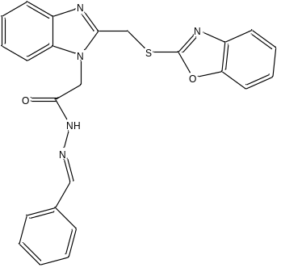 | 2 | 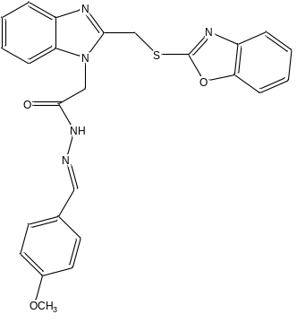
3 | 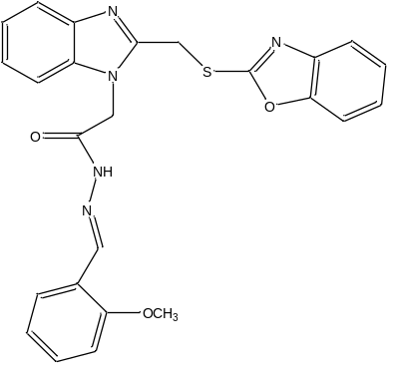 | 4 | 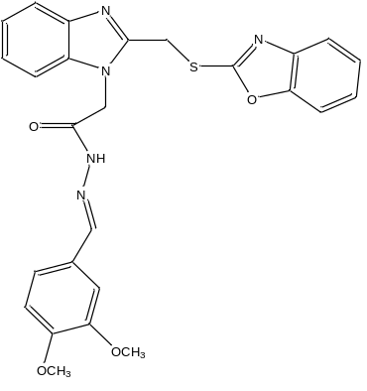
5 | 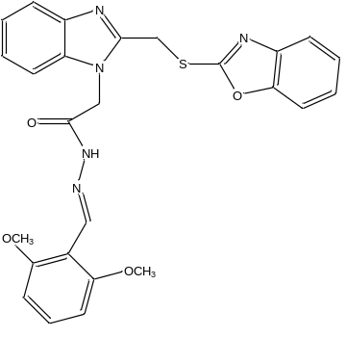 | 6 | 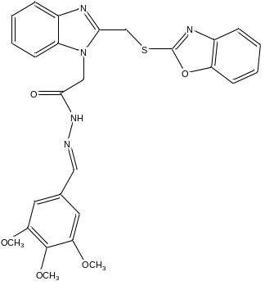
7 | 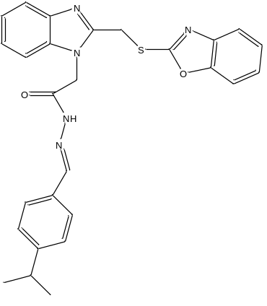 | 8 | 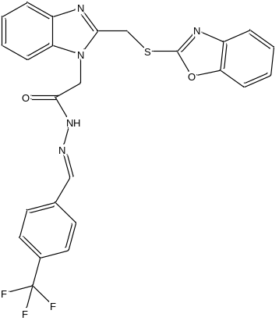
9 | 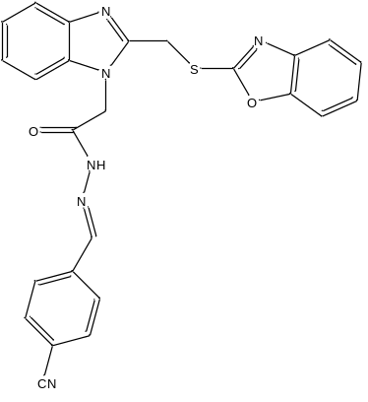 | 10 | 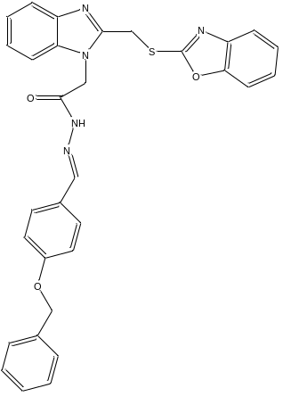
11 | 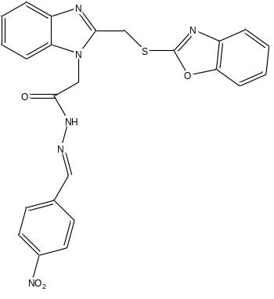 | 12 | 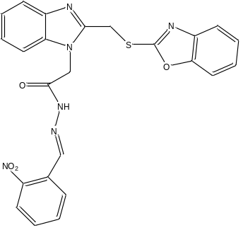
13 | 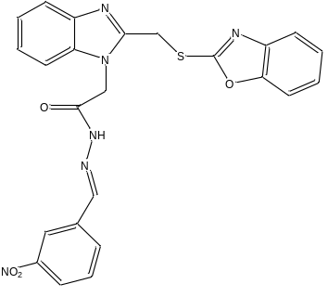 | 14 | 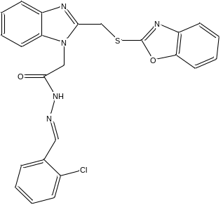
15 | 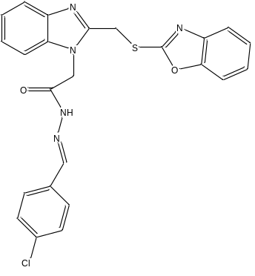 | 16 | 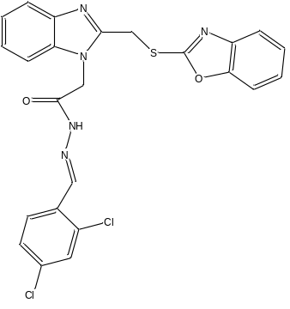
17 | 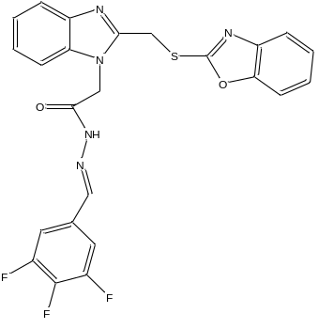 | 18 | 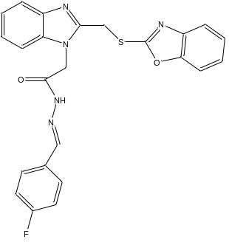
19 | 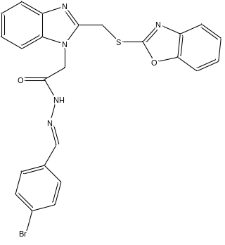 | 20 | 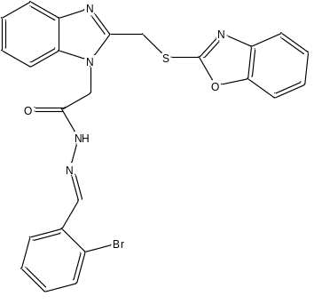
21 | 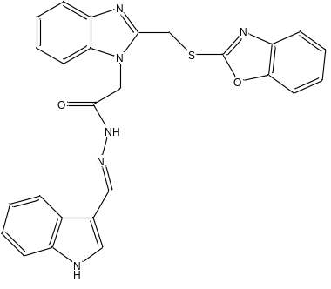 | 22 | 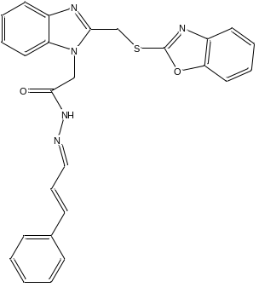
23 | 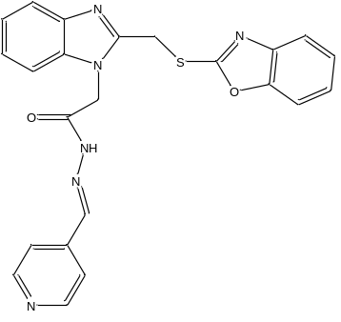 | 24 | 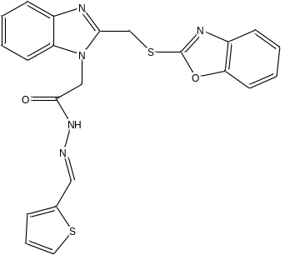
25 | 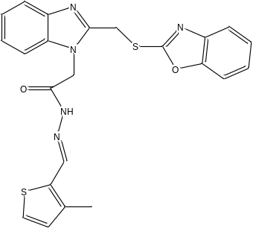 | 26 | 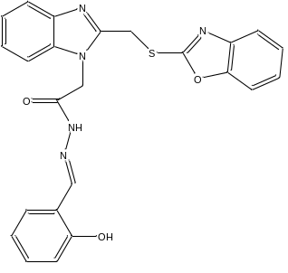
27 | 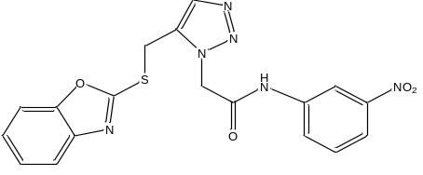 | 28 | 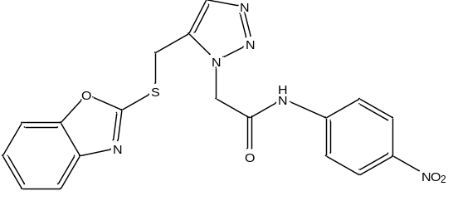
29 | 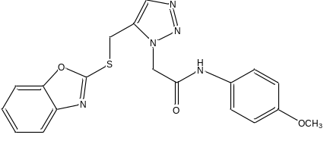 | 30 | 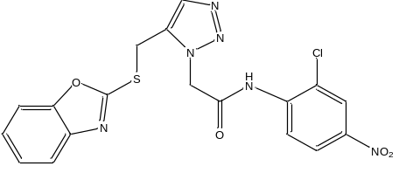
31 | 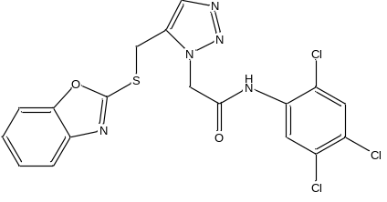 | 32 | 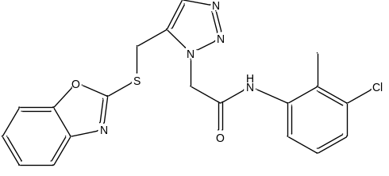
33 | 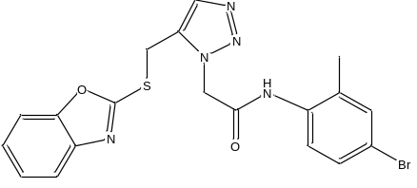 | 34 | 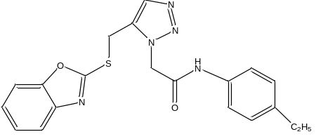
35 | 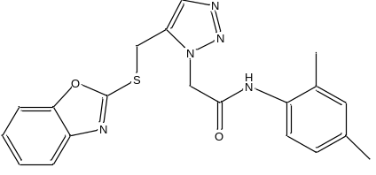 | 36 | 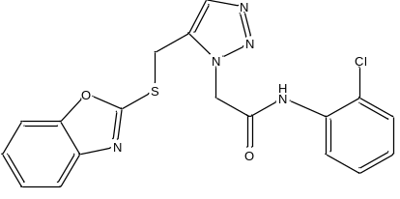
37 | 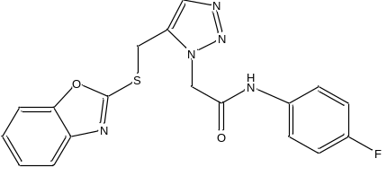 | 38 | 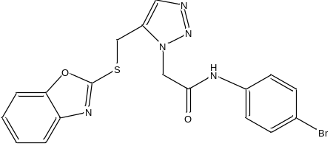
39 | 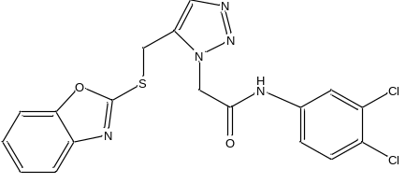 | 40 | 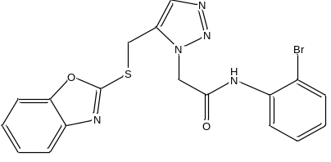
41 | 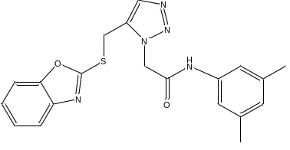 | 42 | 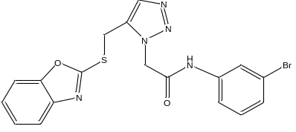
43 | 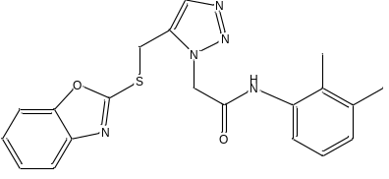 | 44 | 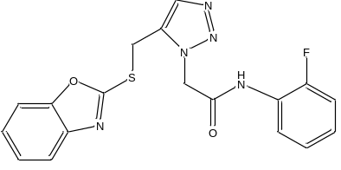
45 | 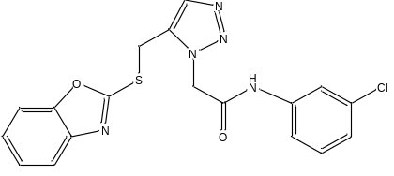 | 46 | 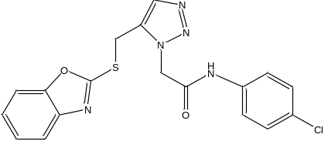

Table 2:- pMIC values of benzoxazole derivatives of all micro-organisms
Compound No. | pMIC_{BS} | pMIC_{EC} | pMIC_{ST} | pMIC_{KP} | pMIC_{AN} | pMIC_{CA}
1 | 0.45 | 0.45 | 0.45 | 0.45 | 0.75 | -0.47
2 | 0.42 | 0.72 | 0.72 | 0.72 | 0.72 | -0.18
3 | 0.42 | 0.42 | 0.42 | 0.42 | 0.42 | -0.18
4 | 0.40 | 0.40 | 0.70 | 0.40 | 0.40 | -0.21
5 | 0.40 | 0.70 | 0.40 | 0.40 | 0.70 | 0.10
6 | 0.07 | 0.37 | 0.37 | 0.67 | 0.67 | -0.23
7 | 0.41 | 0.41 | 0.71 | 0.71 | 0.71 | -0.19
8 | 0.39 | 0.69 | 0.69 | 0.69 | 0.69 | -0.21
9 | 0.43 | 0.73 | 0.73 | 0.73 | 0.43 | -0.17
10 | 0.06 | 0.36 | 0.66 | 0.66 | 0.66 | -0.24
11 | 0.11 | 0.71 | 0.71 | 0.71 | 0.71 | -0.19
12 | 0.41 | 0.71 | 0.71 | 0.41 | 0.71 | 0.11
13 | 0.41 | 0.71 | 0.71 | 0.11 | 0.71 | -0.19
14 | 0.42 | 0.42 | 0.72 | 0.12 | 0.72 | -0.18
15 | 0.42 | 0.72 | 0.42 | 0.12 | 0.72 | 0.12
16 | 0.09 | 0.39 | 0.69 | 0.09 | 0.69 | 0.09
17 | 0.40 | 0.40 | 0.40 | 0.10 | 0.40 | -0.20
18 | 0.43 | 0.43 | 0.43 | 0.13 | 0.74 | 0.74
19 | 0.38 | 0.68 | 0.38 | 0.68 | 0.38 | 0.68
20 | 0.38 | 0.68 | 0.38 | 0.68 | 0.68 | 0.68
21 | 0.41 | 0.41 | 0.41 | 0.72 | 0.41 | 0.72
22 | 0.43 | 0.73 | 0.73 | 0.73 | 0.73 | 0.73
23 | 0.45 | 0.15 | 0.45 | 0.75 | 0.75 | 0.75
24 | 0.45 | 0.15 | 0.45 | 0.45 | 0.45 | 0.45
25 | 0.43 | 0.43 | 0.43 | 0.73 | 0.43 | 0.43
26 | 0.44 | 0.44 | 0.44 | 0.74 | 0.74 | 0.74
27 | 1.78 | 2.09 | 1.78 | 1.78 | 1.78 | 1.48
28 | 1.48 | 1.78 | 1.48 | 1.78 | 1.78 | 1.78
29 | 1.50 | 1.80 | 1.50 | 1.80 | 1.80 | 1.50
30 | 1.45 | 1.15 | 1.45 | 1.75 | 1.45 | 1.45
31 | 1.12 | 2.03 | 1.43 | 1.73 | 1.73 | 1.73
32 | 1.48 | 1.48 | 1.78 | 1.48 | 1.48 | 1.48
33 | 1.44 | 1.74 | 1.74 | 1.44 | 1.74 | 1.44
34 | 1.20 | 1.80 | 1.80 | 1.80 | 1.50 | 1.80
35 | 1.20 | 1.20 | 1.80 | 1.50 | 1.50 | 1.50
36 | 1.50 | 1.50 | 1.50 | 1.50 | 1.50 | 1.50
37 | 1.21 | 1.21 | 1.51 | 1.51 | 1.51 | 1.81
38 | 1.75 | 1.75 | 1.75 | 1.75 | 2.05 | 1.75
39 | 1.76 | 1.76 | 1.76 | 1.76 | 2.06 | 1.76
40 | 1.45 | 1.15 | 1.45 | 1.75 | 1.75 | 1.45
41 | 1.20 | 1.20 | 1.50 | 1.80 | 1.50 | 1.50
42 | 1.15 | 1.75 | 1.75 | 1.75 | 1.45 | 1.75
43 | 1.50 | 1.20 | 1.50 | 1.80 | 1.50 | 1.80
44 | 1.21 | 1.51 | 1.51 | 1.51 | 1.51 | 1.51
45 | 1.19 | 1.80 | 1.80 | 1.80 | 1.50 | 1.50
46 | 1.50 | 1.80 | 1.80 | 1.80 | 2.10 | 2.10

Table 3: Values of Calculated Descriptors of Benzoxazole derivatives
Molecules | µ | log P | MR | ¹χ | ¹χ ^{V} | ³χ ^{V} | K¹ | kα³ | R | J | LUMO | VTDM
1 | 6.50 | 4.72 | 124.01 | 15.76 | 11.12 | 0.69 | 23.73 | 5.24 | 15.76 | 1.02 | -1.11 | 3.12
2 | 6.59 | 4.47 | 130.48 | 16.69 | 11.64 | 0.76 | 25.64 | 5.70 | 16.69 | 1.01 | -0.85 | 2.31
3 | 5.13 | 4.47 | 130.48 | 16.71 | 11.65 | 0.73 | 25.64 | 5.54 | 16.71 | 1.03 | -1.05 | 2.28
4 | 7.00 | 4.22 | 136.94 | 17.64 | 12.17 | 0.81 | 27.56 | 6.00 | 17.64 | 1.00 | -0.72 | 1.67
5 | 6.87 | 4.22 | 136.94 | 17.66 | 12.18 | 0.78 | 27.56 | 5.83 | 17.66 | 1.05 | -0.97 | 3.42
6 | 7.58 | 3.97 | 143.40 | 18.59 | 12.70 | 0.86 | 29.49 | 6.29 | 18.59 | 1.01 | -0.91 | 4.53
7 | 7.66 | 5.92 | 138.20 | 17.06 | 12.48 | 1.07 | 26.60 | 5.95 | 17.06 | 1.00 | -0.68 | 2.13
8 | 7.69 | 5.61 | 129.99 | 17.36 | 11.85 | 0.91 | 27.56 | 6.11 | 17.36 | 1.00 | -0.82 | 4.42
9 | 7.23 | 4.59 | 130.21 | 16.69 | 11.51 | 0.77 | 25.64 | 5.51 | 16.69 | 1.01 | -0.88 | 5.08
10 | 6.69 | 6.25 | 155.09 | 19.71 | 13.79 | 0.87 | 30.04 | 7.00 | 19.71 | 0.85 | -0.85 | 2.24
11 | 6.89 | 4.68 | 131.34 | 17.06 | 11.62 | 0.80 | 26.60 | 5.77 | 17.06 | 1.00 | -1.31 | 7.91
12 | 9.39 | 4.68 | 131.34 | 17.08 | 11.63 | 0.78 | 26.60 | 5.61 | 17.08 | 1.03 | -1.18 | 1.81
13 | 9.57 | 4.68 | 131.34 | 17.06 | 11.62 | 0.80 | 26.60 | 5.77 | 17.06 | 1.01 | -1.26 | 8.27
14 | 9.30 | 5.24 | 128.82 | 16.17 | 11.64 | 0.85 | 24.68 | 5.42 | 16.17 | 1.03 | -0.70 | 2.28
15 | 7.73 | 5.24 | 128.82 | 16.15 | 11.63 | 0.89 | 24.68 | 5.59 | 16.15 | 1.02 | -0.86 | 3.17
16 | 8.51 | 5.76 | 133.62 | 16.56 | 12.14 | 1.05 | 25.64 | 5.79 | 16.56 | 1.03 | -1.16 | 4.11
17 | 7.76 | 5.14 | 124.66 | 16.97 | 11.43 | 0.84 | 26.60 | 5.54 | 16.97 | 1.01 | -1.25 | 5.66
18 | 7.71 | 4.86 | 124.23 | 16.15 | 11.22 | 0.75 | 24.68 | 5.44 | 16.15 | 1.02 | -0.92 | 3.42
19 | 7.59 | 5.52 | 131.64 | 16.15 | 12.03 | 1.02 | 24.68 | 5.67 | 16.15 | 1.02 | -0.86 | 3.17
20 | 8.95 | 5.52 | 131.64 | 16.17 | 12.04 | 0.96 | 24.68 | 5.50 | 16.17 | 1.03 | -0.86 | 3.03
21 | 9.57 | 4.50 | 135.10 | 17.24 | 12.12 | 0.82 | 25.29 | 4.93 | 17.24 | 0.92 | -1.06 | 3.91
22 | 7.71 | 5.13 | 134.26 | 16.76 | 11.79 | 0.69 | 25.64 | 5.97 | 16.76 | 0.98 | -0.71 | 2.33
23 | 7.76 | 3.88 | 121.82 | 15.76 | 10.97 | 0.69 | 23.73 | 5.37 | 15.76 | 1.02 | -0.89 | 3.86
24 | 8.56 | 4.02 | 122.85 | 15.26 | 11.56 | 0.81 | 22.78 | 5.08 | 15.26 | 1.04 | -1.10 | 2.82
25 | 8.13 | 4.48 | 127.89 | 15.67 | 11.97 | 0.92 | 23.73 | 5.16 | 15.67 | 1.04 | -0.61 | 3.01
26 | 8.62 | 4.44 | 125.71 | 16.17 | 11.26 | 0.74 | 24.68 | 5.29 | 16.17 | 1.03 | -1.16 | 4.05
27 | 5.15 | 2.78 | 107.92 | 14.08 | 9.55 | 0.67 | 22.20 | 5.18 | 14.08 | 1.08 | -1.32 | 7.68
28 | 8.63 | 2.78 | 107.92 | 14.08 | 9.55 | 0.67 | 22.20 | 5.18 | 14.08 | 1.09 | -1.44 | 11.12
29 | 9.32 | 2.58 | 107.05 | 13.71 | 9.57 | 0.63 | 21.24 | 5.12 | 13.71 | 1.09 | -0.86 | 2.25
30 | 7.26 | 3.30 | 112.72 | 14.49 | 10.06 | 0.83 | 23.17 | 5.37 | 14.49 | 1.11 | -1.38 | 10.58
31 | 8.14 | 4.38 | 115.00 | 13.99 | 10.59 | 1.07 | 22.20 | 5.37 | 13.99 | 1.12 | -0.95 | 7.02
32 | 6.25 | 3.81 | 110.44 | 13.60 | 9.98 | 0.85 | 21.24 | 4.89 | 13.60 | 1.11 | -1.10 | 5.24
33 | 7.32 | 4.09 | 113.25 | 13.60 | 10.38 | 0.96 | 21.24 | 4.97 | 13.60 | 1.11 | -0.95 | 3.94
34 | 8.49 | 3.69 | 110.23 | 13.71 | 10.02 | 0.68 | 21.24 | 5.14 | 13.71 | 1.09 | -1.17 | 6.74
35 | 7.52 | 3.76 | 110.67 | 13.58 | 9.88 | 0.86 | 21.24 | 4.95 | 13.58 | 1.11 | -1.18 | 6.33
36 | 7.36 | 3.35 | 105.40 | 13.19 | 9.56 | 0.72 | 20.28 | 4.82 | 13.19 | 1.11 | -0.87 | 5.93
37 | 8.19 | 2.97 | 100.81 | 13.17 | 9.15 | 0.62 | 20.28 | 4.85 | 13.17 | 1.10 | -0.97 | 4.52
38 | 8.24 | 3.62 | 108.21 | 13.17 | 9.96 | 0.89 | 20.28 | 5.10 | 13.17 | 1.10 | -0.99 | 4.27
39 | 6.76 | 3.86 | 110.20 | 13.58 | 10.07 | 0.90 | 21.24 | 5.20 | 13.58 | 1.10 | -1.01 | 4.94
40 | 7.50 | 3.62 | 108.21 | 13.19 | 9.97 | 0.84 | 20.28 | 4.90 | 13.19 | 1.11 | -0.87 | 5.94
41 | 8.40 | 3.76 | 110.67 | 13.56 | 9.87 | 0.89 | 21.24 | 5.14 | 13.56 | 1.10 | -1.16 | 6.57
42 | 7.17 | 3.62 | 108.21 | 13.17 | 9.96 | 0.89 | 20.28 | 5.10 | 13.17 | 1.09 | -1.22 | 6.54
43 | 8.70 | 3.76 | 110.67 | 13.60 | 9.88 | 0.82 | 21.24 | 4.77 | 13.60 | 1.11 | -0.84 | 7.10
44 | 7.46 | 2.97 | 100.81 | 13.19 | 9.16 | 0.60 | 20.28 | 4.67 | 13.19 | 1.11 | -0.87 | 5.62
45 | 6.84 | 3.35 | 105.40 | 13.17 | 9.56 | 0.76 | 20.28 | 5.01 | 13.17 | 1.09 | -0.96 | 4.09
46 | 8.18 | 3.35 | 105.40 | 13.17 | 9.56 | 0.76 | 20.28 | 5.01 | 13.17 | 1.10 | -0.95 | 4.12

Table 4: Correlation matrix for antimicrobial activity against Bacillus subtilis
 | pMIC_{BS} | µ | log P | MR | ¹χ | ¹χ ^{V} | ³χ ^{V} | k¹ | Kα³ | R | J | LUMO | VTDM
pMIC_{BS} | 1.00
µ | -0.10 | 1.00
log P | -0.79 | 0.07 | 1.00
MR | -0.90 | 0.01 | 0.82 | 1.00
¹χ | -0.90 | -0.01 | 0.75 | 0.97 | 1.00
¹χ ^{V} | -0.90 | 0.03 | 0.85 | 0.99 | 0.95 | 1.00
³χ ^{V} | -0.21 | 0.09 | 0.58 | 0.34 | 0.19 | 0.41 | 1.00
K¹ | -0.86 | -0.03 | 0.73 | 0.95 | 0.99 | 0.92 | 0.21 | 1.00
Kα³ | -0.71 | -0.13 | 0.70 | 0.86 | 0.87 | 0.83 | 0.29 | 0.90 | 1.00
R | -0.90 | -0.01 | 0.75 | 0.97 | 1.00 | 0.95 | 0.19 | 0.99 | 0.87 | 1.00
J | 0.83 | -0.03 | -0.74 | -0.89 | -0.90 | -0.87 | -0.11 | -0.84 | -0.76 | -0.90 | 1.00
LUMO | -0.23 | 0.04 | 0.32 | 0.28 | 0.19 | 0.31 | 0.18 | 0.15 | 0.19 | 0.19 | -0.23 | 1.00
VTDM | 0.49 | 0.00 | -0.47 | -0.49 | -0.43 | -0.52 | -0.10 | -0.35 | -0.32 | -0.43 | 0.48 | -0.68 | 1.00

Table 5: Correlation matrix for antimicrobial activity against Escherichia coli
 | pMIC_{EC} | µ | log P | MR | ¹χ | ¹χ ^{V} | ³χ ^{V} | K¹ | Kα³ | R | J | LUMO | VTDM
pMIC_{EC} | 1.00
µ | -0.11 | 1.00
log P | -0.69 | 0.07 | 1.00
MR | -0.81 | 0.01 | 0.82 | 1.00
¹χ | -0.81 | -0.01 | 0.75 | 0.97 | 1.00
¹χ ^{V} | -0.82 | 0.03 | 0.85 | 0.99 | 0.95 | 1.00
³χ ^{V} | -0.15 | 0.09 | 0.58 | 0.34 | 0.19 | 0.41 | 1.00
K¹ | -0.76 | -0.03 | 0.73 | 0.95 | 0.99 | 0.92 | 0.21 | 1.00
Kα³ | -0.55 | -0.13 | 0.70 | 0.86 | 0.87 | 0.83 | 0.29 | 0.90 | 1.00
R | -0.81 | -0.01 | 0.75 | 0.97 | 1.00 | 0.95 | 0.19 | 0.99 | 0.87 | 1.00
J | 0.75 | -0.03 | -0.74 | -0.89 | -0.90 | -0.87 | -0.11 | -0.84 | -0.76 | -0.90 | 1.00
LUMO | -0.26 | 0.04 | 0.32 | 0.28 | 0.19 | 0.31 | 0.18 | 0.15 | 0.19 | 0.19 | -0.23 | 1.00
VTDM | 0.49 | 0.00 | -0.47 | -0.49 | -0.43 | -0.52 | -0.10 | -0.35 | -0.32 | -0.43 | 0.48 | -0.68 | 1.00

Table 6: Correlation matrix for antimicrobial activity against Salmonella typhi
 | pMIC_{ST} | µ | log P | MR | ¹χ | ¹χ ^{V} | ³χ ^{V} | K¹ | Kα³ | R | J | LUMO | VTDM
pMIC_{ST} | 1.00
µ | -0.11 | 1.00
log P | -0.71 | 0.07 | 1.00
MR | -0.84 | 0.01 | 0.82 | 1.00
¹χ | -0.86 | -0.01 | 0.75 | 0.97 | 1.00
¹χ ^{V} | -0.86 | 0.03 | 0.85 | 0.99 | 0.95 | 1.00
³χ ^{V} | -0.15 | 0.09 | 0.58 | 0.34 | 0.19 | 0.41 | 1.00
K¹ | -0.81 | -0.03 | 0.73 | 0.95 | 0.99 | 0.92 | 0.21 | 1.00
Kα³ | -0.60 | -0.13 | 0.70 | 0.86 | 0.87 | 0.83 | 0.29 | 0.90
R | -0.86 | -0.01 | 0.75 | 0.97 | 1.00 | 0.95 | 0.19 | 0.99 | 0.87 | 1.00
J | 0.77 | -0.03 | -0.74 | -0.89 | -0.90 | -0.87 | -0.11 | -0.84 | -0.76 | -0.90 | 1.00
LUMO | -0.25 | 0.04 | 0.32 | 0.28 | 0.19 | 0.31 | 0.18 | 0.15 | 0.19 | 0.19 | -0.23 | 1.00
VTDM | 0.50 | 0.00 | -0.47 | -0.49 | -0.43 | -0.52 | -0.10 | -0.35 | -0.32 | -0.43 | 0.48 | -0.68 | 1.00

Table 7: Correlation matrix for antimicrobial activity against Klebsiella pneumoniae
 | pMIC_{KP} | µ | log P | MR | ¹χ | ¹χ ^{V} | ³χ ^{V} | K¹ | Kα³ | R | J | LUMO | VTDM
pMIC_{KP} | 1.00
µ | -0.09 | 1.00
log P | -0.76 | 0.07 | 1.00
MR | -0.82 | 0.01 | 0.82 | 1.00
¹χ | -0.84 | -0.01 | 0.75 | 0.97 | 1.00
¹χ ^{V} | -0.83 | 0.03 | 0.85 | 0.99 | 0.95 | 1.00
³χ ^{V} | -0.17 | 0.09 | 0.58 | 0.34 | 0.19 | 0.41 | 1.00
K¹ | -0.80 | -0.03 | 0.73 | 0.95 | 0.99 | 0.92 | 0.21 | 1.00
Kα³ | -0.60 | -0.13 | 0.70 | 0.86 | 0.87 | 0.83 | 0.29 | 0.90 | 1.00
R | -0.84 | -0.01 | 0.75 | 0.97 | 1.00 | 0.95 | 0.19 | 0.99 | 0.87 | 1.00
J | 0.74 | -0.03 | -0.74 | -0.89 | -0.90 | -0.87 | -0.11 | -0.84 | -0.76 | -0.90 | 1.00
LUMO | -0.20 | 0.04 | 0.32 | 0.28 | 0.19 | 0.31 | 0.18 | 0.15 | 0.19 | 0.19 | -0.23 | 1.00
VTDM | 0.52 | 0.00 | -0.47 | -0.49 | -0.43 | -0.52 | -0.10 | -0.35 | -0.32 | -0.43 | 0.48 | -0.68 | 1.00

Table 8: Correlation matrix for antimicrobial activity against Aspergillus niger
 | pMIC_{AN} | µ | log P | MR | ¹χ | ¹χ ^{V} | ³χ ^{V} | K¹ | Kα³ | R | J | LUMO | VTDM
pMIC_{AN} | 1.00
µ | -0.04 | 1.00
log P | -0.72 | 0.07 | 1.00
MR | -0.85 | 0.01 | 0.82 | 1.00
¹χ | -0.86 | -0.01 | 0.75 | 0.97 | 1.00
¹χ ^{V} | -0.86 | 0.03 | 0.85 | 0.99 | 0.95 | 1.00
³χ ^{V} | -0.15 | 0.09 | 0.58 | 0.34 | 0.19 | 0.41 | 1.00
K¹ | -0.81 | -0.03 | 0.73 | 0.95 | 0.99 | 0.92 | 0.21 | 1.00
Kα³ | -0.59 | -0.13 | 0.70 | 0.86 | 0.87 | 0.83 | 0.29 | 0.90 | 1.00
R | -0.86 | -0.01 | 0.75 | 0.97 | 1.00 | 0.95 | 0.19 | 0.99 | 0.87 | 1.00
J | 0.79 | -0.03 | -0.74 | -0.89 | -0.90 | -0.87 | -0.11 | -0.84 | -0.76 | -0.90 | 1.00
LUMO | -0.23 | 0.04 | 0.32 | 0.28 | 0.19 | 0.31 | 0.18 | 0.15 | 0.19 | 0.19 | -0.23 | 1.00
VTDM | 0.48 | 0.00 | -0.47 | -0.49 | -0.43 | -0.52 | -0.10 | -0.35 | -0.32 | -0.43 | 0.48 | -0.68 | 1.00

Table 9: Correlation matrix for antimicrobial activity against Candida albicans
 | pMIC_{CA} | µ | log P | MR | ¹χ | ¹χ ^{V} | ³χ ^{V} | K¹ | Kα³ | R | J | LUMO | VTDM
pMIC_{CA} | 1.00
µ | 0.09 | 1.00
log P | -0.74 | 0.07 | 1.00
MR | -0.87 | 0.01 | 0.82 | 1.00
¹χ | -0.90 | -0.01 | 0.75 | 0.97 | 1.00
¹χ ^{V} | -0.86 | 0.03 | 0.85 | 0.99 | 0.95 | 1.00
³χ ^{V} | -0.17 | 0.09 | 0.58 | 0.34 | 0.19 | 0.41 | 1.00
K¹ | -0.89 | -0.03 | 0.73 | 0.95 | 0.99 | 0.92 | 0.21 | 1.00
Kα³ | -0.73 | -0.13 | 0.70 | 0.86 | 0.87 | 0.83 | 0.29 | 0.90 | 1.00
R | -0.90 | -0.01 | 0.75 | 0.97 | 1.00 | 0.95 | 0.19 | 0.99 | 0.87 | 1.00
J | 0.77 | -0.03 | -0.74 | -0.89 | -0.90 | -0.87 | -0.11 | -0.84 | -0.76 | -0.90 | 1.00
LUMO | -0.21 | 0.04 | 0.32 | 0.28 | 0.19 | 0.31 | 0.18 | 0.15 | 0.19 | 0.19 | -0.23 | 1.00
VTDM | 0.47 | 0.00 | -0.47 | -0.49 | -0.43 | -0.52 | -0.10 | -0.35 | -0.32 | -0.43 | 0.48 | -0.68 | 1.00

Table 10: The observed, predicted and residual value of the organisms
Compound | pMIC_{BS} |  |  | pMIC_{EC} |  |  | pMIC_{ST}
Compound | Obs. | Pre. | Res. | Obs. | Pre. | Res. | Obs. | Pre. | Res.
1 | 0.45 | 0.71 | -0.26 | 0.45 | 0.91 | -0.46 | 0.45 | 0.92 | -0.46
2 | 0.42 | 0.45 | -0.03 | 0.72 | 0.69 | 0.03 | 0.72 | 0.66 | 0.06
3 | 0.42 | 0.45 | -0.03 | 0.42 | 0.69 | -0.26 | 0.42 | 0.66 | -0.24
4 | 0.40 | 0.19 | 0.20 | 0.40 | 0.47 | -0.07 | 0.70 | 0.41 | 0.29
5 | 0.40 | 0.19 | 0.21 | 0.70 | 0.46 | 0.23 | 0.40 | 0.40 | -0.01
6 | 0.07 | -0.07 | 0.14 | 0.37 | 0.24 | 0.13 | 0.37 | 0.15 | 0.22
7 | 0.41 | 0.35 | 0.06 | 0.41 | 0.34 | 0.07 | 0.71 | 0.56 | 0.15
8 | 0.39 | 0.27 | 0.12 | 0.69 | 0.60 | 0.09 | 0.69 | 0.48 | 0.21
9 | 0.43 | 0.45 | -0.03 | 0.73 | 0.75 | -0.02 | 0.73 | 0.66 | 0.07
10 | 0.06 | -0.38 | 0.44 | 0.36 | -0.21 | 0.57 | 0.66 | -0.15 | 0.81
11 | 0.11 | 0.35 | -0.24 | 0.71 | 0.70 | 0.01 | 0.71 | 0.56 | 0.15
12 | 0.41 | 0.35 | 0.06 | 0.71 | 0.70 | 0.01 | 0.71 | 0.56 | 0.15
13 | 0.41 | 0.35 | 0.06 | 0.71 | 0.70 | 0.01 | 0.71 | 0.56 | 0.15
14 | 0.42 | 0.60 | -0.18 | 0.42 | 0.69 | -0.27 | 0.72 | 0.80 | -0.08
15 | 0.42 | 0.60 | -0.18 | 0.72 | 0.70 | 0.02 | 0.42 | 0.81 | -0.39
16 | 0.09 | 0.49 | -0.40 | 0.39 | 0.48 | -0.09 | 0.69 | 0.70 | -0.01
17 | 0.40 | 0.38 | 0.03 | 0.40 | 0.78 | -0.38 | 0.40 | 0.59 | -0.19
18 | 0.43 | 0.60 | -0.17 | 0.43 | 0.87 | -0.43 | 0.43 | 0.81 | -0.37
19 | 0.38 | 0.60 | -0.22 | 0.68 | 0.53 | 0.16 | 0.38 | 0.81 | -0.43
20 | 0.38 | 0.60 | -0.22 | 0.68 | 0.52 | 0.16 | 0.38 | 0.80 | -0.42
21 | 0.41 | 0.30 | 0.11 | 0.41 | 0.49 | -0.08 | 0.41 | 0.51 | -0.10
22 | 0.43 | 0.43 | -0.01 | 0.73 | 0.63 | 0.10 | 0.73 | 0.65 | 0.08
23 | 0.45 | 0.71 | -0.26 | - | - | - | 0.45 | 0.92 | -0.47
24 | 0.45 | 0.85 | -0.40 | 0.15 | 0.73 | -0.58 | 0.45 | 1.05 | -0.61
25 | 0.43 | 0.74 | -0.30 | 0.43 | 0.55 | -0.12 | 0.43 | 0.94 | -0.51
26 | 0.44 | 0.60 | -0.16 | 0.44 | 0.85 | -0.41 | 0.44 | 0.80 | -0.37
27 | 1.78 | 1.17 | 0.61 | 2.09 | 1.57 | 0.51 | 1.78 | 1.37 | 0.41
28 | 1.48 | 1.17 | 0.31 | 1.78 | 1.57 | 0.21 | 1.48 | 1.37 | 0.11
29 | 1.50 | 1.28 | 0.22 | 1.80 | 1.56 | 0.24 | 1.50 | 1.47 | 0.03
30 | 1.45 | 1.06 | 0.39 | 1.15 | 1.36 | -0.21 | 1.45 | 1.26 | 0.19
31 | 1.12 | 1.20 | -0.08 | - | - | - | 1.43 | 1.39 | 0.03
32 | 1.48 | 1.31 | 0.17 | 1.48 | 1.39 | 0.09 | 1.78 | 1.50 | 0.28
33 | 1.44 | 1.31 | 0.13 | 1.74 | 1.22 | 0.52 | 1.74 | 1.50 | 0.24
34 | 1.20 | 1.28 | -0.08 | 1.80 | 1.37 | 0.43 | 1.80 | 1.47 | 0.33
35 | 1.20 | 1.31 | -0.11 | 1.20 | 1.43 | -0.23 | 1.80 | 1.51 | 0.30
36 | 1.50 | 1.42 | 0.07 | 1.50 | 1.57 | -0.07 | 1.50 | 1.61 | -0.12
37 | 1.21 | 1.43 | -0.21 | 1.21 | 1.74 | -0.53 | 1.51 | 1.62 | -0.10
38 | 1.75 | 1.43 | 0.32 | 1.75 | 1.40 | 0.35 | 1.75 | 1.62 | 0.13
39 | 1.76 | 1.31 | 0.45 | 1.76 | 1.35 | 0.41 | 1.76 | 1.51 | 0.25
40 | 1.45 | 1.42 | 0.03 | 1.15 | 1.40 | -0.25 | 1.45 | 1.61 | -0.16
41 | 1.20 | 1.32 | -0.12 | 1.20 | 1.44 | -0.24 | 1.50 | 1.51 | -0.01
42 | 1.15 | 1.43 | -0.28 | 1.75 | 1.40 | 0.35 | 1.75 | 1.62 | 0.13
43 | 1.50 | 1.31 | 0.19 | 1.20 | 1.43 | -0.23 | 1.50 | 1.50 | 0.00
44 | 1.21 | 1.42 | -0.21 | 1.51 | 1.74 | -0.23 | 1.51 | 1.61 | -0.10
45 | 1.19 | 1.43 | -0.23 | 1.80 | 1.57 | 0.23 | 1.80 | 1.62 | 0.18
46 | 1.50 | 1.43 | 0.07 | 1.80 | 1.57 | 0.23 | 1.80 | 1.62 | 0.18

Table 11: The observed, predicted and residual value of the organisms
Compound | pMIC_{KP} |  |  | pMIC_{AN} |  |  | pMIC_{CA}
Compound | Obs. | Pre. | Res. | Obs. | Pre. | Res. | Obs. | Pre. | Res.
1 | 0.45 | 0.89 | -0.44 | 0.75 | 0.94 | -0.20 | -0.47 | 0.62 | -1.09
2 | 0.72 | 0.57 | 0.15 | 0.72 | 0.71 | 0.02 | - | - | -
3 | 0.42 | 0.57 | -0.14 | 0.42 | 0.70 | -0.28 | - | - | -
4 | 0.40 | 0.25 | 0.15 | 0.40 | 0.46 | -0.07 | -0.21 | -0.18 | -0.03
5 | 0.40 | 0.25 | 0.15 | 0.70 | 0.46 | 0.24 | 0.10 | -0.19 | 0.28
6 | - | - | - | 0.67 | 0.22 | 0.45 | -0.23 | -0.58 | 0.35
7 | 0.71 | 0.45 | 0.27 | 0.71 | 0.61 | 0.10 | -0.19 | 0.07 | -0.25
8 | 0.69 | 0.34 | 0.35 | 0.69 | 0.53 | 0.16 | -0.21 | -0.06 | -0.15
9 | 0.73 | 0.57 | 0.16 | 0.43 | 0.71 | -0.28 | - | - | -
10 | - | - | - | - | - | -- | - | - | -
11 | 0.71 | 0.45 | 0.26 | 0.71 | 0.61 | 0.10 | -0.19 | 0.07 | -0.26
12 | 0.41 | 0.44 | -0.03 | 0.71 | 0.61 | 0.10 | 0.11 | 0.06 | 0.05
13 | 0.11 | 0.45 | -0.34 | 0.71 | 0.61 | 0.10 | -0.19 | 0.07 | -0.26
14 | - | - | - | 0.72 | 0.84 | -0.12 | - | - | -
15 | - | - | - | 0.72 | 0.84 | -0.12 | 0.12 | 0.45 | -0.34
16 | 0.09 | 0.62 | -0.53 | 0.69 | 0.74 | -0.05 | 0.09 | 0.28 | -0.19
17 | 0.10 | 0.48 | -0.38 | 0.40 | 0.63 | -0.23 | -0.20 | 0.10 | -0.31
18 | 0.13 | 0.76 | -0.62 | 0.74 | 0.84 | -0.11 | 0.74 | 0.45 | 0.28
19 | 0.68 | 0.76 | -0.08 | - | - | - | 0.68 | 0.45 | 0.23
20 | 0.68 | 0.75 | -0.07 | 0.68 | 0.84 | -0.16 | 0.68 | 0.45 | 0.23
21 | 0.72 | 0.39 | 0.33 | 0.41 | 0.57 | -0.15 | 0.72 | -0.01 | 0.73
22 | 0.73 | 0.55 | 0.18 | 0.73 | 0.69 | 0.04 | - | - | -
23 | 0.75 | 0.89 | -0.14 | 0.75 | 0.94 | -0.19 | 0.75 | 0.62 | 0.13
24 | - | - | - | - | - | - | 0.45 | 0.83 | -0.39
25 | 0.73 | 0.92 | -0.19 | - | - | - | 0.43 | 0.66 | -0.23
26 | 0.74 | 0.75 | -0.01 | 0.74 | 0.84 | -0.10 | 0.74 | 0.45 | 0.29
27 | 1.78 | 1.46 | 0.32 | - | - | - | 1.48 | 1.34 | 0.15
28 | 1.78 | 1.46 | 0.32 | - | - | -- | 1.50 | 1.49 | 0.01
29 | 1.80 | 1.59 | 0.21 | 1.80 | 1.47 | 0.34 | 1.45 | 1.16 | 0.29
30 | 1.75 | 1.32 | 0.43 | 1.45 | 1.27 | 0.18 | 1.73 | 1.37 | 0.35
31 | 1.73 | 1.49 | 0.24 | 1.73 | 1.39 | 0.33 | 1.48 | 1.54 | -0.06
32 | 1.48 | 1.62 | -0.14 | 1.48 | 1.49 | -0.01 | 1.44 | 1.54 | -0.10
33 | 1.44 | 1.62 | -0.19 | 1.74 | 1.49 | 0.24 | 1.80 | 1.49 | 0.31
34 | 1.80 | 1.59 | 0.22 | 1.50 | 1.47 | 0.04 | 1.50 | 1.55 | -0.05
35 | 1.50 | 1.63 | -0.13 | 1.50 | 1.50 | 0.00 | 1.50 | 1.72 | -0.22
36 | 1.50 | 1.76 | -0.27 | 1.50 | 1.60 | -0.10 | 1.81 | 1.72 | 0.09
37 | 1.51 | 1.77 | -0.26 | 1.51 | 1.60 | -0.09 | 1.75 | 1.72 | 0.03
38 | 1.75 | 1.77 | -0.02 | - | - | - | 1.76 | 1.55 | 0.21
39 | 1.76 | 1.63 | 0.13 | - | - | - | 1.45 | 1.72 | -0.27
40 | 1.75 | 1.76 | -0.01 | 1.75 | 1.60 | 0.15 | 1.50 | 1.56 | -0.05
41 | 1.80 | 1.64 | 0.17 | 1.50 | 1.50 | 0.00 | 1.75 | 1.72 | 0.03
42 | 1.75 | 1.77 | -0.02 | 1.45 | 1.60 | -0.15 | 1.80 | 1.54 | 0.26
43 | 1.80 | 1.62 | 0.18 | 1.50 | 1.49 | 0.01 | 1.51 | 1.72 | -0.20
44 | 1.51 | 1.76 | -0.25 | 1.51 | 1.60 | -0.08 | 1.50 | 1.72 | -0.23
45 | 1.80 | 1.77 | 0.03 | 1.50 | 1.60 | -0.11 | 2.10 | 1.72 | 0.37
46 | 1.80 | 1.77 | 0.03 | - | - | -- | 0.75 | 0.62 | 0.13
Note: (-) symbol used in the table refers to the outliers that were removed against the particular organisms
Table 12. Docking score of all compounds
Compound No. | Docking Score | Compound No. | Docking Score | Compound No. | Docking Score | Compound No. | Docking Score
1 | -5.852 | 13 | -6.414 | 25 | -6.103 | 37 | -5.526
2 | -5.81 | 14 | -6.463 | 26 | -6.687 | 38 | -5.659
3 | -6.388 | 15 | -6.027 | 27 | -5.696 | 39 | -4.369
4 | -5.871 | 16 | -6.301 | 28 | -5.858 | 40 | -5.82
5 | -5.708 | 17 | -5.947 | 29 | -5.372 | 41 | -5.865
6 | -5.846 | 18 | -5.659 | 30 | -5.125 | 42 | -5.294
7 | -5.929 | 19 | -5.895 | 31 | -5.511 | 43 | -4.598
8 | -5.487 | 20 | -6.22 | 32 | -4.856 | 44 | -5.34
9 | -5.689 | 21 | -6.171 | 33 | -4.749 | 45 | -4.832
10 | -6.389 | 22 | -5.696 | 34 | -5.867 | 46 | -4.61
11 | -5.604 | 23 | -6.039 | 35 | -5.742 | Std | -6.092
12 | -5.607 | 24 | -5.491 | 36 | -5.838 | Std | -6.092
Std. Ciprofloxacin

Table 13. Docking score of the best selected compounds
Comp. No. | Docking Score | XP G score | Glide energy | Glide emodel | Interactions
26 | -6.687 | -6.687 | -60.768 | -93.858 | H-bond interaction with GLN 119 and SER 122
14 | -6.463 | -6.463 | -52.706 | -85.32 | H-bond interaction with ASN 48
13 | -6.414 | -6.414 | -59.981 | -94.375 | H-bond interaction with GLN 85 and SER 122
10 | -6.389 | -6.389 | -56.424 | -77.663 | H-bond interaction with H₂O, LYS 138, SER 122, Pi-cation with ARG 78
3 | -6.388 | -6.388 | -56.939 | -82.5 | Pi-Pi stacked interaction with HI 101
Std | -6.0 | -6.092 | -44.345 | -51.18 | H-bond interaction with H₂O
Std. Ciprofloxacin
Table 14. ADME analysis of benzoxazole derivatives
Mol. | Formula | MW(g/mol) | MR | iLOGP | #H-bond acceptors | #H-bond donors | ESOL Solubility (mg/ml) | ESOL. Class | GI absorption | BBB permeant | log Kp (cm/s) | Lipinski #violations
1 | C₂₄H₁₉N₅O₂S | 441.5 | 125.56 | 3.49 | 5 | 1 | 1.15E-03 | Moderately soluble | High | No | -5.63 | 0
2 | C₂₅H₂₁N₅O₃S | 471.53 | 132.05 | 3.67 | 6 | 1 | 1.05E-03 | Moderately soluble | High | No | -5.84 | 0
3 | C₂₅H₂₁N₅O₃S | 471.53 | 132.05 | 3.94 | 7 | 1 | 1.05E-03 | Moderately soluble | High | No | -5.84 | 0
4 | C₂₆H₂₃N₅O₄S | 501.56 | 138.54 | 3.82 | 7 | 1 | 9.31E-04 | Moderately soluble | Low | No | -6.04 | 1
5 | C₂₆H₂₃N₅O₄S | 501.56 | 138.54 | 3.91 | 7 | 1 | 9.31E-04 | Moderately soluble | Low | No | -6.04 | 1
6 | C₂₇H₂₅N₅O₅S | 531.58 | 145.03 | 3.72 | 5 | 1 | 8.30E-04 | Moderately soluble | Low | No | -6.24 | 1
7 | C₂₇H₂₅N₅O₂S | 483.58 | 140.14 | 4.18 | 5 | 1 | 1.74E-04 | Poorly soluble | Low | No | -5.09 | 0
8 | C₂₅H₁₈F₃N₅O₂S | 509.5 | 130.56 | 3.7 | 5 | 1 | 1.85E-04 | Poorly soluble | Low | No | -5.42 | 1
9 | C₂₅H₁₈N₆O₂S | 466.51 | 130.27 | 3.06 | 8 | 1 | 1.38E-03 | Moderately soluble | Low | No | -5.99 | 0
10 | C₃₁H₂₅N₅O₃S | 547.63 | 156.54 | 4.45 | 6 | 1 | 5.86E-05 | Poorly soluble | Low | No | -5.24 | 1
11 | C₂₄H₁₈N₆O₄S | 486.5 | 134.38 | 3.02 | 5 | 1 | 1.11E-03 | Moderately soluble | Low | No | -6.03 | 0
12 | C₂₄H₁₈N₆O₄S | 486.5 | 134.38 | 3.1 | 6 | 1 | 1.11E-03 | Moderately soluble | Low | No | -6.03 | 0
13 | C₂₄H₁₈N₆O₄S | 486.5 | 134.38 | 2.89 | 5 | 1 | 1.11E-03 | Moderately soluble | Low | No | -6.03 | 0
14 | C₂₄H₁₈ClN₅O₂S | 475.95 | 130.57 | 3.41 | 5 | 2 | 3.16E-04 | Poorly soluble | High | No | -5.4 | 0
15 | C₂₄H₁₈ClN₅O₂S | 475.95 | 130.57 | 3.72 | 5 | 1 | 3.16E-04 | Poorly soluble | High | No | -5.4 | 0
16 | C₂₄H₁₇Cl₂N₅O₂S | 510.4 | 135.58 | 3.84 | 6 | 1 | 8.62E-05 | Poorly soluble | Low | No | -5.16 | 1
17 | C₂₄H₁₆F₃N₅O₂S | 495.48 | 125.43 | 3.54 | 5 | 1 | 4.31E-04 | Poorly soluble | Low | No | -5.75 | 0
18 | C₂₄H₁₈FN₅O₂S | 459.5 | 125.52 | 3.59 | 5 | 1 | 8.32E-04 | Moderately soluble | High | No | -5.67 | 0
19 | C₂₄H₁₈BrN₅O₂S | 520.4 | 133.26 | 3.86 | 6 | 2 | 1.68E-04 | Poorly soluble | Low | No | -5.63 | 1
20 | C₂₄H₁₈BrN₅O₂S | 520.4 | 133.26 | 3.55 | 7 | 1 | 1.68E-04 | Poorly soluble | Low | No | -5.63 | 1
21 | C₂₆H₂₀N₆O₂S | 480.54 | 137.41 | 2.89 | 7 | 1 | 5.72E-04 | Moderately soluble | Low | No | -5.78 | 0
22 | C₂₆H₂₁N₅O₂S | 467.54 | 135.49 | 3.88 | 6 | 1 | 5.65E-04 | Moderately soluble | High | No | -5.49 | 0
23 | C₂₃H₁₈N₆O₂S | 442.49 | 123.35 | 2.91 | 6 | 1 | 5.37E-03 | Moderately soluble | High | No | -6.4 | 0
24 | C₂₂H₁₇N₅O₂S₂ | 447.53 | 123.43 | 3.24 | 7 | 1 | 1.05E-03 | Moderately soluble | Low | No | -5.66 | 0
25 | C₂₃H₁₉N₅O₂S₂ | 461.56 | 128.4 | 3.57 | 5 | 1 | 5.49E-04 | Moderately soluble | Low | No | -5.49 | 0
26 | C₂₄H₁₉N₅O₃S | 457.5 | 127.58 | 3.14 | 5 | 1 | 1.64E-03 | Moderately soluble | Low | No | -5.98 | 0
27 | C₁₈H₁₄N₆O₄S | 410.41 | 107.71 | 2.31 | 5 | 1 | 3.31E-02 | Moderately soluble | Low | No | -6.86 | 0
28 | C₁₈H₁₄N₆O₄S | 410.41 | 107.71 | 2.13 | 5 | 1 | 3.31E-02 | Moderately soluble | Low | No | -6.86 | 0
29 | C₁₉H₁₇N₅O₃S | 395.43 | 105.38 | 3 | 5 | 1 | 3.09E-02 | Moderately soluble | High | No | -6.67 | 0
30 | C₁₈H₁₃ClN₆O₄S | 444.85 | 112.72 | 2.61 | 5 | 1 | 9.16E-03 | Moderately soluble | Low | No | -6.62 | 0
31 | C₁₈H₁₂Cl₃N₅O₂S | 468.74 | 113.92 | 3.67 | 6 | 1 | 7.22E-04 | Moderately soluble | High | No | -5.76 | 0
32 | C₁₉H₁₆ClN₅O₂S | 413.88 | 108.87 | 3.44 | 5 | 1 | 4.87E-03 | Moderately soluble | High | No | -6.06 | 0
33 | C₁₉H₁₆BrN5O2S | 458.33 | 111.56 | 3.77 | 5 | 1 | 2.62E-03 | Moderately soluble | High | No | -6.28 | 0
34 | C₂₀H₁₉N₅O₂S | 393.46 | 108.67 | 3.32 | 7 | 1 | 9.50E-03 | Moderately soluble | High | No | -6.07 | 0
35 | C₂₀H₁₉N₅O₂S | 393.46 | 108.82 | 3.35 | 5 | 1 | 9.03E-03 | Moderately soluble | High | No | -6.12 | 0
36 | C₁₈H₁₄ClN₅O₂S | 399.85 | 103.9 | 3.26 | 5 | 1 | 9.26E-03 | Moderately soluble | High | No | -6.23 | 0
37 | C₁₈H₁₄FN₅O₂S | 383.4 | 98.85 | 2.88 | 5 | 1 | 2.42E-02 | Moderately soluble | High | No | -6.5 | 0
38 | C₁₈H₁₄BrN₅O₂S | 444.31 | 106.59 | 3.04 | 5 | 1 | 5.00E-03 | Moderately soluble | High | No | -6.45 | 0
39 | C₁₈H₁₃Cl₂N₅O₂S | 434.3 | 108.91 | 2.99 | 6 | 1 | 2.62E-03 | Moderately soluble | High | No | -6 | 0
40 | C₁₈H₁₄BrN₅O₂S | 444.31 | 106.59 | 3.47 | 5 | 1 | 5.00E-03 | Moderately soluble | High | No | -6.45 | 0
41 | C₂₀H₁₉N₅O₂S | 393.46 | 108.82 | 3.4 | 5 | 1 | 9.03E-03 | Moderately soluble | High | No | -6.12 | 0
42 | C₁₈H₁₄BrN₅O₂S | 444.31 | 106.59 | 3.22 | 7 | 1 | 5.00E-03 | Moderately soluble | High | No | -6.45 | 0
43 | C₂₀H₁₉N₅O₂S | 393.46 | 108.82 | 3.07 | 8 | 1 | 9.03E-03 | Moderately soluble | High | No | -6.12 | 0
44 | C₁₈H₁₄FN₅O₂S | 383.4 | 98.85 | 3.1 | 5 | 1 | 2.42E-02 | Moderately soluble | High | No | -6.5 | 0
45 | C₁₈H₁₄ClN₅O₂S | 399.85 | 103.9 | 3.1 | 8 | 1 | 9.26E-03 | Moderately soluble | High | No | -6.23 | 0
46 | C₁₈H₁₄ClN₅O₂S | 399.85 | 103.9 | 3.05 | 6 | 1 | 9.26E-03 | Moderately soluble | High | No | -6.23 | 0
Properties calculated using SwissADME: LogP - Predicted octanol/water partition coefficient; MW – molecular weight; MR-Molar refractivity; BBB-Blood Brain Barrier; log_{KP}; skin permeation

