Table S1. Acetonitrile-0.03%phosphate gradient for hapagide and harpagoside separation and analysis on reversed-phase HPLC.
Time (min) | Acetonitrile-A (%) | 0.03% Phosphate-B (%)
0~10 | 3→10 | 97→90
10~20 | 10→33 | 90→67
20~25 | 33→50 | 67→50
25~30 | 50→80 | 50→20
30~35 | 80 | 20
35~37 | 80→3 | 20→97
37~42 | 3 | 97

Table S2. Methodological investigation.
Ingredient | Regression equation | Linear range | R | RSD’s stability test | RSD’s precision test | RSD’s repeatability test | RSD’s recovery test
Harpagide | Y=2964.3X+5156.4 | 0.1020～0.5100 mg/ml | 0.9998 | 0.24% | 0.11% | 0.59% | 97.44%
Harpagoside | Y=13919X+366.1 | 0.0340～0.1700 mg/ml | 0.9999 | 0.17% | 0.09% | 0.50% | 97.08%

Table S3. Alpha richness and diversity of endophytic and rhizosphere community associated with S. ningpoensis.
 | Chao | Shannon
Rhizosphere | 1138.033ª | 4.299ª
Endosphere | 228.645^{b} | 2.280^{b}

Table S4. Correlation indicating Spearman’s r values relating rhizosphere fungi genus and soil parameters. Statistically significant correlations are indicated in bold type, * and ** denote p values ≤ 0.05 and ≤ 0.01, respectively. TOM = organic matter, TOC = total organic carbon, TN = total nitrogen, TP = total phosphorus, TK= total potassium.

 | OM | TOC | TN | pH | TP | TK | Hg | Mn | Cu | Cr
Plectosphaerella | -0.673** | -.673** | -0.532* | 0.45 | 0.278 | 0.537* | 0.197 | 0.45 | 0.147 | -0.168
Mortierella | 0.141 | 0.141 | 0.018 | 0.121 | -0.442 | -0.147 | -0.024 | 0.053 | 0.259 | 0.181
unclassified_p_Ascomycota | 0.515* | 0.515* | 0.521* | -0.079 | -0.570* | -0.467 | 0.003 | 0.044 | 0.068 | -0.009
Saitozyma | 0.443 | 0.443 | 0.297 | -0.353 | -0.338 | -0.637** | -0.4 | -0.486 | -0.303 | 0.154
unclassified_f_Chaetomiaceae | -0.144 | -0.144 | -0.094 | 0.103 | 0.361 | 0.799** | 0.582* | 0.159 | 0.238 | 0.054
Apiotrichum | 0.601* | 0.601* | 0.596* | -0.607* | -0.051 | -0.238 | 0.119 | -0.246 | -0.174 | -0.146
unclassified_f_Ceratobasidiaceae | 0.031 | 0.031 | 0.224 | 0.149 | -0.311 | -0.296 | 0.218 | 0.203 | -0.259 | -0.352
Bulleromyces | -0.702** | -0.702** | -0.597* | 0.334 | 0.228 | 0.232 | -0.061 | 0.349 | -0.077 | -0.178
Cephaliophora | 0.032 | 0.032 | 0.147 | 0.026 | 0.228 | 0.706** | 0.631** | 0.529* | 0.589* | -0.024
Leucoagaricus | -0.252 | -0.252 | -0.199 | 0.157 | -0.148 | -0.166 | 0.056 | -0.258 | -0.412 | -0.201
unclassified_o_Cystofilobasidiales | -0.17 | -0.17 | 0.042 | 0.133 | 0.131 | 0.036 | 0.034 | 0.334 | -0.251 | -0.11

Table S5. Correlation indicating Spearman’s r values relating endophytic fungi genus and soil parameters. Statistically significant correlations are indicated in bold type, * denote p value ≤ 0.05, ** denote p value ≤ 0.01, respectively. OM = organic matter, TOC = total organic carbon, TN = total nitrogen, TP = total phosphorus, TK= total potassium.

 | OM | TOC | TN | pH | TP | TK | Hg | Mn | Cu | Cr
Plectosphaerella | -0.505* | -0.505* | -0.365 | 0.150 | 0.366 | 0.375 | 0.118 | 0.424 | 0.088 | -0.234
unclassified_c_Leotiomycetes | 0.324 | 0.324 | 0.444 | -0.108 | -0.225 | -0.313 | -0.018 | 0.034 | -0.196 | 0.426
unclassified_p_Ascomycota | 0.473 | 0.473 | 0.379 | -0.185 | -0.403 | -0.562* | -0.203 | -0.185 | -0.250 | -0.078
Cladosporium | 0.323 | 0.323 | 0.374 | -0.152 | -0.115 | 0.235 | 0.306 | -0.185 | -0.015 | 0.050
Tetracladium | -0.261 | -0.261 | -0.209 | -0.119 | 0.007 | 0.514* | 0.338 | 0.115 | -0.182 | -0.152
Ceratobasidium | -0.323 | -0.323 | -0.397 | 0.406 | -0.411 | -0.331 | -0.191 | -0.338 | -0.517* | 0.049
Filobasidium | -0.612* | -0.612* | -0.439 | 0.447 | -0.040 | 0.572* | 0.222 | 0.201 | -0.074 | 0.277
unclassified_f_Schizoporaceae | 0.097 | 0.097 | 0.015 | 0.067 | -0.276 | -0.571* | -0.412 | -0.325 | -0.135 | 0.143
Acremonium | 0.296 | 0.296 | 0.124 | -0.389 | 0.000 | 0.183 | 0.231 | -0.452 | -0.190 | -0.206
Guehomyces | 0.289 | 0.289 | 0.318 | -0.571* | 0.322 | 0.369 | 0.141 | 0.106 | -0.250 | 0.150
unclassified_f_Ceratobasidiaceae | 0.610* | 0.610* | 0.579* | -0.397 | 0.318 | -0.262 | -0.059 | 0.071 | -0.094 | -0.735**
Vishniacozyma | -0.057 | -0.057 | 0.115 | 0.138 | 0.347 | 0.497* | 0.191 | 0.385 | 0.400 | -0.189
Cutaneotrichosporon | -0.032 | -0.032 | -0.094 | -0.366 | -0.590* | 0.060 | 0.165 | -0.388 | -0.538* | 0.370
Pyrenochaeta | 0.729** | 0.729** | 0.736** | -0.360 | 0.047 | -0.351 | -0.059 | 0.160 | 0.189 | -0.091
unclassified_f_Melanommataceae | 0.600* | 0.600* | 0.674** | -0.183 | -0.378 | -0.242 | 0.266 | 0.285 | -0.172 | -0.125
Exophiala | 0.403 | 0.403 | 0.426 | -0.169 | -0.118 | -0.367 | -0.172 | -0.152 | -0.078 | 0.359

Table S6. The active ingredients in S. ningpoensis from 16 areas (x±s, n=3, mg/g, *p<0.05).
Sample | Harpagide | Harpagoside | Sum of harpagide and harpagoside
PA | 0.598±0.003^{i} | 0.852±0.003ª | 1.450±0.006^{d}
TQ | 0.730±0.021^{f} | 0.626±0.017^{d} | 1.355±0.038e
ZWY | 0.600±0.007^{i} | 0.152±0.009^{m} | 0.752±0.013^{k}
LA | 0.979±0.002^{c} | 0.520±0.004^{g} | 1.499±0.006^{c}
ZZ | 0.642±0.004^{g} | 0.655±0.004^{c} | 1.297±0.008^{f}
NF | 0.921±0.007^{d} | 0.563±0.006e | 1.484±0.002^{c}
LL | 0.759±0.006e | 0.385±0.005^{j} | 1.144±0.009^{h}
YX | 1.120±0.009^{b} | 0.234±0.015^{l} | 1.355±0.024e
YuX | 1.140±0.007ª | 0.297±0.294^{k} | 1.434±0.010^{d}
LD | 1.147±0.006ª | 0.382±0.002^{j} | 1.529±0.008^{b}
WL | 0.560±0.002^{j} | 0.422±0.001^{i} | 0.983±0.002^{j}
YF | 0.992±0.016^{c} | 0.036±0.002^{n} | 1.029±0.017^{i}
GY | 0.625±0.003^{h} | 0.542±0.003^{f} | 1.167±0.004^{gh}
QC | 0.489±0.002^{k} | 0.831±0.008^{b} | 1.320±0.009^{f}
LX | 0.558±0.003^{j} | 0.615±0.006^{d} | 1.173±0.009^{g}

Table S6: Continued
Sample | Harpagide | Harpagoside | Sum of harpagide and harpagoside
NC | 1.135±0.009ª | 0.486±0.001^{h} | 1.621±0.010ª
Average | 0.812* | 0.475* | 1.287*
*PA: Pan’ an; ZWY: Zhiwuyuan; LA: Lin’ an; TQ: Taiqiu; ZZ: Zhuzhuang; NF: Nanfeng; LL: Luolong; YX: Yangxi; YuX: Yuxi; LD: Longdong; WL: Wulong;
YF: Yongfu; GY; Guoyang; QC: Qiaocheng; LX: Lixin; NC: Nanchuan.

Table S7. Coefficients of linear correlation regression evaluating relationship between rhizosphere and endophytic fungi composition and active constituents.
Model |  | Unstandardized Coefficients |  | Standardized Coefficients | t | Sig.
 |  | B | Std. Error | Beta
Harpagide | (Constant) | 0.430 | 0.032 |  | 13.545 | 0.000
Harpagide | Cladosporium | 8.901 | 0.948 | 0.547 | 9.448 | 0.000
Harpagide | Pyrenochaeta | 6.966 | 0.805 | 0.467 | 8.650 | 0.000
Harpagide | Unclassified_f_Melanommataceae | -7.406 | 0.945 | -0.435 | -7.834 | 0.000
Harpagide | Unclassified_o_Pezizales | 30.859 | 4.763 | 0.365 | 6.479 | 0.000
Harpagide | Unclassified_p_Basidiomycota | 8.908 | 2.485 | 0.198 | 3.585 | 0.006
Harpagide | Aspergillus | 5.344 | 1.993 | 0.144 | 2.681 | 0.025
Harpagoside | (Constant) | 0.107 | 0.007 |  | 15.621 | 0.000
Harpagoside | Alternaria | 20.816 | 0.483 | 0.538 | 43.130 | 0.000
Harpagoside | Apiotrichum | 7.604 | 0.132 | 0.873 | 57.651 | 0.000
Harpagoside | Unclassified_f_Ceratobasiddiaceae | -5.126 | 0.112 | -0.410 | -45.673 | 0.000
Harpagoside | Plectosphaerella | 0.626 | 0.016 | 0.474 | 38.139 | 0.000
Harpagoside | Minimelanolocus | 8.785 | 0.327 | 0.237 | 26.891 | 0.000
Harpagoside | Penicillium | 8.439 | 0.589 | 0.132 | 14.332 | 0.000
Harpagoside | Geotichum | -4.735 | -4.735 | 0.453 | -10.458 | 0.000
Harpagoside | Unclassified_f_Cordycipitaceae | 37.104 | 37.104 | 4.678 | 7.932 | 0.000
Harpagoside | Trichoderma | -3.186 | -3.186 | 0.706 | -4.513 | 0.004
Sum of harpagide and harpogoside | (Constant) | 1.249 | 0.070 |  | 17.734 | 0.000
Sum of harpagide and harpogoside | Unclassified_f_Schizoporaceae | -3.405 | 0.551 | -0.850 | -6.180 | 0.000
Sum of harpagide and harpogoside | Unclassified_f_Ceratobasidiaceae | -6.643 | 1.529 | -0.574 | -4.343 | 0.001
Sum of harpagide and harpogoside | Unclassified_c_Sordariomycetes | 8.585 | 2.689 | 0.432 | 3.193 | 0.008

Table S8. Regression analysis were performed on the horizontal coordinate (X) of the root fungal of S. ningpoensis and the vertical coordinate (Y) of the harpagide content, harpagoside content and the sum of them.
Ingredient | Regression equation | R²
Harpagide | Y1= 0.430 + 8.955CL + 6.966PY – 7.406UFM + 30.859UOP +8.908UPB + 5.344AS, R2=0.975 (adjust R2=0.958) | R²=0.975 (adjust R²=0.958)
Harpagoside | Y2=0.107 +20.816AL + 7.604AP – 5.126UFCE + 0.626PL + 8.785MI + 8.439PE – 4.735GE + 37.104UFCO – 3.186TR | R²=1.000 (adjust R²=0.999)
Harpagide + harpagoside | Y3=1.249 + 8.585UCS – 3.405UFS – 6.643UFCE | R²=0.802 (adjust R²=0.753)
*CL: Cladosporium, PY: Pyrenochaeta, UFM: unclassified_f_Melanommataceae, UOP: unclassified_o_Pezizales, UPB: unclassified_p_Basidiomycota, AS: Aspergillus;AL: Alternaria, AP: Apiotrichum, UFCE: unclassified_f_Ceratobasidiaceae, PL: Plectosphaerella, MI: Minimelanolocus, PE: Penicillium, GE: Geotrichum, UFCO: unclassified_f_Cordycipitaceae, and TR:Trichoderma.
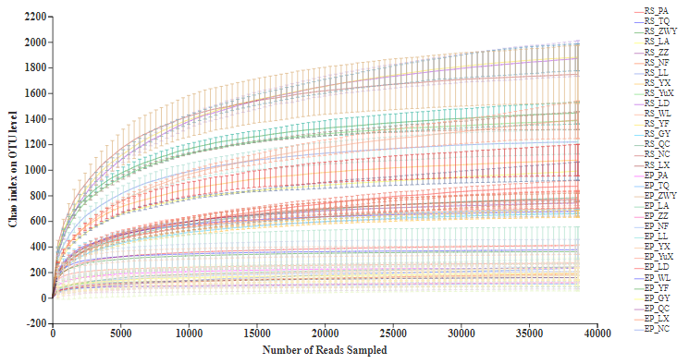
Fig. S1. Rarefaction curves of fungi community based on observed operational taxonomic units (OTUs) for 16 different area. Each soil and plant samples (32 samples, totally) were randomly divided into three subsamples (32×3), and were analyzed using the average data of their subsamples, respectively.

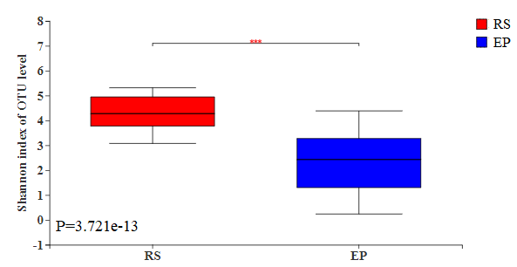
Fig. S2. Wilcoxon signed rank test of the rhizosphere to endophytic fungal community, P <0.001. RS: rhizosphere; EP: endophytic.

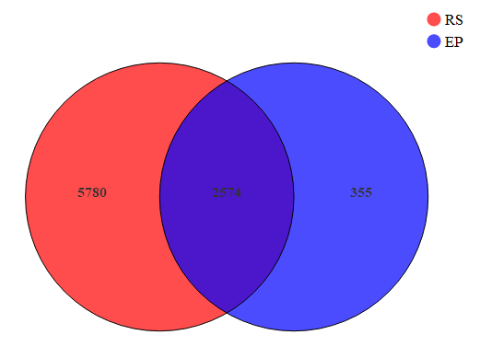
Fig. S3. Venn diagram for endosphere (EP) and rhizosphere (RS) fungal community associated with S. ningpoensis.

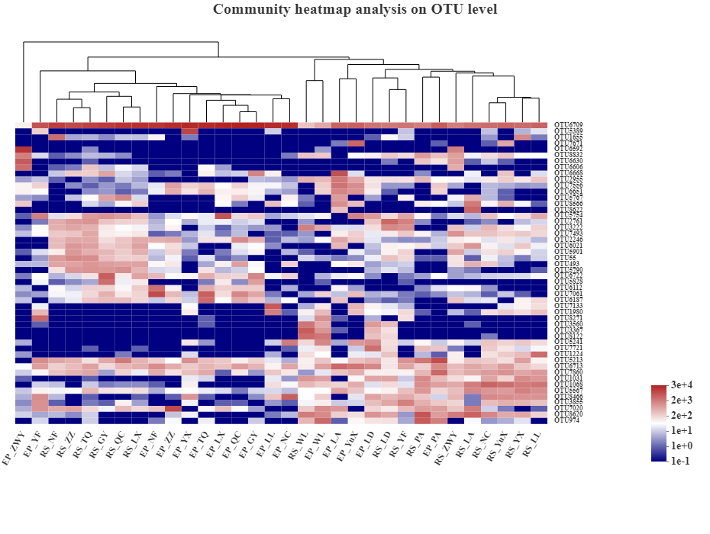

Fig. S4. The top 50 most abundant fungal community based on OTU level across 32 rhizosphere and endophytic samples.

