Ultra-mechanosensitive ion transport through bioinspired high-density elastomeric nanochannels

Table of contents:
- Experimental procedures
- Supplementary figures
- Supplementary tables
- Supplementary references

- Experimental procedures
Transmission electron microscopy (TEM). TEM images were recorded using JEM-2100. The accelerating voltage was 200 kV. 0.5 wt% BCP toluene solution was directly dropped onto the copper grid. After the complete evaporation of the solvent, the sample was thermally annealed under 120 ºC for 24 h. To increase the contrast, the dispersal phase (P4VP) was selectively stained with iodine vapor for 20 min.
Atomic force microscopy (AFM). The surface morphologies of the PI-b-P4VP membrane were detected by AFM (Bruker Dimension Icon) with Scanasyst-Air mode. EMC-1 membrane was coated onto the PDMS membrane (2 cm × 5 mm ). Before the AFM test, PDMS was stretched with 20% stains and was further fixed in the stretching state. The surface morphology in an aqueous solution was measured with Bruker Dimension Icon (tapping mode) in 0.1 M KCl solution at pH=7.0. EMC-1 membrane was transformed onto a PI membrane with a 160-µm circle hole. The solution height above the EMC-1 membrane is controlled at 5 mm.
Grazing-incidence small-angle X-ray scattering (GI-SAXS). GI-SAXS experiments were performed by Xeuss 3.0 HR. A monochromated X-ray radiation source with a wavelength λ of 0.154 nm (10 keV) was used. The distance from the sample to the detector was 1800 mm.
X-ray photoelectron spectroscopy (XPS). The chemical compositions of different crosslinking-degree membrane surfaces were measured by Thermo Scientific K-Alpha under the pressure of 5E-7 mbar with a monochromatic Al Kα X-ray source (hv = 1486.6 eV). All XPS spectra were collected at normal emission and room temperature.
Fourier-transform infrared spectroscopy (FT-IR). FT-IR tests of crosslinking BCP membranes were performed using a Bruker Vertex70, between 400 and 4000 cm^{–1}. The crosslinking degree of EMC membranes is calculated according to the previous literature¹.
Mechanical strength measurement. Micro-mechanical strength was measured by a commercial TI 950 triboindenter (Hyitron) equipped with a Berkovich diamond tip (R=100 nm) using a continuous depth-sensing indentation technique and a PI-85 SEM Picoindenter (Hyitron). The samples with different crosslinking times were measured in ambient conditions (25 °C, 15 % of RH). Indentation Young’s modulus (E') of the sample was calculated using the Oliver-Pharr method, which was performed automatically by the nanoindenter. Different positions were chosen for the detection.
Numerical simulation of mechanosensitive ion transport. To simplify the simulation, a single P4VP nanochannel is taken for analysis. As the P4VP channel is filled with pyridine groups, we simplified that the charges of polymer chains are strictly confined to the channel walls. And the surface charge density of P4VP nanochannel is set as 0.24 C$∙$m⁻² according to the previous literature². And the nanochannel width, height, and length toward different pressures and stretches are listed in Table 2.
The Nernst-Planck equation that describes the transport properties of charged nanochannels is shown below:
$$j_{i}=D_{i}(∇c_{i}+\frac{z_{i}Fc_{i}}{RT}∇φ)$$
where, j_{i}, D_{i}, c_{i}, z_{i}, F, R, T, and φ are the ionic flux, diffusion coefficient, ion concentration for each species, valence number for each species, Faraday constant, the universal gas constant, Kelvin temperature, and electrical potential, respectively.
The electrical potential inside the nanochannel can be related to the ionic concentration by the Poisson equation:
$$∇^{2}φ=-\frac{F}{ε}\sum{z_{i}c_{i}}$$
Simplified by assuming steady-state conditions, the flux should satisfy the time-independent continuity equation:
$$∇⋅j_{i}=0$$
The diffusion coefficients towards K⁺ and Cl⁻ are 1.96×10⁻⁹ and 2.03×10⁻⁹m²$∙$s⁻¹. The valence numbers for K⁺ and Cl⁻ are +1 and -1. The temperature is 298 K. The dielectric constant of the aqueous solution was assumed to be 80. For simulation of ion transport regulation under potentials, the concentration of the electrolyte is set as 0.1 M on both sides of the membrane.

- Supplementary figures
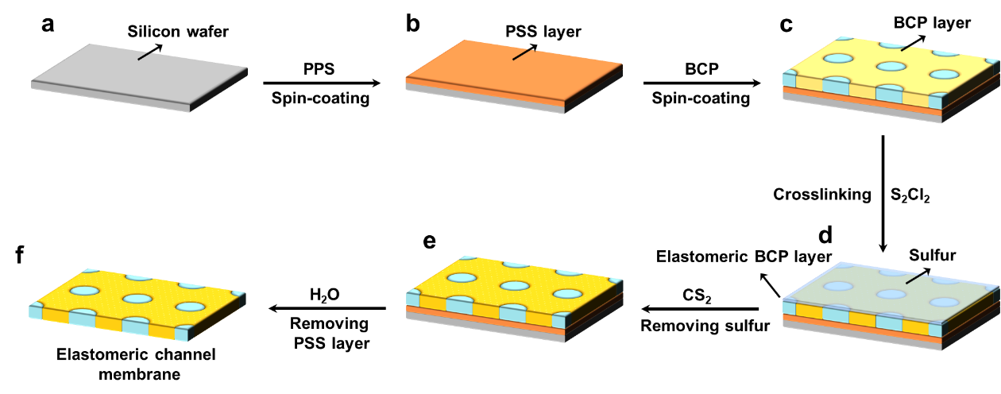
Fig. 1 Fabrication processes of flexible channel membrane based on PI-b-P4VP. (a) Silicon wafer as the substrate. (b) The formation of a sacrificial PSS layer. (c) The formation of the hexagonal-packed nanochannel structure by PI-b-P4VP. (d) The crosslinking of BCP membrane by S₂Cl₂ to bestow elastomeric property. (e) The removal of sulfur deposited onto the BCP layer by CS₂. (f) The removal of the PSS layer to obtain a self-standing and elastomeric membrane.

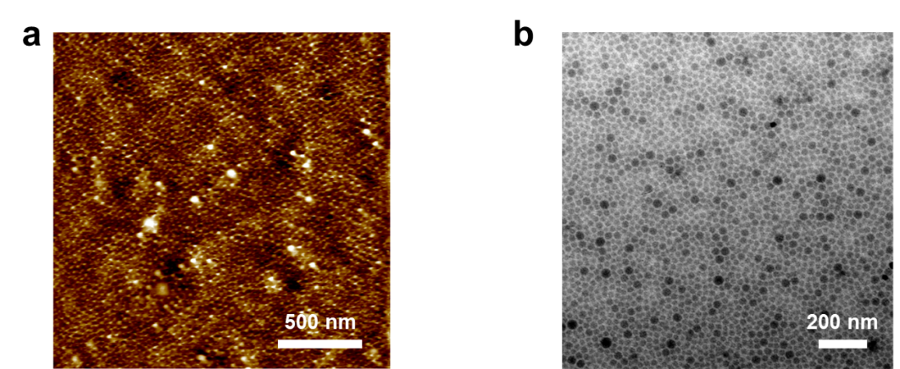
Fig. 2 Nanostructure of BCP membrane. (a) AFM height image and (b) TEM image of BCP membrane, showing hexagonal-packed nanocylinder structure.

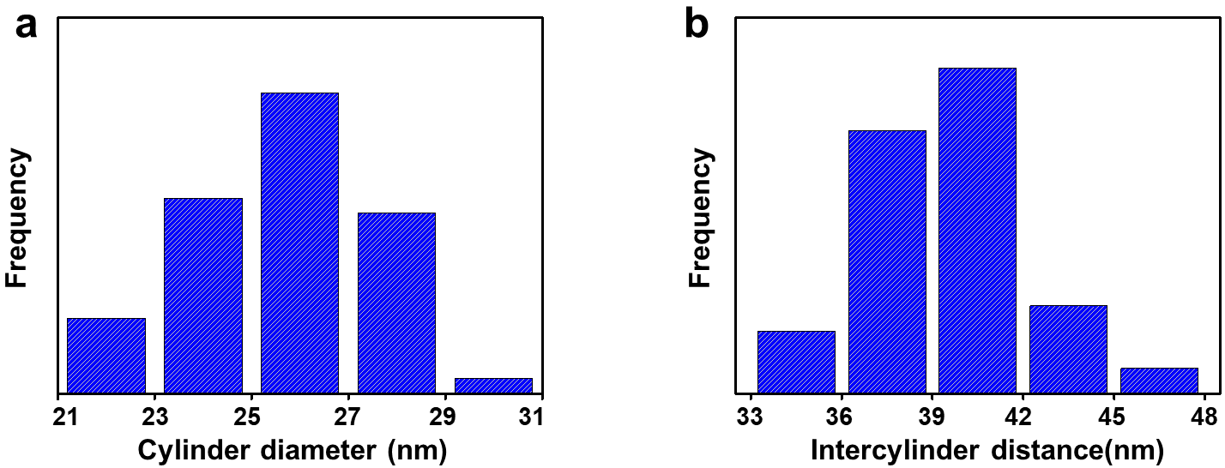
Fig. 3 Nanostructure parameters of BCP membrane. (a) The P4VP cylinder diameter distribution and (b) intercylinder distance distribution of BCP membrane. The average diameter is ~25.7 nm. The average intercylinder is ~ 40.7 nm.
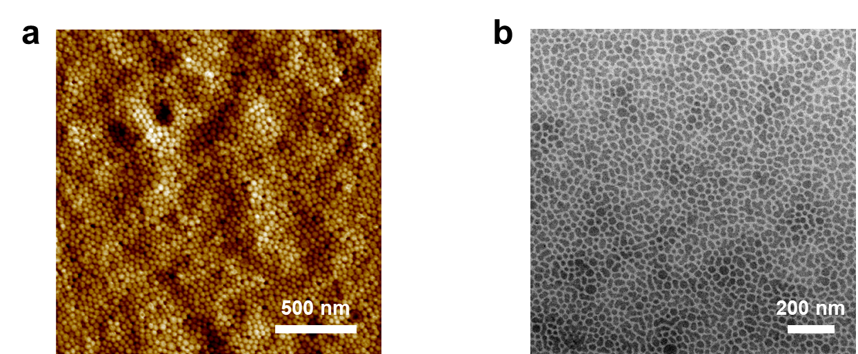
Fig. 4 Nanostructure of EMC-2 membrane. (a) AFM height image and (b) TEM image of EMC-2 membrane, showing hexagonal-packed nanocylinder structure.
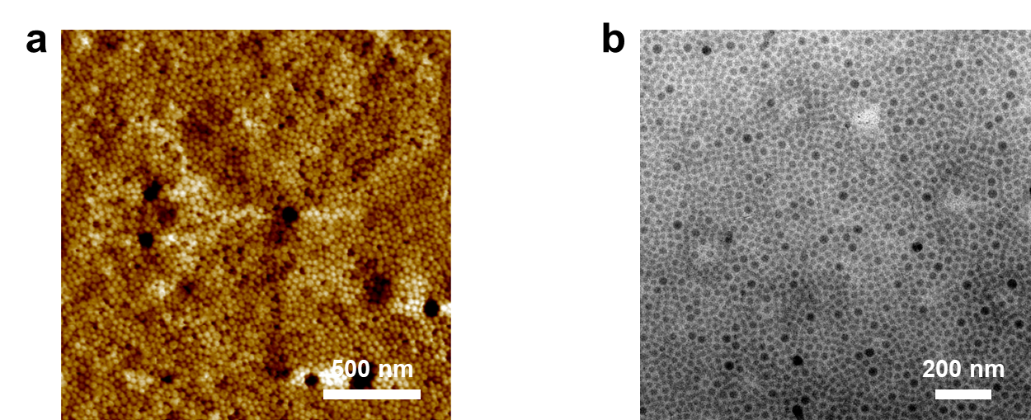
Fig. 5 Nanostructure of EMC-3 membrane. (a) AFM height image and (b) TEM image of EMC-3 membrane, showing hexagonal-packed nanocylinder structure.

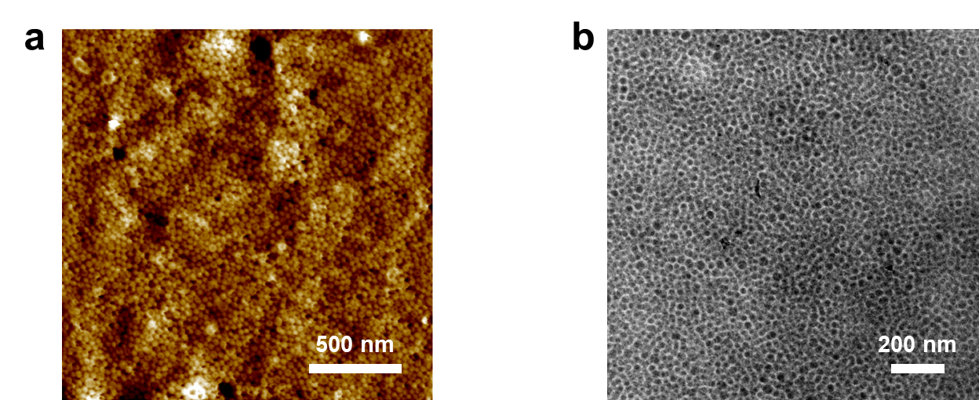
Fig. 6 Nanostructure of ECM-4 membrane. (a) AFM height image and (b) TEM image of EMC-4 membrane, showing hexagonal-packed nanocylinder structure.
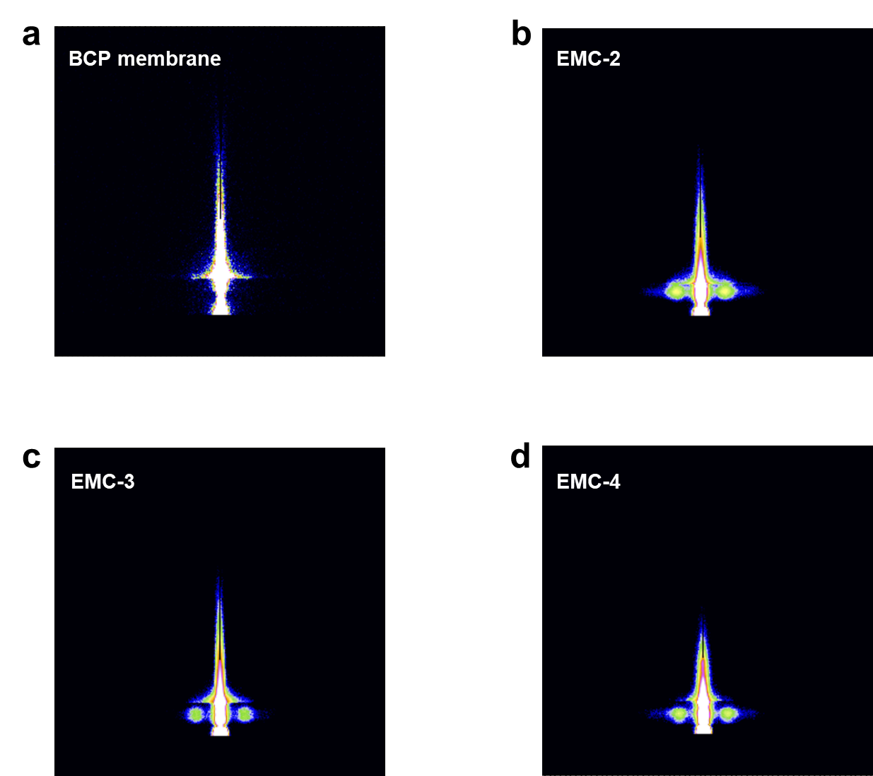
Fig. 7 GI-SAXS 2D patterns of (a) BCP, (b) EMC-2, (c) EMC-3, and (d) EMC-4 membranes. For all the samples, the appearance of diffraction spots on both sides of the meridian indicates a large-scale perpendicular nanochannel structure.
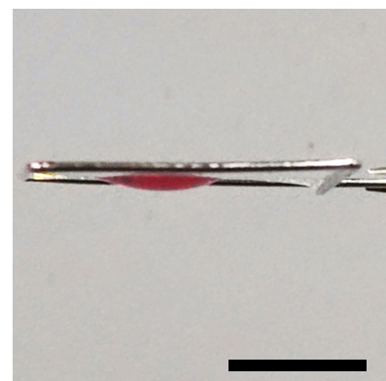
Fig. 8 Photographs of the membrane with a red droplet, indicating the excellent elastomeric property (scale bar: 1 cm).
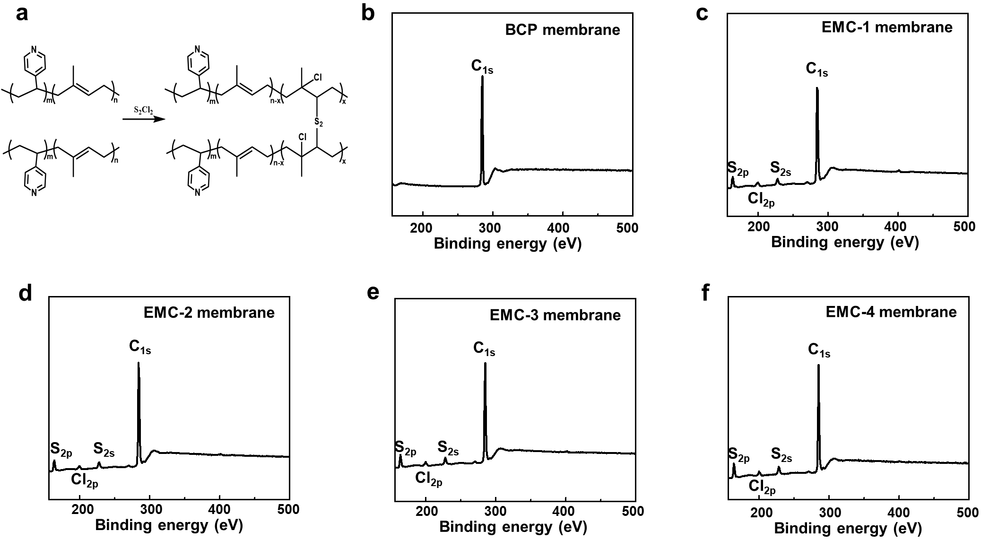
Fig. 9 XPS spectra of BCP and EMC membranes. (a) Illustrated scheme of BCP crosslinking. XPS spectra of (b) BCP, (c) EMC-1, (d) EMC-2, (e) EMC-3, and (f) EMC-4 membranes. The appearance of S and Cl signals indicates successful crosslinking.
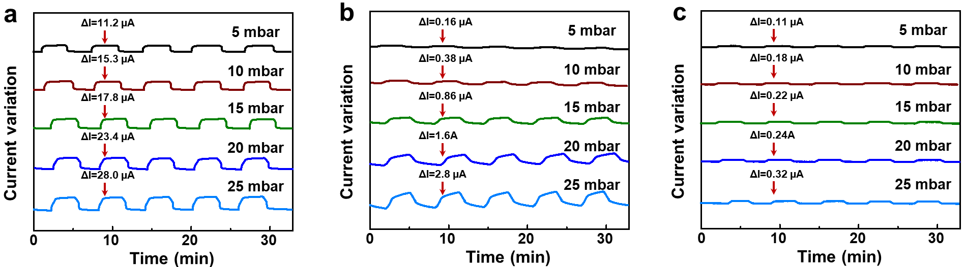
Fig. 10 The time-dependent response of ionic current of (a) EMC-2, (b) EMC-3, and (c) EMC-4 membranes towards different pressure, indicating deformation-regulated electrochemical response and excellent recovery.
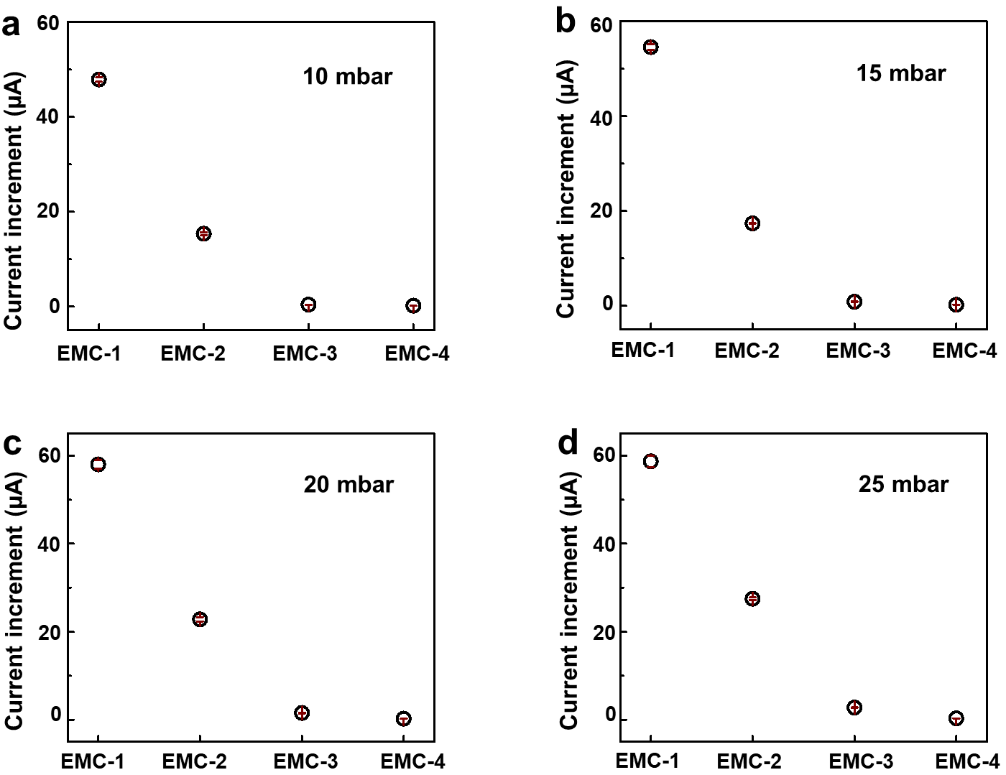
Fig. 11 The current increment for different EMC membranes with different bias pressures (a) 10 mbar, (b) 15 mbar, (c) 20 mbar, and (d) 25 mbar.
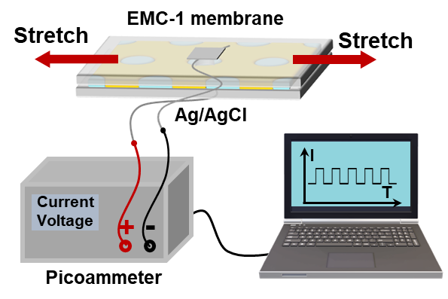
Fig. 12 Schematic of in-situ detection of stretch-induced electrochemical responses.

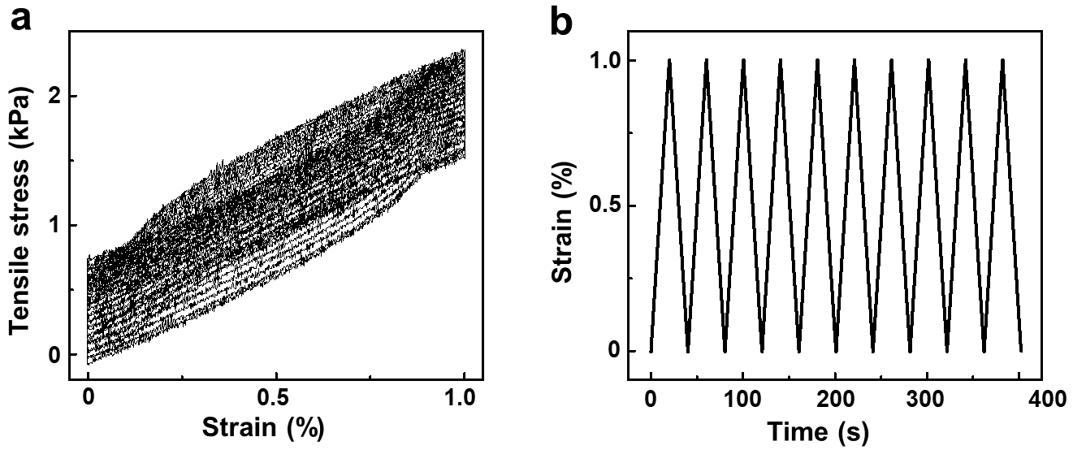
Fig. 13 (a) Stress-strain cycles of EMC-1 membranes at a 1% strain and (b) the cycle of stains as a function of time.
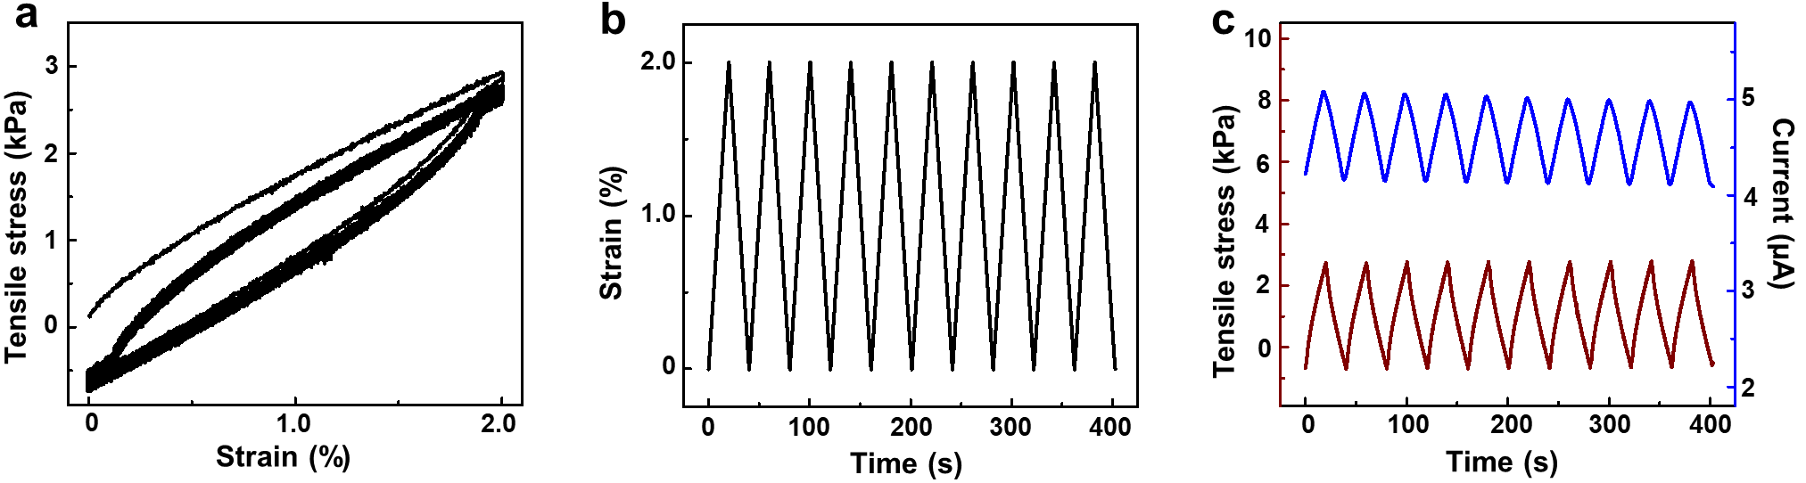
Fig. 14 The electrochemical response toward tensile stress at a 2% strain. (a) stress-strain cycles of EMC-1 membranes at a 2% strain. (b) the cycle of stains as a function of time. (c) ionic current values at 0.1 V versus tensile stress cycles. The variable trend of the ionic current value is well consistent with that of tensile stress.
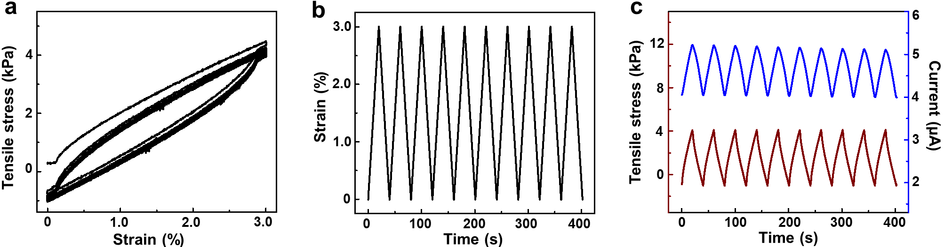
Fig. 15 The electrochemical response toward tensile stress at a 3% strain. (a) stress-strain cycles of EMC-1 membranes at a 3% strain. (b) the cycle of stains as a function of time. (c) ionic current values at 0.1 V versus tensile stress cycles. The variable trend of the ionic current value is well consistent with that of tensile stress.
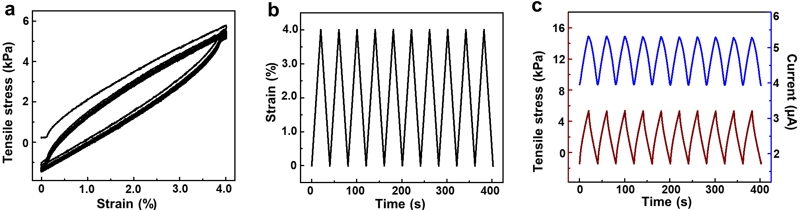
Fig. 16 The electrochemical response toward tensile stress at a 4% strain. (a) stress-strain cycles of EMC-1 membranes at a 4% strain. (b) the cycle of stains as a function of time. (c) ionic current values at 0.1 V versus tensile stress cycles. The variable trend of the ionic current value is well consistent with that of tensile stress.

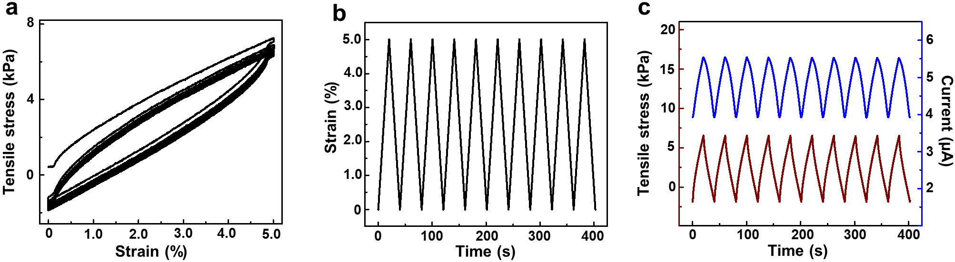
Fig. 17 The electrochemical response toward tensile stress at a 5% strain. (a) stress-strain cycles of EMC-1 membranes at a 5% strain. (b) the cycle of stains as a function of time. (c) ionic current values at 0.1 V versus tensile stress cycles. The variable trend of the ionic current value is well consistent with that of tensile stress.
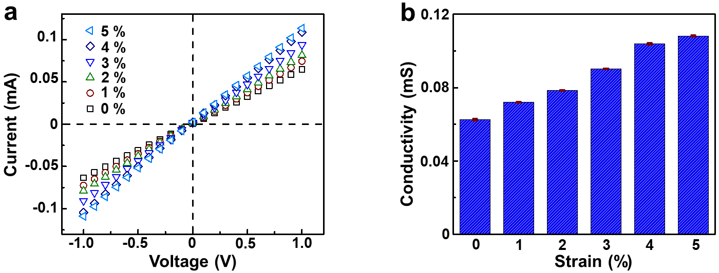
Fig. 18 The electrochemical response toward different strains. (a) I-V curves of EMC-1 membrane towards different stains. (b) Ionic conductivity of EMC-1 membrane towards different strains.

- Supplementary Tables
Table 1 Crosslinking degree of EMC membranes
Membranes | Crosslinking time (min) | Crosslinking degree (%) ^{[a]}
EMC-1 | 2 | 21.8
EMC-2 | 4 | 28.9
EMC-3 | 6 | 37.7
EMC-4 | 8 | 53.8
[a] The crosslinking degree of EMC membranes is evaluated by double-bond conversion of PI with the FT-IR technique.

Table 2 Comparison of mechanosensitivity between the elastomeric channels (EMCs), reported rigid channels (RMCs), and biological channels (BMCs).
Materials | Bias voltage (V) | Bias pressure (mbar) | Current increment (nA) | Mechanosensitivity  (nS·mbar⁻¹) | Ref.
Carbon nanotubes | 0.025 | 400 | ~0.03 | ~0.003 | 3
Graphite crystals | 0.05 | 25 | ~0.005 | ~0.004 | 4
Conical glass nanopores | 0.4 | 213 | ~0.2 | ~0.002 | 5
Conical glass nanocapillaries | 0.4 | 200 | ~0.18 | ~0.002 | 6
MscS homologs | 0.182 | 10.7 | ~0.0096 | ~0.005 | 7
MscL channel | 0.02 | 213 | ~0.5 | ~0.047 | 8
Elastomeric BCP | 1.0 | 5 | 35600 | ~7120 | This work

Table 3 Parameters of a single nanochannel toward different strains
Strains (%) | Width (nm) | Height (nm) | Length (nm)
0 | 27.10 | 27.10 | 200
1 | 27.43 | 26.99 | 199.2
2 | 27.76 | 26.88 | 198.4
3 | 28.09 | 26.77 | 197.6
4 | 28.42 | 26.66 | 196.8
5 | 28.76 | 26.54 | 195.9

Supplementary references
1 Liu, G., Li, Z. & Yan, X. Synthesis and characterization of polystyrene-block-polyisoprene nanofibers with different crosslinking densities. Polymer 44, 7721-7727 (2003).
2 Zhang, Z. et al. Ultrathin and ion-selective Janus membranes for high-performance osmotic energy conversion. J. Am. Chem. Soc. 139, 8905-8914 (2017).
3 Marcotte, A., Mouterde, T., Niguès, A., Siria, A. & Bocquet, L. Mechanically activated ionic transport across single-digit carbon nanotubes. Nat. Mater. 19, 1057-1061 (2020).
4 Mouterde, T. et al. Molecular streaming and its voltage control in ångström-scale channels. Nature 567, 87-90 (2019).
5 Lan, W.-J., Holden, D. A. & White, H. S. Pressure-dependent ion current rectification in conical-shaped glass nanopores. J. Am. Chem. Soc. 133, 13300-13303 (2011).
6 Jubin, L., Poggioli, A., Siria, A. & Bocquet, L. Dramatic pressure-sensitive ion conduction in conical nanopores. P. Natl. Acad. Sci. U.S.A. 115, 4063-4068 (2018).
7 Haswell, E. S., Peyronnet, R., Barbier-Brygoo, H., Meyerowitz, E. M. & Frachisse, J. M. Two MscS homologs provide mechanosensitive channel activities in the Arabidopsis root. Curr. Biol. 18, 730-734 (2008).
8 Doerner, J. F., Febvay, S. & Clapham, D. E. Controlled delivery of bioactive molecules into live cells using the bacterial mechanosensitive channel MscL. Nat. Commun. 3, 1-8 (2012).

