Supplementary Figures
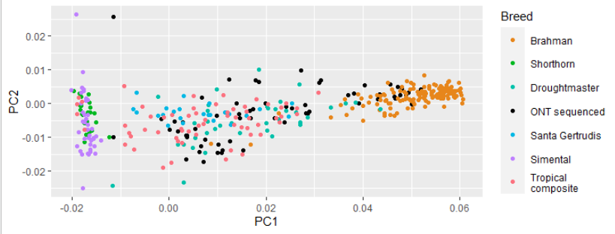

Figure S1. Principal component plot for the 1,208 animals in the SNP reference panel and 64 animals sequenced using Oxford Nanopore Technologies’ (ONT) MinION as part of this study.

Figure S2. Correlations between hip height (HH) genomic estimated breeding values (GEBV) derived from 35k SNP array genotypes and HH GEBVs derived from Oxford Nanopore Technologies (ONT) data. ONT GEBVs were imputed using four different imputation strategies and across five sequencing coverages. SNP reference panel size is indicated by the minor allele frequency (MAF) filter on the right-hand side in descending order of size from top to bottom. The largest panel had 48,203,338 SNP and was referred to as the No MAF filter panel, while the smallest panel was referred to as the bovine high density (HD) SNP which had only the 641k SNP used to calculate the GEBVs. Error bars indicate 95% confidence of the Pearson correlation.

Figure S3. Correlations between corpus luteum score (CL score) genomic estimated breeding values (GEBV) derived from 35k SNP array genotypes and HH GEBVs derived from Oxford Nanopore Technologies (ONT) data. ONT GEBVs were imputed using four different imputation strategies and across five sequencing coverages in descending order of size from top to bottom. The largest panel had 48,203,338 SNP and was referred to as the No MAF filter panel, while the smallest panel was referred to as the bovine high density (HD) SNP which had only the 641k SNP used to calculate the GEBVs. SNP reference panel size is indicated by the minor allele frequency (MAF) filter on the right-hand side. Error bars indicate 95% confidence in the Pearson correlation.
Figure S4. Correlations between body condition score (BCS) genomic estimated breeding values (GEBV) derived from 35k SNP array genotypes and HH GEBVs derived from Oxford Nanopore Technologies (ONT) data. ONT GEBVs were imputed using four different imputation strategies and across five sequencing coverages. SNP reference panel size is indicated by the minor allele frequency (MAF) filter on the right-hand side in descending order of size from top to bottom. The largest panel had 48,203,338 SNP and was referred to as the No MAF filter panel, while the smallest panel was referred to as the bovine high density (HD) SNP which had only the 641k SNP used to calculate the GEBVs. Error bars indicate 95% confidence in the Pearson correlation.

