Supplementary Materials
Table S1. The datum of LIPs^{16,20-22}
Linked to the African or Pacific LLSVP (superplume) | Name and age of LIPs
The red solid line representes linked to the African LLSVP (superplume), from right to left is: | 1. Ethiopia(31Ma); 2.North Atlantic(54Ma);  3. Deccan Traps(65Ma); 4. S.Leone Rise(73Ma);  5. Madagascar(84Ma); 6. Broken Ridge(95Ma);  7. Wallaby Plateau(96Ma); 8. Central Kerguelen(100Ma);  9. Southern Kerguelen(114Ma);  10. Rajmahal Traps(118Ma); 11. Banbury Basalts(132Ma);  12. Parana-Etendeka(132Ma); 13. Gascoyne(136Ma);  14.Karroo(183Ma); 15. CAMP(201Ma);  16. Panjal Traps(285Ma); 17. Skagerrak LIP(297Ma);  18.Yakutsk LIP (360 Ma); 19. Altay-Sayan (400Ma);  20. Kalkarindji (510Ma).
The cray solid line representes linked to the Pacific LLSVP (superplume), from right to left is: | 1. Ontong Java 2(90Ma); 2. Hess Rise(99Ma);  3. Nauru(111Ma); 4. Ontong Java 1(121Ma);  5. Manihiki Plateau(123Ma); 6. Magellan Rise(145Ma);  7. Shatsky Rise(147Ma); 8. Emeishan(258Ma).

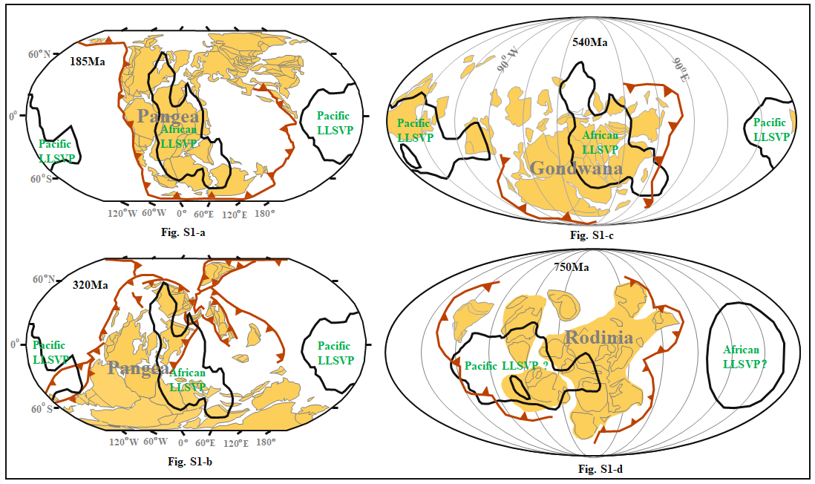

Figure S1. Reconstruction of plate tectonics at 185 Ma (a) ⁶⁷, 320 Ma (b) ⁶⁷, 540 Ma (c) ^{21,67,71} and 750 Ma (d) ^{67,69,71}, showing the distribution of subduction zones and the possible locations of the Pacific and African LLVSPs (modified after Refs. 21, 40, 67, 69 and 71).

