Fig. S1 The frequency distribution of all traits for the RIL population. The x-axis indicates the traits; the y-axis indicates the number of individuals. The arrows indicate the phenotype in two parental lines (1423 and 2205)
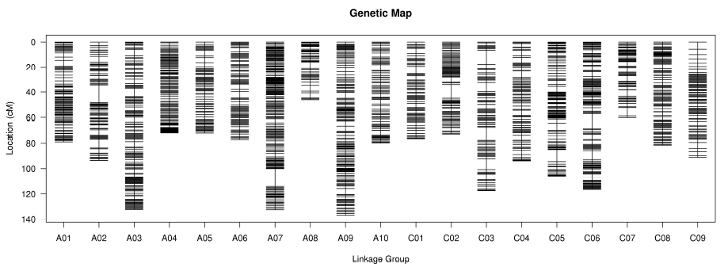

Fig. S2 Genetic map constructed using the RIL population derived from the parental lines
Fig. S3 The effect of salt (200mM NaCl) on roots length of Brassica napus L.

Fig. S4 Pearson’s correlation and principal component analysis between eighteen samples of RNA-Seq.

Fig. S5 Comparison of RNA-seq and qRT-PCR results for the relative expression of selected genes at 0, 3 and 24h salt stress. Error bars refer to ± SD (n = 3).

Fig. S6 Cluster analysis and heat maps of relative expression profiles for the 99 (left) and 162 (right) DEG

