Supplementary Appendix
This appendix has been provided by the authors to give readers additional information about their work

Supplemental Appendix Table of Contents
S1 (Search Strategy) ……………………………………………………………………………………………………………….Pages 2-3
S2 (PRISMA Flow Diagram of Study Selection Process) …………………………………..………………………Page 4
S3 (ROBINS-I Assessment Summary) ..…………………………………………………………………………………….Page 5
S4 (Funnel Plot) …………………………………..……………………………………………………………………….…………Page 6
S5 (Forest Plot of Humoral Response Rate to SARS-CoV-2 Vaccination in CAR-T Recipients After a Primary Vaccination Course Stringently Stratified by Target Construct) ………………………………………………Page 7

Appendix S1: Search Strategy
Ovid MEDLINE(R) ALL
1 | Immunotherapy, Adoptive/
2 | (CAR-T or car t or car t-cell*).mp.
3 | (chimeric antigen receptor* adj3 (t cell* or therap*)).mp.
4 | ((nk or natural killer) adj3 (therap* or immunotherap*)).mp.
5 | (adoptive adj3 immunotherap*).mp.
6 | (immune-based adj3 therap*).mp.
7 | (immune effector adj3 therap*).mp.
8 | or/1-7
9 | exp COVID-19 Nucleic Acid Testing/ or exp COVID-19/ or exp COVID-19 Testing/ or exp COVID-19 Serological Testing/
10 | exp SARS-CoV-2/
11 | exp Coronavirus/
12 | (COVID-19 or COVID19 or SARS-CoV-2 or Severe Acute Respiratory Syndrome Coronavirus 2 or NCOV or 2019 NCOV or coronavirus or COV).mp.
13 | or/9-12
14 | exp Vaccines/ or exp Vaccination/
15 | (vaccinat* or vaccine* or immuniz*).mp.
16 | 14 or 15
17 | 13 and 16
18 | COVID-19 Vaccines/
19 | 17 or 18
20 | 8 and 19
21 | limit 20 to (english language and yr="2019 -Current")
Scopus
1 | TITLE-ABS-KEY("CAR-T" OR "car t" OR "car t-cell") OR TITLE-ABS-KEY(("chimeric antigen receptor*" W/3 ("t cell*" OR therap*))) OR TITLE-ABS-KEY((nk OR "natural killer") W/3 (therap* OR immunotherap*)) OR TITLE-ABS-KEY(adoptive W/3 immunotherap*) OR TITLE-ABS-KEY("immune-based" W/3 therap*) OR TITLE-ABS-KEY("immune effector" W/3 therap*)
2 | TITLE-ABS-KEY("COVID-19" OR COVID19 OR "SARS-CoV-2" OR "Severe Acute Respiratory Syndrome Coronavirus 2" OR NCOV OR "2019 NCOV" OR coronavirus OR COV)
3 | TITLE-ABS-KEY(vaccinat* or vaccine* or immuniz*)
4 | #1 AND #2 AND #3
 | Limit 2019 - Current, English Language
Web of Science
1 | TS=("CAR-T" OR "car t" OR "car t-cell") OR TS=("chimeric antigen receptor*" NEAR/3 ("t cell*" OR therap*)) OR TS=((nk OR "natural killer") NEAR/3 (therap* OR immunotherap*)) OR TS=(adoptive NEAR/3 immunotherap*) OR TS=("immune-based" NEAR/3 therap*) OR TS=("immune effector" NEAR/3 therap*)
2 | TS=("COVID-19" OR COVID19 OR "SARS-CoV-2" OR "Severe Acute Respiratory Syndrome Coronavirus 2" OR NCOV OR "2019 NCOV" OR coronavirus OR COV)
3 | TS=(vaccinat* OR vaccine* OR immuniz*)
4 | 1 AND 2 AND 3
 | Limit 2019 - Current, English Language
Cochrane Central Register of Controlled Trials (Wiley)
1 | ("CAR-T" OR "car t" OR "car t-cell") OR ("chimeric antigen receptor*" NEAR/3 ("t cell*" OR therap*)) OR ((nk OR "natural killer") NEAR/3 (therap* OR immunotherap*)) OR (adoptive NEAR/3 immunotherap*) OR ("immune-based" NEAR/3 therap*) OR ("immune effector" NEAR/3 therap*)
2 | ("COVID-19" OR COVID19 OR "SARS-CoV-2" OR "Severe Acute Respiratory Syndrome Coronavirus 2" OR NCOV OR "2019 NCOV" OR coronavirus OR COV)
3 | (vaccinat* OR vaccine* OR immuniz*)
4 | #1 AND #2 AND #3
5 | Limited to Cochrane Central Register of Controlled Trials

Appendix S2: PRISMA Flow Diagram of Study Selection Process
Title and abstract screened (n = 633)
Included
Eligibility
Screening
Identification
Records identified through database searching (n = 974)
  - Ovid MEDLINE (n = 249)
  - Scopus (n = 517)
  - Web of Science (n = 160)
  - Cochrane Library (n= 48)
Additional records identified through other sources
(n = 21)
- medRxiv (n = 5)
- Hand searching (n = 17)

Records after duplicates removed
(n = 633)

Records excluded (n=571)

Full-text articles excluded (n = 44)

Reasons for exclusion:
- No CAR-T construct-specific data (n = 32)
- No primary data (n = 6)
- Case report (n = 3)
- Duplication (n = 3)

Full-text articles assessed for eligibility
(n = 62)

Studies included in scoping review
(n = 18)

Appendix S3: (ROBINS-I Assessment Summary)
 | Domain 1: Risk of bias due to confounding | Domain 2: Bias in selection of participants into the study | Domain 3: Bias in classification of interventions |  | Domain 4: Bias due to deviations from intended interventions | Domain 5: Bias due to missing data | Domain 6: Bias in measurement of outcomes | Domain 7: Bias in selection of the reported results | Overall bias
Bergman et al. | Low | Low | Low | Low |  | Low | Low | Low | Low
Dahiya et al. | Medium | Low | Low | Low |  | Low | Low | Low | Medium
Dhakal et al. | Medium | Low | Low | Low |  | Low | Low | Low | Medium
Fox et al. | Low | Low | Low | Low |  | Low | Low | Low | Low
Greenberger et al. | Low | Low | Low | Low |  | Low | Low | Low | Low
Gastinne et al. | Medium | Low | Low | Low |  | Low | Low | Low | Medium
Haggenburg et al. | Low | Low | Low | Low |  | Low | Low | Low | Low
Healy et al. | Medium | Low | Low | Low |  | Low | Low | Low | Medium
Lim et al. | Medium | Medium | Low | Low |  | Medium | Low | Low | Medium
Parvathaneni et al. | Medium | Low | Low | Low |  | Low | Low | Low | Medium
Ram et al. (2021) | Low | Low | Low | Low |  | Low | Low | Low | Low
Shapiro et al. | Low | Medium | Low | Low |  | Low | Low | Low | Medium
Tamari et al. | Low | Low | Low | Low |  | Low | Low | Low | Low
Thakkar et al. | Low | Medium | Low | Low |  | Medium | Low | Low | Medium
Van Oekelen et al. | Low | Low | Low | Low |  | Low | Low | Low | Low
Abid et al. | Low | Low | Low | Low |  | Low | Low | Low | Low
Sesques et al. | Low | Low | Low | Low |  | Low | Low | Low | Low
Ram et al. (2022) | Medium | Low | Low | Low |  | Low | Low | Low | Medium

Appendix S4: (Funnel Plot)
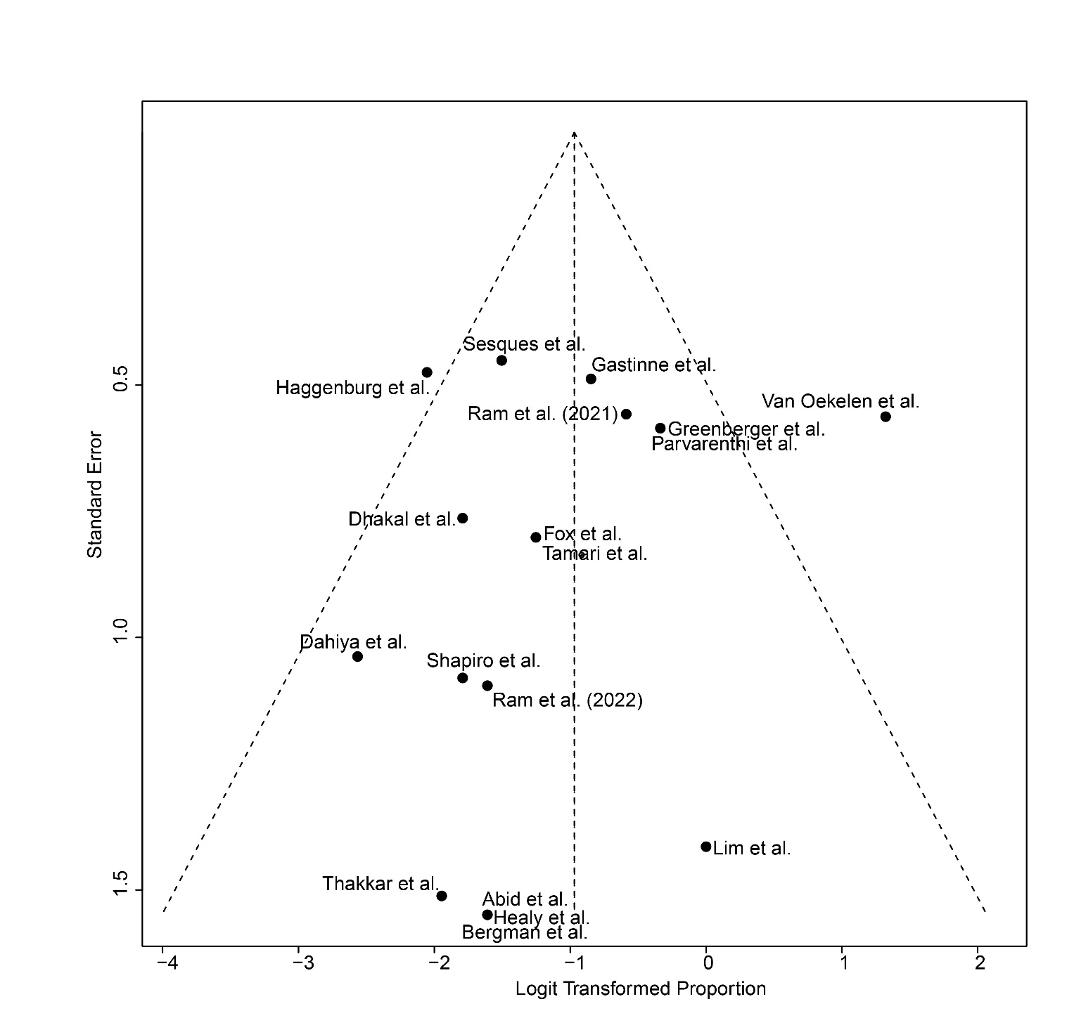

Appendix S5: Forest Plot of Humoral Response Rate to SARS-CoV-2 Vaccination in CAR-T Recipients After Primary Vaccination Series Strictly Stratified by CAR-T Target Antigen
