Appendix- additional results
Table A1. Results of the Cox proportional regression model without random factor. Likelihood ratio test=7.76 on 4 df, p=0.1007.
Fixed effect included in the model | coef | exp(coef) | se(coef) | z | p
Sex - male | 0.299 | 1.348 | 0.481 | 0.622 | 0.534
Age - juvenile | 0.878 | 2.406 | 0.597 | 1.469 | 0.142
Mean max-displacement | 0.127 | 1.136 | 0.313 | 0.408 | 0.683
Mean max-displacement rIIV | -1.482 | 0.227 | 0.645 | -2.299 | 0.021

Table A2. Results of the Cox proportional regression model with ring ID as a random factor. Integrated loglik: Chisq=7.79; df=5; p=0.15. Random effect Ring_ID Intercept: Std Dev=0.553; Variance=0.3.
Fixed effect included in the model | coef | exp(coef) | se(coef) | z | p
Sex - male | 0.369 | 1.447 | 0.527 | 0.70 | 0.48
Age - juvenile | 0.917 | 2.502 | 0.632 | 1.45 | 0.15
Mean max-displacement | 0.080 | 1.083 | 0.343 | 0.23 | 0.82
Mean max-displacement rIIV | -1.519 | 0.219 | 0.660 | -2.23 | 0.021

Table A3. Number of individuals tracked each trimester. Trimesters are 1st-trimester Feb-May, incubating/nesting period; 2nd-trimester Jun-Sep, rearing/post-breeding period; and 3rd-trimester Oct-Jan, fall-winter time.
Trimester | Adult female | Adult male | Juvenile female | Juvenile male | Total
2020 trimester 2 | 5 | 1 | 11 | 9 | 26
2020 trimester 3 | 2 | 2 | 5 | 8 | 17
2021 trimester 1 | 10 | 5 | 3 | 2 | 20
2021 trimester 2 | 20 | 6 | 12 | 10 | 48
2021 trimester 3 | 12 | 2 | 1 | 2 | 17
Total | 49 | 16 | 32 | 31 | 128
Table A4. Repeatability (Rp) and coefficient of variation for among-individual variance (CVi) values for total-distance and nightly max-displacement.
 | Rp | CVi
Total distance | 0.391 [0.302, 0.483] | 0.526 [0.441, 0.611]
Max displacement | 0.228 [0.158, 0.297] | 0.362 [0.303, 0.426]

Table A5. Modified Akaike Information Criterion (AICc) for top ten models estimating HR size by all our fixed effects. All top models include (i) Age; and (ii) Trimester as fixed effects, as well as additional fixed effects which are mentioned in detail. Abbreviations: TrackingNights is the number of tracking night for each trimester, to account for tracking duration; MaxDisp - mean nightly maximal displacement; rIIV - the index of predictability in max-displacement, mean value; TotalDist - mean nightly total-distance.
Fixed effect included in the model | K | AICc | Delta_AICc | AICcWt | Cum.Wt | LL
TrackingNights; MaxDisp; rIIV | 9 | 345.64 | 0 | 0.54 | 0.54 | -163.05
Sex; TrackingNights; MaxDisp; rIIV | 10 | 347.88 | 2.24 | 0.18 | 0.72 | -162.99
TrackingNights; MaxDisp | 8 | 349.94 | 4.3 | 0.06 | 0.78 | -166.36
MaxDisp | 7 | 350.53 | 4.9 | 0.05 | 0.83 | -167.8
TrackingNights; MaxDisp; TotalDist | 9 | 351.69 | 6.05 | 0.03 | 0.89 | -166.07
MaxDisp; TotalDist | 8 | 352.19 | 6.55 | 0.02 | 0.91 | -167.48
Sex; TrackingNights; MaxDisp | 9 | 352.25 | 6.62 | 0.02 | 0.93 | -166.36
Sex; MaxDisp | 8 | 352.79 | 7.16 | 0.02 | 0.96 | -167.79
Sex; TrackingNights; MaxDisp; TotalDist | 10 | 354.00 | 8.36 | 0.0 | 0.99 | -166.05
Sex; MaxDisp; TotalDist | 9 | 354.41 | 8.77 | 0.01 | 0.99 | -167.43

Table A6. Fixed effect estimation on the home-range (HR) size from the best ranked model.
 | Estimate | Std. Error | t. value
(Intercept) | 15.69 | 0.26 | 58.90
Age - juvenile | 0.35 | 0.20 | 1.75
Trimester - tri2 | 0.51 | 0.22 | 2.26
Trimester - tri3 | 0.43 | 0.25 | 1.75
Tracking night number | -0.003 | 0.002 | -1.39
Mean max-displacement | 0.49 | 0.09 | 5.18
Mean MaxDisp rIIV | 0.27 | 0.10 | 2.66

Table A7. Models estimating rIIV by all our fixed effects. Ranking based on ΔAICc of models comparing fixed effect combination affecting rIIV.
Fixed effect included in the model | df | logLik | AICc | Delta_AICc | AICcWt
age | 4 | -145.97 | 300.26 | 0.00 | 0.49
Age-year | 5 | -145.20 | 3000.88 | 0.62 | 0.36
Age-sex | 5 | -146.87 | 304.22 | 3.96 | 0.07
Age-sex-year | 6 | -146.12 | 304.93 | 4.67 | 0.05
Age-trimester | 6 | -147.41 | 307.51 | 7.24 | 0.01
age-trimester-year | 7 | -146.38 | 307.68 | 7.41 | 0.01
Age-sex-trimester | 7 | -148.32 | 311.57 | 11.31 | 0.00
Age-sex-trimester-year | 8 | -147.31 | 311.83 | 11.56 | 0.00
(Null) | 3 | -160.58 | 327.36 | 27.10 | 0.00
sex | 4 | -160.84 | 330.01 | 29.74 | 0.00
year | 4 | -161.39 | 331.10 | 30.84 | 0.00
Sex- year | 5 | -161.68 | 333.84 | 33.58 | 0.00
trimester | 5 | -161.98 | 334.45 | 34.18 | 0.00
sex-trimester | 6 | -162.21 | 337.12 | 36.85 | 0.00
Trimester- year | 6 | -162.76 | 338.22 | 37.95 | 0.00
sex-trimester- year | 7 | -163.02 | 340.97 | 40.70 | 0.00

Table A8. Model-averaged coefficients (full) for fixed effect describing rIIV.
 | Estimate | Std.Error | Adj SE | Z value | Pr(>|z|)
(Intercept) | 1.078 | 0.185 | 0.186 | 5.795 | 6.8321e-09 | ***
Age_binary young | 0.932 | 0.154 | 0.155 | 6.005 | 1.9161e-09 | ***
Year2021 | 0.12 | 0.173 | 0.173 | 0.697 | 0.48477
sexmale | -0.004 | 0.055 | 0.056 | 0.079 | 0.93669
Trimestertrimester2 | 0.005 | 0.042 | 0.042 | 0.11 | 0.91197
Trimestertrimester3 | 0.002 | 0.04 | 0.04 | 0.06 | 0.95243

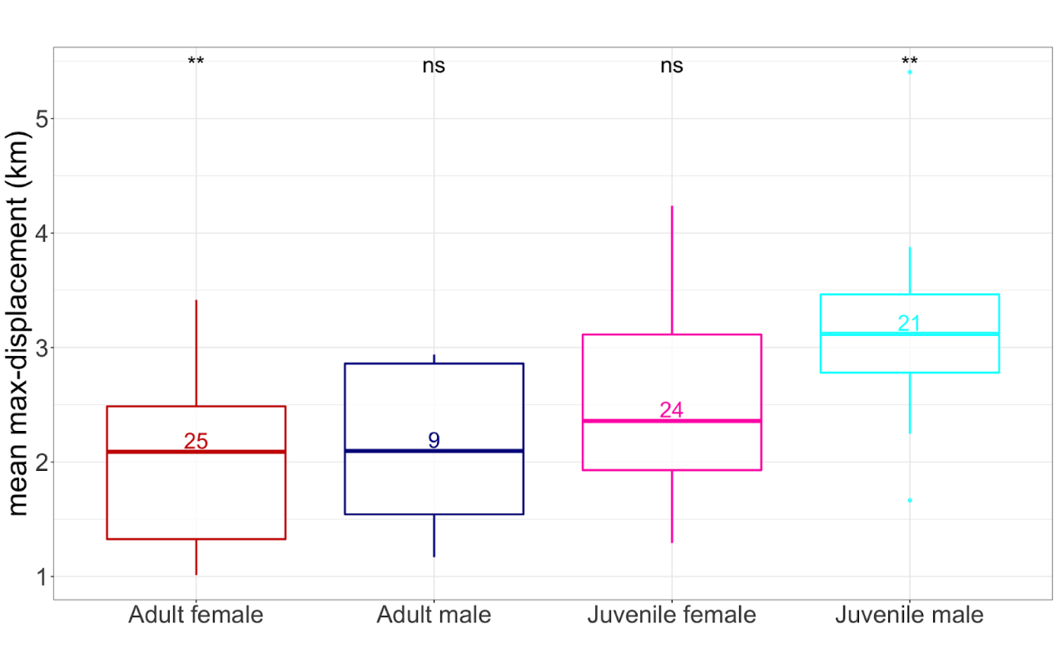
Figure A1. Age and sex related differences in the nightly max-displacement for the entire dataset (not divided by trimesters). Juveniles have longer distances compared to adults, and males tend to have longer distances compared to females (one-way ANOVA, F_{df=3}=8.97, P<0.001).
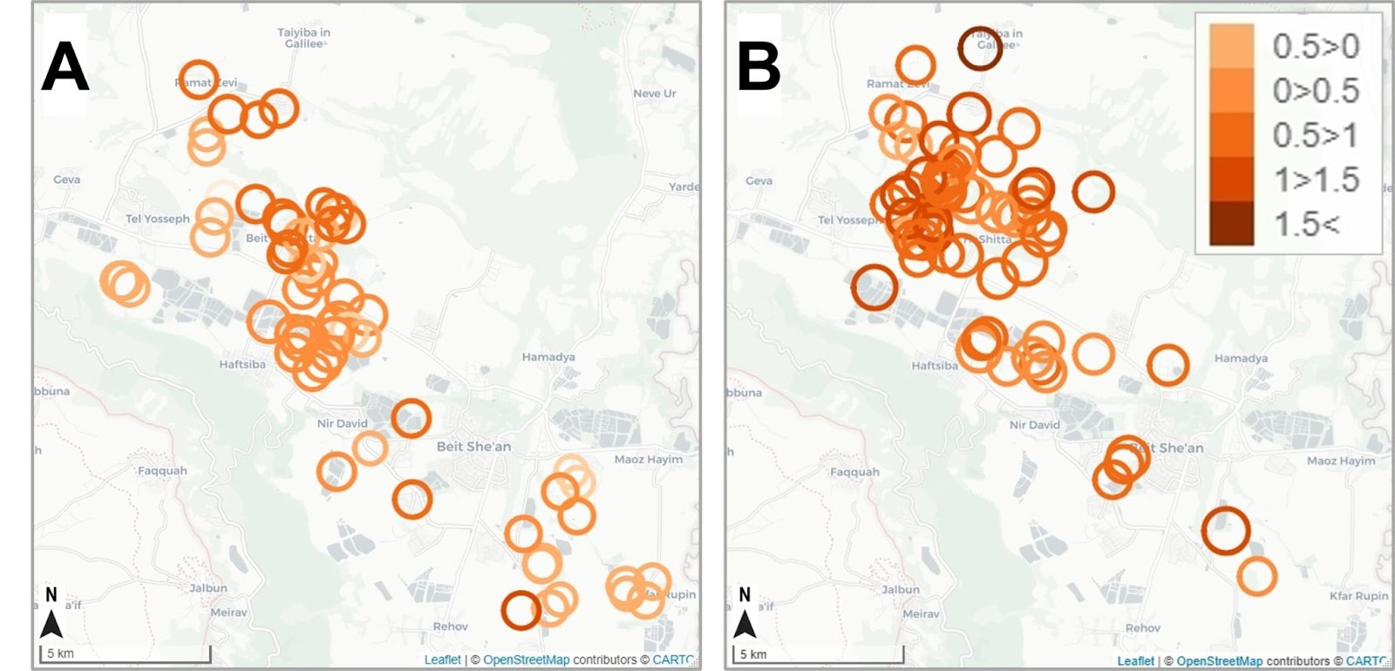
Figure A2. Barn owls' central Home-range (HR) and rIIV spatial scattering across the study area of the Harod valley, for adults (A) and juveniles (B). Each circle represents a single individual, where the center and the radius of the circle represent the HR center and size (log HR size, by addCircleMarkers function), respectively. Colors indicate each individual's predictability value (i.e., mean rIIV, splits into five groups).

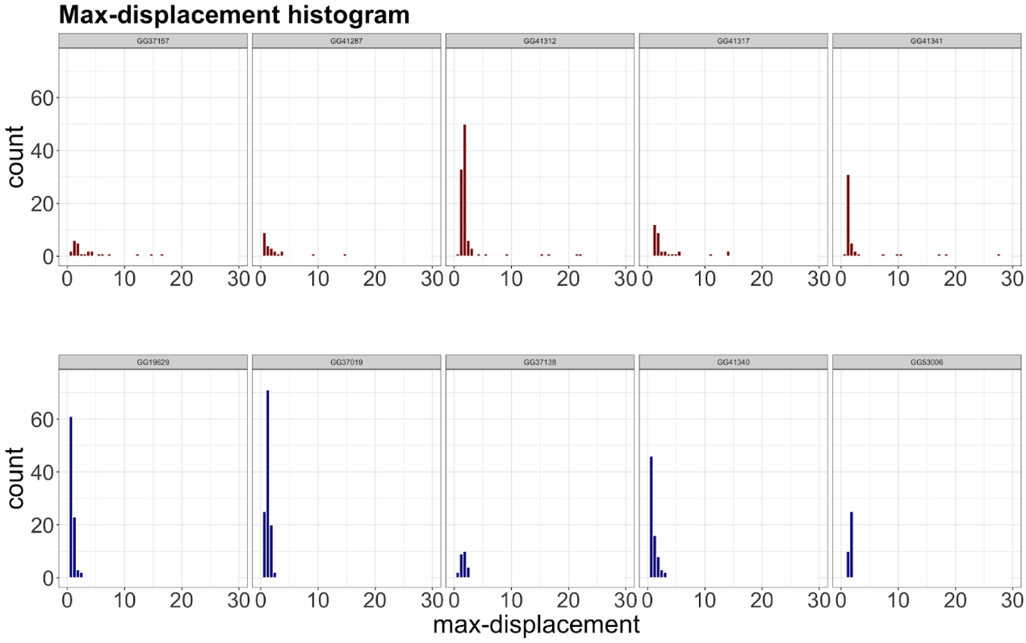
Figure A3. Histogram of nightly max-displacement values for the five most unpredictable individuals (top, red) and five most predictable individuals (bottom, blue) for the second trimester of 2021. Both groups were generally characterized by a well-defined peak around 3-5 km, but unpredictable individuals had occasionally long values of max-displacement contributing to their higher rIIV values.

