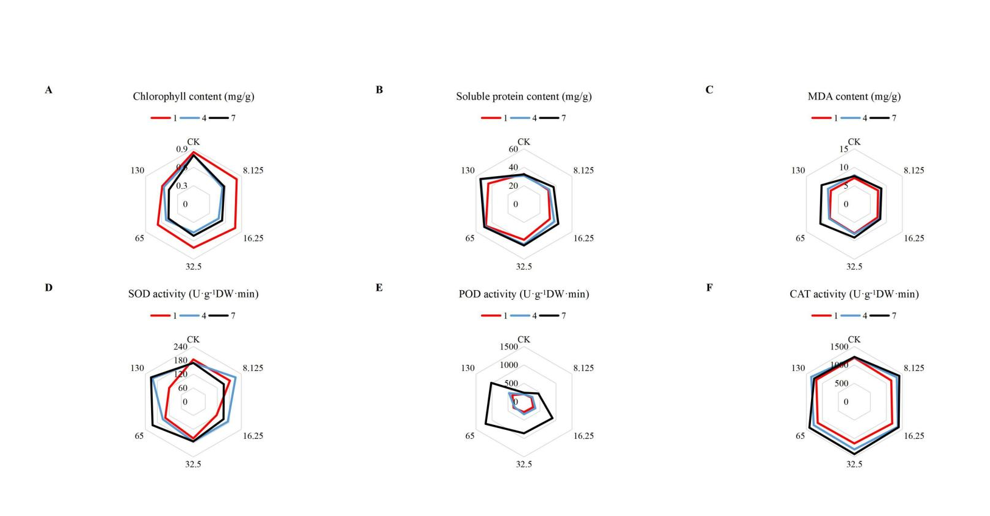

Fig. S1 Effect of MCPA-Na exposure with time on the (A) chlorophyll, (B) soluble protein, and (C) MDA (malondialdehyde) content, and (D) SOD (superoxide dismutase), (E) POD (peroxidase), (F) CAT (catalase) activities at the seedling stage.

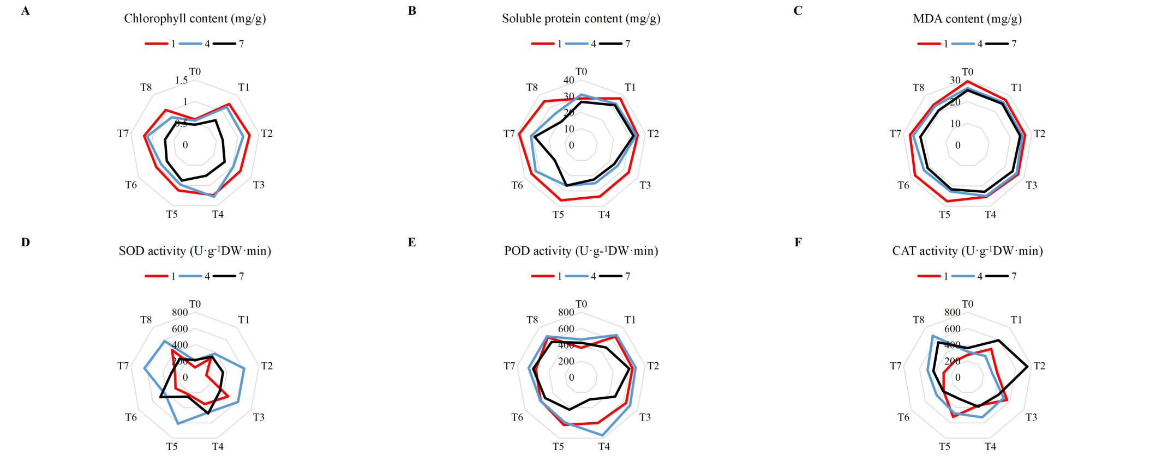

Fig. S2 Effect of different combinations of plant growth regulators with time on the (A) chlorophyll, (B) soluble protein, and (C) MDA (malondialdehyde) content, and (D) SOD (superoxide dismutase), (E) POD (peroxidase), (F) CAT (catalase) activities at the seedling stage. T0 (control), T1 (brassinosteroids), T2 (gibberellin + seaweed fertilizer), T3 (brassinosteroids + seaweed fertilizer) and T4 (phthalanilic acid + seaweed fertilizer), T5 (gibberellin), T6 (brassinosteroids + gibberellin + phthalanilic acid + seaweed fertilizer), T7 (phthalanilic acid), T8 (brassinosteroids + gibberellin + phthalanilic acid).
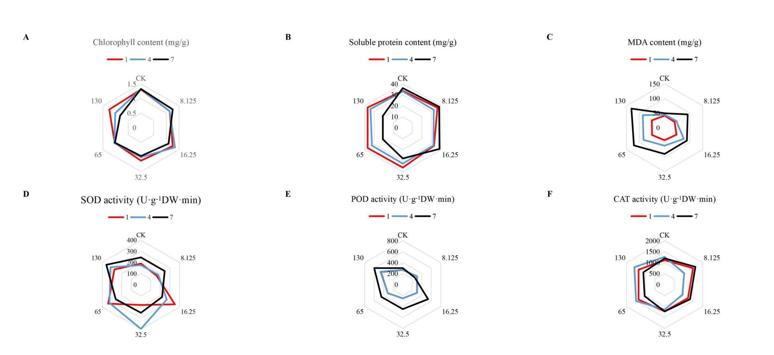

Fig. S3 Effect of MCPA-Na exposure with time on the (A) chlorophyll, (B) soluble protein, and (C) MDA (malondialdehyde) content, and (D) SOD (superoxide dismutase), (E) POD (peroxidase), (F) CAT (catalase) activities at the budding stage.

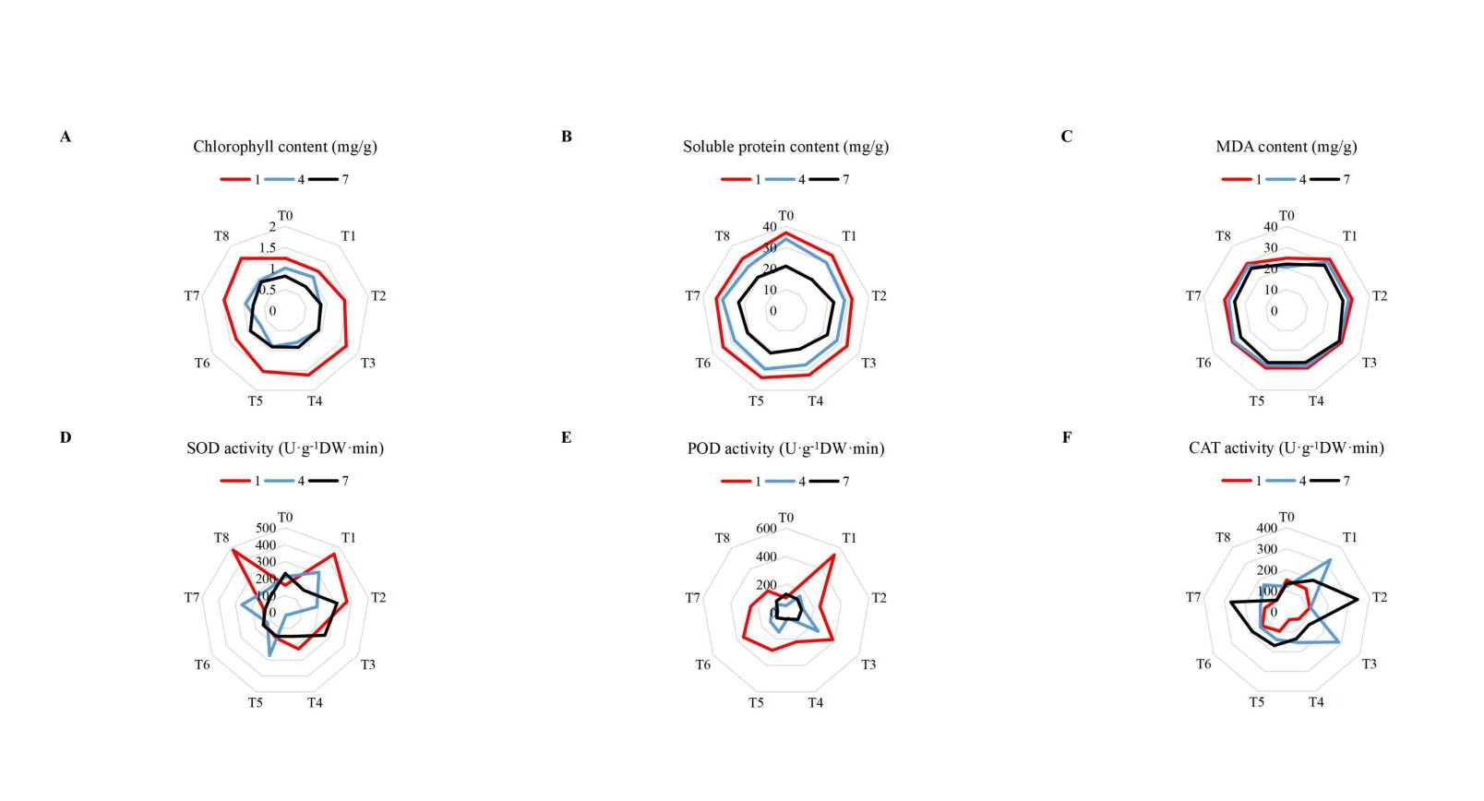

Fig. S4 Effect of different combinations of plant growth regulators with time on the (A) chlorophyll, (B) soluble protein, and (C) MDA (malondialdehyde) content, and (D) SOD (superoxide dismutase), (E) POD (peroxidase), (F) CAT (catalase) activities at the budding stage. T0 (control), T1 (brassinosteroids), T2 (gibberellin + seaweed fertilizer), T3 (brassinosteroids + seaweed fertilizer) and T4 (phthalanilic acid + seaweed fertilizer), T5 (gibberellin), T6 (brassinosteroids + gibberellin + phthalanilic acid + seaweed fertilizer), T7 (phthalanilic acid), T8 (brassinosteroids + gibberellin + phthalanilic acid).

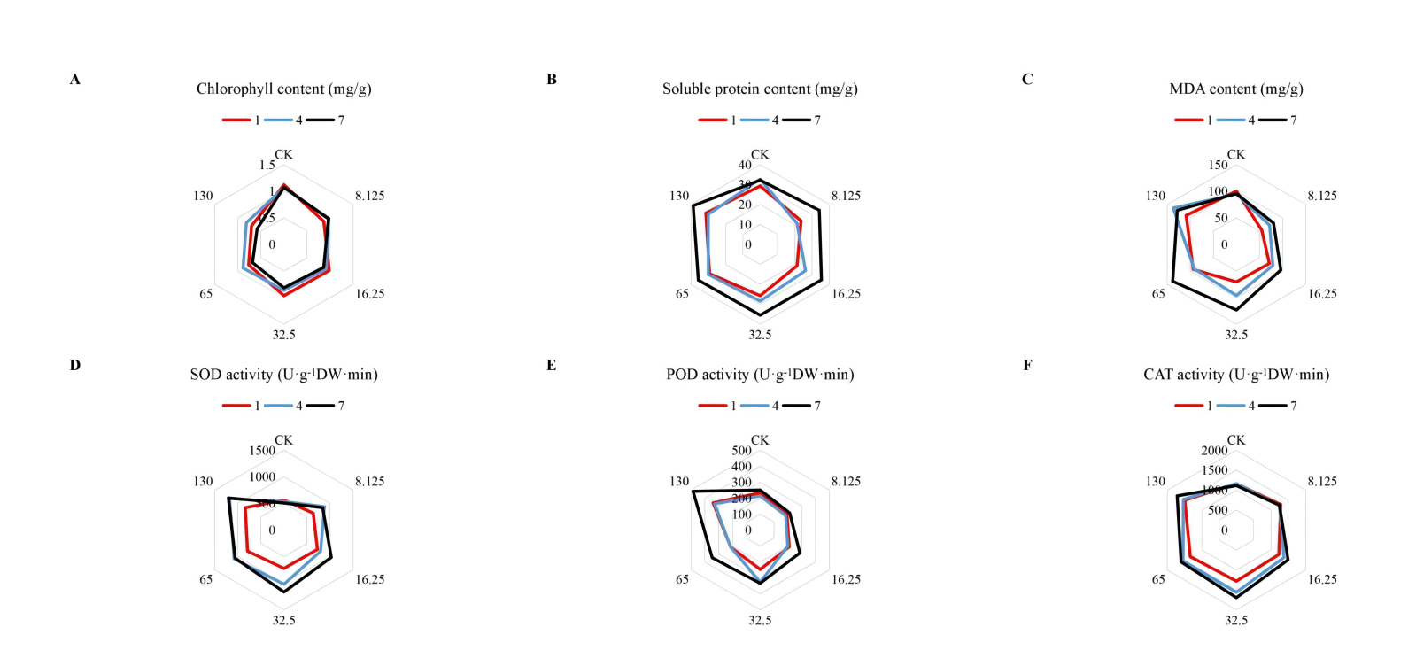

Fig. S5 Effect of MCPA-Na exposure with time on the (A) chlorophyll, (B) soluble protein, and (C) MDA (malondialdehyde) content, and (D) SOD (superoxide dismutase), (E) POD (peroxidase), (F) CAT (catalase) activities at the flowering and boll stages.

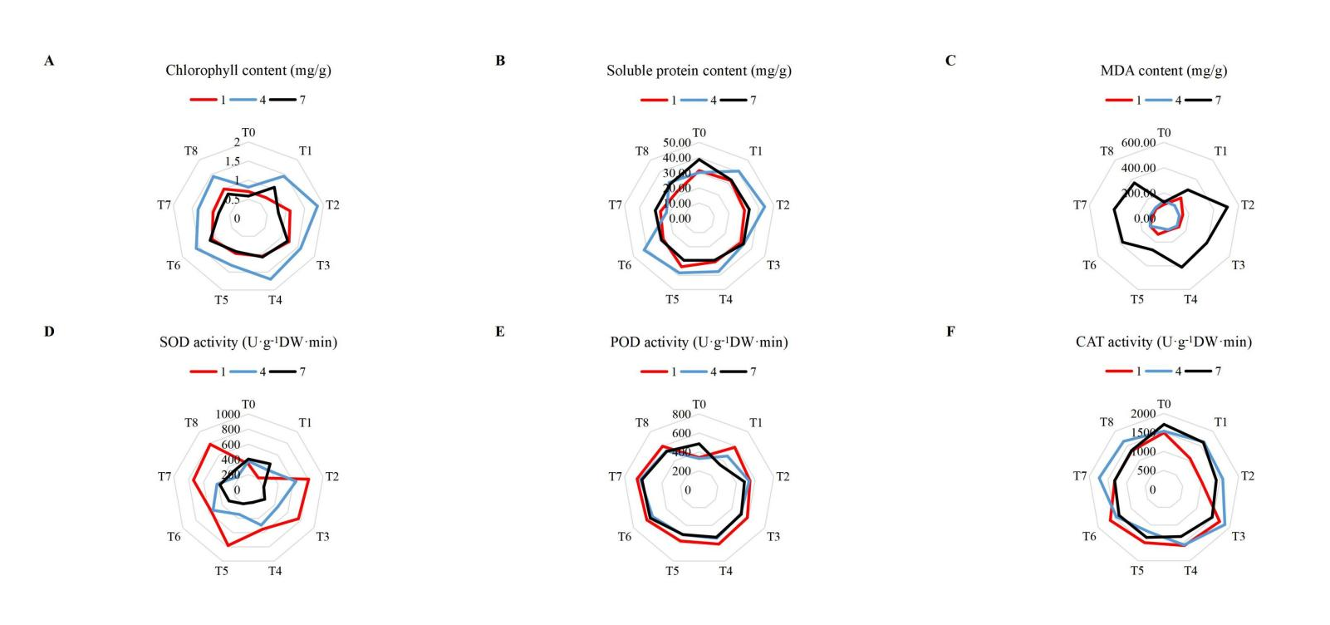

Fig. S6 Effect of different combinations of plant growth regulators with time on the (A) chlorophyll, (B) soluble protein, and (C) MDA (malondialdehyde) content, and (D) SOD (superoxide dismutase), (E) POD (peroxidase), (F) CAT (catalase) activities at the flowering and boll stages. T0 (control), T1 (brassinosteroids), T2 (gibberellin + seaweed fertilizer), T3 (brassinosteroids + seaweed fertilizer) and T4 (phthalanilic acid + seaweed fertilizer), T5 (gibberellin), T6 (brassinosteroids + gibberellin + phthalanilic acid + seaweed fertilizer), T7 (phthalanilic acid), T8 (brassinosteroids + gibberellin + phthalanilic acid).

