Author’s and co-author’s biography
Author Details

Name : G. Sharmila
Designation and Address : Assistant Professor, Dept. of CSE,
Syed Ammal Engineering College,
Ramanathapuram
Email : sharmilaragaventhiran@gmail.com
Ph. No : 9944508466

Co - Author Details

Name : Dr. M. K. Kavitha Devi
Designation and Address : Professor, Dept. of CSE,
Thiagarajar College of Engineering,
Madurai.
Email : mkkdit@tce.edu
Ph.No : 9080019454

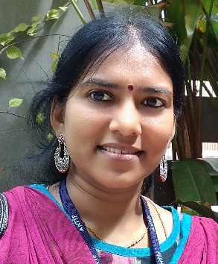
SHARMILA .G received her B.E and M.E degree in Computer Science and Engineering from Madurai Kamaraj University and Anna University, Tamil Nadu, India in 2002 and 2010 respectively. She is currently pursuing Ph.D in the Department of Information and Communication Engineering in Anna University, Tamil Nadu, India. She is currently working as an Assistant Professor in Syed Ammal Engineering College, Ramanathapuram, Tamil Nadu, India. Her research interest includes Graph mining, Blockchain, Cryptography and Data Security. She is a life member in Computer Society of India (CSI) and Institution of Engineers (IEI) India.
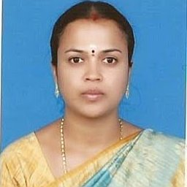
Dr. KAVITHA DEVI. M.K received her B.E. degree in Computer Science and Engineering from Bharathidasan University, Tiruchirappalli, India in 1994 and M.E. degree in Computer Science and Engineering from Madurai Kamaraj University, Madurai, India in 2004 .She has received Ph.D. degree in Information and Communication Engineering from Anna University, Chennai, India in 2011. Her research interests include Recommender System, Web Intelligence, Cryptography & Information Security, Data Mining, and Data Structures. She is currently working as a Professor in Department of Computer Science and Engineering, Thiagarajar College of Engineering, Madurai, Tamilnadu, India. She is a life member of Association of Computing Machinery (ACM) and Computer Society of India (CSI). She has served as an active reviewer, editor and chair for many reputed International conferences and refereed journals including IEEE, Springer, Elsevier, Inderscience and etc. She has more than 50 publications in many reputed International conferences and refereed journals.

