Supplementary Figure 1A (SF 1A)

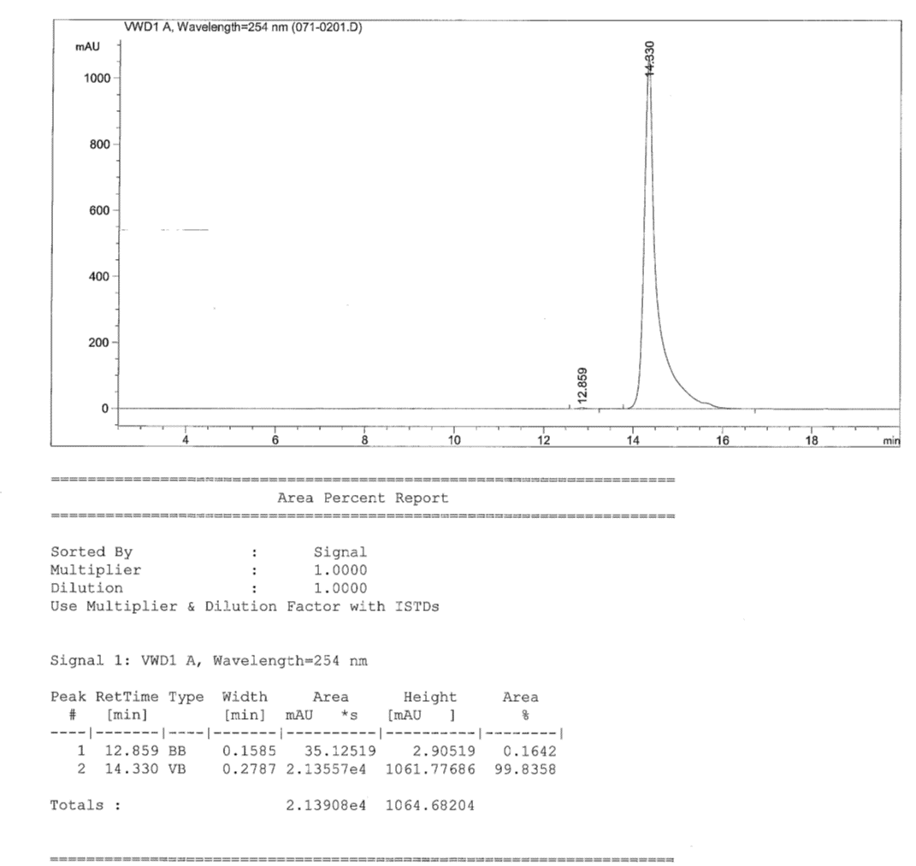

Supplementary Figure 1B (SF 1B)

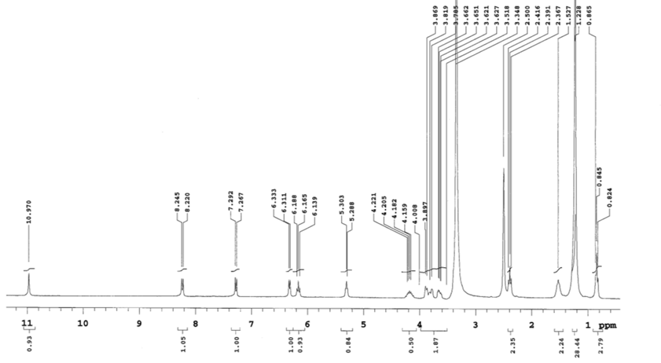

Supplementary Figure 1C (SF 1C)

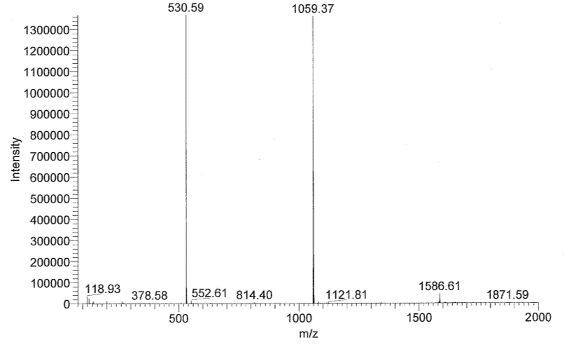

Supplementary Figure 2 (SF2 )

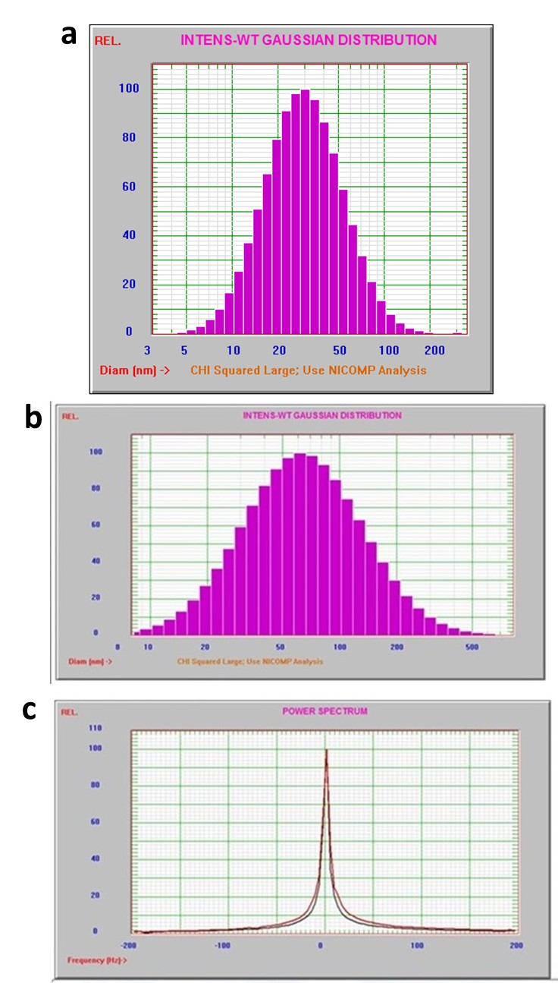

Supplementary Figure Legends

Supplementary Figure 1A (SF 1A)
HPLC spectrum for detecting the purity of 4NSG at 254 nm

Supplementary Figure 1B (SF 1B)
Proton nuclear resonance imaging (¹HNMR) for 4NSG

Supplementary Figure 1C (SF 1C)
Mass spectrum for 4NSG at 530.59 m/z

Supplementary Figure 2 (SF2)
Dynamic light scattering (DLS) graph showing the hydrodynamic particle size distribution of freshly prepared SLN with a mean diameter of 35 nm, (b) Dynamic light scattering (DLS) graph showing the hydrodynamic particle size distribution of freshly prepared SLN with a mean diameter of 82 nm, (c) Graph of zeta potential distribution for 4NSG-SLN

