HIDDEN DECOMPOSERS: THE ROLE OF BACTERIA AND FUNGI IN RECENTLY INTERMITTENT ALPINE STREAMS FUNCTIONAL PROCESSES
Gruppuso L.^{1,2*}, Receveur J.^{3*}, Fenoglio S.^{1,2}, Bona F.^{1,2}, Benbow M. E.^{4,5,6}
Corresponding author: Laura Gruppuso, laura.gruppuso@unito.it
Supplementary material
Table S1 ANOVA comparison of bacterial Shannon diversity. Model = Shannon Diversity ~ River Type x Leaf Type x Days. Df = Degrees of Freedom, SS = Sum of Squares, MS = Mean Squares
 | Df | SS | MS | F | P
River Type | 1 | 2.145 | 2.145 | 16.666 | <0.001
Leaf Type | 1 | 1.26 | 1.26 | 9.788 | 0.003
Days | 5 | 1.262 | 0.252 | 1.961 | 0.098
RiverType:Treatment | 1 | 0.026 | 0.026 | 0.203 | 0.654
RiverType:Days | 5 | 0.718 | 0.144 | 1.116 | 0.362
LeafType:days | 5 | 0.872 | 0.174 | 1.355 | 0.254
RiverType:LeafType:Days | 5 | 0.184 | 0.037 | 0.286 | 0.919
Residuals | 60 | 7.722 | 0.1287

Table S2 Bacterial Shannon diversity by river and date for each leaf type. ANOVA model = Bacterial diversity ~ River Type * Date. Results are shown separately for each leaf type
Chestnut | Model Term | Df | SS | MS | F | P
Chestnut | River Type | 1 | 1.322 | 1.3222 | 9.674 | 0.00408
Chestnut | Days | 5 | 1.992 | 0.3984 | 2.915 | 0.02921
Chestnut | River Type:Days | 5 | 0.491 | 0.0982 | 0.718 | 0.61469
Chestnut | Residuals | 30 | 4.1 | 0.1367
Oak | Model Term | Df | SS | MS | F | P
Oak | RiverType | 1 | 0.849 | 0.8488 | 7.031 | 0.0127
Oak | Days | 5 | 0.142 | 0.0284 | 0.235 | 0.9438
Oak | RiverType: Days | 5 | 0.411 | 0.0822 | 0.681 | 0.6411
Oak | Residuals | 30 | 3.622 | 0.1207

Table S3 Differences in family level bacterial relative abundance over time separated by leaf and river type. Kruskal-Wallis test with a FDR comparison was used to identify taxa that differed by day
Leaf Type | River Type | Family | p | p.adj
 |  | Pseudomonadaceae | 0.135 | 0.16
 |  | Flavobacteraceae | 0.0201 | 0.044
 |  | Comamonadaceae | 0.0117 | 0.044
 |  | Sphingomonadaceae | 0.00577 | 0.044
 |  | Spirosomaceae | 0.023 | 0.044
 | Perennial | Oxalobacteraceae | 0.148 | 0.16
 |  | Methylophilaceae | 0.0276 | 0.044
 |  | Rhodobacteraceae | 0.0282 | 0.044
 |  | Rubritalaceae | 0.207 | 0.21
 |  | Chitinophagaceae | 0.0401 | 0.055
Chestnut |  | Caulobacteraceae | 0.0184 | 0.044
 |  | Oxalobacteraceae | 0.805 | 0.8
 |  | Comamonadaceae | 0.057 | 0.094
 |  | Flavobacteriaceae | 0.0601 | 0.094
 |  | Sphingomonadaceae | 0.205 | 0.25
 |  | Methylophilaceae | 0.0274 | 0.094
 | Intermittent | Caulobacteraceae | 0.0372 | 0.094
 |  | Rubritaleaceae | 0.157 | 0.22
 |  | Pseudomonadaceae | 0.391 | 0.43
 |  | Chitinophagaceae | 0.057 | 0.094
 |  | Rhodobacteraceae | 0.0451 | 0.094
 |  | Spirosomaceae | 0.0521 | 0.094
 |  | Pseudomonadaceae | 0.0618 | 0.11
 |  | Sphingomonadaceae | 0.0217 | 0.08
 |  | Flavobacteriaceae | 0.447 | 0.45
 |  | Comamonadaceae | 0.13 | 0.2
 |  | Oxalobacteraceae | 0.0355 | 0.098
 |  | Spirosomaceae | 0.399 | 0.44
 |  | Rhodobacteraceae | 0.00228 | 0.025
 | Perennial | Methylophilaceae | 0.00915 | 0.05
 |  | Rubritaleaceae | 0.198 | 0.24
 |  | Chitinophagaceae | 0.0608 | 0.11
 |  | Caulobacteraceae | 0.143 | 0.2
 |  | Oxalobacteraceae | 0.279 | 0.56
 |  | Sphingomonadaceae | 0.016 | 0.18
 |  | Comamonadaceae | 0.41 | 0.56
 |  | Flavobacteriaceae | 0.178 | 0.49
Oak |  | Rhodobacteraceae | 0.138 | 0.49
 |  | Oxalobacteraceae | 0.279 | 0.56
 |  | Sphingomonadaceae | 0.016 | 0.18
 |  | Comamonadaceae | 0.41 | 0.56
 |  | Flavobacteriaceae | 0.178 | 0.49
 |  | Rhodobacteraceae | 0.138 | 0.49
 | Intermittent | Caulobacteraceae | 0.756 | 0.76
 |  | Rubritaleaceae | 0.537 | 0.59
 |  | Pseudomonadaceae | 0.367 | 0.56
 |  | Methylophilaceae | 0.485 | 0.59
 |  | Chitinophagaceae | 0.0476 | 0.26
 |  | Spirosomaceae | 0.377 | 0.56

Table S4 Top genus level indicators for leaf type. Tope indicators were chosen using a Mean Decrease Accuracy Score > 5. p.adj indicates a FDR corrected p value. Kruskal-Wallis test was used for comparison
Family: Genus | p | p.adj
Caulobacteraceae: Caulobacter | 2.22E-07 | 2.70E-06
Flavobacteriaceae: Flavobacterium | 0.01256199 | 0.013
Rubritaleaceae: Luteolibacter | 0.0122487 | 0.013
Oxalobacteraceae: Massilia | 0.00039612 | 0.00079
Methylophilaceae: Methylotenera | 3.15E-06 | 1.30E-05
Sphingobacteriaceae: Pedobacter | 0.00525177 | 0.0063
Pseudomonadaceae: Pseudomonas | 0.00112848 | 0.0017
Spingomonadaceae: Rhizorhapis | 0.00196589 | 0.0026
Comamonadaceae: Rhodoferax | 0.00112848 | 0.0017
Sphingomonadaceae: Sphingomonas | 2.53E-06 | 1.30E-05
Sandaracinaceae: uncultured | 0.00016657 | 4.00E-04
Solirubrobacteraceae: uncultured | 1.32E-05 | 4.00E-05

Table S5 Difference in bacterial beta diversity between groups. DF = degrees of freedom, SS = Sum of Squares, MS = Mean Squares. Model = Distance matrix ~ River Type x Leaf Type x Site + Date. PERMANOVA test used 999 permutations
 | DF | SS | MS | F | R2 | P
River Type | 1 | 1.76 | 1.18 | 10.15 | 0.07 | <0.001
Leaf Type | 1 | 1.29 | 1.29 | 11.1 | 0.07 | <0.001
Site | 5 | 0.76 | 0.76 | 6.53 | 0.21 | <0.001
Date | 5 | 0.72 | 0.72 | 6.26 | 0.2 | <0.001
River Type: Leaf Type | 1 | 0.08 | 0.08 | 0.73 | 0.004 | 0.78
Leaf Type: Site | 5 | 0.38 | 0.08 | 0.66 | 0.02 | 0.99
Residuals | 65 | 7.53 | 0.11

Table S6 Comparison of bacterial beta diversity between leaf types within individual dates
Day | Model Term | DF | SS | MS | F | R2 | P
21 | Leaf Type | 1 | 0.91 | 0.91 | 7.23 | 0.38 | 0.002
 | Residuals | 12 | 1.5 | 0.13
42 | Leaf Type | 1 | 0.42 | 0.42 | 3.1 | 0.21 | <0.001
 | Residuals | 12 | 1.62 | 0.13
63 | Leaf Type | 1 | 0.29 | 0.29 | 1.95 | 0.14 | 0.04
 | Residuals | 12 | 1.78 | 0.15
84 | Leaf Type | 1 | 0.27 | 0.27 | 1.68 | 0.12 | 0.083
 | Residuals | 12 | 1.91 | 0.16
105 | Leaf Type | 1 | 0.17 | 0.17 | 0.81 | 0.06 | 0.65
 | Residuals | 12 | 2.53 | 0.21
126 | Leaf Type | 1 | 0.18 | 0.18 | 0.81 | 0.06 | 0.6
 | Residuals | 12 | 2.67 | 0.22

Table S7 Fungal Shannon diversity by river type (perennial vs intermittent) and sampling date. ANOVA model = Fungal diversity ~ River Type x Date. Results are shown separately for each leaf type
 | Model Term | Df | SS | MS | F | P
 | RiverType | 1 | 0.348 | 0.348 | 1.98 | 0.17
 | Days | 5 | 3.94 | 0.788 | 4.47 | 0.004
Chestnut | RiverType:  Days | 5 | 0.461 | 0.09 | 0.52 | 0.76
 | Residuals | 30 | 5.29 | 0.18
 | RiverType | 1 | 0.522 | 0.522 | 4.66 | 0.038
 | Days | 5 | 2.1 | 0.42 | 3.75 | 0.009
Oak | RiverType:  Days | 5 | 0.197 | 0.0395 | 0.353 | 0.877
 | Residuals | 30 | 3.358 | 0.111

Table S8 Differences in family level fungal communities between leaf species (chestnut vs oak). Samples were combined across day and river types. P-adj indicates a Kruskal-Wallis test with a FDR correction for multiple comparisons

Family | P-adj | Leaf Type | Mean | SEM
Aureobasidiaceae | 0.57 | Chestnut  Oak | 39.8  38.4 | 3.02  2.12
Cladosporiaceae | < 0.001 | Chestnut  Oak | 1.3  8.4 | 0.14  0.59
Cucurbitariaceae | < 0.001 | Chestnut  Oak | 0.3  6.6 | 0.06  0.62
Didymellaceae | < 0.001 | Chestnut  Oak | 3.1  6.2 | 0.47  0.46
Helotiaceae | 0.52 | Chestnut  Oak | 4.1  2.7 | 0.75  0.39
Hyaloscyphaceae | < 0.001 | Chestnut  Oak | 14.8  7.0 | 1.79  0.69
Pleomassariaceae | 0.18 | Chestnut  Oak | 2.4  2.3 | 0.62  0.62
Pleosporaceae | < 0.001 | Chestnut  Oak | 1.7  4.8 | 0.30  056

Table S9 PERMANOVA test comparing fungal beta diversity (Bray-Curtis dissimilarity) between groups. PERMANOVA model: Distance matrix ~ RiverType*Treatment*Site+Date. DF= Degrees of Freedom, SS = Sum of Squares, MS = Mean Squares
 | DF | SS | MS | F | R2 | P
RiverType | 1 | 0.2719 | 0.27186 | 2.477 | 0.01806 | 0.016
Treatment | 1 | 2.7946 | 2.79456 | 25.4621 | 0.18564 | 0.001
Site | 5 | 1.5187 | 0.30375 | 2.7676 | 0.10089 | 0.001
Date | 5 | 2.5244 | 0.50488 | 4.6002 | 0.16769 | 0.001
RiverType:  Treatment | 1 | 0.1165 | 0.11649 | 1.0614 | 0.00774 | 0.334
Treatment:  Site | 5 | 0.6939 | 0.13877 | 1.2644 | 0.04609 | 0.099
Residuals | 65 | 7.134 | 0.10975 |  | 0.4739
Total | 83 | 15.0539 |  |  | 1

Table S10 PERMANOVA test comparing fungal beta diversity (Bray-Curtis dissimilarity) between groups. PERMANOVA model: Distance matrix ~ SampleType*Treatment*Site+Date. DF= Degrees of Freedom, SS = Sum of Squares, MS = Mean Squares
 | DF | SS | MS | F | R2 | P
Sample Type | 2 | 0.6387 | 0.31936 | 2.8599 | 0.04243 | 0.003
Leaf Type | 1 | 2.7946 | 2.79456 | 25.0256 | 0.18564 | 0.001
Site | 6 | 1.3829 | 0.23048 | 2.064 | 0.09186 | 0.001
Date | 5 | 2.4963 | 0.49926 | 4.4709 | 0.16582 | 0.001
SampleType:LeafType | 2 | 0.2397 | 0.11985 | 1.0733 | 0.01592 | 0.352
SampleType:Site | 3 | 0.2955 | 0.09851 | 0.8822 | 0.01963 | 0.62
LeafType:Site | 6 | 0.7813 | 0.13022 | 1.1662 | 0.0519 | 0.181
SampleType:LeafType:Site | 3 | 0.2831 | 0.09438 | 0.8452 | 0.01881 | 0.676
Residuals | 55 | 6.1417 | 0.11167 |  | 0.40798
Total | 83 | 15.0539 |  |  | 1

Figure S1 Differences in bacterial Shannon diversity between intermittent and perennial leaf bags. a) Shannon diversity across day between leaf species for each river type. Error bars are Standard Error of the Mean (SEM). Panel b) shows paired comparisons between chestnut and oak leaf bags (i.e. between leaf bags sampled at the same site and date)
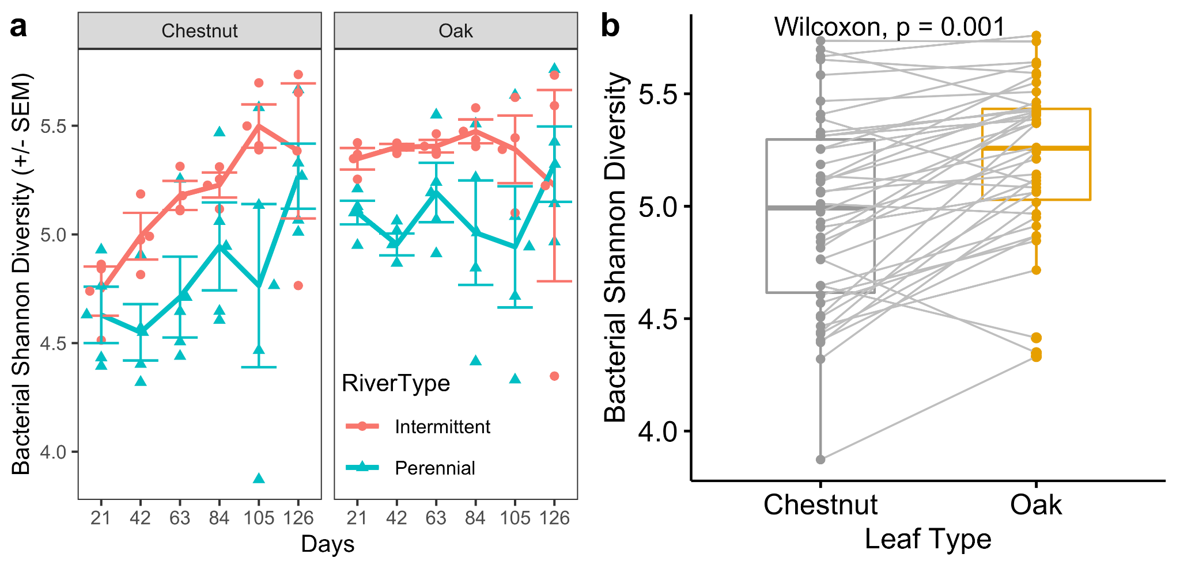
Figure S2 Top genus level random forest indicators for predicting river type. a) Top predictors of river type for chestnut leaves. b) Top predictors of river type for oak leaves. Error bars are SEM
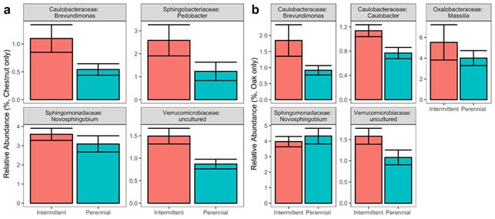

Figure S3 Fungal Shannon diversity. a) Fungal Shannon diversity by leaf and river type across sampling days. Error bars are SEM. b) Difference in diversity between paired samples (i.e. between chestnut and oak samples taken from the same site and date). Lines connect paired samples

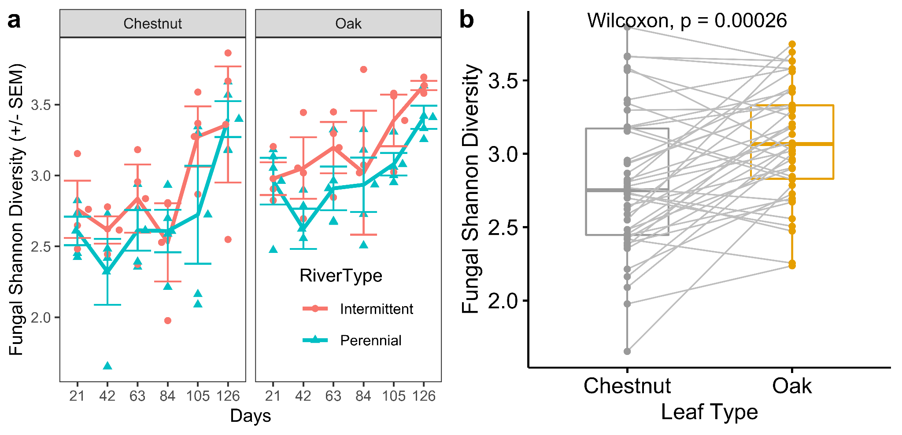

Figure S4 Relative abundance of fungal phyla across sampling day and river type for each leaf species. Only phyla which comprised greater than 3% of the total relative abundance are shown

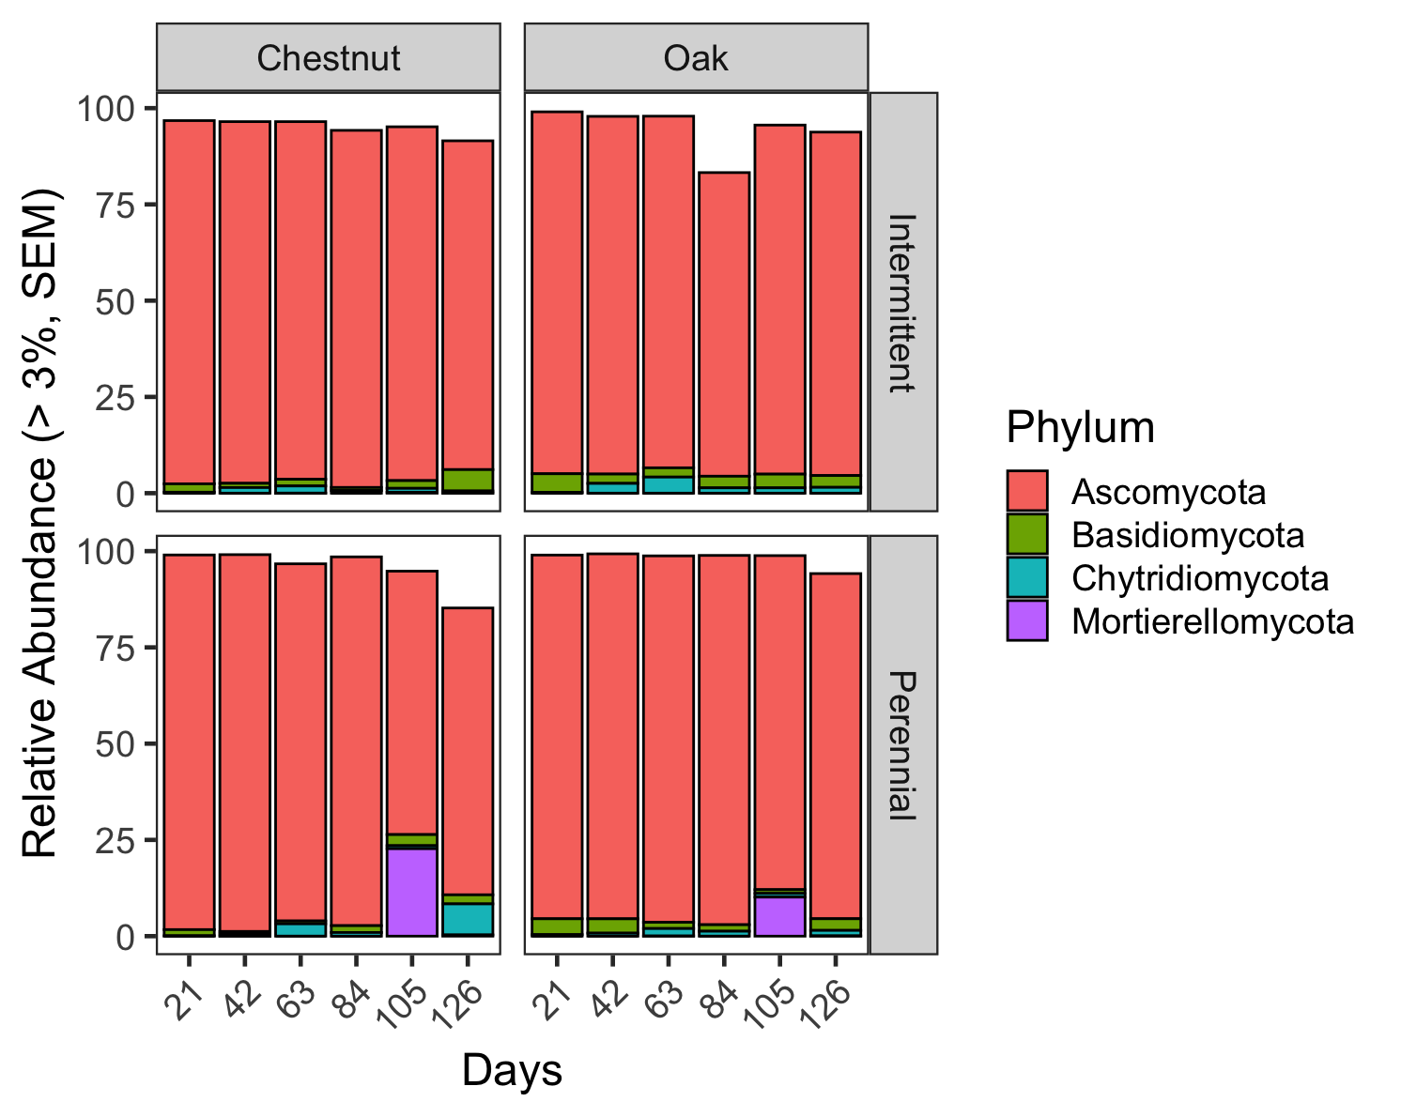

Figure S5 PCoA plot of fungal beta diversity between leaf type and flow conditions (dry, low flow, normal flow). Ellipses represent 95% CI for the mean of each leaf species
