Conjugated polymer-functionalized perovskite semiconductors for electrolyte-gated transistors

Supplementary Fig. 1| MAPbI₃/P3HT structure. Cross-sectional SEM image of MAPbI₃/P3HT film on glass substrate.

Supplementary Fig. 2| TOF-SIMS analysis. TOF-SIMS negative ion depth profiles for electrolyte/P3HT/MAPbI₃/Si structure. From the S‒, C‒ and H‒ signals of the thiophene unit, the P3HT layer can be characteristically indicated in the electrolyte/P3HT/MAPbI₃/Si structure. Particularly, the C‒ and H‒ signals showed double peaking behavior, indicting the P3HT/MAPbI₃ bilayer structure. Noticeably, the existence of I‒ and PbI₃‒ signals in the MAPbI₃ perovskite beneath the P3HT layer can also be clearly identified. The above signals evidenced that three distinctive layers of electrolyte/P3HT/MAPbI₃ were formed, as shown in a photographic image of Supplementary Fig. 4. Without the P3HT layer, the electrolyte solution will dissolve the MAPbI₃ perovskite.

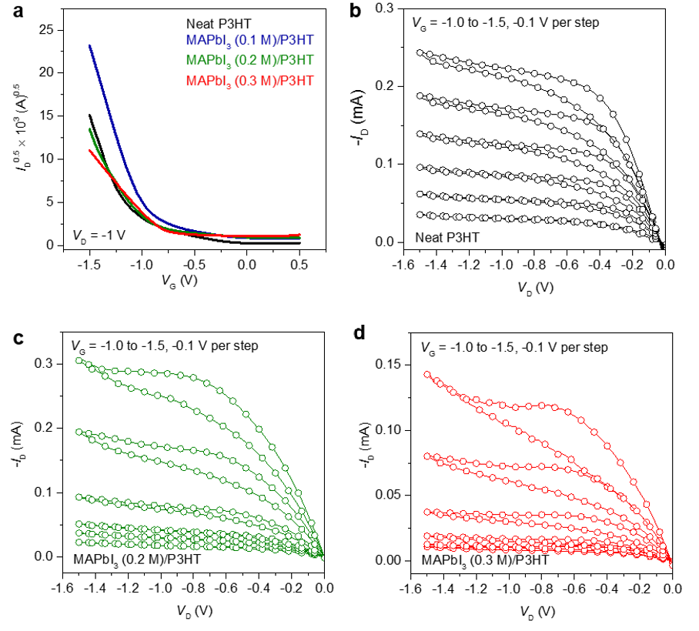
Supplementary Fig. 3| Transistor characteristics of the P3HT-capped MAPbI₃ FETs with high capacitance electrolyte dielectric. a, I_{D}^{0.5}−V_{G} plot for the neat P3HT and MAPbI₃/P3HT FETs in the saturation regime. V_{G} was swept at a rate of 85 mV s^{–1}. b-d, Output characteristics of the pristine P3HT (b), MAPbI₃ (0.2 M)-P3HT FETs (c) and MAPbI₃ (0.3 M)-P3HT FETs (d).

Table 1| Summary of transistor parameters for the control P3HT and P3HT IFL-capped MAPbI₃ transistors with high-capacitance electrolyte dielectric.ª

Polymer IFL | MAPbI₃  Conc. (M) | µ_{FET (Best)}  (cm² V^{–1} s^{–1}) | µ_{FET(avg)}  (cm² V^{–1} s^{–1}) | V_{T}  (V) | I_{on/off}
P3HT | - | 8.89 | 6.22 ± 1.87 | –0.98 ± 0.05 | >10³
P3HT | 0.1 | 13.51 | 10.65 ± 0.84 | –0.90 ± 0.04 | ~10³
 | 0.2 | 6.16 | 5.09 ± 0.48 | –0.90 ± 0.04 | >10²
 | 0.3 | 3.74 | 2.01 ± 0.74 | –0.79 ± 0.07 | >10²
ª Average values were obtained from at least 10 devices.

Supplementary Fig. 4| Perovskite/electrolyte dielectric contact. a-c, Photographic images of the pristine MAPbI₃ spin-coated from 0.3 M concentration (a), MAPbI₃ film after the deposition of electrolyte dielectric (b), and MAPbI₃/P3HT/electrolyte dielectric showing perovskite protection capability (c) on a 15 mm × 15 mm substrates.

Supplementary Fig. 5| Surface morphology of the MAPbI₃ films depending on the concentration of precursor solution. a, SEM images of the pristine MAPbI₃ films on the glass substrates prepared with different precursor concentrations (0.1, 0.2, and 0.3 M). b, AFM images of the pristine MAPbI₃ films on glass substrates prepared with different precursor concentrations. c, AFM images of the MAPbI₃/P3HT films on glass substrates with different MAPbI₃ concentrations. σ_{RMS} is root mean square surface roughness.

Supplementary Fig. 6| Energy level analysis of the MAPbI₃ film. Ultraviolet photoelectron spectroscopy plots of the MAPbI₃ prepared with different precursor concentrations on Au films (left) and its magnification of the region close to valence band edge of MAPbI₃ (right). Bare Au film was used as a reference.

Supplementary Fig. 7| Transistor characteristics of the P3HT-capped MAPbI₃ FETs with PMMA and P(VDF-HFP) dielectrics. a, Transfer curves of the neat P3HT and MAPbI₃/P3HT transistors with low-κ PMMA dielectric. b,c, Output curves of the neat P3HT (b) and MAPbI₃/P3HT (c) transistors with low-κ PMMA dielectric. d, Transfer curves of the neat P3HT and MAPbI₃/P3HT transistors with high-κ P(VDF-HFP) dielectric. e,f, Output curves of the neat P3HT (e) and MAPbI₃/P3HT (f) transistors with high-κ P(VDF-HFP) dielectric.

Table 2| Summary of metal halide perovskite FETs with top-gate structure.

Perovskiteª | Structure^{b} | Dielectric | µ_{h}  (cm² V^{–1} s^{–1}) | µ_{e}  (cm² V^{–1} s^{–1}) | Year | Ref.
MAPbI_{3-x}Cl_{x} | TGBC | Cytop | 1.3 | 1 | 2015 | 1
(PEA)₂SnI₄ | TGTC | Cytop | 15 |  | 2016 | 2
Cs_{x}(MA_{0.17}FA_{0.83})_{1-x}Pb(Br_{0.17}I_{0.83})₃ | TGBC | PMMA | 2.1 | 2.5 | 2017 | 3
(PEA)₂SnI₄ | TGTC | Cytop | 26 | 4.6 | 2017 | 4
CsPbBr₃ | TGBC | PMMA | 0.26 |  | 2017 | 5
FAMAPbBr₃ | TGBC | Cytop | 0.02 |  | 2020 | 6
MAPbI₃ | TGBC | Cytop | 1.8 | 3 | 2020 | 7
Cs_{x}(MA_{0.17}FA_{0.83})_{1-x} Pb(Br_{0.17}I_{0.83})₃ (with DPP) | TGBC | PMMA/Y₂O₃ | 4.02 | 3.35 | 2020 | 8
MAPbI₃/Py1 | TGBC | Electrolyte | 30.87 |  | 2022 | This  work
ª PEA = phenethylamine; MA = methylammonium; FA = formamidinium.
^{b} TGBC = top gate bottom contact; TGTC = top gate top contact.

Supplementary Fig. 8| Defects passivation of the perovskite films after capping with IFLs. a-d, Pb 4f XPS plots of the MAPbI₃/PTB7 (a), MAPbI₃/Py0 (b), MAPbI₃/Py2 (c) and MAPbI₃/Py3 (d) films. e-f, I 3d XPS plots of the MAPbI₃/PTB7 (e), MAPbI₃/Py0 (f), MAPbI₃/Py2 (g) and MAPbI₃/Py3 (h) films. Diluted IFL solutions (1 mg mL^{–1} in chlorobenzene) were used for XPS analysis.

References
- Mei, Y., Zhang, C., Vardeny, Z. & Jurchescu, O. Electrostatic gating of hybrid halide perovskite field-effect transistors: balanced ambipolar transport at room-temperature. MRS Commun. 5, 297–301 (2015).
- Matsushima, T. et al. Solution-processed organic–inorganic perovskite field-effect transistors with high hole Mobilities. Adv. Mater. 28, 10275–10281 (2016).
- Yusoff, A. R. b, M. et al. Ambipolar triple cation perovskite field effect transistors and inverters. Adv. Mater. 29, 1602940 (2017).
- Matsushima, T. et al. Intrinsic carrier transport properties of solution-processed organic–inorganic perovskite films. Appl. Phys. Express 10, 024103 (2017).
- Hu, X. et al. Direct vapor growth of perovskite CsPbBr₃ nanoplate electroluminescence devices. ACS Nano 11, 9869–9876 (2017).
- Senanayak, S. P. et al. A general approach for hysteresis-free, operationally stable metal halide perovskite field-effect transistors. Sci. Adv. 6, eaaz4948 (2020).
- She, X.-J. et al. A solvent-based surface cleaning and passivation technique for suppressing ionic defects in high-mobility perovskite field-effect transistors. Nat. Electron. 3, 694–703 (2020).
- Kim, H. P. et al. A hysteresis-free perovskite transistor with exceptional stability through molecular crosslinking and amine-based surface passivation. Nanoscale 12, 7641–7650 (2020).

