Supporting information for
Probing Chirality of Crystals using Electron Paramagnetic Resonance (EPR) spectroscopy
Gil Otis,† Denial Aias,† Ilya Grinberg,† Sharon Ruthstein,†,⁎ and Yitzhak Mastai. †,⁎
†Department of Chemistry and Institute for Nanotechnology and Advanced Materials, Bar-Ilan University Ramat Gan 5290002, Israel.

Table of contents:
Section | Page no.
- FTIR spectra of Cu²⁺-doped L-His and DL-His crystals | 2
- Cu²⁺ concentrations measured by inductive coupled plasma (ICP) | 2
- Nitrogen and oxygen atoms in closest proximity to ion in L-His crystals and DL-His crystals | 3
- Distances between the Cu²⁺ ion and nearby atoms derived from the DFT calculations | 3
- EPR spectra and simulated EPR spectra for the crystal dry mixtures | 4
- Simulated EPR parameters using easyspin program, and axial symmetry of the Cu²⁺ ion | 4
- CD spectra of mixtures of L-His and DL-His crystals that were dissolved in HCl | 5
- Diffraction pattern of Cu-doped NaClO₃ crystals with and without stirring | 5
- Diffraction pattern of R/S - [Cu(binap)I]₂ crystals | 6

Figure S1: FTIR spectra of Cu²⁺-doped L-His and DL-His crystals.

Table S1: Cu²⁺ concentrations in ppm per 1 mg of powder of L and DL-His crystals, measured by inductive coupled plasma (ICP).
Sample | Cu Conc (ppm/mg powder) | StdDev
L-His | 0.097298 | 0.001287
DL-His | 0.006401 | 0.000619

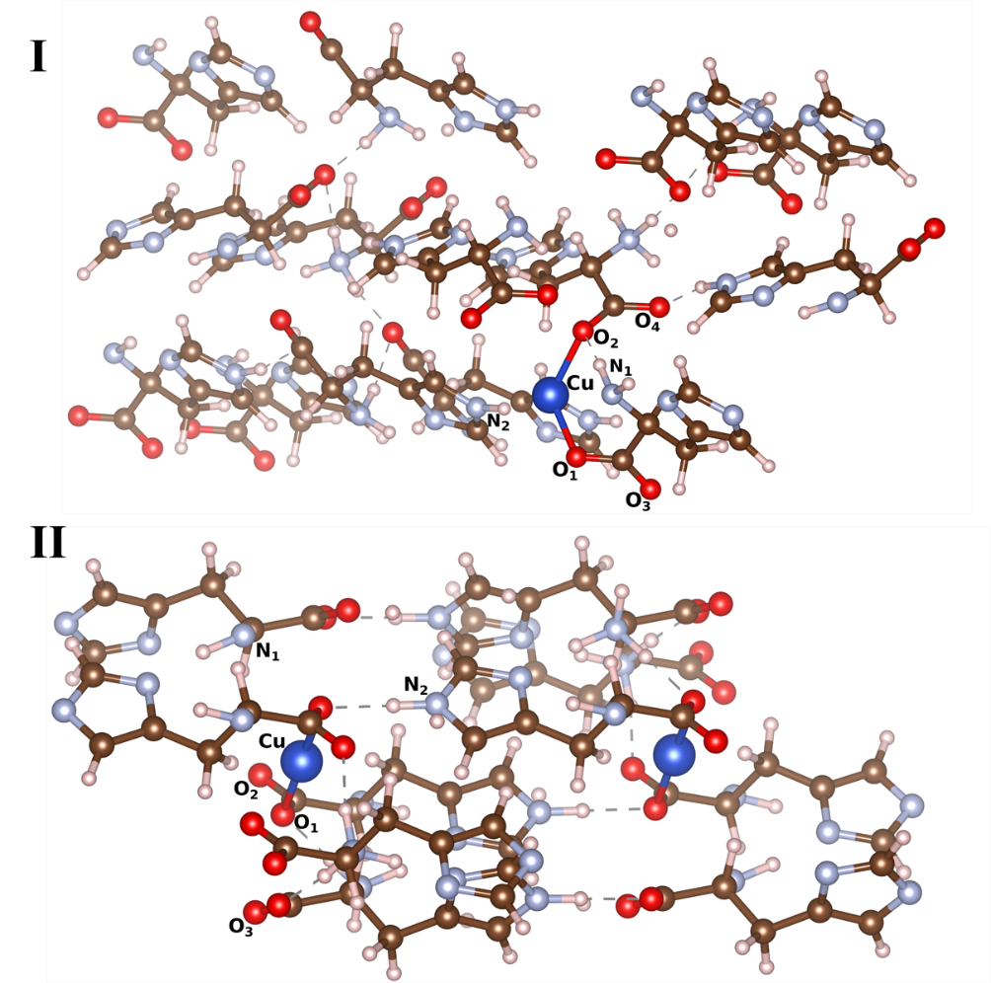

Figure S2: Nitrogen and oxygen atoms in closest proximity to Cu²⁺ ion in L-His crystals (I) and DL-His crystals (II) derived from DFT calculations.

Table S2: Distances between the Cu²⁺ ion and nearby atoms derived from DFT calulations.
Crystal | Cu-O (Å) | Cu-N (Å)
DL-Crystal | 2.073 | 3.32
DL-Crystal | 3.706 | 3.64
DL-Crystal | 3.87
L-Crystal | 2.046 | 3.16
L-Crystal | 2.103 | 3.17
L-Crystal | 3.805
L-Crystal | 3.854

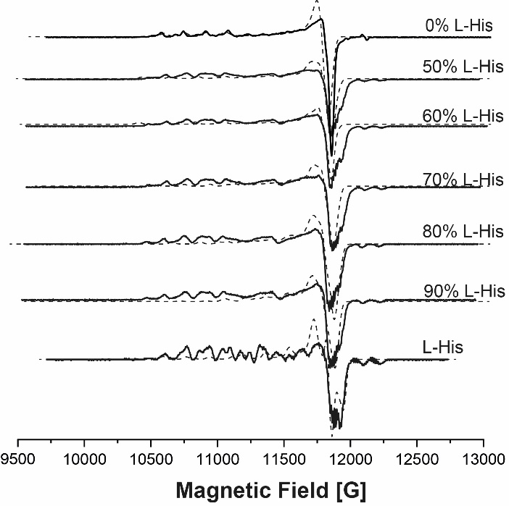

Figure S3: EPR spectra for the various crystals (solid lines) and simulated EPR spectra (dashed lines).

Table S3: Simulated EPR parameters using easyspin program, and axial symmetry of the Cu²⁺ ion.
 | % Species I  g=[2.04 2.235]  A=[50 620] MHz | % Species II  g=[2.05 2.1]  A=[50 400] MHz | % Species III  g=[2.035 2.14]  A=[50 460] MHz
DL-His | 1 | 0 | 0
0.5 | 0.75 | 0.15 | 0.1
0.6 | 0.55 | 0.25 | 0.2
0.7 | 0.45 | 0.25 | 0.3
0.8 | 0.4 | 0.3 | 0.3
0.9 | 0.15 | 0.3 | 0.55
L-His | 0.2 | 0.4 | 0.4

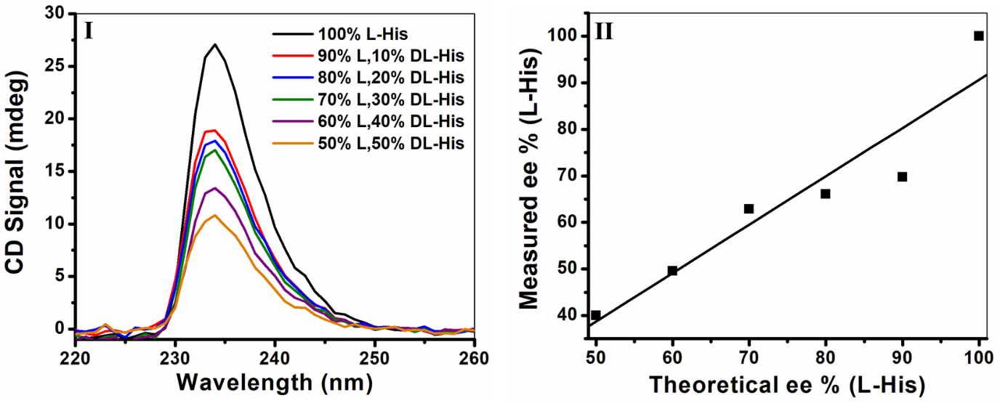
Figure S4 : CD spectra of mixtures of L-His and DL-His crystals that were dissolved in HCl- CD spectra (I) and enantiomeric excess (II) compared to theoretical ee (R² = 0.8933) of L/DL-His crystal mixtures.

Figure S5 : Diffraction pattern of Cu-doped NaClO₃ crystals with and without stirring producing the pure enantiomer and the conglomerate powder correspondingly, the results are compared to the NaClO₃ diffraction from the database (AMSD Nu: 0017303).

Figure S6 : Diffraction pattern of R/S - [Cu(binap)I]₂ crystals compared to the database (CCDC Nu: 1547694).

