Supplementary Data; Text, Tables and Figures
Supplementary Text
Supplementary methods 1
Copy number profile smoothing for CCNE1 classification
First, a baseline, unsmoothed segmentation was performed using CBS. This however produced a number of noisy profiles, identified by expert classification. Next, using logistic regression, the number of segments in the copy number profile $\left(N_{s}\right)$and the observed read variance $\left(\hat{σ^{2}}\right)$were determined to be most predictive of being classified as noisy in the previous step. Using these variables, a boolean smoothing function, $Sm\left(N_{s},\hat{σ^{2}}\right)$, was defined with: $Sm\left(N_{s},\hat{σ^{2}}\right)={(N}_{s}>t_{N_{s}}) \& (\hat{σ^{2}}>t_{\hat{σ^{2}}})$. $N_{s}$ represents the number of segments and $\hat{σ^{2}}$ the observed variance of the reads at the currently used smoothing parameter. $t_{N_{s}}$ and $t_{\hat{σ^{2}}}$ represent threshold parameters which are user-selected. If both the number of segments and the variance exceed their respective thresholds, $Sm\left(N_{s},\hat{σ^{2}}\right)$ evaluates to True and the segmentation is smoothed further. This process is done iteratively until $Sm\left(N_{s},\hat{σ^{2}}\right)$ evaluates to False for all cases. The final segmentation used for each sample is the least-smoothed segmentation for which $Sm\left(N_{s},\hat{σ^{2}}\right)$ still returns False. $t_{N_{s}}$ and $t_{\hat{σ^{2}}}$ were set at 400 and 0.12 respectively. The baseline segmentation used standard CBS settings with the addition of undoing splits which were not at least 1.5 standard deviations apart. Segmentations were smoothed by iteratively increasing the minimal number of standard deviations required for a split.

Supplementary Tables
Supplementary Table 1. Median overall survival of immune cell densities per molecular subtype
 | BRCAm profile | non-BRCAmut HRD | CCNE1 amplification | Double classifier | NSMP
CD8
≤100 | 58.7 (30-109) | 40.4 (25-69)* | 26.8 (16-50) | 26.1 (18-58) | 33.2 (15-53)
>100 | 48.6 (36-97) | 44.2 (27-X)* | 36.1 (18-51) | 48.6 (19-62) | 37.5 (20-82)
CD20
≤50 | 58.2 (30-99) | 40.0 (23-70)* | 26.8 (16-51) | 26.1 (19-62) | 35.4 (18-56)
> 50 | 44.0 (25-97) | 67.8 (41-X)* | 36.1 (36-X) | 47.2 (18-83) | 37.2 (20-77)
CD68
≤100 | 46.1 (36-86) | 40.4 (26-72) | 25.8 (16-51) | 27.0 (18-52) | 33.4 (18-56)
>100 | 57.7 (27-110) | 44.2 (19-85) | 36.1 (26-48) | 55.6 (19-75) | 37.5 (25-84)
CD103
≤100 | 46.1 (29-97) | 40.4 (23-72) | 26.8 (18-50) | 30.0 (19-56) | 33.4 (16-55)*
>100 | 60.4 (41-110) | 44.2 (38-105) | 45.4 (14-57) | 52.1 (18-66) | 62.9 (19-X)*
*P < 0.05
Abbreviations: BRCAm profile: BRCA mutation or BRCA1 promotor methylation; HRD: homologous repair deficient; Double classifier: non-BRCAmut HRD and CCNE1 gain/amplification; NSMP: no specific molecular profile.

Supplementary Table 2. Progression-free survival analysis, immune cell composition
 | Crude HR (95% CI) | Adjusted* HR (95% CI)
CD8
≤100 | REF | REF
>100 | 0.74 (0.56-0.98) | 0.83 (0.62-1.10)
CD20
≤50 | REF | REF
> 50 | 0.64 (0.45-0.91) | 0.56 (0.40-0.80)
CD68
≤100 | REF | REF
>100 | 0.68 (0.51-0.90) | 0.98 (0.72-1.32)
CD103
≤100 | REF | REF
>100 | 0.59 (0.43-0.83) | 0.72 (0.52-1.01)
*Data was adjusted for age, FIGO stage, therapy sequence and outcome of surgery
Abbreviations: CI: Confidence interval; HR: Hazard ratio; REF: reference.

Supplementary Figures

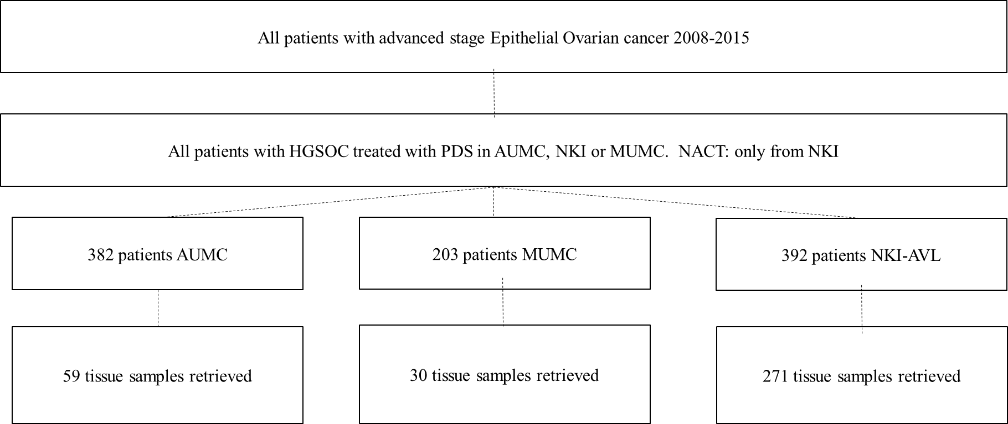
Supplementary Figure 1. Flowchart of patient selection and tissue retrieval
Abbreviations: NKI-AVL: Netherlands Cancer Institute - Antoni van Leeuwenhoek Hospital; MUMC: Maastricht University Medical Centre (MUMC); AUMC: Amsterdam University Medical Centre; PDS: primary debulking surgery; NACT: neoadjuvant chemotherapy
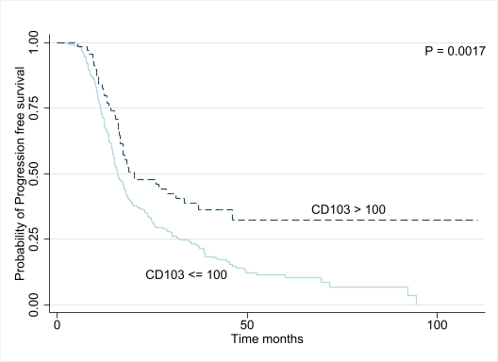
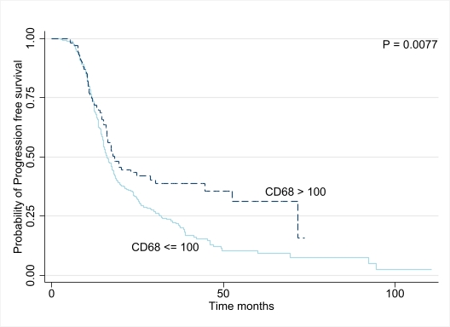
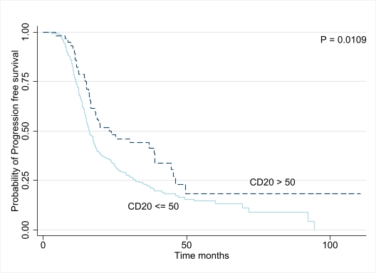
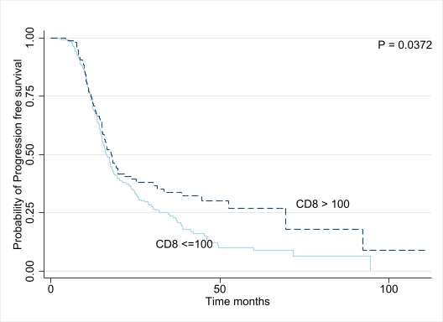
Supplementary Figure 2. Survival Analyses of Patients with HGSOC, According to immune cell densities.
Panels A to D show Kaplan–Meier curves for progression free survival according to density of CD8 cells (A), CD20 (B), CD68 (C) and CD103 (D) respectively. P values were derived with the use of the log-rank statistic.
D
C
A
B

