Supplementary Information

Efficient multiple shoot organogenesis in the African bush apple

Aniefiok N. Osuagwu • Peter Nkachukwu Chukwurah* • Ekerette E. Ekerette

Department of Genetics and Biotechnology, Faculty of Biological Sciences, University of Calabar, Calabar, Cross River State, Nigeria

*Corresponding author

Peter N. Chukwurah
e-mail: pnchukwurah@unical.edu.ng
ORCID: 0000-0003-2445-2792

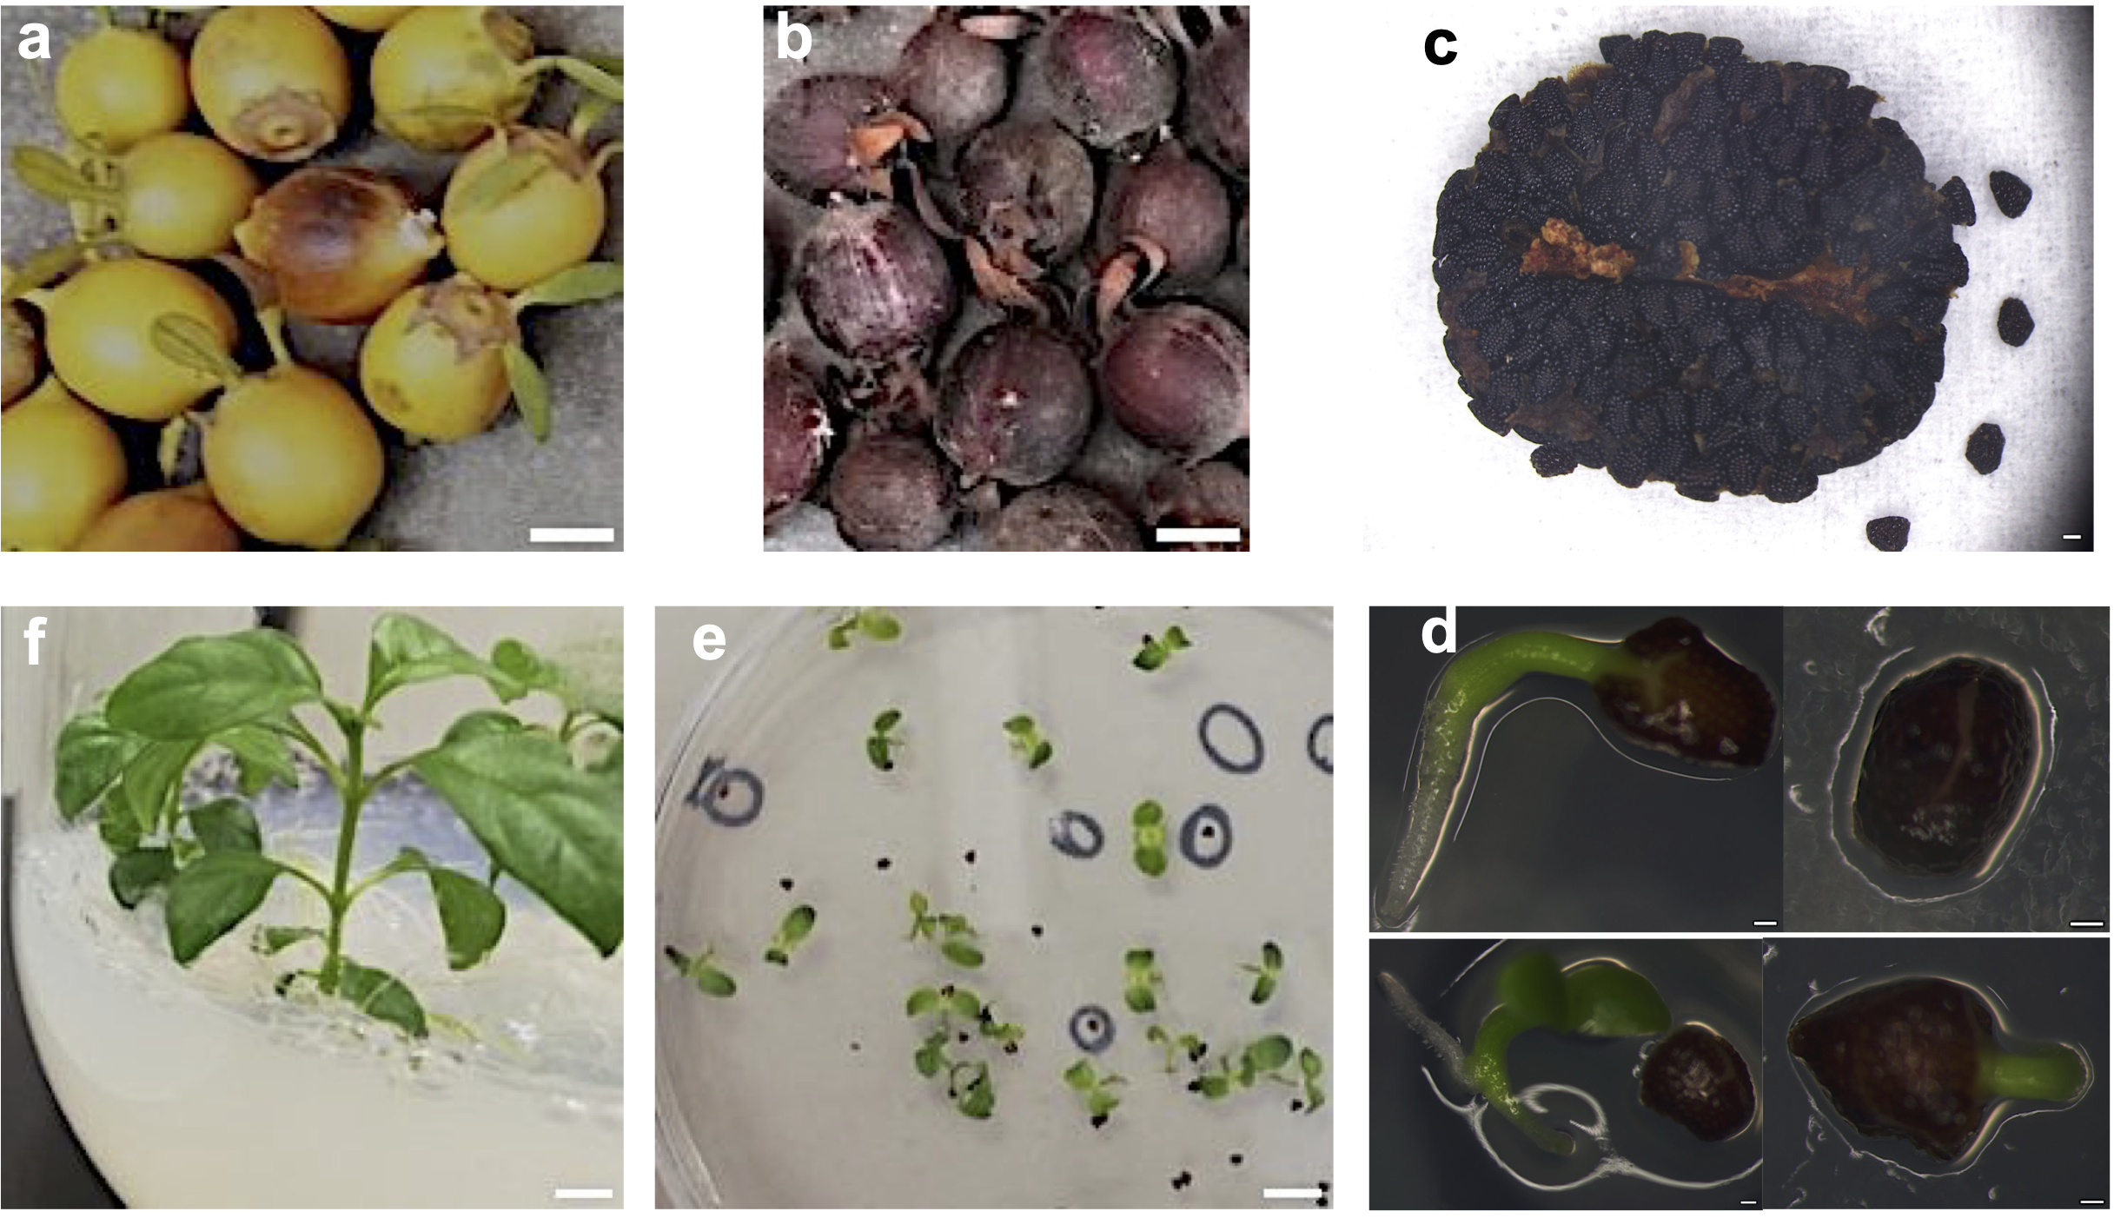

Fig. 1 In vitro germination and seedling establishment of H. crinita
a Fresh fruits of H. crinita; b Dry fruits of H. crinita; c Seeds of H. crinita; d Germination of H. crinita sterile seeds on MS medium; e H. crinita seedlings on MS medium; f H. crinita plantlet after 8-weeks on MS medium. Microscopic images (c, d) were captured using Olympus DP72 stereomicroscope with Cell sense software. Bar (c, d,) = 500 µm

Table 1 Preliminary observation of regeneration activity from 4-weeks old leaf, stem, petiole and root explants of H. crinita on MS medium containing BA and NAA after 4 weeks culture

Treatment  (mg/L) | Observation of explants after 4 weeks of culture
Treatment  (mg/L) | leaf | stem | petiole | root
BA0.5 + NAA0.1  BA0.5 + NAA0.2  BA0.5 + NAA0.5  BA0.5 + NAA1.0  BA1.0 + NAA0.1  BA1.0 + NAA0.2  BA1.0 + NAA0.5  BA1.0 + NAA1.0  BA1.5 + NAA0.1  BA1.5 + NAA0.2  BA1.5 + NAA0.5  BA1.5 + NAA1.0  BA2.0 + NAA0.1  BA2.0 + NAA0.2  BA2.0 + NAA0.5  BA2.0 + NAA1.0  BA2.5 + NAA0.1  BA2.5 + NAA0.2  BA2.5 + NAA0.5  BA2.5 + NAA1.0  BA3.0 + NAA0.1  BA3.0 + NAA0.2  BA3.0 + NAA0.5  BA3.0 + NAA1.0 | no visible activity  no visible activity  slight callusing  callusing  no visible activity  no visible activity  slight callusing  slight callusing  no visible activity  no visible activity  slight callusing  callusing  no visible activity  no visible activity  slight callusing  callusing  no visible activity  no visible activity  slight callusing  callusing  no visible activity  slight callusing  slight callusing  callusing | shoot induction  slight callusing  slight callusing  callusing  shoot induction  shoot induction  shoot induction  callus + shoot  shoot induction  shoot induction  callus + shoot  shoot + callus  shoot induction  shoot induction  shoot induction  shoot + callus  shoot induction  shoot induction  shoot induction  shoot induction  shoot induction  shoot induction  shoot induction  shoot + callus | no visible activity  no visible activity  no visible activity  slight callusing  no visible activity  no visible activity  no visible activity  slight callusing  no visible activity  no visible activity  slight callusing  callusing  no visible activity  slight callusing  callusing  callusing  no visible activity  slight callusing  callusing  callusing  no visible activity  slight callusing  callusing  callusing | callusing  callusing  callusing  callusing  callusing  callusing  callusing  callusing  callusing  callusing  callusing  callusing  callusing  callusing  callusing  callusing  callusing  callusing  callusing  callusing  callusing  callusing  callusing  callusing

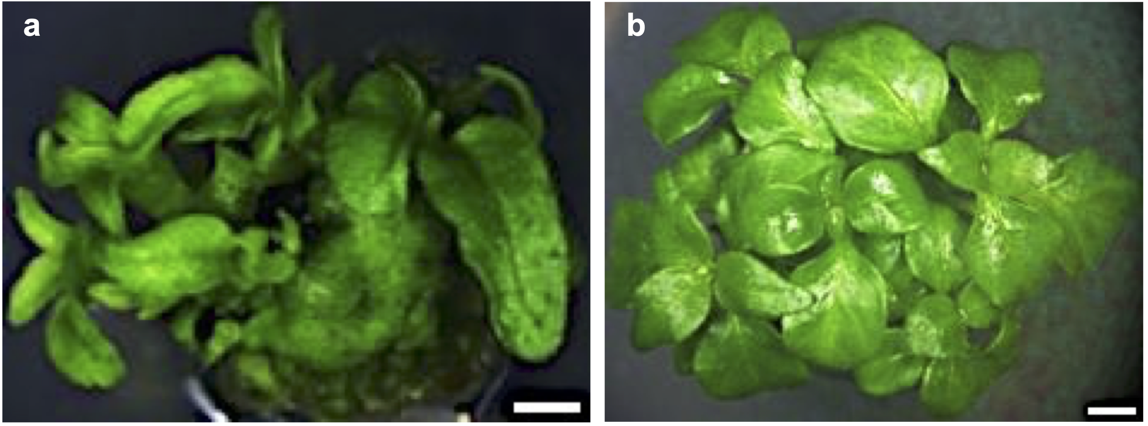

Fig. 2 Multiple shoot induction from 4-weeks old H. crinita petiole explants after 7 weeks
Petiole explants were cultured on MS medium supplemented with (a) 1 mg/L BA + 0.5 mg/L NAA (b) 2 mg/L BA + 1 mg/L NAA. Bar = 200 µm

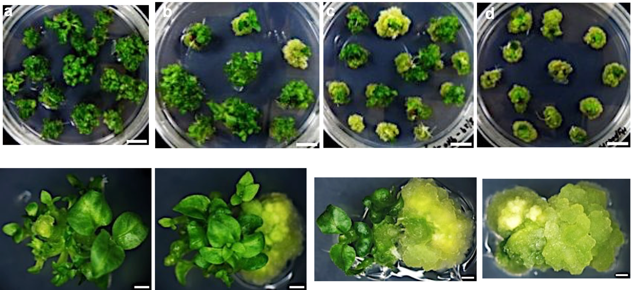

Fig. 3 Multiple shoot induction from 7-day old hypocotyl explants after 30 days.
Explants were cultured on MS medium supplemented with 1 mg/L BA + (a) 0.1 mg/L NAA; (b) 0.2 mg/L NAA; (c) 0.5 mg/L NAA; (d) 1 mg/L NAA. Multiple shoots-inducing explants shown underneath each petri-dish are representative images from each treatment captured using Olympus DP72 stereomicroscope with Cell sense software. Bar = 200 µm

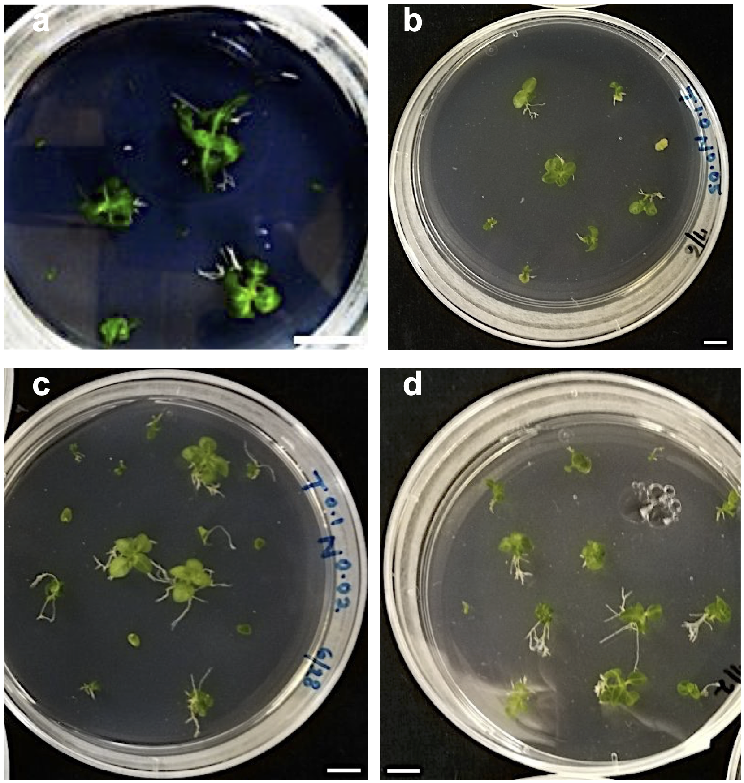

Fig. 4 Regeneration of 7-day old H. crinita hypocotyl explants on TDZ + NAA medium
The hypocotyl explants were cultured on MS medium supplemented with (a) no hormone; (b) 1 μM TDZ + 0.05 μM NAA; (c) 0.5 μM TDZ + 0.01 μM NAA; (d) 0.1 μM TDZ + 0.02 μM NAA

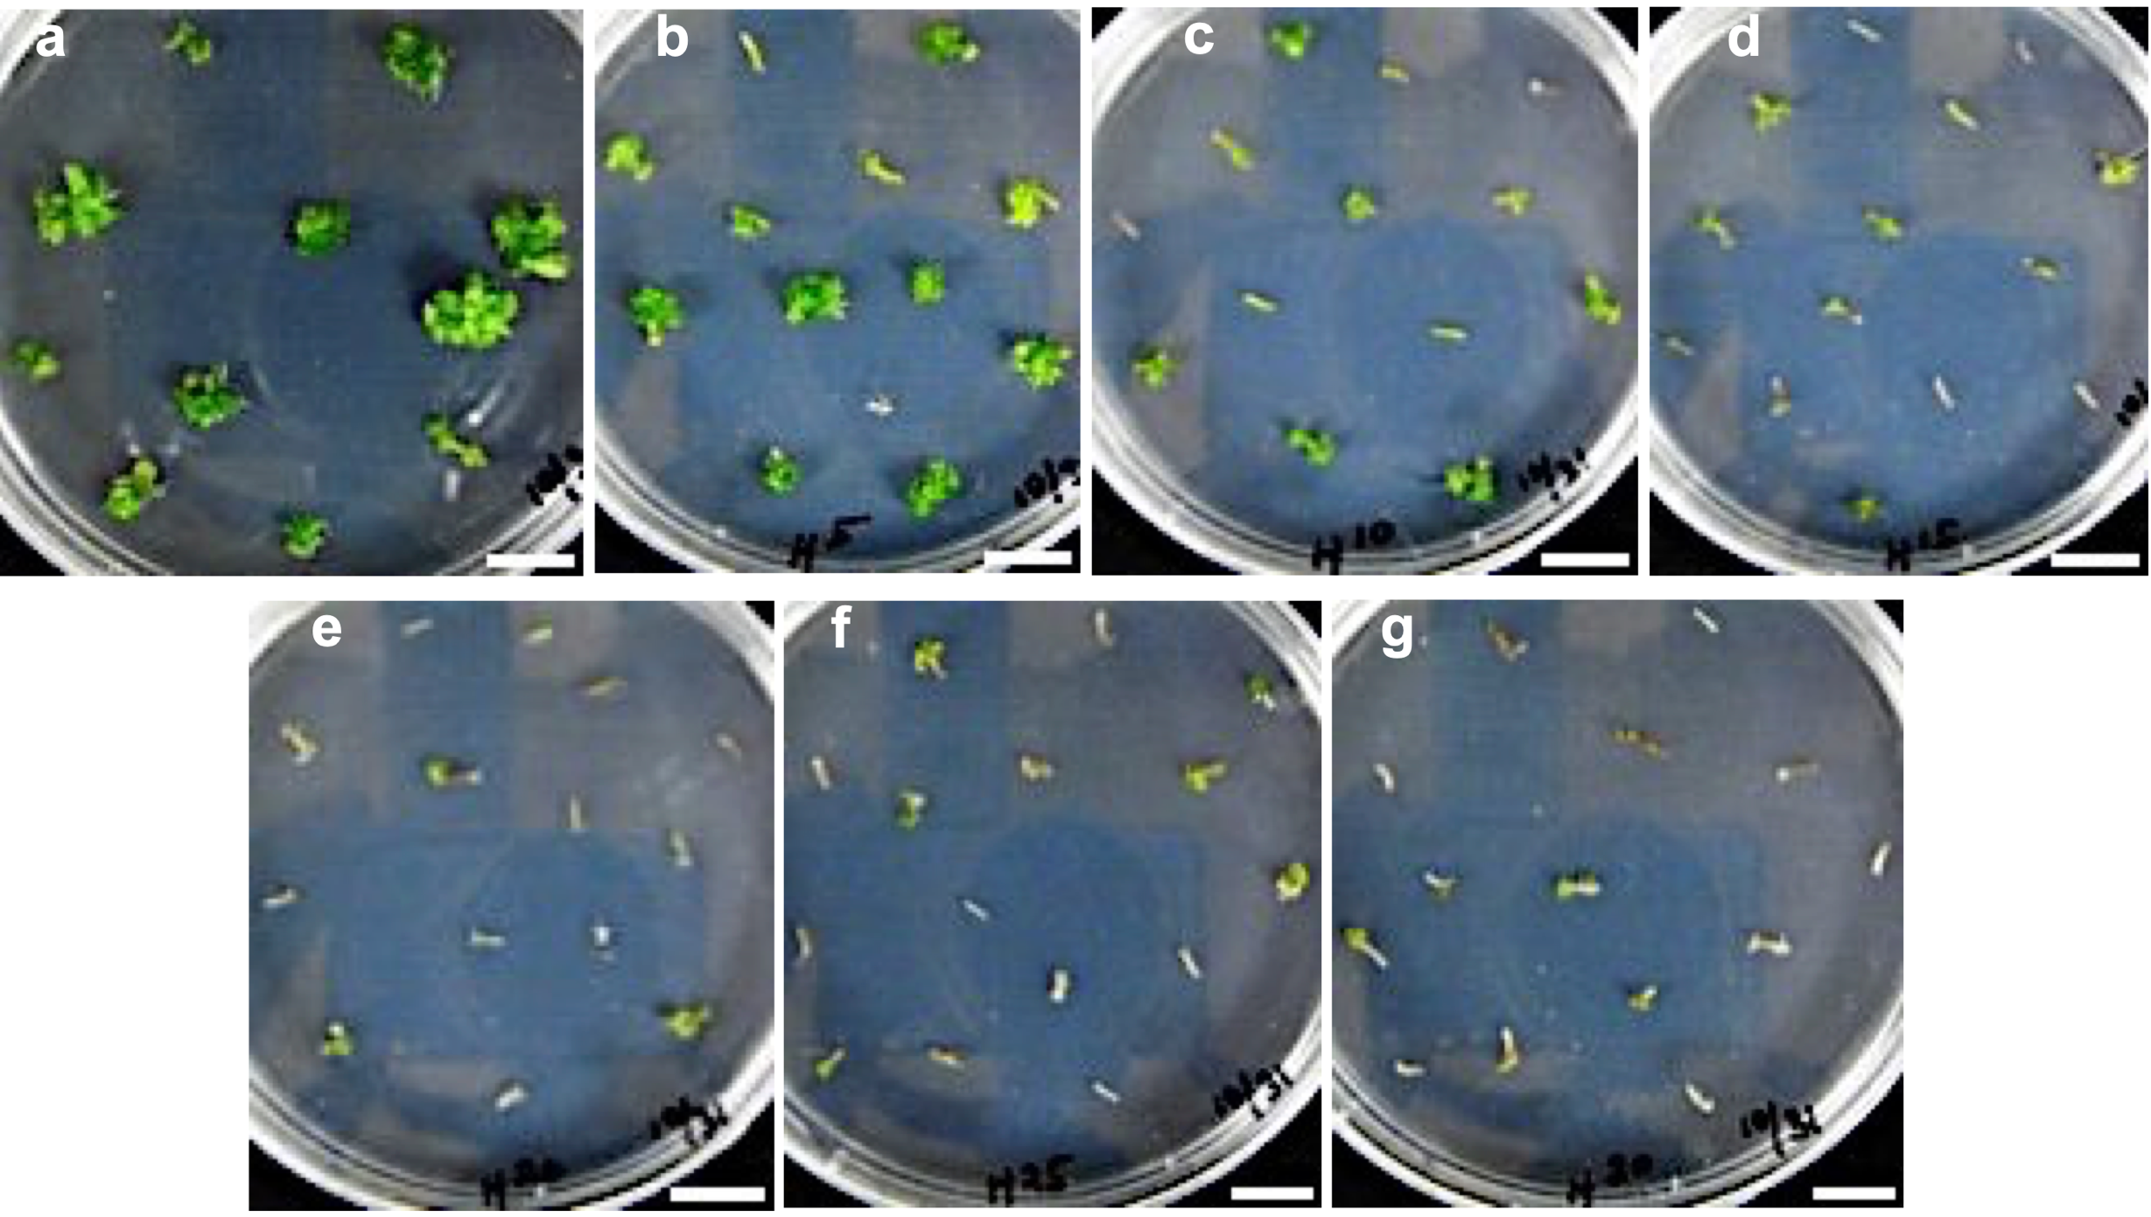

Fig. 5 Regeneration of H. crinita stem explants on hygromycin-supplemented MS medium
30-day old stem explants were cultured on MS medium supplemented with 1 mg/L BA + 0.1 mg/L NAA + (a) no hygromycin (b) 5 mg/L hygromycin (c) 10 mg/L hygromycin (d) 15 mg/L hygromycin (e) 20 mg/L hygromycin (f) 25 mg/L hygromycin (g) 30 mg/L hygromycin. Bar = 0.5 cm

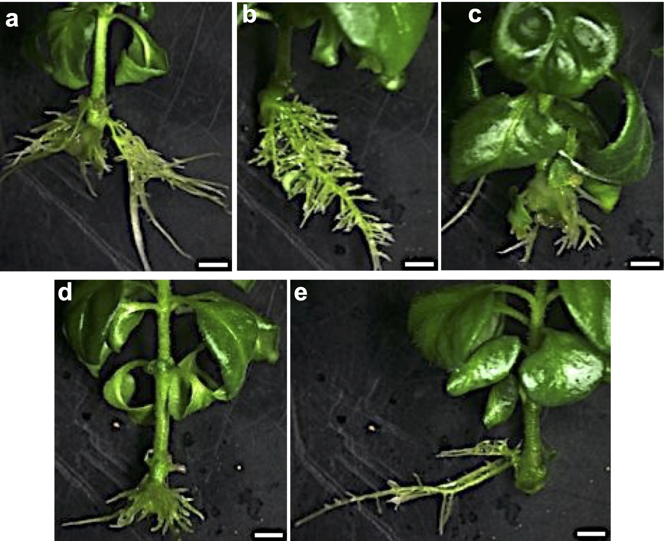

Fig. 6 Rooting of H. crinita shoots after 30 days on hormone-free MS medium
The in vitro shoots of H. crinita regenerated from MS medium supplemented with (a) 1 mg/L BA + 0.1 mg/L NAA; (b) 1 mg/L BA + 0.2 mg/L NAA; (c) 0.5 mg/L BA + 0.2 mg/L NAA; (d) 1.0 mg/L BA + 0.5 mg/L NAA; (e) 1.5 mg/L BA + 0.2 mg/L NAA, were rooted on hormone-free ½ MS medium supplemented with 1.5% sucrose. Images were captured using Olympus DP72 stereomicroscope with Cell sense software. Bar = 200 µm

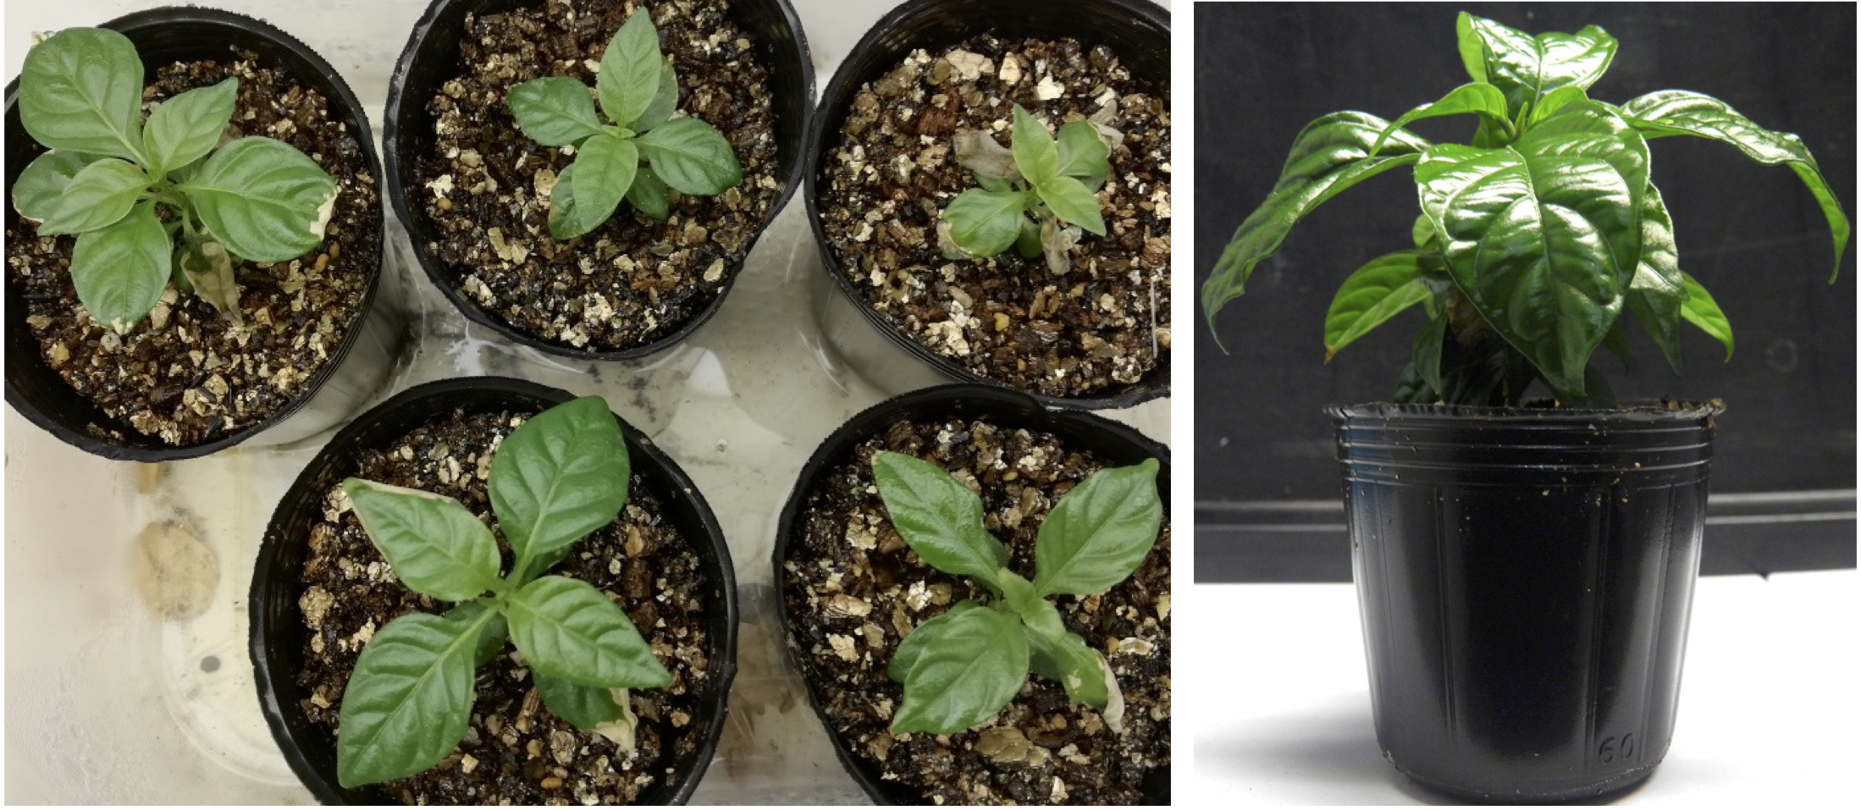

Fig. 7 Acclimatization of H. crinita plantlets
Rooted H. crinita shoots acclimatized on sterile vermiculite

