Influence of Multi-Modal Warning Interface on Takeover Efficiency of Autonomous High-Speed Train
Chunhui Jing¹, Haohong Dai², Xing Yao¹, Yaodong Chen¹, Jinyi Zhi^{1*}
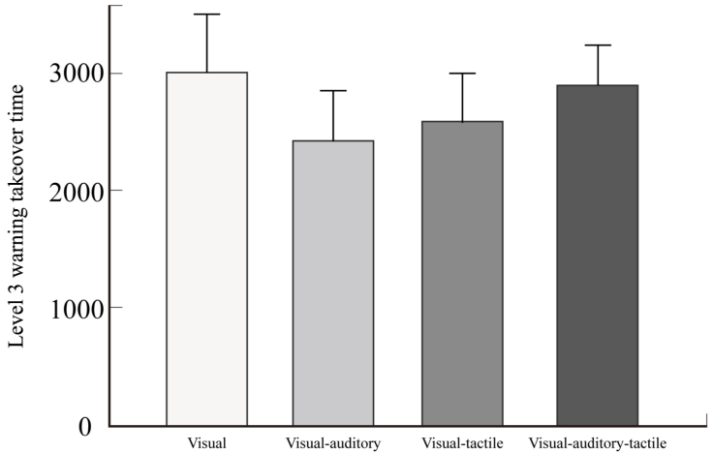
Supplementary Figure 1. Level 3 warning interface takeover time under different warnings

 | First fixation duration within AOI | P
level 1 | 586 (327.5–891.5) | ＜0.001
level 2 | 267.5 (182.25–423.5)
level 3 | 368.5 (271–545.75)
Supplementary Table 1. Comparison of the first fixation duration in AOI under different warning levels

Sample 1 and Sample 2 | Adjusted significance
level 2 and level 1 | 0.118
level 2 and level 3 | ＜0.001
level 1 and level 3 | 0.037
Supplementary Table 2. Pairwise comparison of the significance of the first fixation duration within the AOI under different levels of warning
 | Total fixation duration in AOI | P
level 1 | 392 (322.75–527.5) | ＜0.001
level 2 | 531.5 (422–667.25)
level 3 | 600.5 (426.75–854.25)
Supplementary Table 3. Comparison of total fixation duration in AOI under different warning levels

Sample 1 and Sample 2 | Adjusted significance
level 1 and level 2 | 0.025
level 1 and level 3 | ＜0.001
level 2 and level 3 | 0.435
Supplementary Table 4. Pairwise comparison of the total fixation duration within the AOI under different levels of warning

 | Fixation counts in AOI | P
level 1 | 2 (1–2.33) | 0.001
level 2 | 2 (2–3)
level 3 | 1.67 (1.33–2)
Supplementary Table 5. Comparison of the fixation count points in AOI under different warning levels

Sample 1 and Sample 2 | Adjusted significance
level 1 and level 2 | 1.000
level 1 and level 3 | 0.002
level 2 and level 3 | 0.006
Supplementary Table 6. Pairwise comparison of the significance of the fixation count in the AOI under different levels of warning

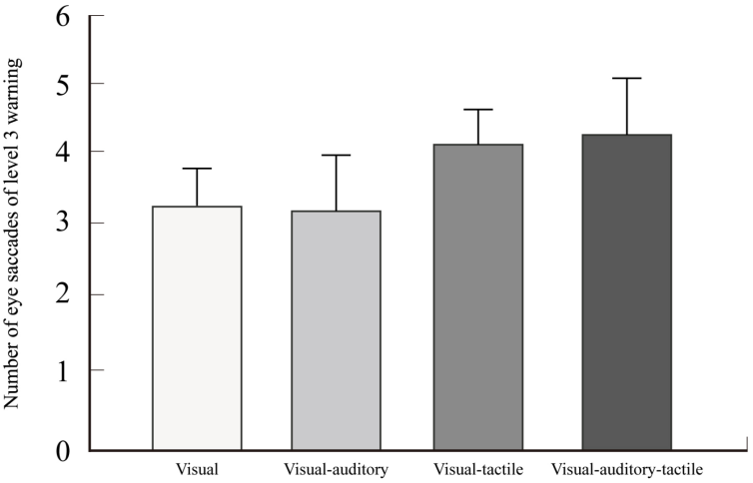
Supplementary Figure 2. Number of eye saccades for level 3 warning interface under different warnings

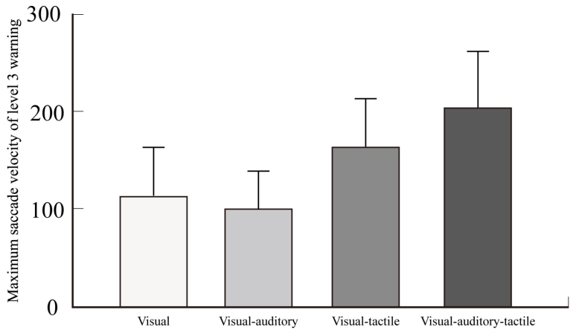
Supplementary Figure 3. Maximum saccade velocity of level 3 warning interface under different warnings

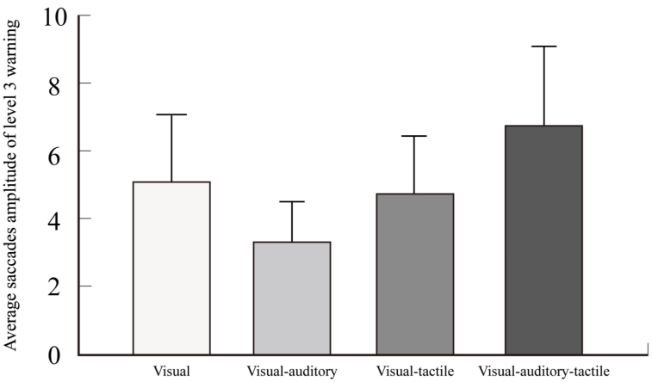
Supplementary Figure 4. Average saccades amplitude of level 3 warning interface under different warnings

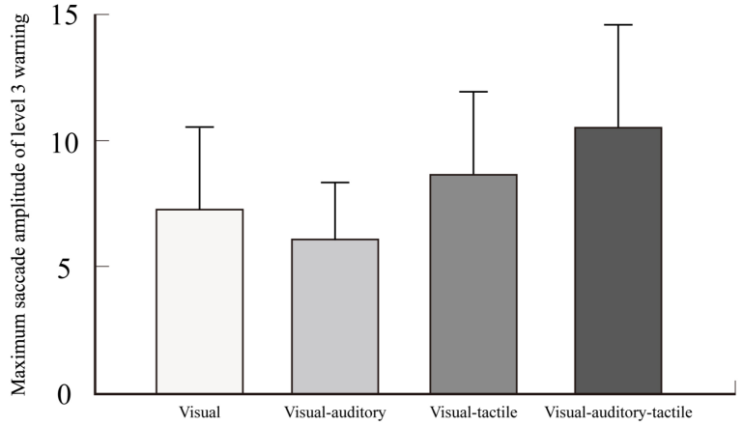
Supplementary Figure 5 Maximum saccades of level 3 warning interface under different warnings

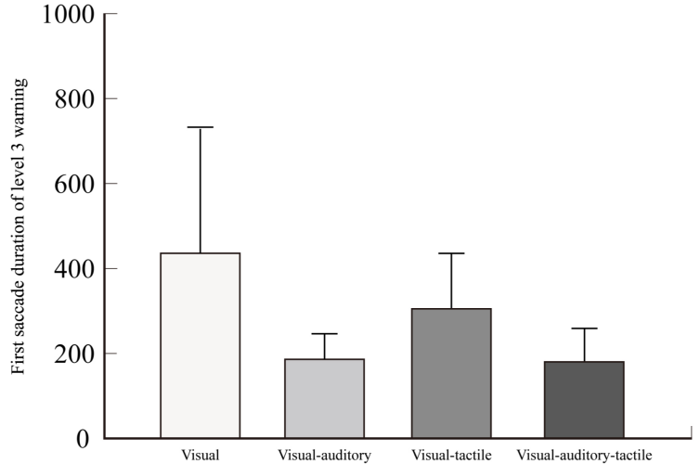
Supplementary Figure 6. First saccade duration of the level 3 warning interface under different warnings

