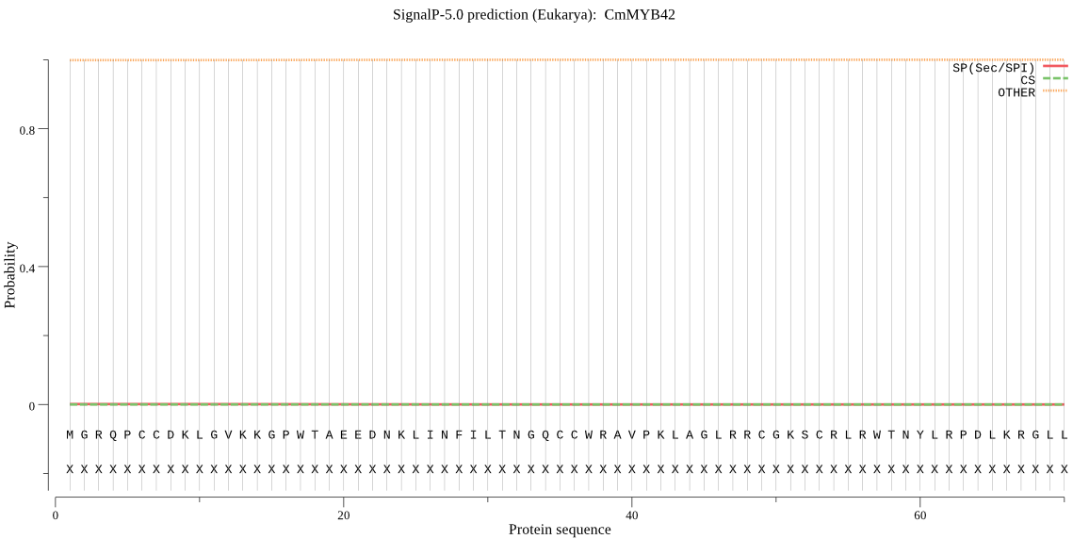
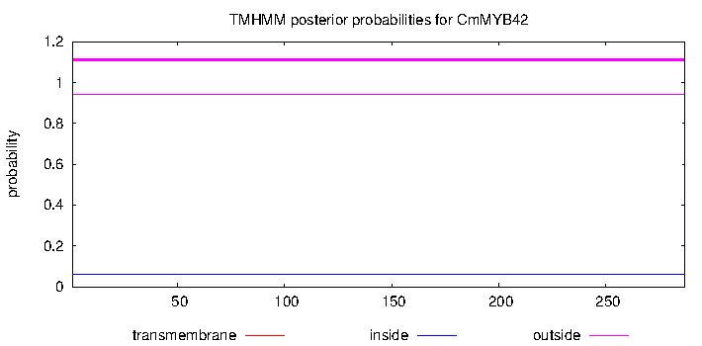

Fig.S1 Signal peptide prediction of CmMYB42

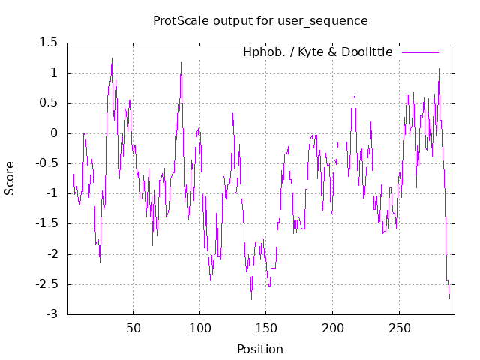
Fig.S2 Hydrophobicity prediction of CmMYB42

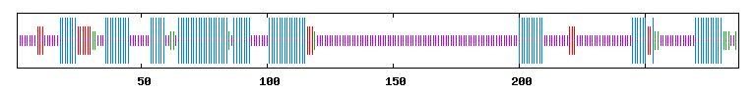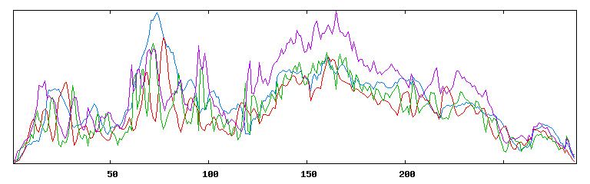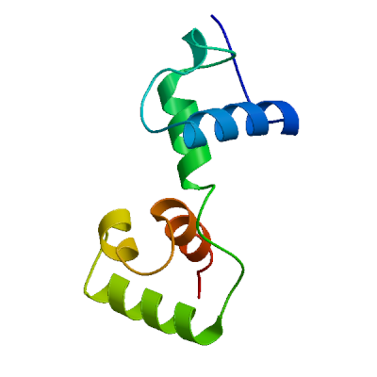
b
a
Fig.S3 a. Secondary structure prediction of CmMYB42 protein (Blue: Helix; Pu: Coil; Red: Sheet; Green: Beta turn); b. Tertiary structure prediction of CmMYB42 protein

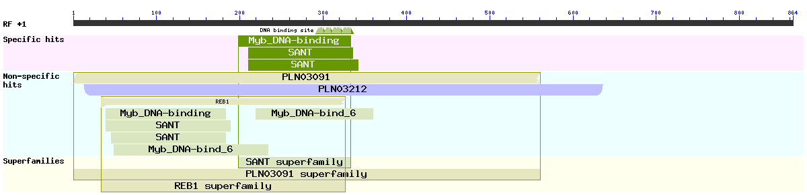
Fig.S4 Conserved domain analysis of CmMYB42 protein

Table S1 The primers for cloning, constructing vectors and qPCR

Primer | Sequence (5’-3’) | Purpose
CmMYB42-F | ATGGGAAGACAACCATGCTG | Gene cloning
CmMYB42-R | TCAATTTTGTTGTTTGTTGTCG | Gene cloning
CmMYB42-OE-F | catatgcccgtcgaccccgggATGGGAAGACAACCATGCTGC | Construction of overexpressing vector
CmMYB42-OE-R | ttctcctttacccatgaattcATTTTGTTGTTTGTTGTCGTTCT | Construction of overexpressing vector
CmMYB42-TRV-F | gaattcTTAAGCTATCTCCTTGGTGA | Construction of silencing vector
CmMYB42-TRV-R | ggatccTTGTTGTTTGTTGTCGTTCT | Construction of silencing vector
TRV1-F | TACTAACCTGGGCGAAGGACAC | Construction of silencing vector
TRV1-R | ACCTCGGA TAAA TCTGGTAAAACG | Construction of silencing vector
TRV2-F | TTTGTTTTTA TGTTCAGGCGGT | Construction of silencing vector
TRV2-R | AAGTCCGTTCCCCTA TGGTAA | Construction of silencing vector
qCmACTIN-F | CTAATGAATGCTTACTGTGACCGAC | qPCR
qCmACTIN-R | AGGCGAATCATCAGTACCAAGTG | qPCR
qCmMYB42-F | GATTGTGCTACGTGGCTATTGG | qPCR
qCmMYB42-R | TTGTTGTTTGTTGTCGTTCTCT | qPCR
qCmNRT1.1-F | AACAGGGACCGTCAAGAGAA | qPCR
qCmNRT1.1-R | AGCAATCAAGAACAGCGAAA | qPCR
qCmNRT1.5-F | TGTCAAGTGTTTGTGGCTGC | qPCR
qCmNRT1.5-R | GTTGGGATTTTCCTGTTTCG | qPCR
qCmNRT1.8-F | TTCCACATTCCTCCTGCAAGCA | qPCR
qCmNRT1.8-R | CTATGACAAGGCCGACCCCCAT | qPCR
qCmNRT2.1-F | GTAACACCTCCGAGCAACAC | qPCR
qCmNRT2.1-R | TTTCACAATGCAATAGCATG | qPCR
qCmNRT2.4-F | CCTCCTTACAACCAATGATG | qPCR
qCmNRT2.4-R | ACCAAGAAGACGACCATAA | qPCR
qCmNRT2.5-F | CAGCTCATTATGCCACTCGTGT | qPCR
qCmNRT2.5-R | TTCATCTTTATGTTTCTCCCCC | qPCR

