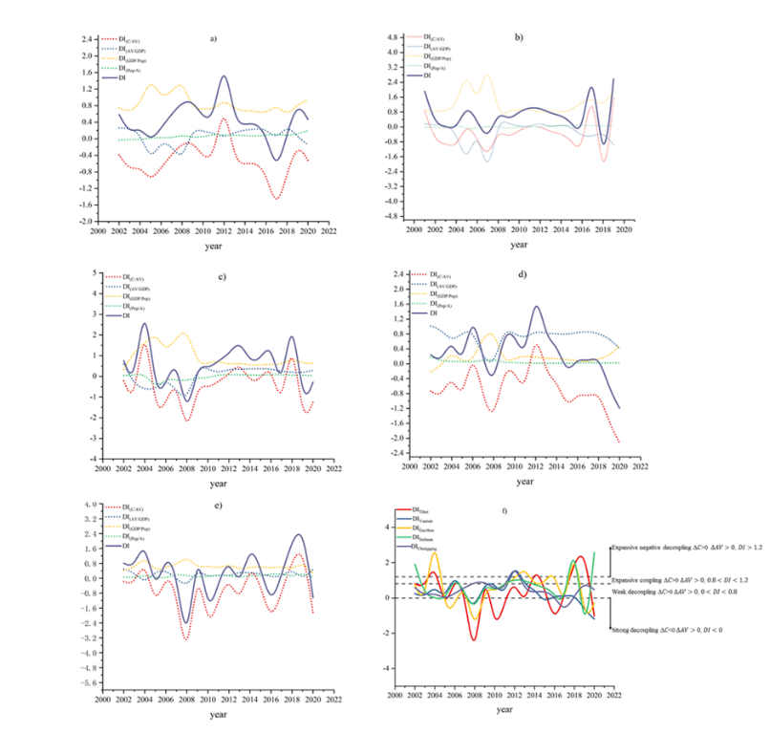
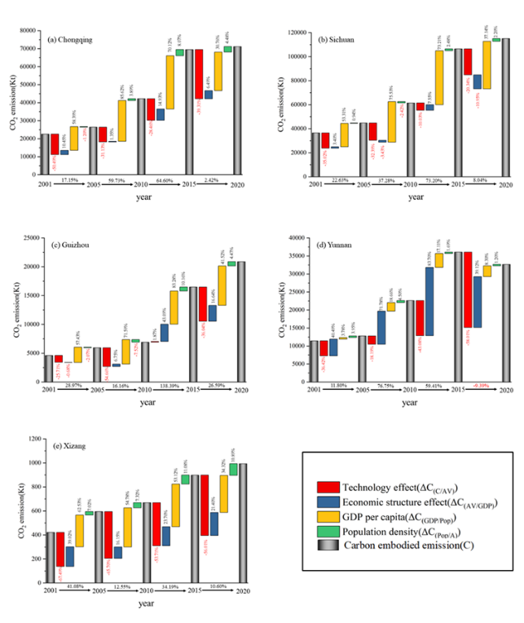
Decomposition and decoupling results of embodied carbon emission in Southwest China in 2001-2020.

