Thermal and mechanical abuse of electric vehicle pouch cell modules
Supplementary information

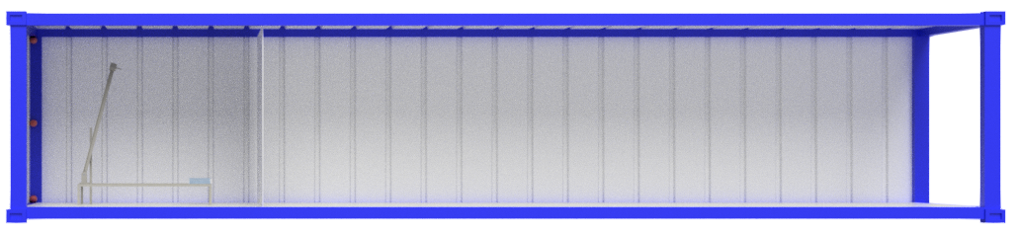
(a)
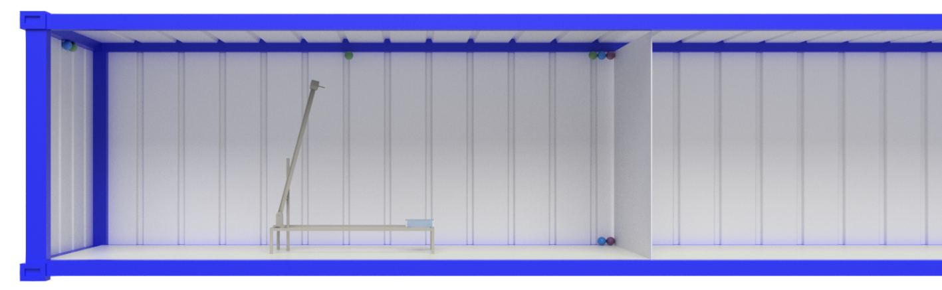
(b)
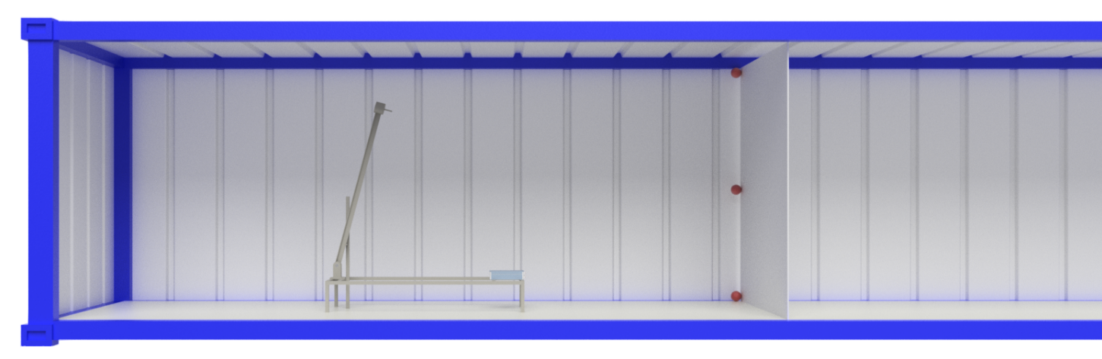
(c)
Figure S1. The location of the thermocouples in the sea container employed in the experiments. Experiment (a) 1, (b) 2 and (c) 3. In experiments 1 and 3 the gas sensors were placed 20 cm, 120 cm and 240 cm from the floor. In experiment 2 the sensors were placed as shown. Key: Green = H₂, blue = NOx, SO₂ and CO, purple = HF/HCl. The experiment volumes were defined by the back wall of the container and a polyethylene “blast wall” placed (a) 3 m and (b), (c) 6.1 m from the back wall of the container: i.e. defining 25% or 50% of the volume, respectively, of the 12.2 m x 2.4 m x 2.6 m sea container.

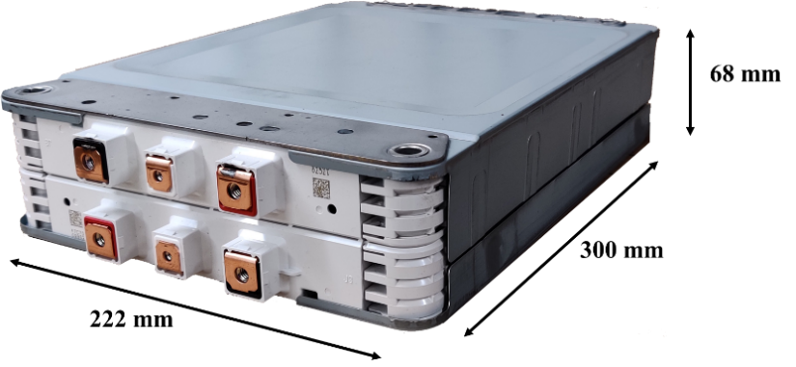
(a)
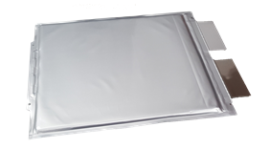
(b)
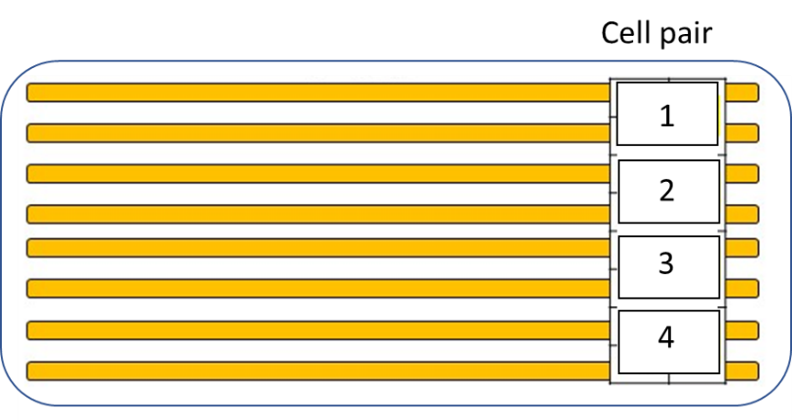
(c)
Figure S2. (a) The 8-cell module, (b) a pouch cell and (c) order of the cell pairs.

