Original western blotting from the manuscript
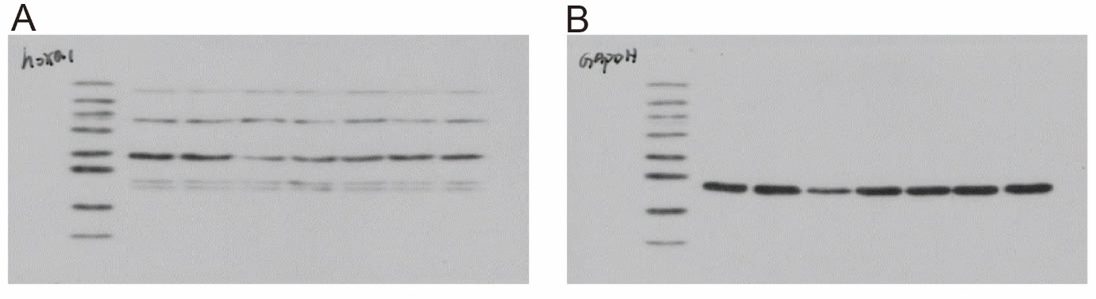
Figure 1A is the original image of HOXA1 western blots in the manuscript (figure 1C), while the red box is the cropped part of the manuscript with a size of 48kDa.
Figure 1B is the original western blot comparison of GAPDH in the manuscript (figure 1C), while the yellow box is the cropped portion of the manuscript with a size of 37kDa.
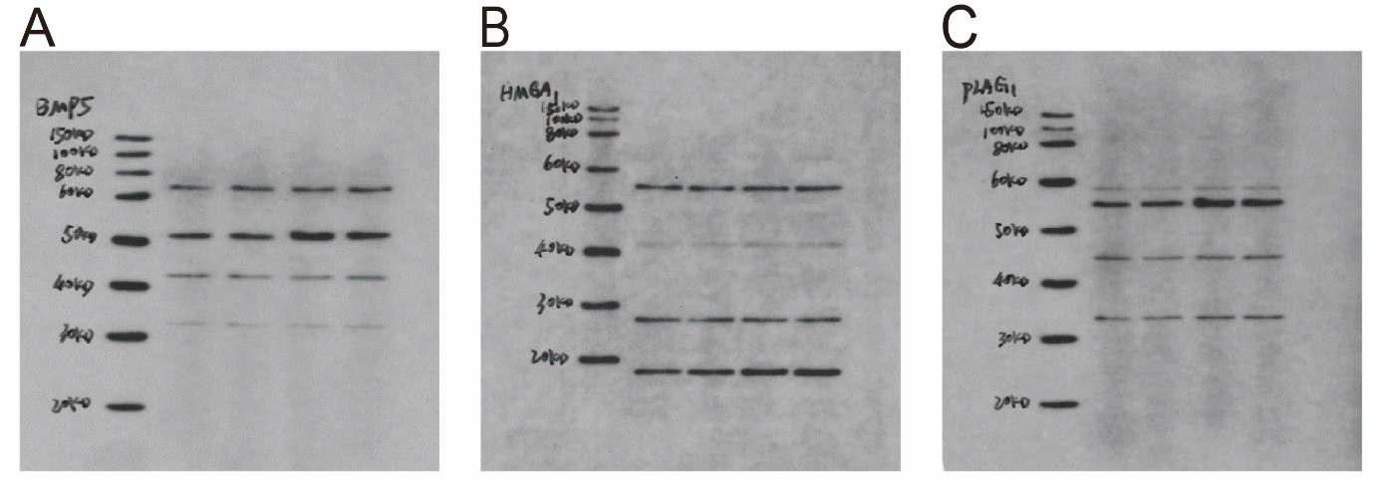
Figure 2A is the original western blotting of BMP5 from the manuscript (figure 2E), while the red box is the clipped portion of the manuscript with a size of 52kDa.
Figure 2B is the original HMGA1 western blotting from the manuscript (figure 2E), while the yellow box is the cropped portion of the manuscript with a size of 17kDa.
Figure 2C is the original western blot of PLAG1 from the manuscript (Figure 2E), while the blue box is the cropped portion of the manuscript with a size of 56kDa.

