Supplementary files
Table 1

Figure1
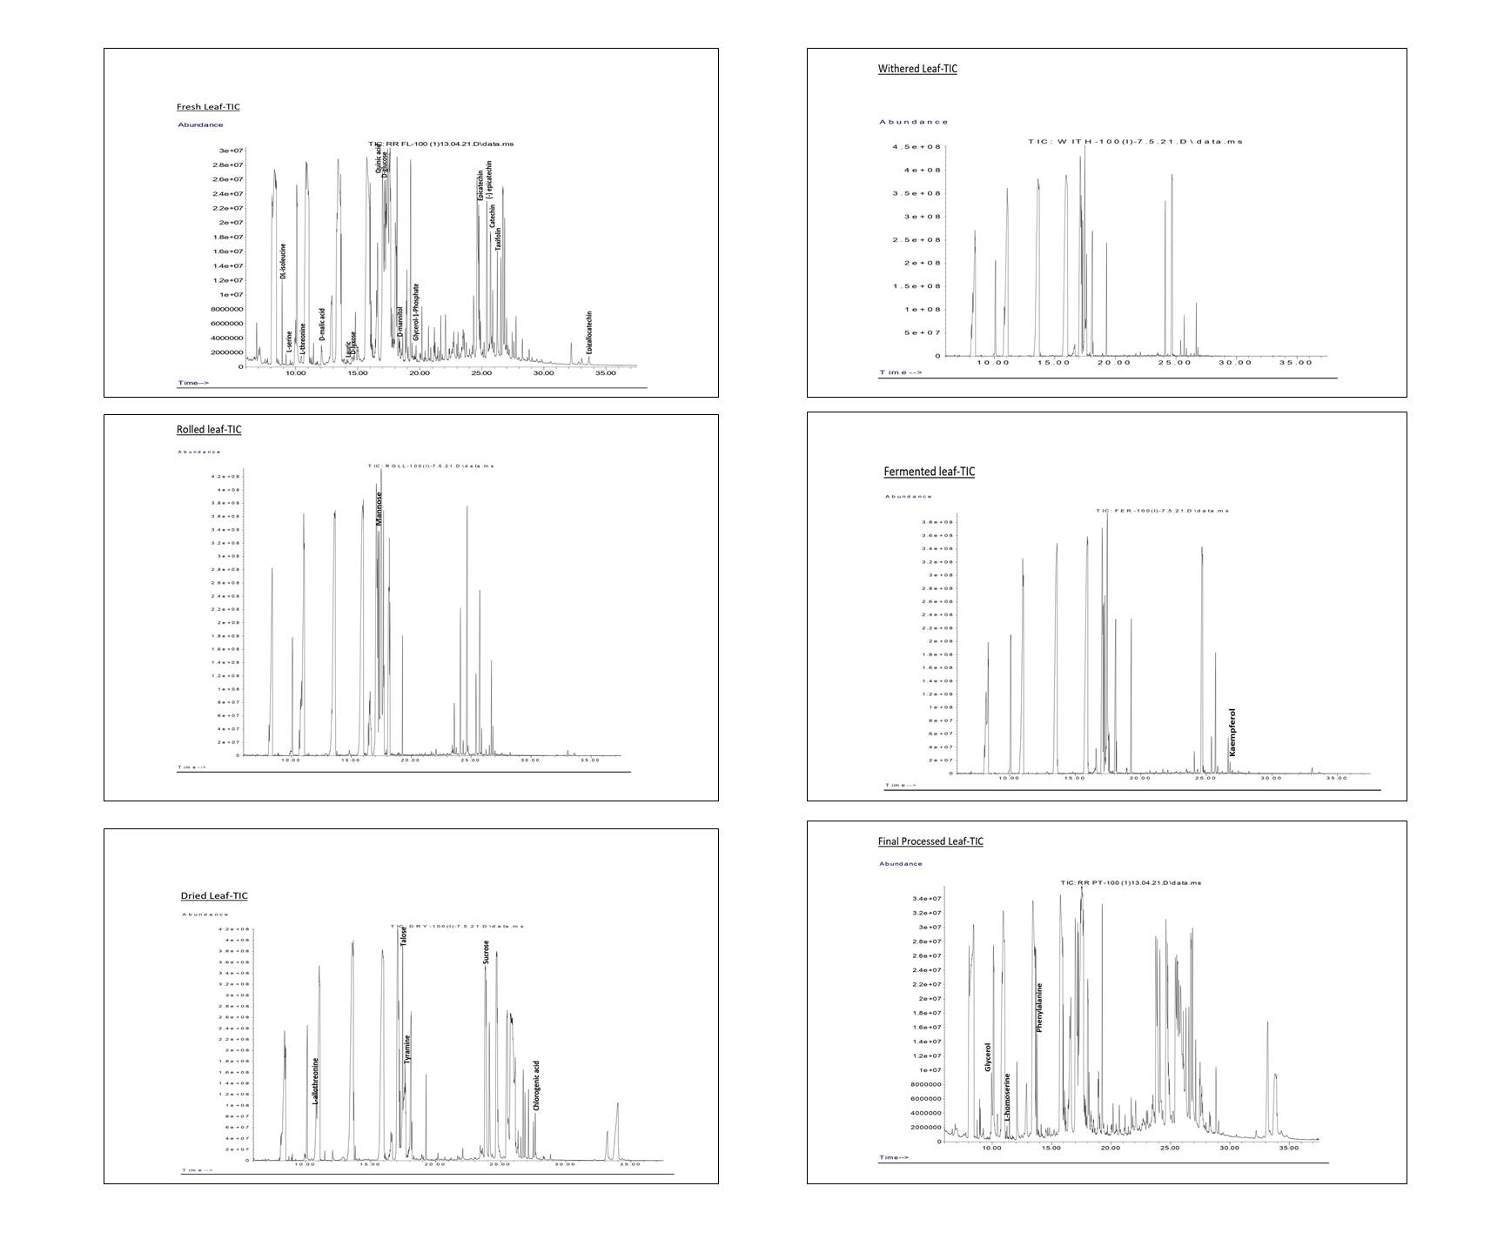

Figure 1. GC/MS TICs of fresh, withered, rolled, fermented, dried and finally processed tea.

