Appendix A. Supplementary data
The following are the Supplementary data to this article:
Supplemental Fig. 1. Detection of the Tbx4 recombinant protein and anti-Tbx4 antibody.
A: Tbx4 recombinant protein, 4μl; BSA, 0.5mg/ml, 2μl. B: immune serum. C: purified antibody, with an IgG concentration of 3.72 mg/ml.

Supplemental Fig. 2. Detection of the Tbx5 recombinant protein and anti-Tbx5 antibody.
A: Tbx5 recombinant protein, 4μl; BSA, 0.5mg/ml, 2μl. B: immune serum. C: purified antibody, with an IgG concentration of 6.95 mg/ml.

Supplemental Fig. 3. Schematic diagram of Pampus argenteus Tbx4 domains. Blue indicates T-box functional domain; gray indicates T-box1 functional domain; brown indicates T-box2 functional domain; green indicates T-box3 functional domain.

Supplemental Fig. 4. Predicted tertiary structure of Pampus argenteus Tbx4 protein.

Supplemental Fig. 5. Alignment of Tbx4 amino acid sequences between Pampus argenteus and other vertebrate speciesa.

Supplemental Fig. 6. Tbx4 phylogenetic tree of 24 vertebrate species constructed according to the maximum likelihood method using MEGA 7.0 software. The number of repeated sampling is 1000; Pampus argenteus is marked with "▲".

Supplemental Fig. 7. Schematic diagram of Pampus argenteus Tbx5 domains. Blue indicates T-box functional domain; gray indicates T-box1 functional domain; green indicates T-box3 functional domain.

Supplemental Fig. 8. Predicted tertiary structure of Pampus argenteus Tbx5 protein.

Supplemental Fig. 9. Alignment of Tbx5 amino acid sequences between Pampus argenteus and other vertebrate species.

Supplemental Fig. 10. Tbx5 phylogenetic tree of 24 vertebrate species constructed according to the maximum likelihood method using MEGA 7.0 software. The number of repeated sampling is 1000; Pampus argenteus is marked with "▲".

Supplemental Fig. 1.

Supplemental Fig. 2.

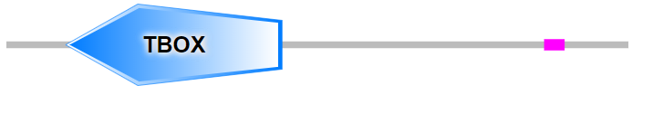

Supplemental Fig. 3.

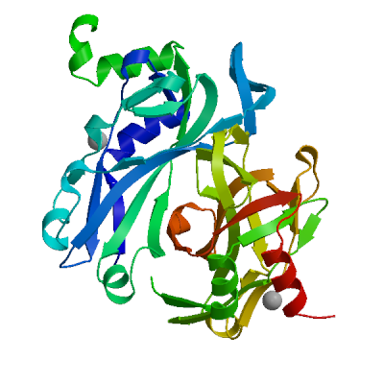
Supplemental Fig. 4.

Supplemental Fig. 5.
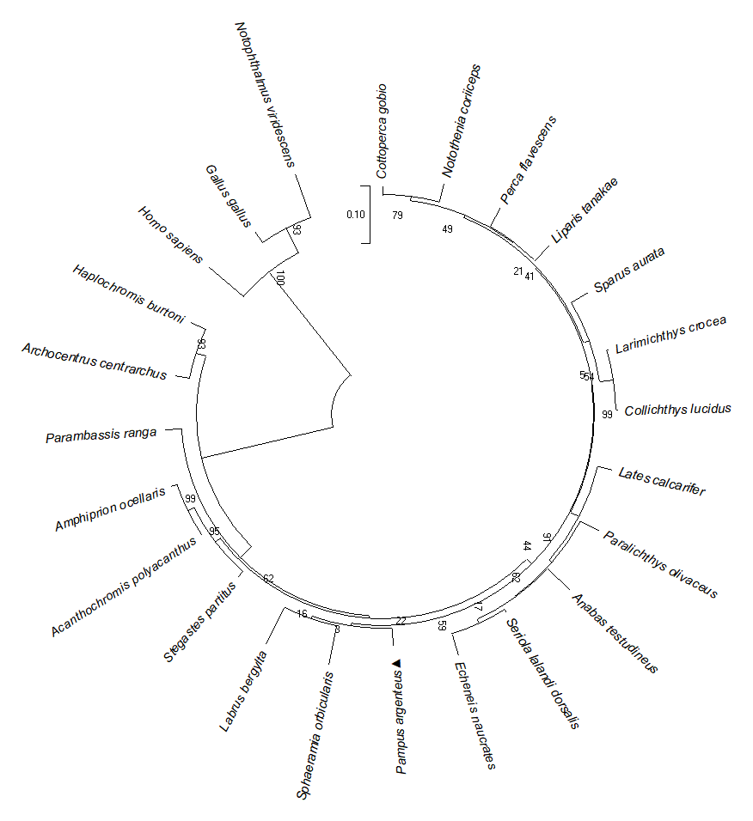
Supplemental Fig. 6.

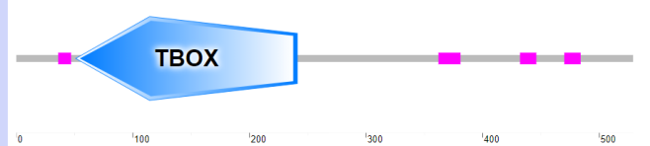
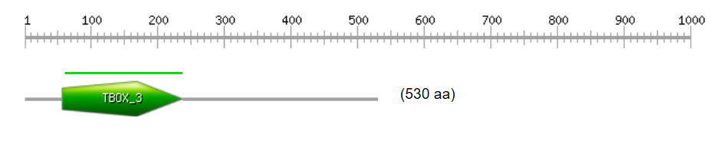
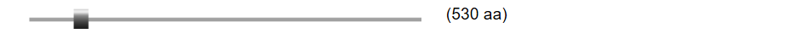
Supplemental Fig. 7.
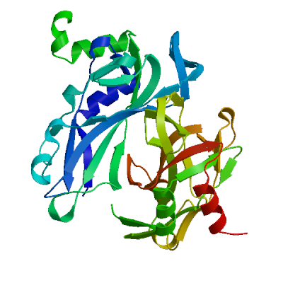
Supplemental Fig. 8.
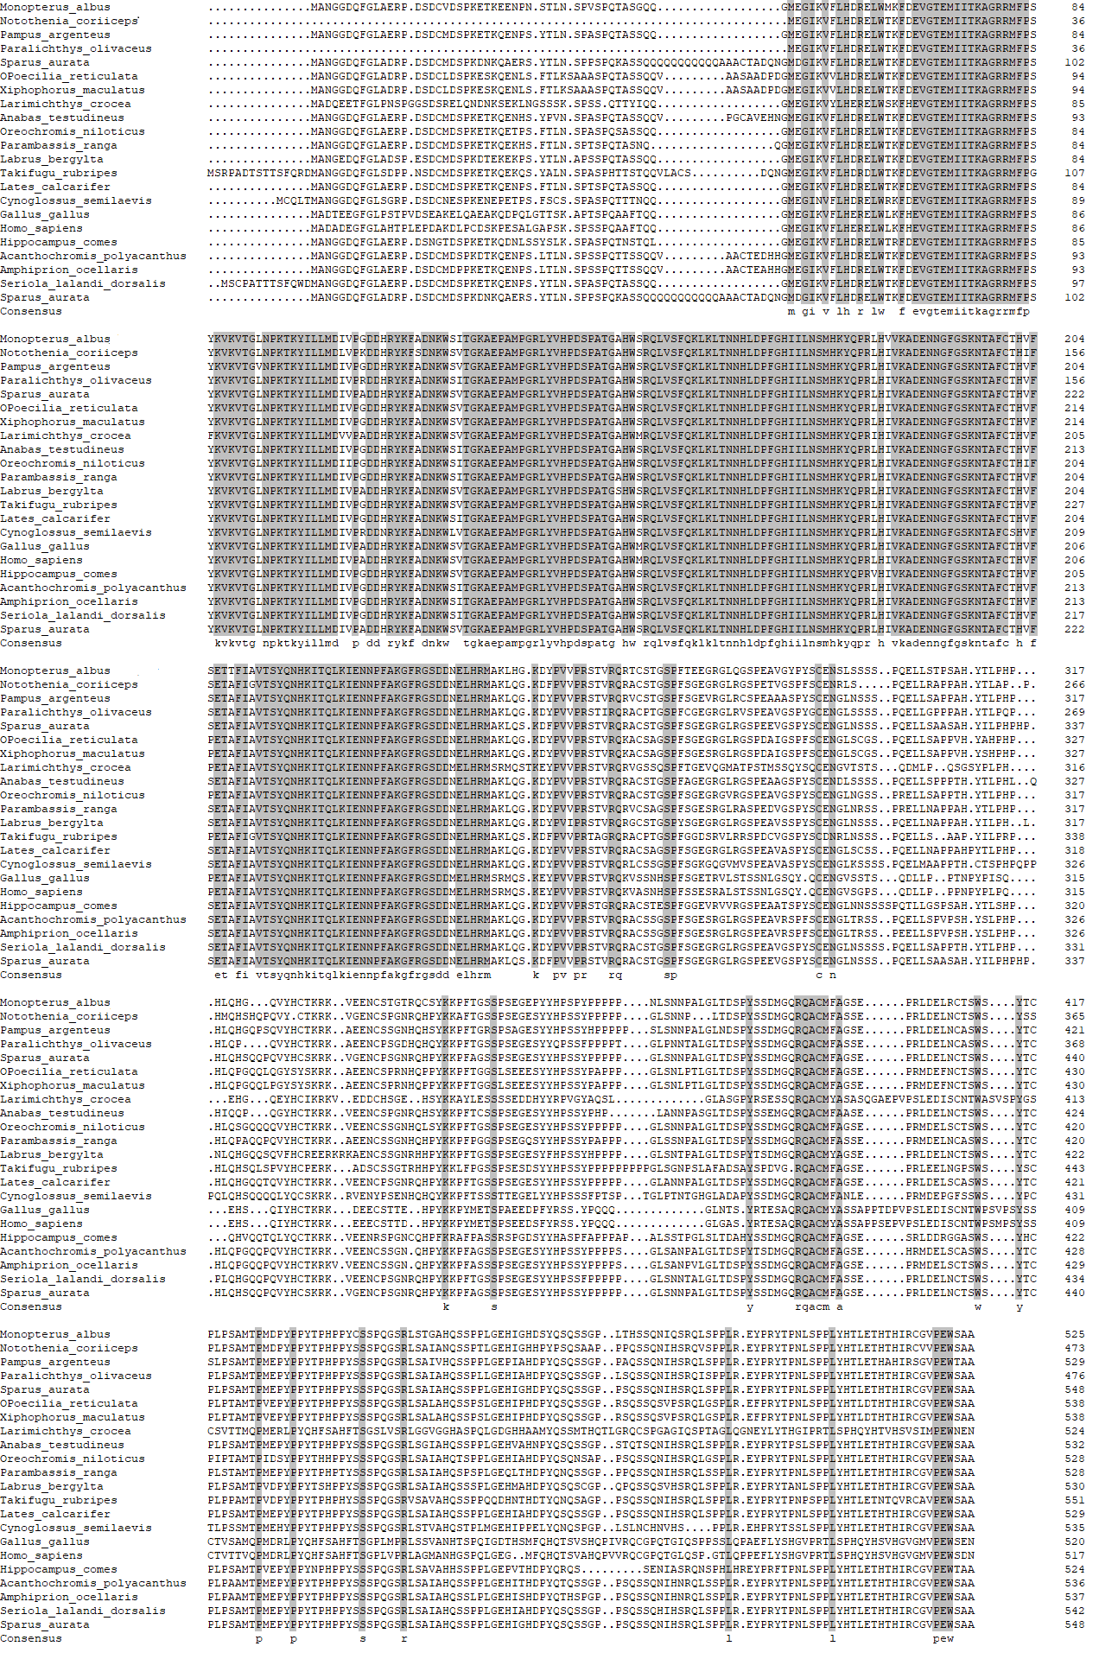
Supplemental Fig. 9.
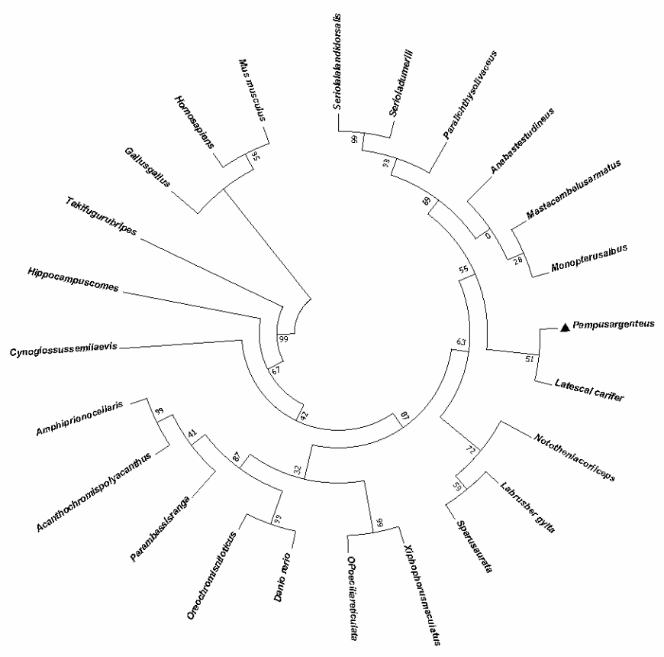
Supplemental Fig. 10.

