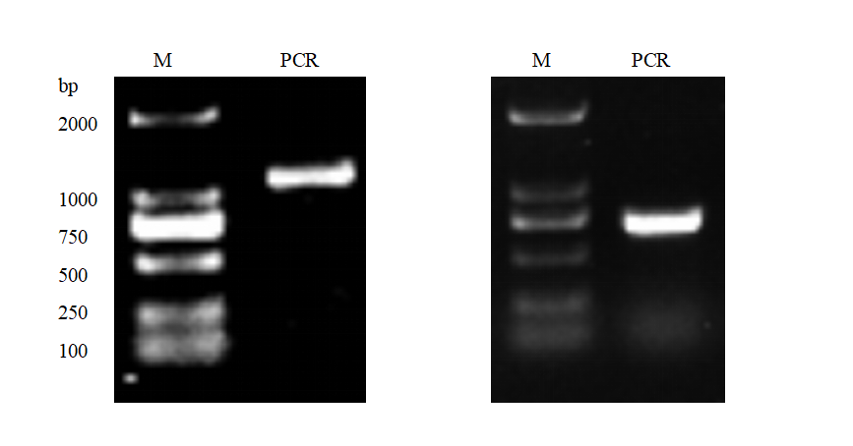
Fig. Tbx4 core fragment electrophoresis. The open reading frame (ORF) of 1642 bp.
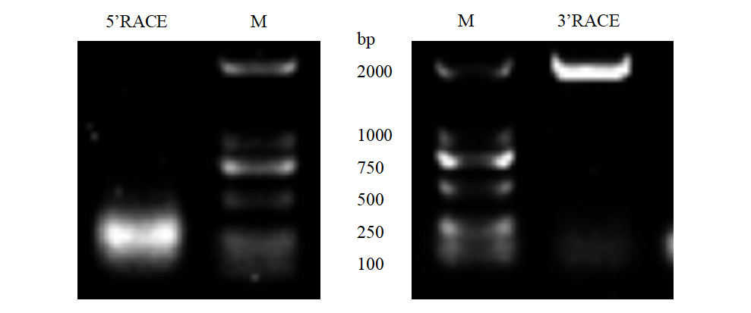
Fig. 5'RACE and 3'RACE electropherograms of Tbx4 cDNA. 5ʹ-UTR is 297 bp and 3ʹ-UTR is 1602 bp.

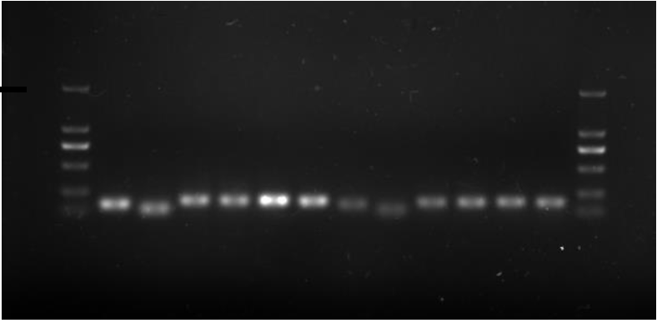
2000bp
M
Fig. PCR electrophoresis image of Tbx5 5 'end of cDNA (M: 2000 Marker). The 5ʹ-UTR is 125 bp .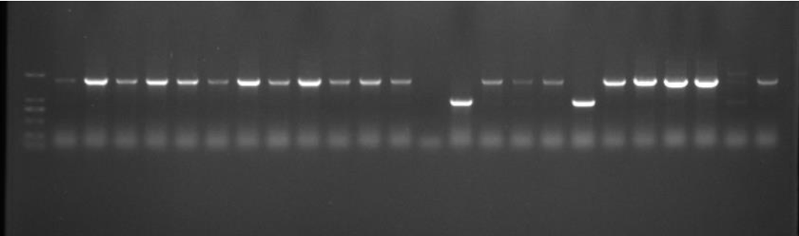
2000bp
M
Fig. PCR electrophoresis image of Tbx5 3 'end of cDNA (M: 2000 Marker). The 3ʹ-UTR is 1750 bp.

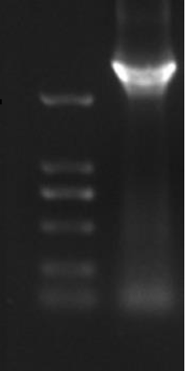
M
2000bp

Fig. cDNA full-length of Tbx5. The full-length is 3467 bp.

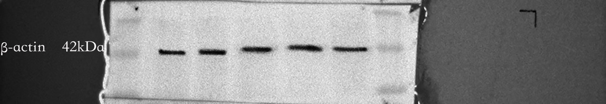
Fig. 2A TBX4 and TBX5 protein expression at various growth stages of Pampus argenteus. The original blot image of β-actin, the protein molecular weight is 42kDa.
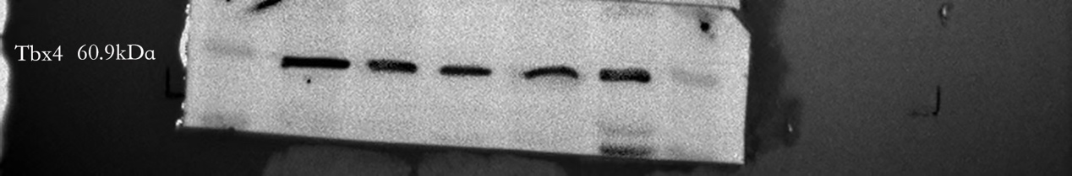
Fig. 2A TBX4 and TBX5 protein expression at various growth stages of Pampus argenteus. The original blot image of TBX4, the protein molecular weight is 60.9kDa.
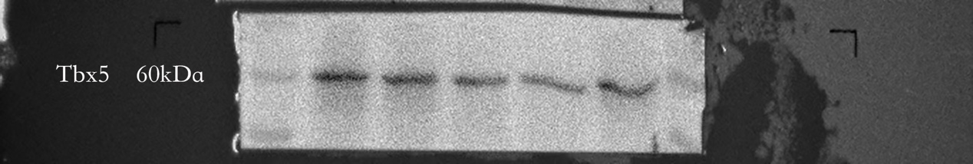
Fig. 2A TBX4 and TBX5 protein expression at various growth stages of Pampus argenteus. The original blot image of TBX5, the protein molecular weight is 60kDa.

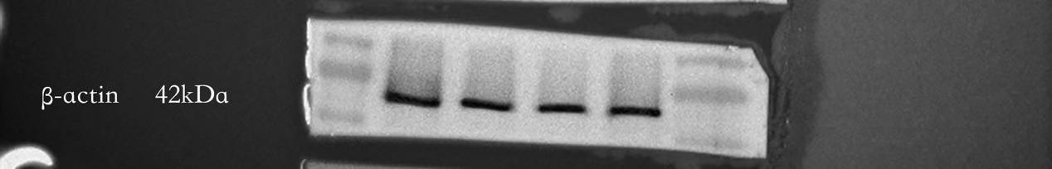
Fig. 6A TBX4 and TBX5 protein expression in different tissues of adult Pampus argenteus. The original blot image of β-actin, the protein molecular weight is 42kDa.
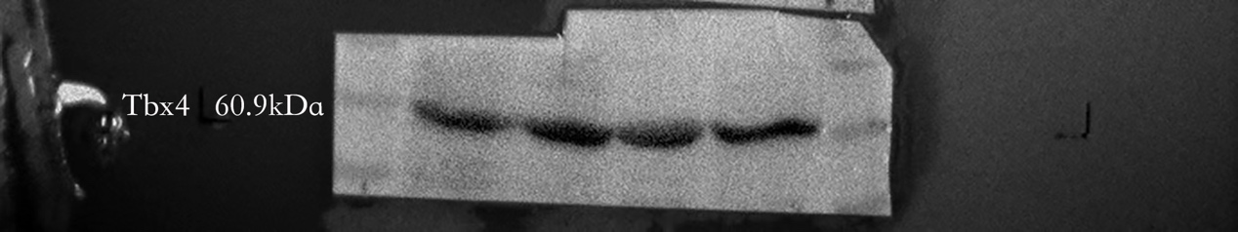
Fig. 6A TBX4 and TBX5 protein expression in different tissues of adult Pampus argenteus. The original blot image of TBX4, the protein molecular weight is 60.9kDa.
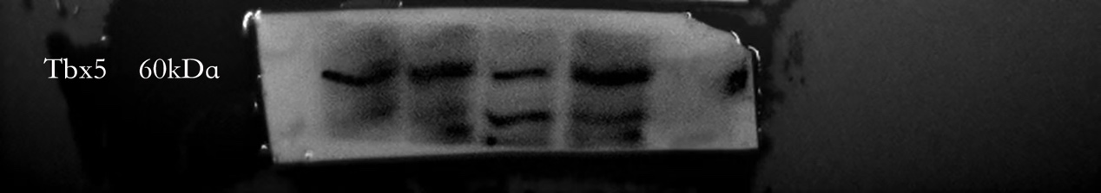
Fig. 6A TBX4 and TBX5 protein expression in different tissues of adult Pampus argenteus. The original blot image of TBX5, the protein molecular weight is 60kDa.

