Supplementary Fig.1
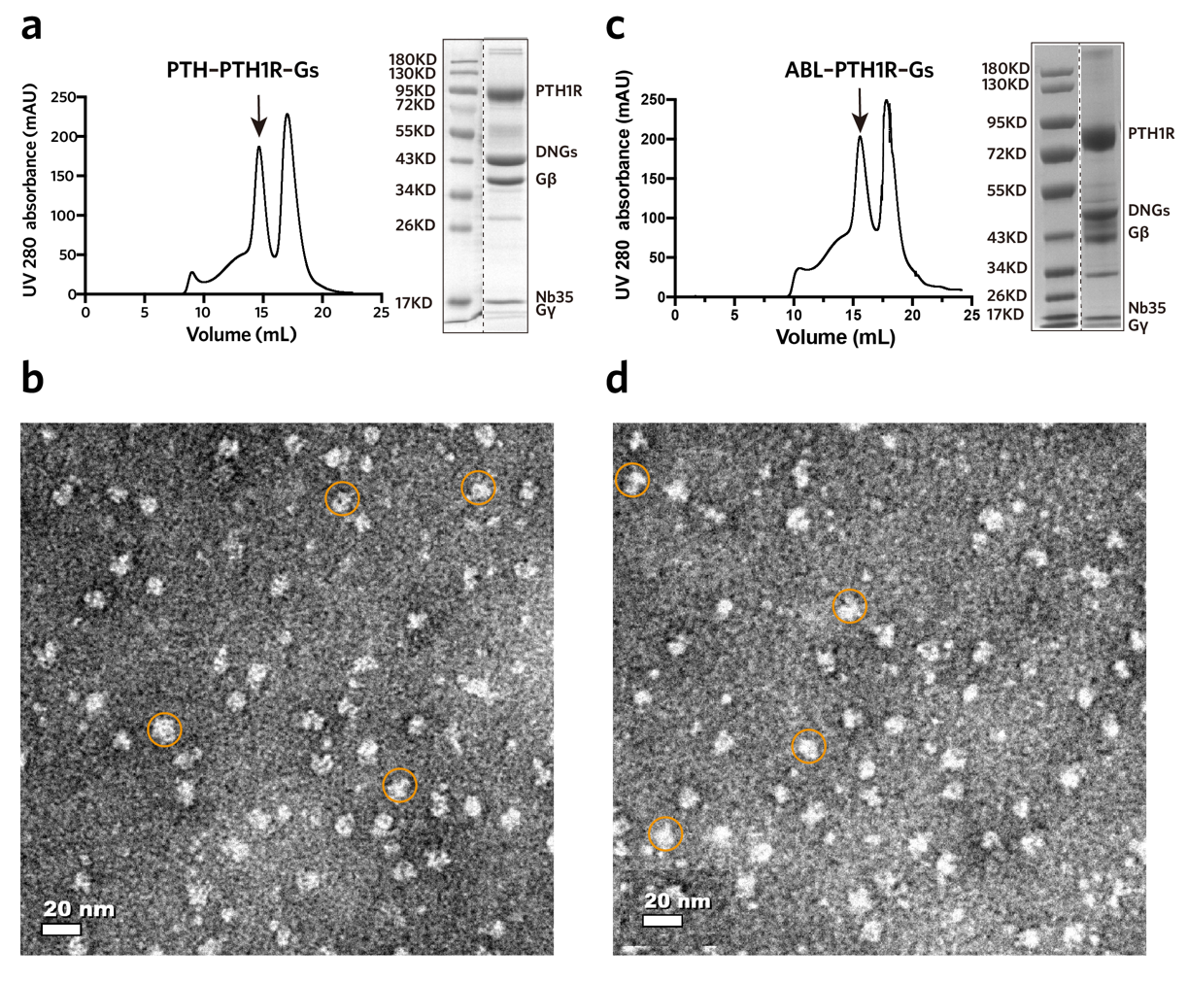
Supplementary Fig.1 | Purification of PTH1R–Gs complexes.
a-b, Size exclusion chromatography (SEC) profile, SDS–PAGE and negative-staining EM analysis of the purified PTH–bound PTH1R–Gs complex. c-d, SEC profile, SDS–PAGE and negative-staining EM analysis of the purified ABL–bound PTH1R–Gs complex. Examples of the complex are circled in orange.
Supplementary Fig.2
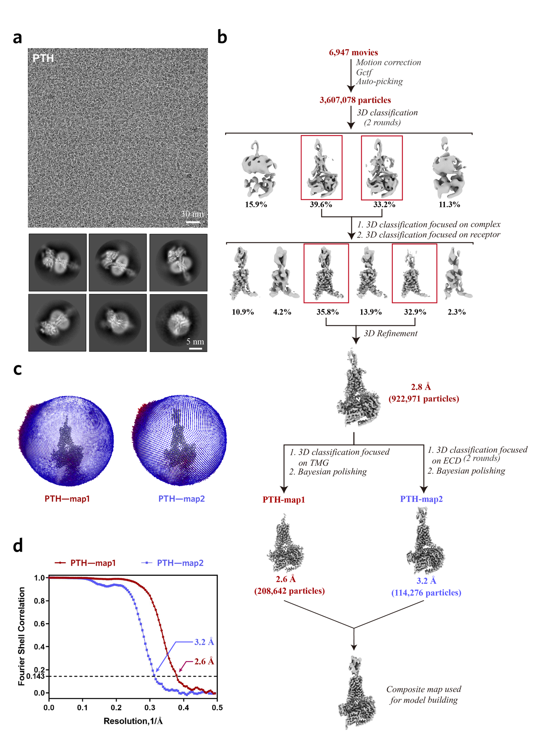
Supplementary Fig.2 | Cryo-EM data processing of PTH–bound PTH1R–Gs complex.
a, Cryo-EM micrograph (scale bar: 30 nm) and 2D class averages (scale bar: 5 nm) of PTH–bound PTH1R–Gs complex. b, Flow chart of cryo-EM data processing (Details are given in the Method). c, Angular distribution of particles used in the final 3D reconstruction. d, Fourier shell correlation (FSC) curves of the final refined map1 and map2.
Supplementary Fig.3
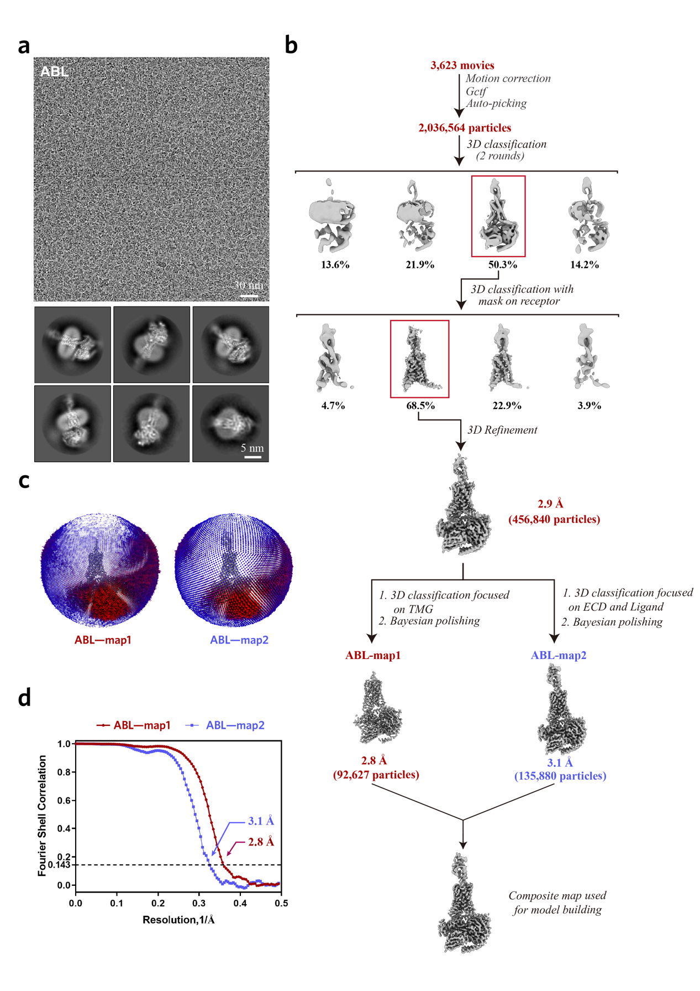
Supplementary Fig.3 | Cryo-EM data processing of ABL–bound PTH1R–Gs complex.
a, Cryo-EM micrograph (scale bar: 30 nm) and 2D class averages (scale bar: 5 nm) of ABL–bound PTH1R–Gs complex. b, Flow chart of cryo-EM data processing (Details are given in the Method). c, Angular distribution of particles used in the final 3D reconstruction. d, Fourier shell correlation (FSC) curves of the final refined map1 and map2.
Supplementary Fig.4
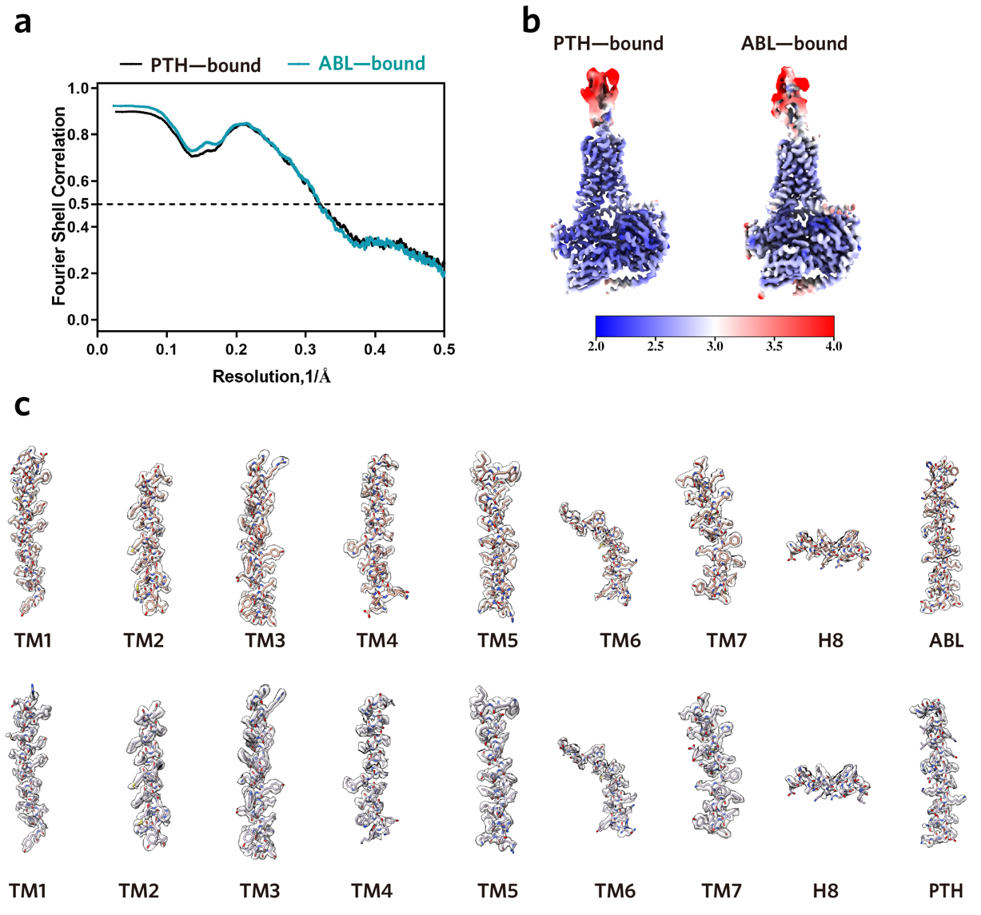Supplementary Fig.4 | Overall resolution and cryo-EM density analysis of the PTH1R–Gs complexes.
a, Fourier shell correlation curves of the model-vs-map. b, Cryo-EM maps coloured by local resolution (Å). c, Cryo-EM density maps and models are shown for all seven-transmembrane helices, helix 8 and peptide agonists of the PTH1R–Gs complexes.
Supplementary Fig.5
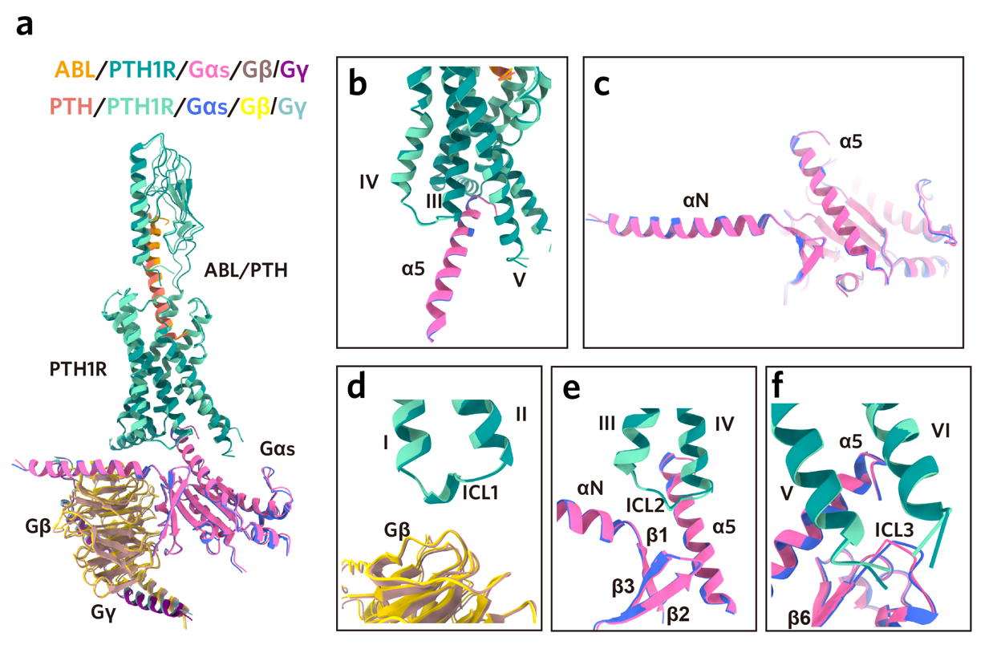
Supplementary Fig.5 | Structural comparisons of the ABL and PTH–bound PTH1R-Gs complexes.
a, The ABL– and PTH–bound PTH1R-Gs complexes adopt highly similar global conformations. Structures were aligned by the TMD of PTH1R. b-f, Conserved interactions between PTH1R and Gs in the ABL– and PTH–bound complexes.
Supplementary Fig.6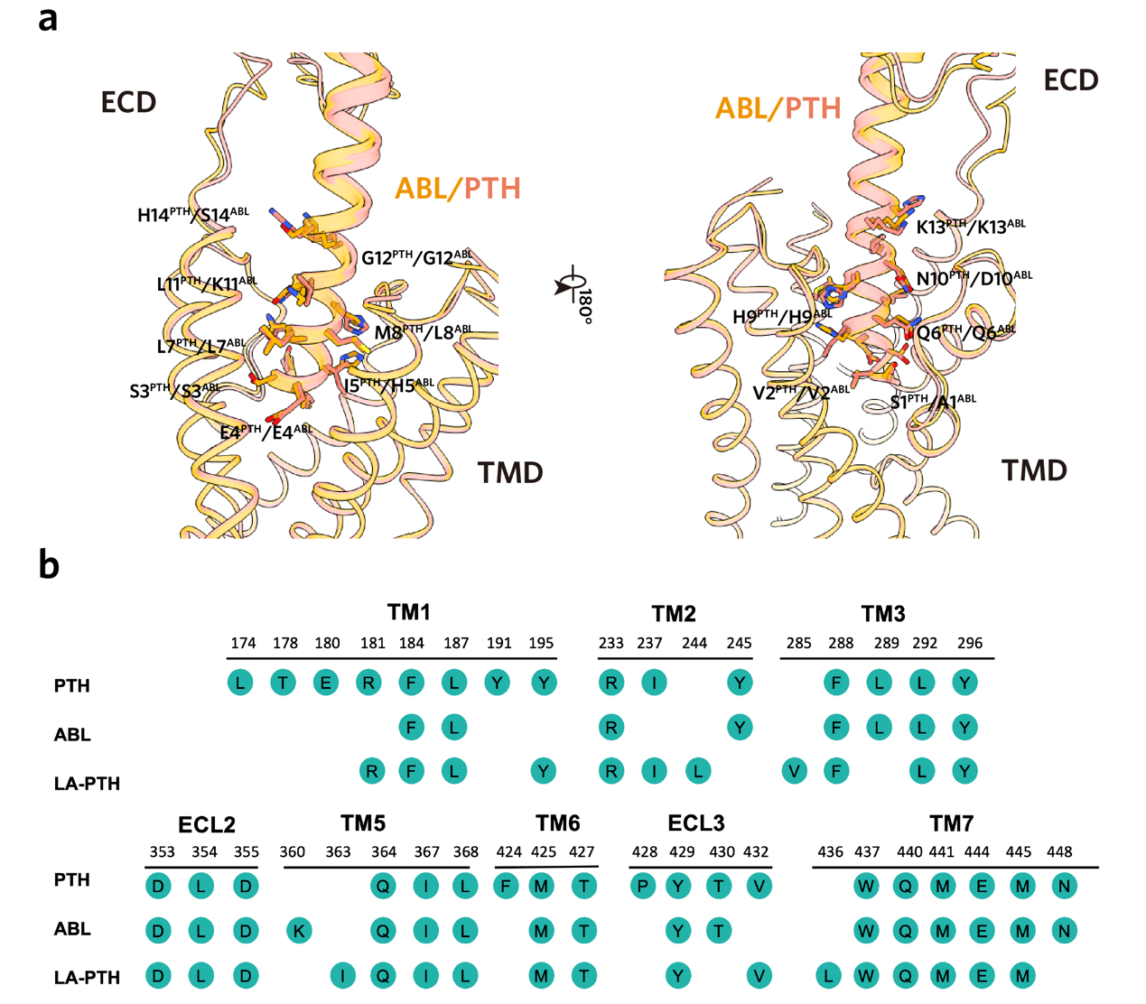
Supplementary Fig.6 | Molecular recognition of peptide agonists by PTH1R.
a, The N-terminal portions of PTH and ABL show similar binding mode within the TM core of PTH1R. b, Detail interactions of PTH1R with the N-terminal portions of three peptide agonists (PTH, ABL and LA-PTH). Interactions between LA-PTH and PTH1R were analyzed by our previously reported structure (PDB 6NBF). Mutagenesis studies for the residues of the receptor that make differential contacts with the three peptides using cAMP signaling assays.

Supplementary Fig.7
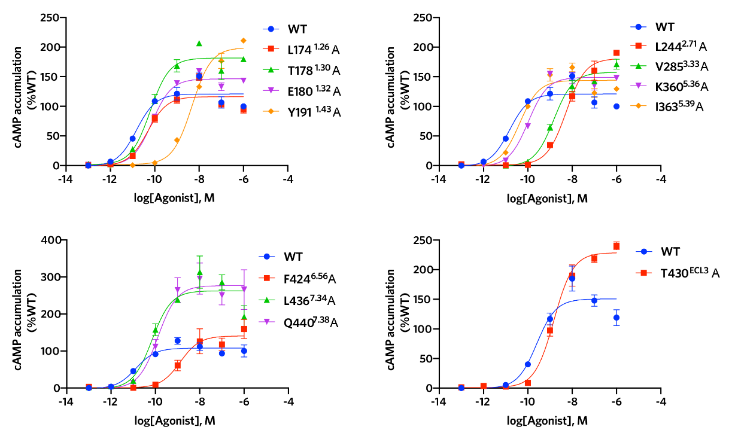
Supplementary Fig.7 | ABL–induced cAMP accumulation of wild-type and mutant PTH1R.
Dose-response curves of cAMP accumulation measured by Glosensor assay. The data were analyzed using the ‘log(agonist) vs. response-Variable slope (four parameters)’ function in Graphpad Prism. All data are presented as mean values ± standard error of measurement (SEM).
Supplementary Fig.8
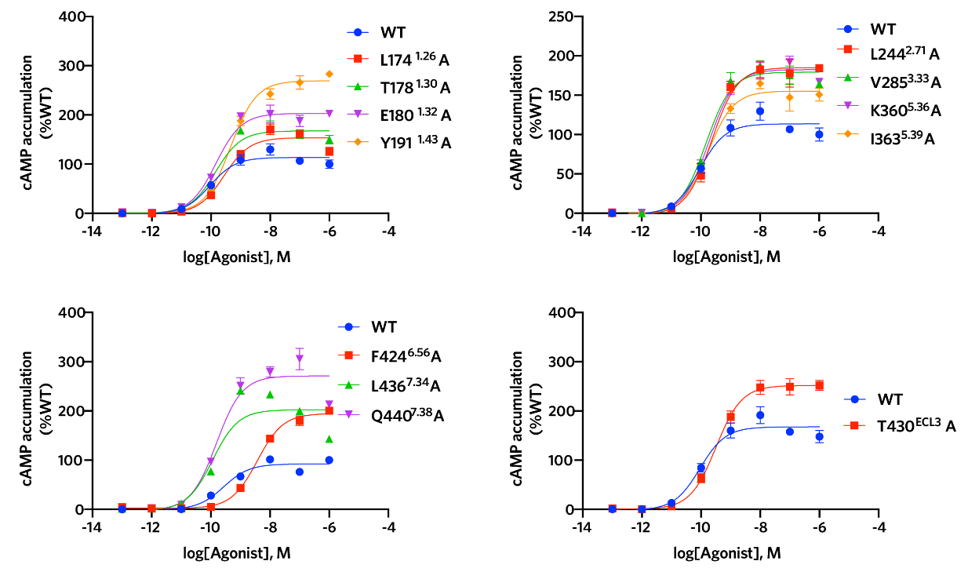
Supplementary Fig.8 | PTH–induced cAMP accumulation of wild-type and mutant PTH1R.
Dose-response curves of cAMP accumulation measured by Glosensor assay. The data were analyzed using the ‘log(agonist) vs. response-Variable slope (four parameters)’ function in Graphpad Prism. All data are presented as mean values ± standard error of measurement (SEM).
Supplementary Fig.9
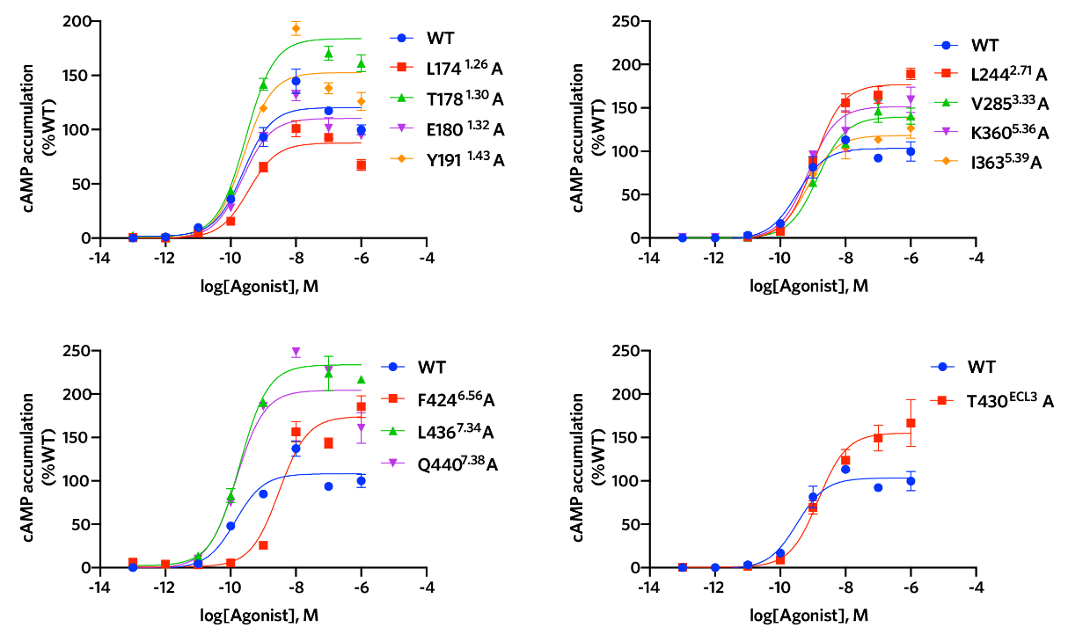
Supplementary Fig.9 | LA-PTH–induced cAMP accumulation of wild-type and mutant PTH1R.
Dose-response curves of cAMP accumulation measured by Glosensor assay. The data were analyzed using the ‘log(agonist) vs. response-Variable slope (four parameters)’ function in Graphpad Prism. All data are presented as mean values ± standard error of measurement (SEM).
Supplementary Fig.10
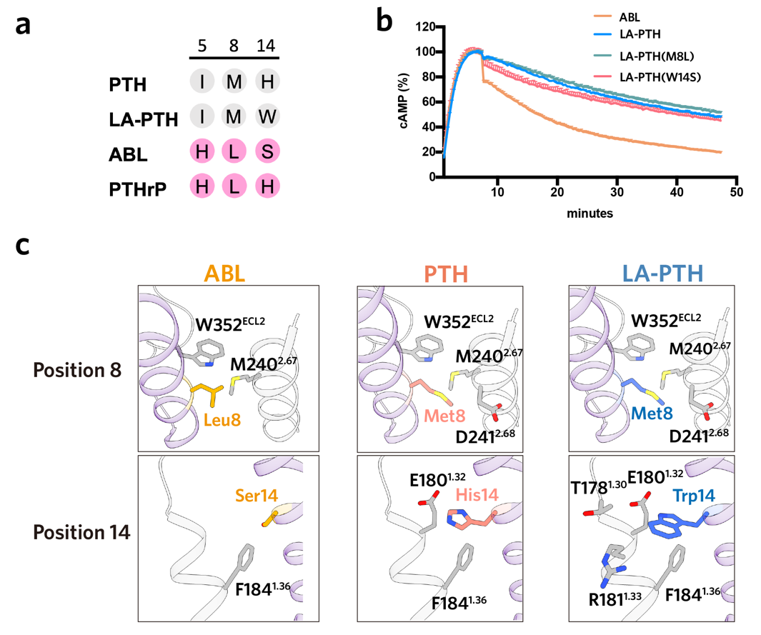
Supplementary Fig.10 | Role of the N-terminal residues of LA-PTH in the prolonged cAMP signaling.
a, Sequence alignment of the residues 5, 8 and 14 in the N-terminal portion of peptide agonists. b, Effects of mutations in residues 8 and 14 of LA-PTH on its induced prolonged cAMP signaling. c, The potential interactions of residues in position 8 and 14 of peptide agonists with the R₀ state receptor (PDB 6FJ3). The potential interactions were analyzed based on the template of ePTH-bound PTH1R.

Supplementary Fig.11
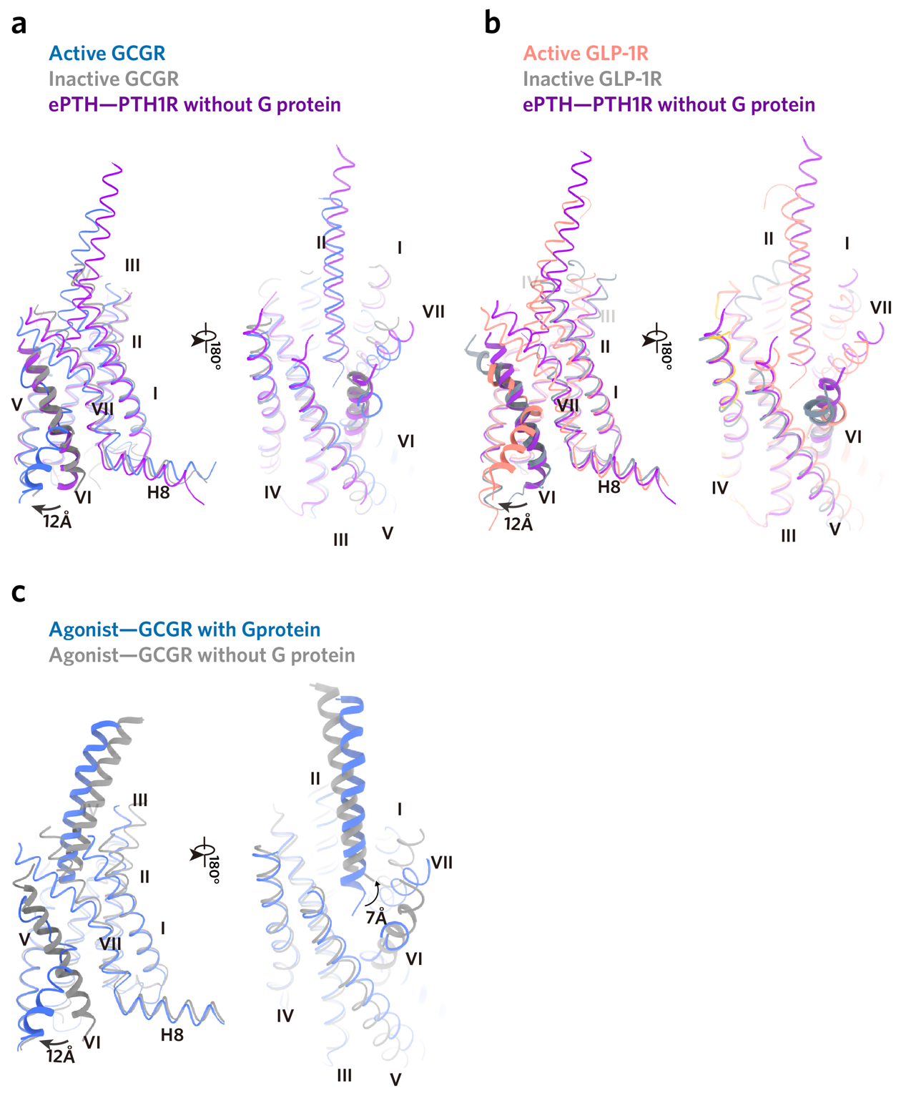
Supplementary Fig.11 | The ePTH–bound PTH1R is probably a representative “intermediate state” in class B1 GPCRs.
a, Structural comparison of the ePTH–PTH1R (PDB 6FJ3) with active (PDB 6LMK) and inactive GCGR (PDB 5XEZ). b, Structural comparison of the ePTH–PTH1R (PDB 6FJ3) with active (PDB 6VCB) and inactive GLP-1R (PDB 6LN2). c, Structural comparison of the peptide–bound GCGR with (PDB 6LMK) and without G-protein (PDB 5YQZ).
Supplementary Fig.12
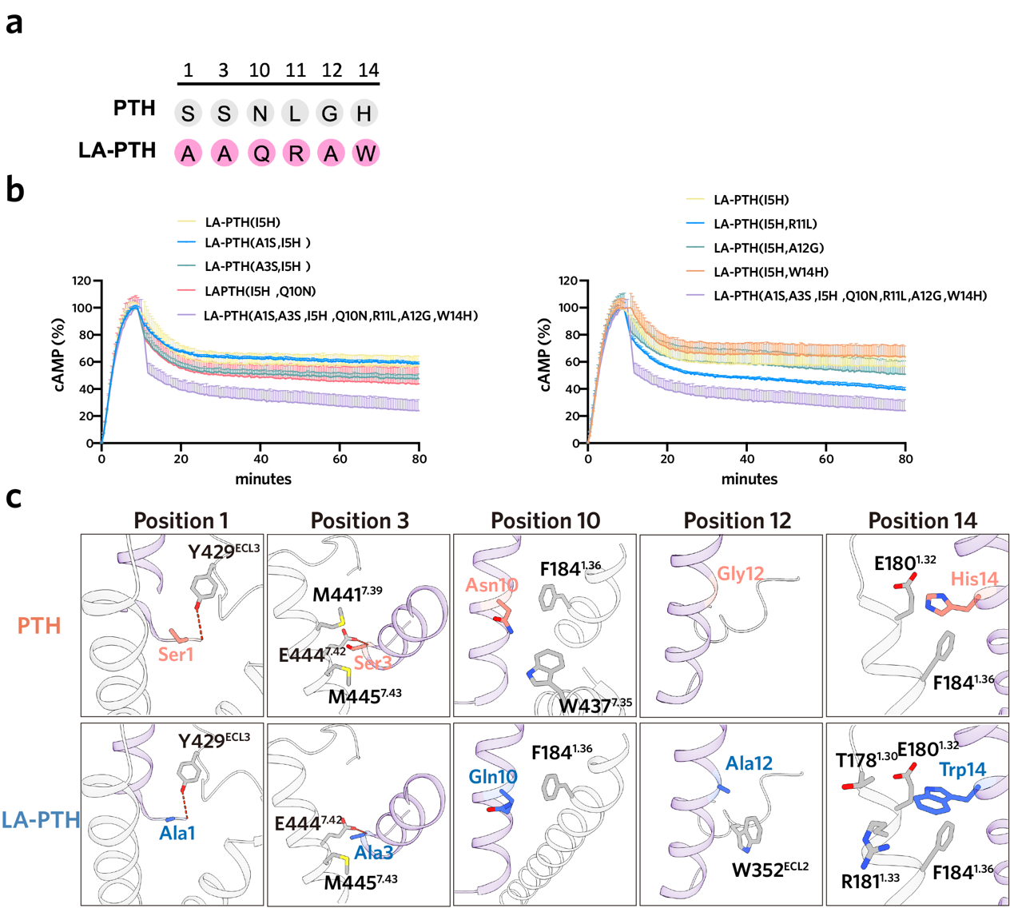
Supplementary Fig.12 | Role of “M” substitutions in LA-PTH–induced prolonged cAMP signaling.
a, Sequence alignment of the divergences in the N-terminal portion of LA-PTH and PTH. “M” substitutions in LA-PTH are colored pink. b, Effects of mutations in the “M” substitutions of LA-PTH on its induced prolonged cAMP signaling. c, The potential interactions of the “M” substitutions in LA-PTH with the R₀ state receptor (PDB 6FJ3). The potential interactions were analyzed based on the template of ePTH-bound PTH1R.
Supplementary Fig.13
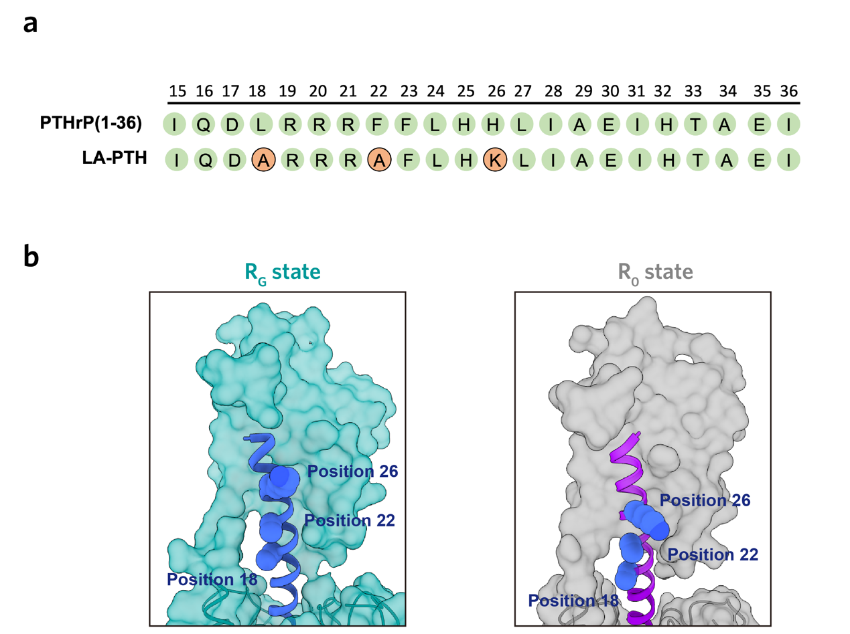
Supplementary Fig.13 | Sequence and structural analysis of the three residue substitutions in the C-terminal portion of LA-PTH.
a, Sequence alignment between the C-terminal portion of LA-PTH and PTHrP. The residue discrepancies in the C-terminal portion of the two peptides are colored orange. b, The three residues (position 18, 22 and 26) in the C-terminal portion of peptide are located at the solvent-accessible side of the peptide agonists for both R_{G} (PDB 6NBF) and R₀ states (PDB 6FJ3) of PTH1R.
Supplementary Table.1 | Cryo-EM data collection, model refinement, and validation statistics.
 | PTH | ABL
Data collection and processing
Magnification | 4,9310 | 4,9310
Voltage (kV) | 300 | 300
Electron exposure (e–/Å²) | 64 | 64
Defocus range (μm) | -0.5 ~ -2.5 | -0.5 ~ -2.5
Pixel size (Å) | 1.014 | 1.014
Symmetry imposed | C1 | C1
Initial particle projections | 3,607,078 | 2,036,564
Final particle projections | on TMG:208,642  on ECD:114,276 | on TMG: 92,627  on ECD:135,880
Map resolution (Å) | 2.8 | 2.9
FSC threshold | 0.143 | 0.143
Map resolution range (Å) | 2.5-5.0 | 2.5-5.0
Refinement
Initial model used | 6NBF | 6NBF
Model resolution (Å)  FSC threshold | 3.2  0.5 | 3.1  0.5
Map sharpening method | DeepEMhancer | DeepEMhancer
Model composition  Non-hydrogen atoms  Protein residues  Ligand | 9218  1153  1 | 9203  1152  1
B factors (Å²)  Protein  Ligand | 99.58  110.91 | 94.67  95.45
R.m.s. deviations  Bond lengths (Å)  Bond angles (°) | 0.007  0.732 | 0.010  0.800
Validation  MolProbity score  Clashscore  Rotamer outliers (%) | 1.68  7.11  0.00 | 1.54  5.09  0.00
Ramachandran plot  Favored (%)  Allowed (%)  Disallowed (%) | 95.84  4.16  0 | 96.01  3.99  0

Supplementary Table.2 | Interactions of PTH with PTH1R.
Residues within 4 Å are shown.
PTH | PTH1R | Interaction
Ser1 | Phe424^{6.56} | Hydrogen bond
Ser1 | Met425^{6.57} | Hydrogen bond
Ser1 | Thr427^{6.59} | Hydrogen bond
Ser1 | Pro428^{ECL3} | Polar interaction
Ser1 | Tyr429^{ECL3} | Van der waals force
Val2 | Tyr296^{3.44} | Van der waals force
Val2 | Gln364^{5.40} | Polar interaction
Val2 | Ile367^{5.43} | Hydrophobic interaction
Ser3 | Gln440^{7.38} | Polar interaction
Ser3 | Glu444^{7.42} | Polar interaction
Ser3 | Met441^{7.39} | Van der waals force
Ser3 | Met445^{7.43} | Van der waals force
Glu4 | Arg233^{2.60} | Electrostatic interaction
Glu4 | Ile237^{2.64} | Van der waals force
Glu4 | Phe288^{3.36} | Van der waals force
Glu4 | Tyr195^{1.47} | Hydrogen bond
Glu4 | Asn448^{7.46} | Hydrogen bond
Ile5 | Leu289^{3.37} | Hydrophobic interaction
Ile5 | Leu292^{3.40} | Hydrophobic interaction
Ile5 | Gln364^{5.40} | Van der waals force
Gln6 | Thr430^{ECL3} | Polar interaction
Gln6 | Trp437^{7.35} | Van der waals force
Gln6 | Gln440^{7.38} | Hydrogen bond
Gln6 | Met441^{7.38} | Hydrophobic interaction
Gln6 | Tyr429^{ECL3} | Hydrophobic interaction
Leu7 | Leu187^{1.39} | Hydrophobic interaction
Leu7 | Met441^{7.38} | Van der waals force
Leu7 | Met445^{7.43} | Van der waals force
Met8 | Tyr245^{2.72} | Van der waals force
Met8 | Asp353^{ECL2} | Van der waals force
His9 | Asp353^{ECL2} | Electrostatic interaction
His9 | Tyr429^{ECL3} | Van der waals force
His9 | Ser354^{ECL2} | Van der waals force
His9 | Ser355^{ECL2} | Van der waals force
Asn10 | Val432^{ECL2} | Van der waals force
Asn10 | Trp437^{7.35} | Van der waals force
Asn10 | Phe184^{1.63} | Van der waals force
Leu11 | Phe184^{1.63} | Hydrophobic interaction
Leu11 | Tyr245^{2.72} | Hydrophobic interaction
Gly12 | Leu354^{ECL3} | Hydrophobic interaction
Lys13 | Leu354^{ECL3} | Van der waals force
His14 | Glu180^{1.32} | Electrostatic interaction
His14 | Arg181^{1.33} | Van der waals force
His14 | Phe184^{1.36} | Van der waals force

Supplementary Table.3 | Interactions of ABL with PTH1R.
Residues within 4 Å are shown.
ABL | PTH1R | Interaction
Ala1 | Leu368^{5.44} | Hydrophobic interaction
Ala1 | Met425^{6.57} | Hydrogen bond
Ala1 | Thr427^{6.59} | Polar interaction
Ala1 | Tyr429^{ECL3} | Van der waals force
Val2 | Tyr296^{3.44} | Van der waals force
Val2 | Gln364^{5.40} | Polar interaction
Val2 | Ile367^{5.43} | Hydrophobic interaction
Ser3 | Met441^{7.39} | Polar interaction
Ser3 | Glu444^{7.42} | Polar interaction
Ser3 | Met445^{7.43} | Van der waals force
Glu4 | Arg233^{2.60} | Salt bridge
Glu4 | Tyr296^{3.44} | Polar interaction
Glu4 | Met445^{7.43} | Hydrophobic interaction
Glu4 | Asn448^{7.46} | Hydrogen bond
His5 | Leu289^{3.37} | Van der waals force
His5 | Lys360^{5.36} | Van der waals force
His5 | Gln364^{5.40} | Hydrogen bond
His5 | Tyr429^{ECL3} | Polar interaction
Gln6 | Tyr429^{ECL3} | Van der waals force
Gln6 | Thr430 ^{ECL3} | Polar interaction
Gln6 | Trp437^{7.35} | Van der waals force
Gln6 | Gln440^{7.38} | Polar interaction
Gln6 | Met441^{7.39} | Hydrophobic interaction
Leu7 | Phe184^{1.36} | Hydrophobic interaction
Leu7 | Leu187^{1.39} | Hydrophobic interaction
Leu7 | Trp437^{7.35} | Van der waals force
Leu7 | Met445^{7.43} | Hydrophobic interaction
Leu8 | Tyr245^{2.72} | Polar interaction
His9 | Asp353^{ECL2} | Polar interaction
His9 | Ser355 ^{ECL2} | Polar interaction
His9 | Tyr429^{ECL3} | Polar interaction

Asp10 | Phe184^{1.63} | Van der waals force
Asp10 | Typ437^{7.35} | Polar interaction
Asp10 | Met441^{7.39} | Van der waals force
Lys11 | Phe184^{1.36} | Van der waals force
Lys11 | Tyr245^{2.72} | Van der waals force
Lys13 | Leu354^{ECL2} | Hydrophobic interaction

Supplementary Table.4 | PTH–induced cAMP accumulation of wild-type and mutant PTH1R.
 | △pEC₅₀±SEM^{a,b} | Span±SEM^{a,b} | Sample size | Expression (%WT)
WT | 0 | 111.75±3.43 | 3 | 100
L174^{1.26}A | -0.20±0.03**** | 118.85±25.65 | 3 | 135.1±12.67
T178^{1.30}A | -0.05±0.02^{ns} | 145.93±20.76 | 3 | 70.43±3.37
E180^{1.32}A | 0.030.04^{ns} | 142.06±24.96 | 3 | 99.65±4.01
Y191^{1.43}A | -0.15±0.06**** | 165.78±18.05 | 3 | 124.6±9.82
L244^{2.71}A | -0.39±0.02*** | 157.45±16.14 | 3 | 99.96±6.93
V285^{3.33}A | -0.41±0.09^{ns} | 152.51±23.63 | 3 | 102.6±7.87
K360^{5.36}A | -0.08±0.09^{ns} | 110.11±24.70 | 3 | 133.7±9.52
I363^{5.39}A | -0.05±0.19* | 130.70±15.62 | 3 | 69.63±2.06
F424^{6.56}A | -1.16±0.1**** | 143.97±16.16 | 3 | 111.1±24.91
T430^{ECL3}A | -1.10±0.03^{ns} | 175.40±20.20 | 3 | 98.22±20.13
L436^{7.34}A | 0.01±0.07^{ns} | 201.20±19.49 | 3 | 104.2±28.38
Q440^{7.38}A | -0.01±0.02^{ns} | 289.33±25.51 | 3 | 145.5±30.32
ªData shown are means ± SEM from at least three independent experiments performed in technical triplicate. ^{ns}P > 0.01, *P < 0.05, **P < 0.01, ***P < 0.001 and ****P < 0.0001 by one-way ANOVA followed by Dunnett’s post-test, compared with the response of theWT. ^{b}The span is defined as the window between the maximal response (Emax) and the vehicle (no PTH).
Supplementary Table.5 | ABL–induced cAMP accumulation of wild-type and mutant PTH1R.
 | △pEC₅₀±SEM^{a,b} | Span±SEM^{a,b} | Sample size | Expression  (% WT)
WT | 0 | 117.30±5.07 | 3 | 100
L174^{1.26}A | -0.52±0.09**** | 131.67±19.32 | 3 | 135.1±12.67
T178^{1.30}A | -0.73±0.06**** | 144.02±21.02 | 3 | 70.43±3.37
E180^{1.32}A | -0.59±0.05**** | 149.65±17.98 | 3 | 99.65±4.01
Y191^{1.43}A | -2.49±0.07**** | 213.53±20.43 | 3 | 124.6±9.82
L244^{2.71}A | -2.40±0.09**** | 205.45±24.71 | 3 | 99.96±6.93
V285^{3.33}A | -2.06±0.1**** | 161.65±12.95 | 3 | 102.6±7.87
K360^{5.36}A | -1.06±0.08**** | 141.43±13.44 | 3 | 133.7±9.52
I363^{5.39}A | -0.57±0.08**** | 138.83±14.63 | 3 | 69.63±2.06
F424^{6.56}A | -2.01±0.04**** | 153.2±9.11 | 3 | 111.1±24.91
T430^{ECL3}A | -0.8±0.03**** | 140.95±50.75 | 3 | 98.22±20.13
L436^{7.34}A | -0.63±0.09**** | 225.53±30.07 | 3 | 104.2±28.38
Q440^{7.38}A | -1.05±0.04**** | 289.77±25.27 | 3 | 145.5±30.32
ªData shown are means ± SEM from at least three independent experiments performed in technical triplicate. ^{ns}P > 0.01, *P < 0.05, **P < 0.01, ***P < 0.001 and ****P < 0.0001 by one-way ANOVA followed by Dunnett’s post-test, compared with the response of theWT. ^{b}The span is defined as the window between the maximal response (Emax) and the vehicle (no ABL).
Supplementary Table.6 | LA-PTH–induced cAMP accumulation of wild-type and mutant PTH1R.
 | △pEC₅₀±SEM^{a,b} | Span±SEM^{a,b} | Sample size | Expression (%WT)
WT | 0 | 111.75±3.43 | 3 | 100
L174^{1.26}A | -0.20±0.03^{ns} | 118.85±25.65 | 3 | 135.1±12.67
T178^{1.30}A | -0.05±0.02^{ns} | 145.93±20.76 | 3 | 70.43±3.37
E180^{1.32}A | 0.030.04^{ns} | 142.06±24.96 | 3 | 99.65±4.01
Y191^{1.43}A | -0.15±0.06^{ns} | 165.78±18.05 | 3 | 124.6±9.82
L244^{2.71}A | -0.39±0.02*** | 157.45±16.14 | 3 | 99.96±6.93
V285^{3.33}A | -0.41±0.09** | 152.51±23.63 | 3 | 102.6±7.87
K360^{5.36}A | -0.08±0.09^{ns} | 110.11±24.70 | 3 | 133.7±9.52
I363^{5.39}A | -0.05±0.19^{ns} | 130.70±15.62 | 3 | 69.63±2.06
F424^{6.56}A | -1.16±0.1**** | 143.97±16.16 | 3 | 111.1±24.91
T430^{ECL3}A | -1.10±0.03**** | 175.40±20.20 | 3 | 98.22±20.13
L436^{7.34}A | 0.01±0.07^{ns} | 201.20±19.49 | 3 | 104.2±28.38
Q440^{7.38}A | -0.01±0.02^{ns} | 289.33±25.51 | 3 | 145.5±30.32
ªData shown are means ± SEM from at least three independent experiments performed in technical triplicate. ^{ns}P > 0.01, *P < 0.05, **P < 0.01, ***P < 0.001 and ****P < 0.0001 by one-way ANOVA followed by Dunnett’s post-test, compared with the response of theWT. ^{b}The span is defined as the window between the maximal response (Emax) and the vehicle (no LA-PTH).

