Longitudinal Volumetric Evaluation of Hippocampus and Amygdala Subregions in Recent Trauma Survivors
Supplementary Information

Supplementary Methods (pages 2-3)
- Selected hippocampus and amygdala subregions.
- Quality control procedures.

Supplementary Results (page 4)
- Volumetric changes over time across all individuals and between groups (T1 to T2)

Supplementary Figures (pages 5-6)
- Figure S1. Quality control procedures.
- Figure S2. Posterior distributions of the main effect of time (T2-T1) and group-by-time interaction (T2-T1).

Supplementary References (pages 7-9)

Supplementary Methods

Selected hippocampus and amygdala subregions
Within the hippocampus, based on previous literature, we focused on the cornu ammonis 1 and 3 (CA1 and CA3), the dentate gyrus (DG), and the subiculum. The CA1 is responsive to global contextual regularities across experiences¹, enabling for instance context-specific extinction memory retrieval², whereas the CA3 is thought to aid in pattern completion given noisy inputs³. Initial findings of lower volumes of both regions in PTSD was recently reported^{4–6}. The DG subfield is essential for successful encoding and retrieval of distinct memory traces of similar experiences, and for disambiguating overlapping perceptually similar sensory inputs (i.e., pattern separation). Dysfunction in this area may be related to memory intrusions in PTSD patients^{7–9}. Finally, while the subiculum has been considerably less investigated than other hippocampal subfields, recent evidence highlighted its importance as the “heart of the extended hippocampal system”¹⁰ and suggested it functions as a unique computational unit¹¹. The subiculum is the primary output of the hippocampus, in charge of integrating cognitively processed stimuli into appropriate neuroendocrine and behavioral responses to stress¹². Few studies to date reported reduced subiculum volume in the broad context of PTSD^{6,13}.
Within the amygdala, based on previous literature, we focused on the lateral, central, and basal nuclei (LA, CeA, and BA, respectively). Animal models divided the amygdala into two main parts, with distinct roles and functional connectivity patterns. The basolateral amygdala (including both the LA and BA) affectively evaluates sensory information and serves as a site for integration with cortical association areas that regulate fear and other emotional responses^{14,15}. The centro-medial amygdala (including the CeA) is critical for the orchestration of fear responses via connections with the brainstem, hypothalamus and basal forebrain¹⁶. Indeed, smaller basolateral and central amygdala nuclei were reported in PTSD patients^{17,18}. A recent large-scale study of military veterans (n=355) found that PTSD was associated with smaller lateral and para-laminar nuclei, but with larger central, medial, and cortical nuclei of the amygdala¹⁹.

Quality control procedures
Quality control of hippocampus and amygdala segmentations, as well as of their subregions, consisted of both visual inspection and qualitative analysis⁴.
During the visual inspection, segmentations of the right and left amygdala and hippocampus were examined for correct shape and location on their original T1-weighted images. We further visually inspected all segmentations for large artifacts, and whether the hippocampal fissure was visualized as a ‘narrow ribbon’ (displayed in the sagittal plane)^{4,20}. Based on the visual inspection, no scans were excluded. The qualitative analysis included computing correlations between the total volume of the selected subregions (hippocampus: CA1, CA3, DG, and subiculum; amygdala: LA, CeA, and BA) and the total volumes of the whole regions (hippocampus/amygdala) from the ‘recon-all’ segmentation procedure. This was done separately for each region (hippocampus/amygdala) in each hemisphere (left/right) at each time point (1-, 6-, and 14-months post-trauma; T1, T2, and T3, respectively) (Figure S1). This procedure led to an exclusion of one subject (marked with red circle in Fig. S1).

Supplementary Results

Volumetric changes over time across all individuals and between groups (T1 to T2)
Results BML analysis for the whole-regions showed no evidence for time-dependent changes in the amygdala or hippocampus (left or right) across all individuals (main effect of Time T2-T1: P+ of ~0.354-0.431; Fig. S2a) or between the two study groups (Time*Group interaction T2-T1: P+ of ~0.379-0.514; Fig. S2c). Similarly, results of the subregion analysis showed no evidence for time-dependent changes in any of the hippocampal subfields or amygdala nuclei (main effect of Time T2-T1: P+ of ~0.385-0.484; Fig. S2b) or between the study groups (Time*Group interaction T2-T1: P+ of ~0.611-0.697; Fig. S2d).

Supplementary Figures
Figure 1. Quality control procedures. Correlations between the sum of (a) selected hippocampal subregions (CA1, CA3, DG, and subiculum) and (b) selected amygdala subregions (LA, CeA, BA) with the respective whole structure volume (right and left amygdala and hippocampus) from the recon-all segmentation procedure, at each time-point separately (T1 = top row, T2 = middle row, T3 = bottom row). Based on this, one subject (red circle) was excluded. T1 = one-month post-trauma, T2 = 6-months post-trauma, T3 = 14-months post-trauma, HC = hippocampus, CA = cornu ammonis, DG = dentate gyrus, LA = lateral amygdala, CeA = central amygdala, BA = basal amygdala.

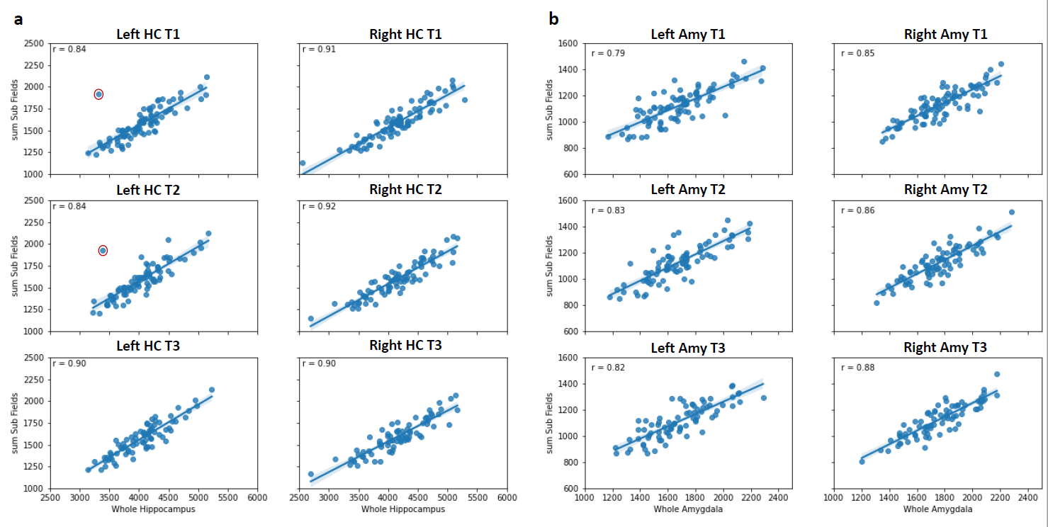
Figure S2. Posterior distributions of the main effect of time (T2-T1) and group-by-time interaction (T2-T1). Posterior distributions are shown for the whole hippocampus and amygdala (panels a & b), as well as for the volumes of their subregions (panels c & d). For the main effect of time (T1 to T2) across all 100 participants (panels a & b), P+ values closer to 0 provide evidence for a general increase in volume, while P+ values closer to 1 convey support for a general decrease in volume. As values are closer to P+=0.5, they provide stronger evidence of no change in volume across all individuals (i.e., no effect). For the group-by-time interaction (T1 to T2) (panels c & d), P+ values closer to 0 or 1 provide evidence for different volume changes over time between groups (Remission>non-Remission or vice versa). As values are closer to P+=0.5, they provide stronger evidence for no-effect (e.g., similar volume changes between groups). CA = cornu ammonis, DG = dentate gyrus, LA = lateral amygdala, CeA = central amygdala, BA = basal amygdala.

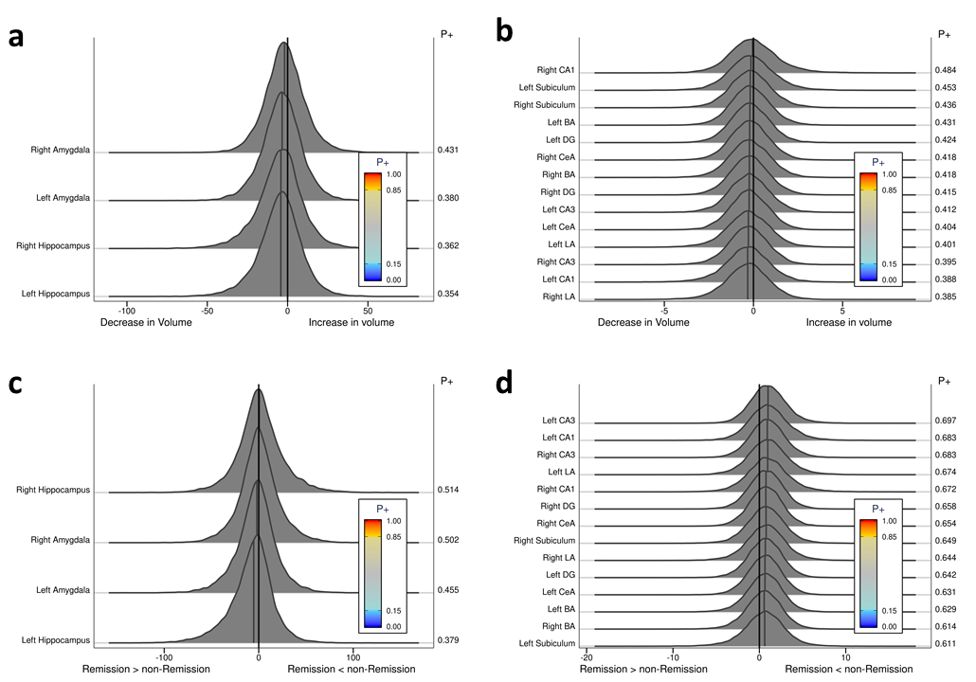

Supplementary References

1. Dimsdale-Zucker HR, Ritchey M, Ekstrom AD, Yonelinas AP, Ranganath C. CA1 and CA3 differentially support spontaneous retrieval of episodic contexts within human hippocampal subfields. Nature Communications. 2018;9(1):1-8. doi:10.1038/s41467-017-02752-1
2. Ji J, Maren S. Differential roles for hippocampal areas CA1 and CA3 in the contextual encoding and retrieval of extinguished fear. Learning and Memory. 2008;15(4):244-251. doi:10.1101/lm.794808
3. Leal SL, Yassa MA. Integrating new findings and examining clinical applications of pattern separation. Nature Neuroscience. 2018;21(2):163-173. doi:10.1038/s41593-017-0065-1
4. Chen LW, Sun D, Davis SL, et al. Smaller hippocampal CA1 subfield volume in posttraumatic stress disorder. Depression and Anxiety. 2018;35(11):1018-1029. doi:10.1002/da.22833
5. Postel C, Mary A, Dayan J, et al. Variations in response to trauma and hippocampal subfield changes. Neurobiology of Stress. 2021;15:100346. doi:10.1016/j.ynstr.2021.100346
6. Luo Y, Liu Y, Qin Y, et al. The atrophy and laterality of the hippocampal subfields in parents with or without posttraumatic stress disorder who lost their only child in China. Neurological Sciences. 2017;38(7):1241-1247. doi:10.1007/s10072-017-2952-3
7. Hayes JP, Hayes S, Miller DR, Lafleche G, Logue MW, Verfaellie M. Automated measurement of hippocampal subfields in PTSD: Evidence for smaller dentate gyrus volume. Journal of Psychiatric Research. 2017;95:247-252. doi:10.1016/j.jpsychires.2017.09.007
8. Wang Z, Neylan TCTC, Mueller SGSG, et al. Magnetic resonance imaging of hippocampal subfields in posttraumatic stress disorder. Archives of General Psychiatry. 2010;67(3):296-303. doi:10.1001/archgenpsychiatry.2009.205
9. Koch SBJ, van Ast VA, Kaldewaij R, et al. Larger dentate gyrus volume as predisposing resilience factor for the development of trauma-related symptoms. Neuropsychopharmacology. 2021;46(7):1283-1292. doi:10.1038/s41386-020-00947-7
10. Aggleton JP, Christiansen K. The subiculum: The heart of the extended hippocampal system. Progress in Brain Research. 2015;219:65-82. doi:10.1016/bs.pbr.2015.03.003
11. Matsumoto N, Kitanishi T, Mizuseki K. The subiculum: Unique hippocampal hub and more. Neuroscience Research. 2019;143:1-12. doi:10.1016/j.neures.2018.08.002
12. Herman JP, Dolgas CM, Carlson SL. Ventral subiculum regulates hypothalamo-pituitary-adrenocortical and behavioural responses to cognitive stressors. Neuroscience. 1998;86(2):449-459. doi:10.1016/S0306-4522(98)00055-4
13. Teicher MH, Anderson CM, Polcari A. Childhood maltreatment is associated with reduced volume in the hippocampal subfields CA3, dentate gyrus,and subiculum. Proc Natl Acad Sci U S A. 2012;109(9). doi:10.1073/pnas.1115396109
14. Jovanovic T, Ressler KJ. How the neurocircuitry and genetics of fear inhibition may inform our understanding of PTSD. American Journal of Psychiatry. 2010;167(6):648-662. doi:10.1176/appi.ajp.2009.09071074
15. Phelps EA, Delgado MR, Nearing KI, Ledoux JE. Extinction learning in humans: Role of the amygdala and vmPFC. Neuron. 2004;43(6):897-905. doi:10.1016/j.neuron.2004.08.042
16. Janak PH, Tye KM. From circuits to behaviour in the amygdala. Nature. 2015;517(7534):284-292. doi:10.1038/nature14188
17. Veer IM, Oei NYL, van Buchem MA, Spinhoven P, Elzinga BM, Rombouts SARB. Evidence for smaller right amygdala volumes in posttraumatic stress disorder following childhood trauma. Psychiatry Research - Neuroimaging. 2015;233(3):436-442. doi:10.1016/j.pscychresns.2015.07.016
18. Akiki TJ, Averill CL, Wrocklage KM, et al. The Association of PTSD Symptom Severity With Localized Hippocampus and Amygdala Abnormalities. Chronic Stress. 2017;1. doi:10.1177/2470547017724069
19. Morey RA, Clarke EK, Haswell CC, et al. Amygdala Nuclei Volume and Shape in Military Veterans With Posttraumatic Stress Disorder. Biological Psychiatry: Cognitive Neuroscience and Neuroimaging. 2020;5(3):281-290. doi:10.1016/j.bpsc.2019.11.016
20. van Leemput K, Bakkour A, Benner T, et al. Automated segmentation of hippocampal subfields from ultra-high resolution in vivo MRI. Hippocampus. 2009;19(6):549-557. doi:10.1002/HIPO.20615

