Supplementary Table S1. Differences of species groups cover and richness between first and second study years within grass-matrix and fallows age groups (factor-level comparisons with emmeans). Significant differences are marked in boldface (p<0.05). Abbreviations: G+D-plots sown with grass and diverse forb seed mixture; D-plots sown only with diverse forb seed mixtures. Numbers indicate the age of the grass-matrix (G+D plots) or fallows (D plots) when diverse forb seed mixture was sown in the plots.
 |  |  | Sown forbs |  |  |  | Weed |  |  |  |  |  | Festuca pseudovina
 |  |  | Cover (%) |  | Richness |  |  | Cover (%) |  |  | Richness |  | Cover (%)
Plot type |  | Study years | t | p | t | p |  |  |  | t |  | p | t | p
G+D0 |  | 1-2 | -2.940 | 0.004 | 0.067 | 0.947 | 5.735 |  | <0.001 | 6.400 |  | <0.001 | 0.551 | 0.583
G+D1 |  | 1-2 | -3.344 | 0.001 | -0.074 | 0.941 | 5.417 |  | <0.001 | 5.544 |  | <0.001 | 0.330 | 0.742
G+D2 |  | 1-2 | 2.101 | 0.038 | -0.333 | 0.740 | 1.566 |  | 0.120 | -0.457 |  | 0.648 | -0.713 | 0.477
G+D3 |  | 1-2 | -0.495 | 0.622 | -0.648 | 0.518 | -2.573 |  | 0.011 | -1.208 |  | 0.229 | 0.041 | 0.967
D0 |  | 1-2 | -4.601 | <0.001 | -1.791 | 0.076 | 4.171 |  | <0.001 | 3.222 |  | 0.002
D1 |  | 1-2 | -3.829 | <0.001 | -0.479 | 0.633 | 5.429 |  | <0.001 | 5.695 |  | <0.001
D2 |  | 1-2 | -7.400 | <0.001 | -2.651 | 0.009 | 2.928 |  | 0.004 | 0.496 |  | 0.621
D3 |  | 1-2 | -8.582 | <0.001 | -1.150 | 0.252 | -1.725 |  | 0.087 | -0.545 |  | 0.587

Supplementary Figure S1. Differences of species groups cover and richness between first and second study years within grass-matrix and fallows age groups. Significant differences are marked with asterisks (factor-level comparisons with emmeans, *** - p<0.001; ** - p<0.01; * - p<0.05). Boxplot lines represent median values. Abbreviations: G+D-plots sown with grass and diverse forb seed mixture; D-plots sown only with diverse forb seed mixtures. Numbers indicate the age of the grass-matrix (G+D plots) or fallows (D plots) when diverse forb seed mixture was sown in the plots. Symbols: - sown forb species; 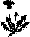- weeds; - Festuca pseudovina.
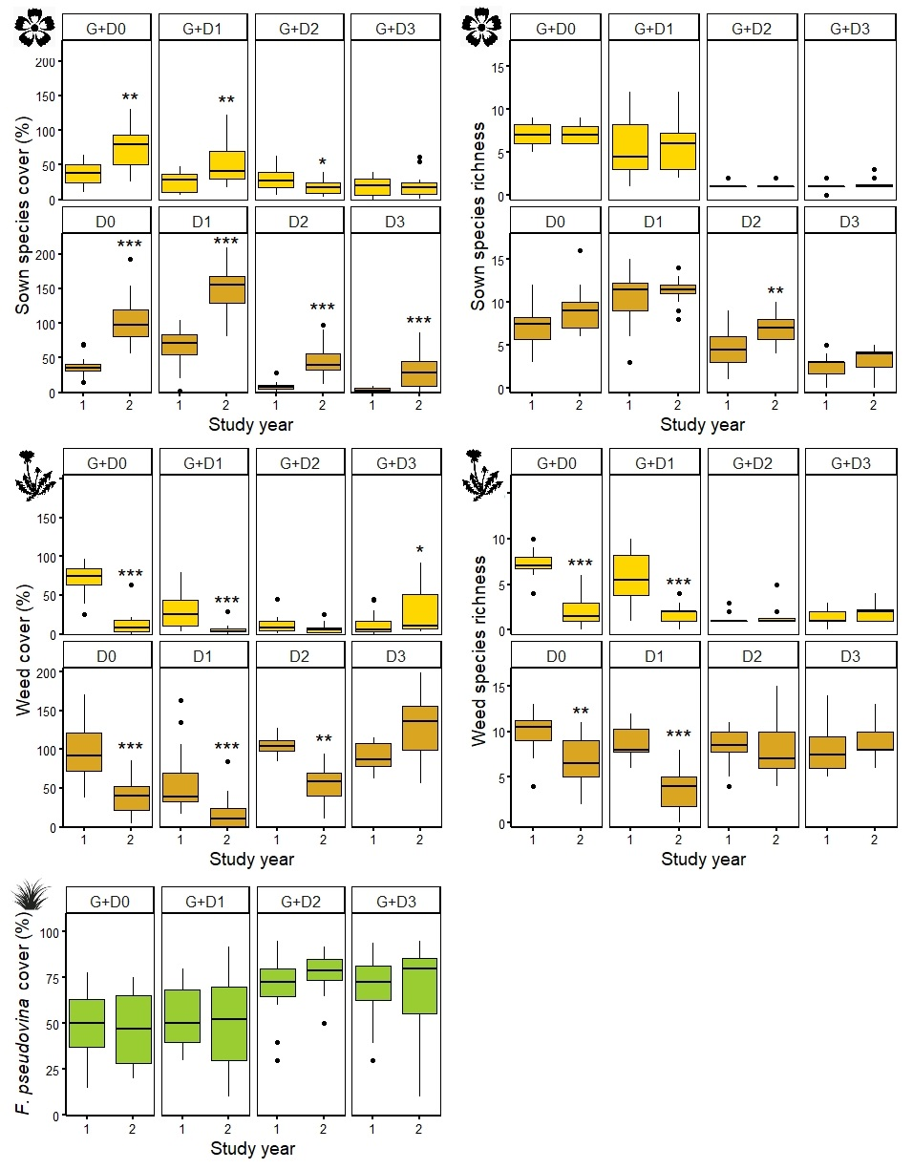

Supplementary Table S2. Differences between grass-matrix ages and fallow ages in species-groups cover and richness in the two study years pooled together (overall) and in the two study years separately (factor-level comparisons with emmeans). Significant differences are marked in boldface (p<0.05). Abbreviations: G+D-plots sown with grass and diverse forb seed mixture; D-diverse forb seed mixture. Numbers indicate the age of the grass-matrix (G+D plots) or fallows (D plots) when diverse forb seed mixture was sown in the plots.
 |  | Sown forbs |  |  |  |  |  |  | Weed |  |  |  |  |  |  |  |  |  |  | Festuca pseudovina
 |  | Cover (%) |  |  | Richness |  |  |  |  |  |  | Cover (%) |  |  | Richness |  |  |  |  |  | Cover (%)
Plot types | t |  | p |  | t |  |  | p |  | t |  |  | p |  |  |  | t | p |  |  |  | t |  | p
Overall
G+D0-G+D1 |  | 2.541 |  | 0.059 |  | 2.076 | 0.167 |  |  |  | 3.731 |  |  | 0.002 |  | 1.362 |  |  | 0.526 |  |  | -0.870 | 0.820
G+D0-G+D2 |  | 5.397 |  | <0.001 |  | 10.204 | <0.001 |  |  |  | 5.672 |  |  | <0.001 |  | 5.693 |  |  | <0.001 |  |  | -4.436 | <0.001
G+D0-G+D3 |  | 6.608 |  | <0.001 |  | 10.124 | <0.001 |  |  |  | 2.150 |  |  | 0.144 |  | 4.753 |  |  | <0.001 |  |  | -3.693 | 0.002
G+D1-G+D2 |  | 2.857 |  | 0.026 |  | 8.915 | <0.001 |  |  |  | 1.941 |  |  | 0.217 |  | 4.454 |  |  | <0.001 |  |  | -3.565 | 0.003
G+D1-G+D3 |  | 4.068 |  | <0.001 |  | 8.808 | <0.001 |  |  |  | -1.582 |  |  | 0.393 |  | 3.441 |  |  | 0.004 |  |  | -2.823 | 0.028
G+D2-G+D3 |  | 1.211 |  | 0.621 |  | -0.214 | 0.997 |  |  |  | -3.522 |  |  | 0.003 |  | -1.146 |  |  | 0.662 |  |  | 0.743 | 0.880
D0-D1 |  | -2.935 |  | 0.021 |  | -3.757 | 0.002 |  |  |  | 4.372 |  |  | <0.001 |  | 3.697 |  |  | 0.002
D0-D2 |  | 7.141 |  | <0.001 |  | 3.820 | 0.001 |  |  |  | -1.335 |  |  | 0.543 |  | 0.079 |  |  | 1.000
D0-D3 |  | 10.762 |  | <0.001 |  | 8.604 | <0.001 |  |  |  | -3.571 |  |  | 0.003 |  | -0.480 |  |  | 0.963
D1-D2 |  | 10.077 |  | <0.001 |  | 7.375 | <0.001 |  |  |  | -5.707 |  |  | <0.001 |  | -3.637 |  |  | 0.002
D1-D3 |  | 13.697 |  | <0.001 |  | 11.522 | <0.001 |  |  |  | -7.943 |  |  | <0.001 |  | -4.164 |  |  | <0.001
D2-D3 |  | 3.621 |  | 0.002 |  | 5.240 | <0.001 |  |  |  | -2.236 |  |  | 0.120 |  | -0.562 |  |  | 0.943
Year 1
G+D0-G+D1 |  | 1.999 |  | 0.194 |  | 1.537 | 0.419 |  |  |  | 2.797 |  |  | 0.030 |  | 1.668 |  |  | 0.345 |  |  | -0.505 | 0.958
G+D0-G+D2 |  | 1.297 |  | 0.567 |  | 7.281 | <0.001 |  |  |  | 6.095 |  |  | <0.001 |  | 7.220 |  |  | <0.001 |  |  | -2.505 | 0.064
G+D0-G+D3 |  | 3.451 |  | 0.004 |  | 7.281 | <0.001 |  |  |  | 5.674 |  |  | <0.001 |  | 7.045 |  |  | <0.001 |  |  | -2.356 | 0.091
G+D1-G+D2 |  | -0.702 |  | 0.896 |  | 6.349 | <0.001 |  |  |  | 3.297 |  |  | 0.007 |  | 6.135 |  |  | <0.001 |  |  | -2.000 | 0.194
G+D1-G+D3 |  | 1.452 |  | 0.470 |  | 6.350 | <0.001 |  |  |  | 2.876 |  |  | 0.024 |  | 5.893 |  |  | <0.001 |  |  | -1.852 | 0.255
G+D2-G+D3 |  | 2.154 |  | 0.142 |  | 0.001 | 1.000 |  |  |  | -0.421 |  |  | 0.975 |  | -0.457 |  |  | 0.968 |  |  | 0.148 | 0.999
D0-D1 |  | -2.461 |  | 0.071 |  | -3.279 | 0.007 |  |  |  | 2.463 |  |  | 0.071 |  | 1.094 |  |  | 0.694
D0-D2 |  | 6.449 |  | <0.001 |  | 3.100 | 0.013 |  |  |  | -0.323 |  |  | 0.988 |  | 1.514 |  |  | 0.432
D0-D3 |  | 9.601 |  | <0.001 |  | 5.807 | <0.001 |  |  |  | 0.423 |  |  | 0.974 |  | 1.636 |  |  | 0.362
D1-D2 |  | 8.910 |  | <0.001 |  | 6.135 | <0.001 |  |  |  | -2.785 |  |  | 0.031 |  | 0.422 |  |  | 0.975
D1-D3 |  | 12.062 |  | <0.001 |  | 8.309 | <0.001 |  |  |  | -2.040 |  |  | 0.179 |  | 0.545 |  |  | 0.948
D2-D3 |  | 3.152 |  | 0.011 |  | 3.058 | 0.014 |  |  |  | 0.746 |  |  | 0.878 |  | 0.123 |  |  | 0.999
Year 2
G+D0-G+D1 |  | 1.594 |  | 0.386 |  | 1.398 | 0.503 |  |  |  | 2.480 |  |  | 0.068 |  | 0.650 |  |  | 0.915 |  |  | -0.726 | 0.887
G+D0-G+D2 |  | 6.337 |  | <0.001 |  | 7.150 | <0.001 |  |  |  | 1.926 |  |  | 0.223 |  | 1.208 |  |  | 0.623 |  |  | -3.768 | 0.001
G+D0-G+D3 |  | 5.895 |  | <0.001 |  | 7.040 | <0.001 |  |  |  | -2.634 |  |  | 0.047 |  | -0.001 |  |  | 1.000 |  |  | -2.866 | 0.025
G+D1-G+D2 |  | 4.743 |  | <0.001 |  | 6.259 | <0.001 |  |  |  | -0.553 |  |  | 0.946 |  | 0.565 |  |  | 0.942 |  |  | -3.042 | 0.015
G+D1-G+D3 |  | 4.301 |  | <0.001 |  | 6.108 | <0.001 |  |  |  | -5.113 |  |  | <0.001 |  | -0.650 |  |  | 0.915 |  |  | -2.140 | 0.146
G+D2-G+D3 |  | -0.442 |  | 0.971 |  | -0.316 | 0.989 |  |  |  | -4.560 |  |  | <0.001 |  | -1.208 |  |  | 0.623 |  |  | 0.902 | 0.804
D0-D1 |  | -1.690 |  | 0.334 |  | -1.990 | 0.198 |  |  |  | 3.721 |  |  | 0.002 |  | 3.756 |  |  | 0.002
D0-D2 |  | 3.650 |  | 0.002 |  | 2.251 | 0.116 |  |  |  | -1.565 |  |  | 0.402 |  | -1.243 |  |  | 0.601
D0-D3 |  | 5.619 |  | <0.001 |  | 6.418 | <0.001 |  |  |  | -5.473 |  |  | <0.001 |  | -2.152 |  |  | 0.143
D1-D2 |  | 5.340 |  | <0.001 |  | 4.183 | <0.001 |  |  |  | -5.286 |  |  | <0.001 |  | -4.889 |  |  | <0.001
D1-D3 |  | 7.309 |  | <0.001 |  | 7.990 | <0.001 |  |  |  | -9.193 |  |  | <0.001 |  | -5.695 |  |  | <0.001
D2-D3 |  | 1.969 |  | 0.206 |  | 4.477 | <0.001 |  |  |  | -3.907 |  |  | <0.001 |  | -0.918 |  |  | 0.800

Supplementary Figure S2. Differences between grass-matrix ages and fallow ages in species-groups cover and richness in the two study years. Lower-case letters indicate significant differences of grass-matrix- (G+D plots) and fallow ages (D plots) in the same development stage (factor-level comparisons with emmeans, p<0.05). Boxplot lines represent median values. Abbreviations: G+D-plots sown with grass and diverse forb seed mixture; D-plots sown only with diverse forb seed mixtures. Numbers indicate the age of the grass-matrix (G+D plots) or fallows (D plots) when diverse forb seed mixture was sown in the plots. Symbols: - sown forb species; -weeds; -Festuca pseudovina.
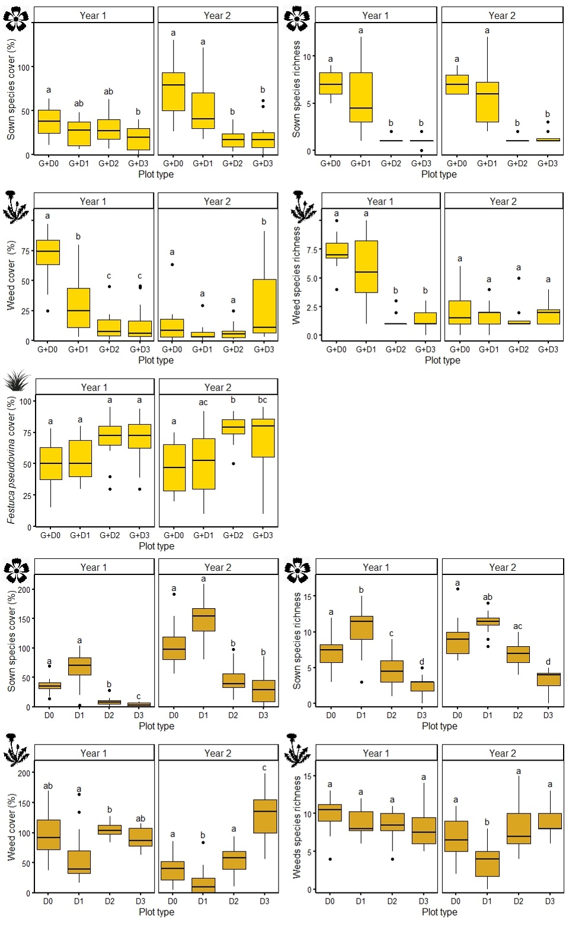

Supplementary Table S3. Differences of species groups cover and richness in the first four study years within grass-matrix and fallows age groups (factor-level comparisons with emmeans). Significant differences are marked in boldface (p<0.05). Abbreviations: G+D-plots sown with grass and diverse forb seed mixture; D-plots sown only with diverse forb seed mixtures. Numbers indicate the age of the grass-matrix (G+D plots) or fallows (D plots) when diverse forb seed mixture was sown in the plots.
 |  | Sown forbs |  |  |  |  |  | Weed |  |  |  |  | Festuca pseudovina
 |  | Cover (%) |  | Richness |  | Cover (%) |  |  |  | Richness |  |  |  | Cover(%)
Plot type | Study year | t | p | t | p |  | t |  | p |  | t | p |  |  | t | p
G+D0 | 1-2 | -3.320 | 0.007 | 0.067 | 0.999 |  | 6.622 |  | <0.001 |  | 6.400 | <0.001 |  |  | 0.394 | 0.979
G+D0 | 1-3 | -4.135 | <0.001 | 0.890 | 0.810 |  | 11.880 |  | <0.001 |  | 7.271 | <0.001 |  |  | 1.340 | 0.540
G+D0 | 1-4 | -3.504 | 0.004 | 0.820 | 0.845 |  | 9.981 |  | <0.001 |  | 6.982 | <0.001 |  |  | -0.138 | 0.999
G+D0 | 2-3 | -0.815 | 0.847 | 0.8237 | 0.843 |  | 5.258 |  | <0.001 |  | 1.800 | 0.279 |  |  | 0.946 | 0.780
G+D0 | 2-4 | -0.184 | 0.998 | 0.753 | 0.875 |  | 3.359 |  | 0.006 |  | 1.065 | 0.711 |  |  | -0.532 | 0.951
G+D0 | 3-4 | 0.631 | 0.922 | -0.071 | 1.000 |  | -1.899 |  | 0.234 |  | -0.761 | 0.872 |  |  | -1.478 | 0.454
G+D1 | 1-2 | -3.812 | 0.001 | -0.074 | 1.000 |  | 6.255 |  | <0.001 |  | 5.544 | <0.001 |  |  | 0.236 | 0.995
G+D1 | 1-3 | -3.524 | 0.003 | -0.721 | 0.888 |  | 7.443 |  | <0.001 |  | 5.808 | <0.001 |  |  | -0.743 | 0.880
G+D1 | 1-4 | -7.896 | <0.001 | -1.537 | 0.419 |  | 6.387 |  | <0.001 |  | 4.992 | <0.001 |  |  | 0.751 | 0.876
G+D1 | 2-3 | 0.288 | 0.992 | -0.648 | 0.916 |  | 1.188 |  | 0.636 |  | 0.420 | 0.975 |  |  | -0.979 | 0.762
G+D1 | 2-4 | -4.084 | <0.001 | -1.464 | 0.462 |  | 0.132 |  | 0.999 |  | -0.773 | 0.866 |  |  | 0.515 | 0.955
G+D1 | 3-4 | -4.372 | <0.001 | -0.820 | 0.845 |  | -1.056 |  | 0.717 |  | -1.187 | 0.636 |  |  | 1.494 | 0.445
D0 | 1-2 | -7.175 | <0.001 | -1.791 | 0.283 |  | 2.605 |  | 0.050 |  | 3.222 | 0.009
D0 | 1-3 | -8.128 | <0.001 | -0.768 | 0.869 |  | 4.282 |  | <0.001 |  | 7.316 | <0.001
D0 | 1-4 | -7.838 | <0.001 | -0.453 | 0.969 |  | 3.785 |  | <0.001 |  | 7.966 | <0.001
D0 | 2-3 | -0.953 | 0.776 | 1.028 | 0.733 |  | 1.678 |  | 0.340 |  | 4.614 | <0.001
D0 | 2-4 | -0.664 | 0.911 | 1.342 | 0.538 |  | 1.180 |  | 0.640 |  | 5.482 | <0.001
D0 | 3-4 | 0.290 | 0.992 | 0.316 | 0.989 |  | -0.497 |  | 0.960 |  | 1.076 | 0.705
D1 | 1-2 | -5.936 | <0.001 | -0.479 | 0.964 |  | 3.390 |  | 0.005 |  | 5.695 | <0.001
D1 | 1-3 | -4.763 | <0.001 | -0.321 | 0.989 |  | 3.411 |  | 0.005 |  | 6.224 | <0.001
D1 | 1-4 | -7.120 | <0.001 | 1.283 | 0.576 |  | 3.310 |  | 0.007 |  | 5.922 | <0.001
D1 | 2-3 | 1.173 | 0.645 | 0.158 | 0.999 |  | 0.021 |  | 1.000 |  | 0.670 | 0.908
D1 | 2-4 | -1.185 | 0.638 | 1.759 | 0.298 |  | -0.080 |  | 1.000 |  | 0.282 | 0.992
D1 | 3-4 | -2.357 | 0.091 | 1.602 | 0.382 |  | -0.102 |  | 1.000 |  | -0.388 | 0.980

Supplementary Figure S3. Differences of species groups cover and richness in the first four study years within grass-matrix and fallows age groups. Lower-case letters indicate significant differences between the study years of the same plot types (factor-level comparisons with emmeans, p<0.05). Boxplot lines represent median values. Abbreviations: G+D-plots sown with grass and diverse forb seed mixture; D-plots sown only with diverse forb seed mixtures. Numbers indicate the age of the grass-matrix (G+D plots) or fallows (D plots) when diverse forb seed mixture was sown in the plots. Symbols: - sown forb species; - weeds; - Festuca pseudovina.
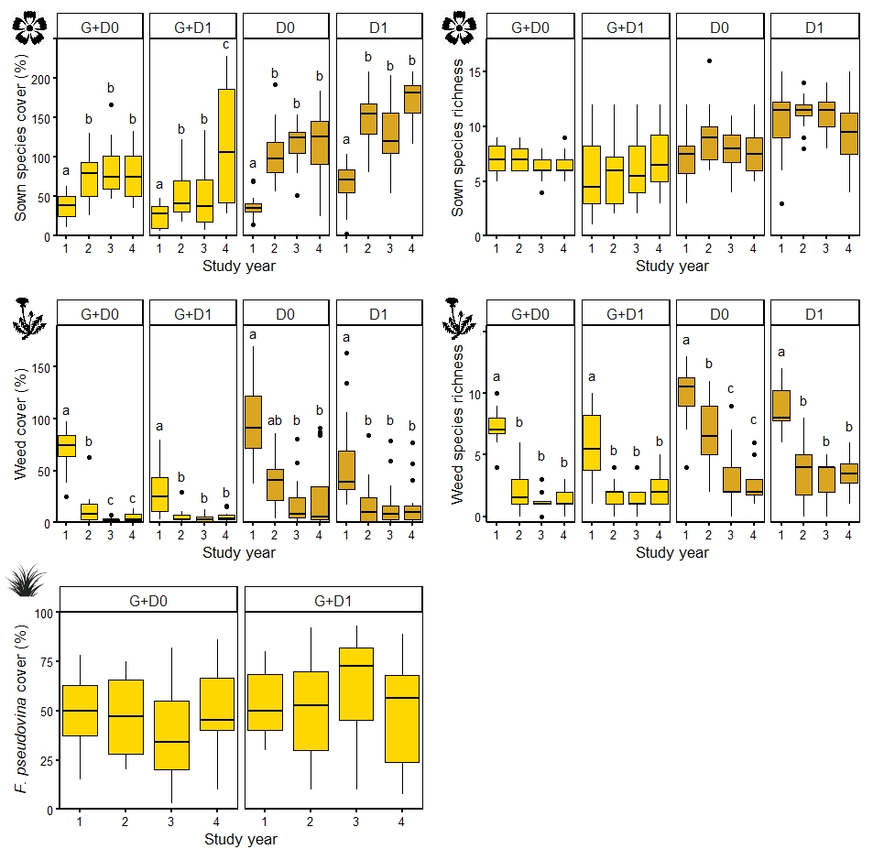

Supplementary Table S4. Differences of species groups cover and richness between the two youngest grass-matrixes and fallows in the four study years (factor-level comparisons with emmeans). Significant differences are marked in boldface (p<0.05). Abbreviations: G+D-plots sown with grass and diverse forb seed mixture; D-plots sown only with diverse forb seed mixtures. Numbers indicate the age of the grass-matrix (G+D plots) or fallows (D plots) when diverse forb seed mixture was sown in the plots.
 |  | Sown forbs |  |  |  |  | Weed |  |  |  |  |  |  | Festuca pseudovina
 |  | Cover (%) |  |  | Richness |  |  | Cover (%) |  |  | Richness |  | Cover (%)
Plot types | Study year | t | p | t |  | p | t |  | p | t |  | p | t |  | p
G+D0 - G+D1 | 1 | 2.288 | 0.024 | 1.537 |  | 0.127 | 3.230 |  | 0.002 | 1.668 |  | 0.098 | -0.361 |  |  | 0.719
G+D0 - G+D1 | 2 | 1.795 | 0.075 | 1.398 |  | 0.165 | 2.863 |  | <0.001 | 0.650 |  | 0.517 | -0.519 |  |  | 0.605
G+D0 - G+D1 | 3 | 2.898 | 0.005 | -0.071 |  | 0.944 | -1.207 |  | 0.230 | -0.761 |  | 0.448 | -2.443 |  |  | 0.016
G+D0 - G+D1 | 4 | -2.105 | 0.037 | -0.820 |  | 0.414 | -0.364 |  | 0.717 | -1.187 |  | 0.238 | 0.528 |  |  | 0.598
D0 - D1 | 1 | -3.852 | <0.001 | -3.279 |  | <0.001 | 1.538 |  | 0.127 | 1.094 |  | 0.275
D0 - D1 | 2 | -2.613 | 0.010 | -1.990 |  | 0.049 | 2.323 |  | 0.022 | 3.756 |  | <0.001
D0 - D1 | 3 | -0.487 | 0.627 | -2.845 |  | 0.005 | 0.667 |  | 0.506 | -0.302 |  | 0.764
D0 - D1 | 4 | -3.134 | 0.002 | -1.574 |  | 0.118 | 1.063 |  | 0.290 | -1.753 |  | 0.082

Supplementary Figure S4. Differences of species groups cover and richness between the two youngest grass-matrixes and fallows in the four study years. Significant differences are marked with asterisks (factor-level comparisons with emmeans, *** - p<0.001; ** - p<0.01; * - p<0.05). Boxplot lines represent median values. Abbreviations: G+D-plots sown with grass and diverse forb seed mixture; D-plots sown only with diverse forb seed mixtures. Numbers indicate the age of the grass-matrix (G+D plots) or fallows (D plots) when diverse forb seed mixture was sown in the plots. Symbols: - sown forb species; - weeds; - Festuca pseudovina
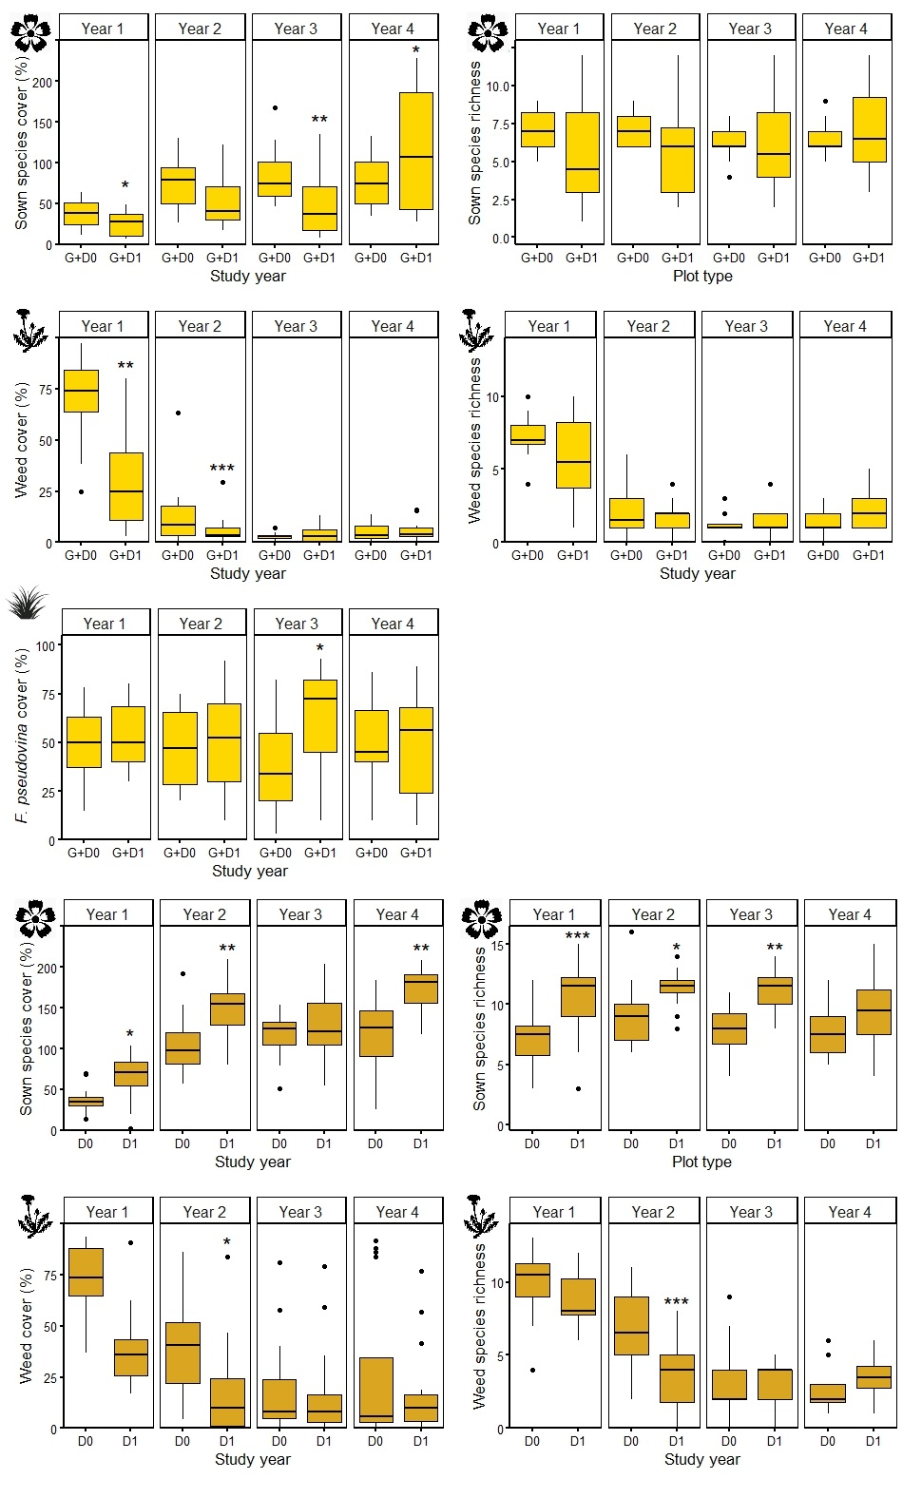

Supplementary Table S5. Effect of year of collection on the average germination success of sown forb species under greenhouse conditions (GLMM). Significant differences are marked in boldface (p<0.05).
Year of collection | z | p
2015 | 3.169 | 0.0015
2016 | -0.359 | 0.7199
2017 | -1.150 | 0.2501

Supplementary Table S6. Year to year differences in the average germination success of sown forb species under greenhouse conditions (factor-level comparisons with emmeans). Significant differences are marked in boldface (p<0.05).
Years | t | p
2014-2015 | -3.169 | 0.009
2014-2016 | 0.359 | 0.984
2014-2017 | 1.150 | 0.659
2015-2016 | 3.627 | 0.002
2015-2017 | 4.492 | <0.001
2016-2017 | 0.834 | 0.838

Supplementary Table S7. Species composition of diverse forb seed mixture, thousand seed weight (mean±sd) of every species and germination capacity (mean±sd) of three lots of 100 seeds under greenhouse conditions, in each collection year.
 | 1000 seed weight (g) |  |  |  |  | Germination %
 | 2014 | 2015 | 2016 | 2017 |  | 2014 | 2015 | 2016 | 2017
Achillea collina | 0.083±0.003 | 0.073±0.004 | 0.073±0.002 | 0.064±0.007 |  | 80.667±6.028 | 50.333±7.371 | 66.333±9.452 | 43.333±11.060
Centaurea jacea subsp. angustifolia | 1.688±0.050 | 1.404±0.081 | 1.418±0.049 | 1.534±0.086 |  | 23.000±4.000 | 23.667±8.505 | 50.000±7.000 | 34.000±5.292
Cruciata pedemontana | 0.386±0.019 | 0.512±0.015 | 0.389±0.005 | 0.382±0.008 |  | 49.667±24.542 | 99.333±1.155 | 91.333±3.055 | 98.667±1.155
Dianthus pontederae | 0.499±0.027 | 0.493±0.013 | 0.516±0.020 | 0.469±0.008 |  | 73.000±17.436 | 87.667±0.577 | 74.667±10.599 | 83.667±1.528
Falcaria vulgaris | 0.988±0.031 | 1.028±0.067 | 0.798±0.054 | 0.771±0.021 |  | 15.000±7.000 | 36.667±3.786 | 30.667±5.033 | 26.667±4.163
Filipendula vulgaris | 1.006±0.063 | 1.022±0.037 | 0.758±0.036 | 1.100±0.073 |  | 61.667±7.095 | 84.333±4.619 | 25.333±5.508 | 71.333±2.082
Galium verum | 0.313±0.014 | 0.252±0.016 | 0.359±0.006 | 0.264±0.030 |  | 59.333±6.429 | 71.667±10.504 | 78.333±4.726 | 80.000±14.799
Hypericum perforatum | 0.068±0.002 | 0.071±0.003 | 0.069±0.002 | 0.055±0.003 |  | 41.667±3.512 | 33.000±1.732 | 52.333±11.504 | 32.333±3.055
Knautia arvensis | 3.713±0.030 | 3.322±0.103 | 3.168±0.066 | 3.546±0.081 |  | 52.333±3.215 | 55.000±2.646 | 55.000±3.606 | 53.333±6.351
Lotus corniculatus | 1.105±0.031 | 1.018±0.000 | 0.937±0.030 | 1.040±0.011 |  | 21.667±5.774 | 14.333±6.028 | 11.333±1.528 | 27.000±2.646
Lycopsis arvensis | 2.679±0.104 | 3.546±0.344 | 2.680±0.137 | 2.699±0.184 |  | 11.667±2.887 | 51.000±10.536 | 5.667±2.309 | 15.000±2.646
Plantago media | 0.298±0.006 | 0.249±0.006 | 0.264±0.014 | 0.194±0.013 |  | 44.667±11.846 | 49.000±5.292 | 45.667±4.726 | 17.667±6.110
Podospermum canum | 3.799±0.382 | 3.839±0.371 | 3.447±0.151 | 3.006±0.105 |  | 83.000±8.888 | 90.000±1.732 | 81.333±6.028 | 88.333±3.215
Rapistrum perenne | 5.407±0.419 | 5.188±0.549 | 6.470±0.454 | 7.345±0.070 |  | 0.667±0.577 | 12.333±3.215 | 4.667±4.041 | 2.667±2.082
Salvia austriaca | 1.551±0.113 | 1.789±0.115 | 1.921±0.039 | 1.375±0.130 |  | 35.000±10.536 | 80.333±6.807 | 70.333±4.509 | 35.667±13.204
Salvia nemorosa | 0.585±0.018 | 0.675±0.048 | 0.521±0.033 | 0.543±0.044 |  | 18.333±0.577 | 37.667±3.055 | 0.000±0.000 | 0.667±0.577
Securigera varia | 4.014±0.111 | 4.928±0.112 | 4.290±0.270 | 3.599±0.100 |  | 14.667±8.021 | 16.667±3.786 | 9.667±3.215 | 3.333±1.528
Silene viscosa | 0.211±0.004 | 0.179±0.004 | 0.243±0.007 | 0.194±0.005 |  | 78.000±26.851 | 60.000±12.000 | 87.000±3.000 | 79.000±11.269
Scabiosa ochroleuca | 1.284±0.050 | 1.422±0.083 | 1.633±0.108 | 1.630±0.053 |  | 44.667±13.577 | 66.667±11.547 | 54.667±6.658 | 62.667±4.041
Thymus glabrescens | 0.144±0.002 | 0.144±0.010 | 0.081±0.011 | 0.054±0.002 |  | 72.333±16.442 | 75.667±1.528 | 13.000±10.817 | 0.333±0.577
Seed density/plot (g) | 29.821±0.136 | 31.154±0.176 | 30.035±0.132 | 29.864±0.072

