eTable 1. Summary table of included studies.
 | Key characteristic
Study | Study design | Treatment | Sample size | Age (yrs) | Male (%) | ECOG performance status |  |  |  | BRAF mutation status (%)
 |  |  |  |  |  | 0 | 1 |  | Unknow | BRAF^{V600E} | BRAF^{V600K}
First-line treatment
IMspire150 | Phase III double-blind, placebo-controlled RCT | ATE-VEM-COB  VEM-COB | 256  258 | 54  53.5 | 59  58 | 76  77 | 24  22 | 0  2 |  | 77  71 |  | 11  11
COMBI-AD | Phase III double-blind, placebo-controlled RCT | DAB-TRA | 438 | 50 | 45 | 92 | 8 | 1 |  | 91 |  | 9
COLUMBUS | Phase III open-label RCT | ENC-BIN | 192 | 57 | 60 | 71 | 29 | - |  | 89 |  | 11
Second-line treatment
CheckMate 037 | Phase III open-label RCT | Nivolumab | 272 | 59 | 65 | 60 | 40 | - |  | 22
* ATE-VEM-COB = atezolizumab-vemurafenib-cobimetinib; VEM-COB = vemurafenib-plus-cobimetinib; DAB-TRA = dabrafenib-plus-trametinib; ENC-BIN = encorafenib-plus-binimetinib.

Table 2. Drug dose and costs
Drug | Dose | Route | Unit Price ($) | Cost for 1 model cycle ($, 28 days)
Atezolizumab + vemurafenib + cobimetinib strategy
Cycle 1
Atezolizumab | - | - | - | -
Vemurafenib | 960 mg twice-daily (for 21 day) followed by 720 mg vemurafenib twice-daily | Oral | 0.16 | 8064
Cobimetinib | 60 mg once-daily | Oral | 4.32 | 7257.6
From cycle 2 onwards
Atezolizumab | 840 mg on day 1 and 15 | IV | 7.82 | 13137.6
Vemurafenib | 720 mg twice daily | Oral | 0.16 | 6451.2
Cobimetinib | 60 mg once-daily (21 days on–7 days off) | Oral | 4.32 | 5443.2
vemurafenib + cobimetinib strategy
Cycle 1
Vemurafenib | 960 mg twice-daily (for 21 day) followed by vemurafenib 960 mg for 7 days | Oral | 0.16 | 7526.4
Cobimetinib | 60 mg once-daily | Oral | 4.32 | 7257.6
From cycle 2 onwards
Vemurafenib | 960 mg vemurafenib twice daily | Oral | 0.16 | 8601.6
Cobimetinib | 60 mg cobimetinib once-daily (21 days on–7 days off) | Oral | 4.32 | 5443.2
Dabrafenib + trametinib strategy
Dabrafenib | 150 mg twice daily for 12 months | Oral | 0.89 | 7476
Trametinib | 2 mg once daily for 12 months | Oral | 144.95 | 8117.2
Encorafenib + Binimetinib strategy
Encorafenib | 450 mg once daily | Oral | 0.89 | 11214
Binimetinib | 45 mg twice daily | Oral | 4.63 | 11667.6
Second-line treatment
Nivolumab | 3 mg/kg every 2 weeks | IV | 28.54 | 11986.8

eTable 3. Background mortality rate
Estimates of background mortality rate for each age are provided in the US life table; Arias E, Heron M, Xu J. United States Life Tables, 2019. Natl Vital Stat Rep. 2019; 68:1-65.
Age (years) | Background | Age (years) | Background | Age (years) | Background
18 | 0.000603 | 54 | 0.007003 | 90 | 0.166829
19 | 0.000698 | 55 | 0.007607 | 91 | 0.185047
20 | 0.000795 | 56 | 0.008219 | 92 | 0.204441
21 | 0.000889 | 57 | 0.008857 | 93 | 0.224919
22 | 0.000970 | 58 | 0.009542 | 94 | 0.246354
23 | 0.001424 | 59 | 0.010285 | 95 | 0.26890
24 | 0.001497 | 60 | 0.011098 | 96 | 0.291442
25 | 0.001561 | 61 | 0.011952 | 97 | 0.314700
26 | 0.001624 | 62 | 0.012814 | 98 | 0.338142
27 | 0.001682 | 63 | 0.013657 | 99 | 0.361537
28 | 0.001737 | 64 | 0.014502 | 100 | 1
29 | 0.001792 | 65 | 0.015384
30 | 0.001847 | 66 | 0.016444
31 | 0.001900 | 67 | 0.017624
32 | 0.001952 | 68 | 0.018968
33 | 0.002003 | 69 | 0.029586
34 | 0.002053 | 70 | 0.022109
35 | 0.002111 | 71 | 0.024359
36 | 0.002174 | 72 | 0.026347
37 | 0.002233 | 73 | 0.028810
38 | 0.002285 | 74 | 0.031309
39 | 0.002340 | 75 | 0.034486
40 | 0.002413 | 76 | 0.038026
41 | 0.002516 | 77 | 0.042286
42 | 0.002649 | 78 | 0.046547
43 | 0.002811 | 79 | 0.051534
44 | 0.002999 | 80 | 0.057008
45 | 0.003203 | 81 | 0.062923
46 | 0.003433 | 82 | 0.069911
47 | 0.003709 | 83 | 0.078099
48 | 0.004047 | 84 | 0.086754
49 | 0.004445 | 85 | 0.096549
50 | 0.004874 | 86 | 0.106472
51 | 0.005331 | 87 | 0.119677
52 | 0.005844 | 88 | 0.134128
53 | 0.006408 | 89 | 0.149846

eTable 4. The results of scenario analyses.
Strategy | Total cost | LY | QALY | ICER
Scenario 1
5 years
Vemurafenib + cobimetinib | 312875 | 1.99 | 1.65 | Dominate
Encorafenib + binimetinib | 517534 | 2.20 | 1.84 | Extend dominated
Dabrafenib + trametinib | 383970 | 2.18 | 1.82 | 402359
Atezolizumab + vemurafenib + cobimetinib | 577914 | 2.23 | 1.89 | 3201604
10 years
Vemurafenib + cobimetinib | 347548 | 2.24 | 1.88 | Dominate
Encorafenib + binimetinib | 578454 | 2.50 | 2.14 | Dominated
Dabrafenib + trametinib | 447242 | 2.56 | 2.18 | 335118
Atezolizumab + vemurafenib + cobimetinib | 670036 | 2.66 | 2.26 | 2829557
20 years
Vemurafenib + cobimetinib | 357053 | 2.33 | 1.99 | Dominate
Encorafenib + binimetinib | 596896 | 2.60 | 2.25 | Dominated
Dabrafenib + trametinib | 458757 | 2.66 | 2.30 | 325391
Atezolizumab + vemurafenib + cobimetinib | 683692 | 2.78 | 2.40 | 2340589
Scenario 2
10% patents switch to BSC
Vemurafenib + cobimetinib | 339320 | 2.27 | 1.89 | Domimate
Encorafenib + binimetinib | 578851 | 2.56 | 2.16 | Dominated
Dabrafenib + trametinib | 443650 | 2.62 | 2.21 | 325092
Atezolizumab + vemurafenib + cobimetinib | 670693 | 2.73 | 0.10 | 2225006
30% patents switch to BSC
Vemurafenib + cobimetinib | 317539 | 2.10 | 1.77 | Dominate
Encorafenib + binimetinib | 558446 | 2.41 | 2.06 | Dominated
Dabrafenib + trametinib | 424906 | 2.48 | 2.12 | 303800
Atezolizumab + vemurafenib + cobimetinib | 653105 | 2.61 | 2.22 | 2380948
Scenario 3
Adjust nivolumab 75% of its original price in the first-line setting.
Vemurafenib + cobimetinib | 357509 | 2.34 | 1.98 | -
Atezolizumab + vemurafenib + cobimetinib | 620446 | 2.82 | 2.41 | 611481
Adjust nivolumab 50% of its original price in the first-line setting.
Vemurafenib + cobimetinib | 353758 | 2.34 | 1.97 | -
Atezolizumab + vemurafenib + cobimetinib | 544589 | 2.82 | 2.40 | 443793
Adjust nivolumab 25% of its original price in the first-line setting.
Vemurafenib + cobimetinib | 358197 | 2.35 | 1.99 | -
Atezolizumab + vemurafenib + cobimetinib | 475322 | 2.80 | 2.43 | 266193

eFigure 1. The Cost-Effective Frontier of 4 Different Competing Strategies.
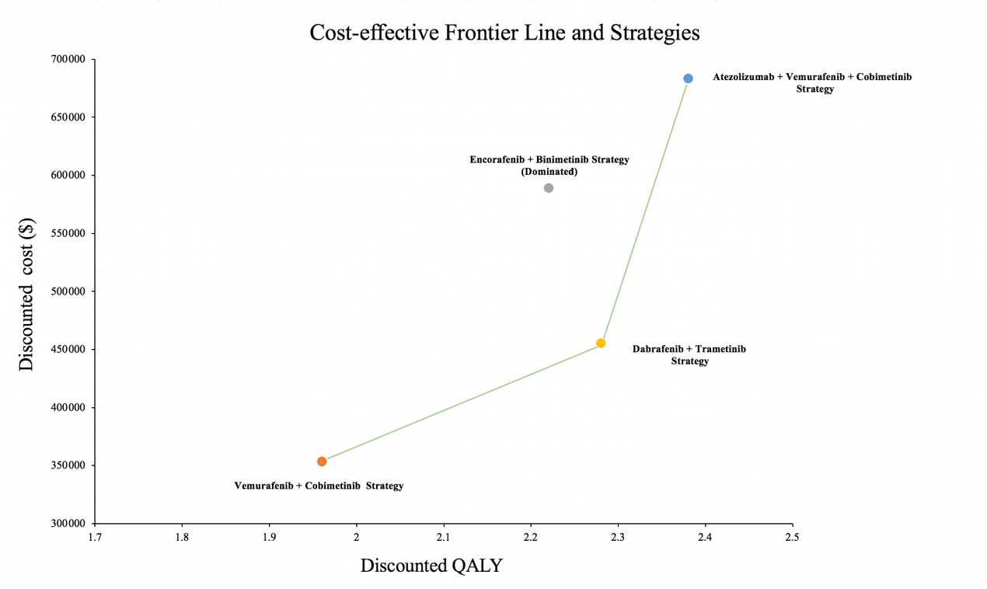

eFigure 2. Tornado Diagrams Showing the Effect of Lower and Upper Values of Each Parameter on the ICERs of the Pembrolizumab-plus-Axitinib Versus Sunitinib Strategy.
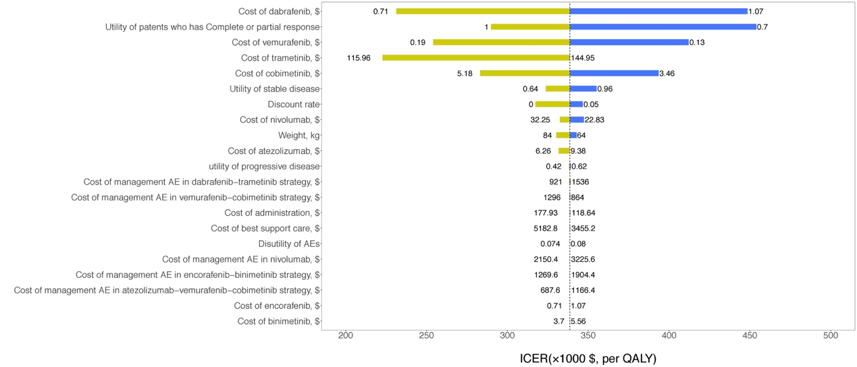
eFigure 3. Tornado Diagrams Showing the Effect of Lower and Upper Values of Each Parameter on the ICERs of the Nivolumab-plus-Cabozantinib Versus Sunitinib Strategy.

eFigure 4: Parametric Distributions for First-Line Treatment (Atezolizumab + vemurafenib + cobimetinib strategy). KM = Kaplan-Meier.
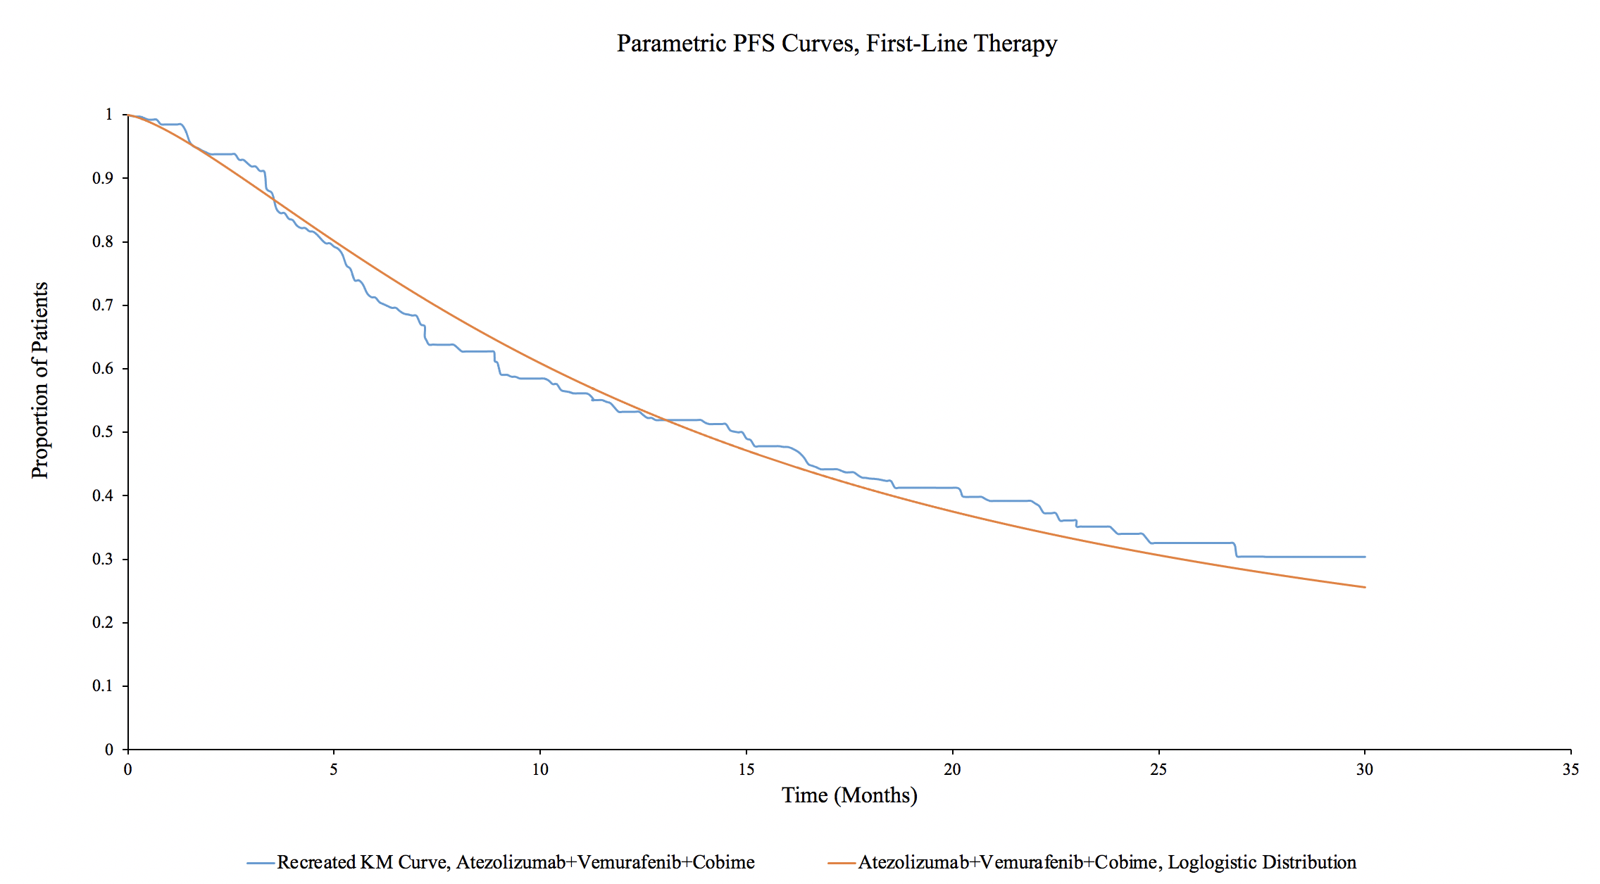

eFigure 5: Parametric Distributions for First-Line Treatment (Vemurafenib + cobimetinib strategy). KM = Kaplan-Meier.
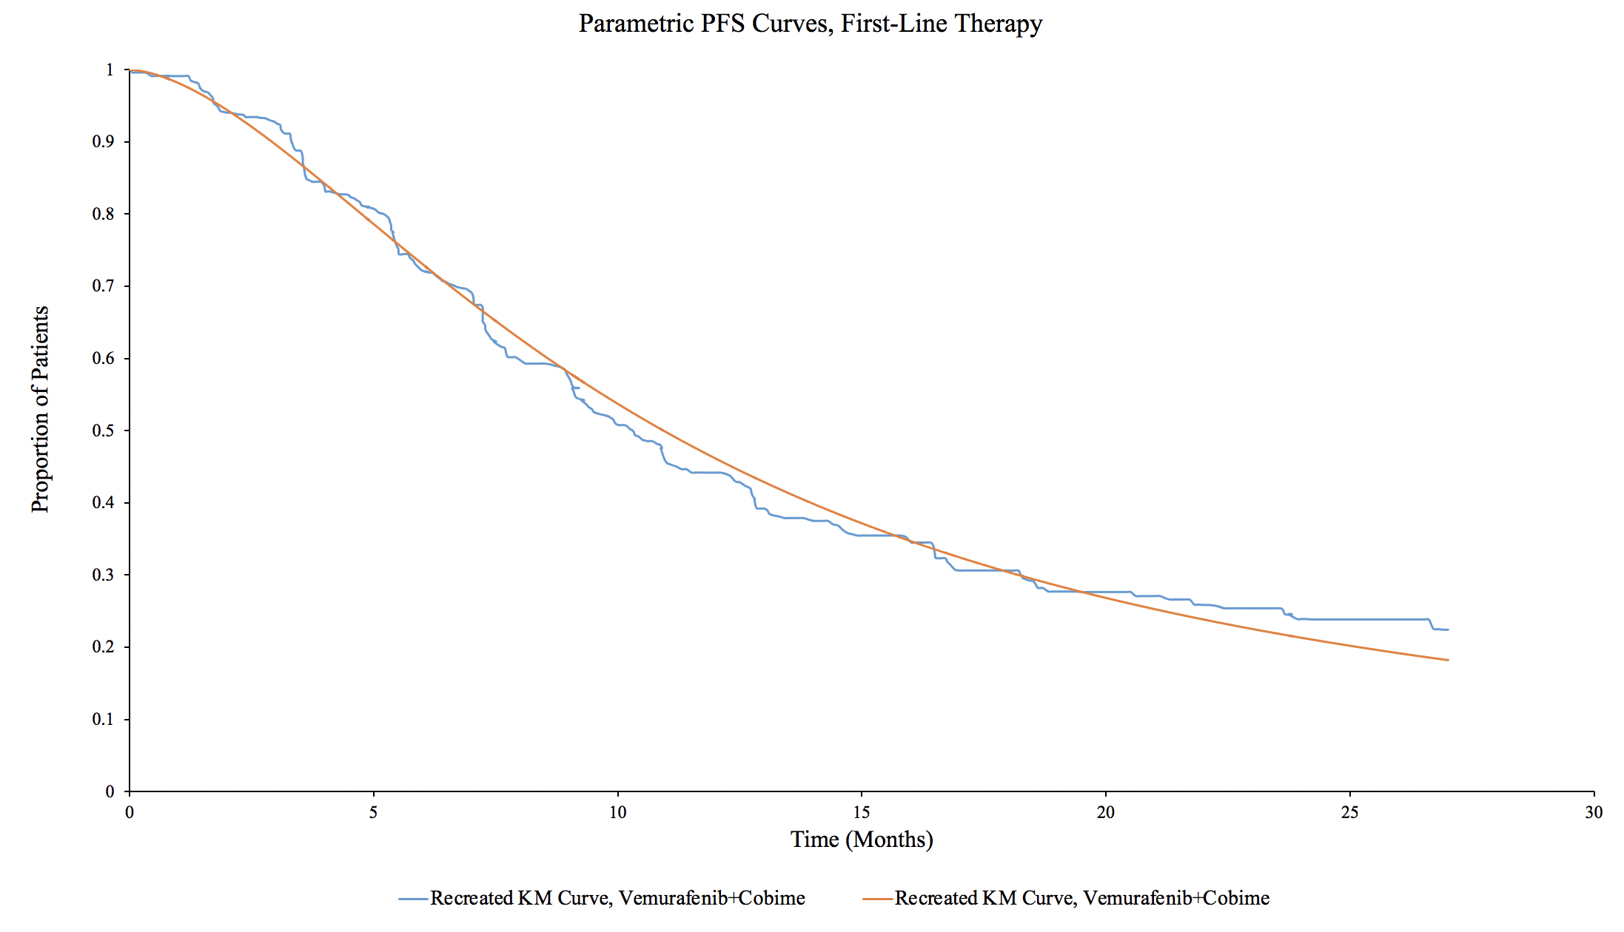

eFigure 6: Parametric Distributions for First-Line Treatment (Dabrafenib + trametinib strategy). KM = Kaplan-Meier.
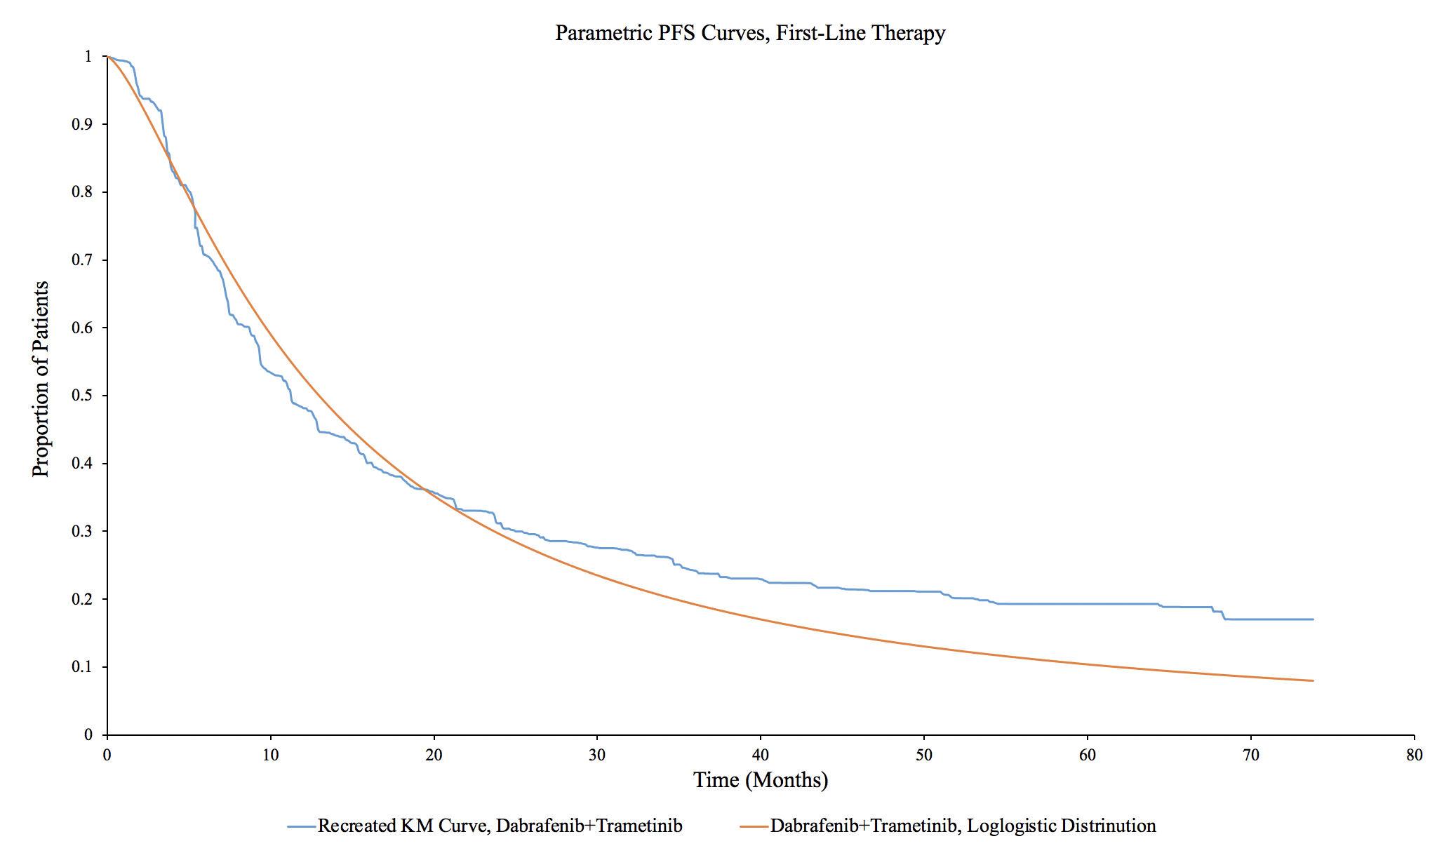

eFigure 7: Parametric Distributions for First-Line Treatment (Encorafenib + binimetinib strategy). KM = Kaplan-Meier.
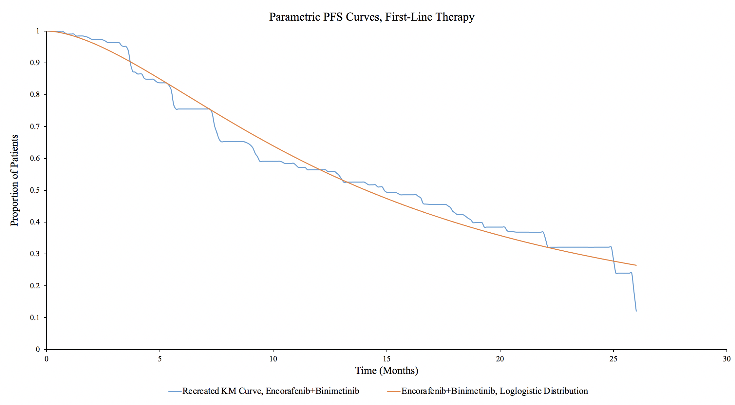

eFigure 8: Parametric Distributions for Second-Line Treatment. KM = Kaplan-Meier.
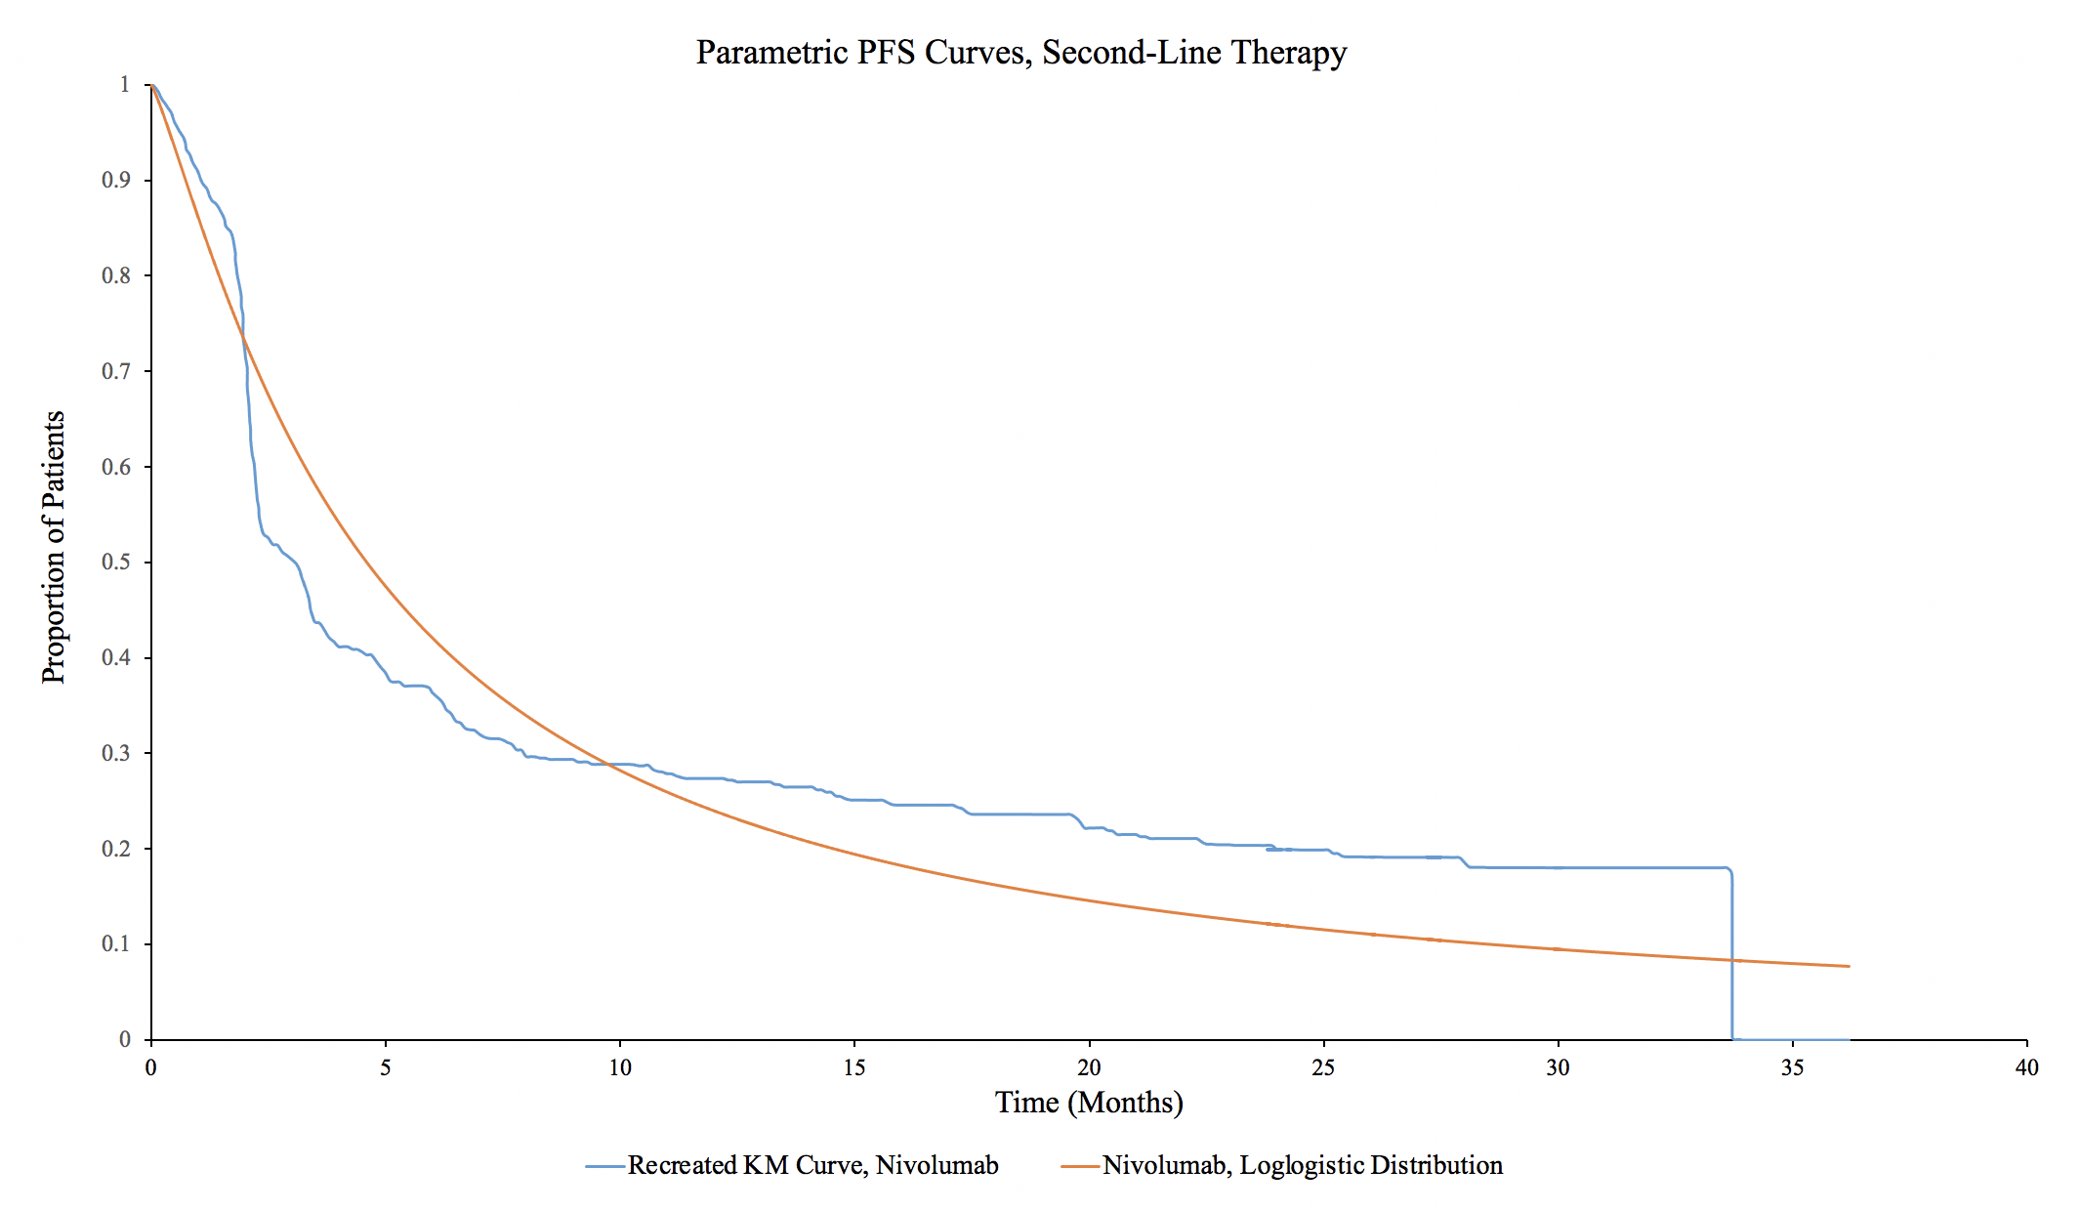

eFigure 9: Parametric Distributions for Best Support Care State.
*BSC = Best support care.
