Supplementary Materials for
‘Herpes simplex type 1 UL43 multiple membrane-spanning protein increases energy metabolismin of host cells through interacting with ARL2’
Jianshan Deng^{1, #}, Zhiying Zhong^{1, #}, Chengxu Geng^{1, #}, Zhenning Dai^{2, 3}, Weihan Zheng², Ziyue Li², Zi Yan², Jiaxin Yang⁴, Wenfeng Deng⁵, Wei Tan^{2, *}, Hanxiao Sun^{1, *}, Shiyu Li^{1, 2, 4*}
¹ Institute of Genomic Medicine, College of Pharmacy, Jinan University, Guangzhou 511436, China.
² Guangdong Medical Innovation Platform for Translation of 3D Printing Application, The third Affiliated Hospital of Southern Medical University, Southern Medical University, Guangzhou 510630, China.
³ Department of Stomatology, Guangdong Second Traditional Chinese Medicine Hospital, Guangzhou 510095, China.
⁴ Department of Anatomy, Guangdong Provincial Key Laboratory of Digital Medicine and Biomechanics, School of Basic Medical Sciences, Southern Medical University, Guangzhou 510515, China
⁵ Guangzhou Women and Children’s Medical Center, Guangzhou Medical University, Guangzhou 510799, China.

#These authors contributed equally to this work and share first authorship
*Corresponding author:
tandoctor@163.com (W.T.);
sunhx718@163.com(H.S.);
li421@126.com(S.L.)

This PDF file includes:
Supplementary Table S1 to S3, Figure S1 and Western blots figures of the manuscript
Supplementary Table S1. The primers of selected genes for quantitative real-time PCR
Gene title | Forward primer | Reverse primer | Size(bp)
ACLY | 5’-GGTGGGGACAGGTAATCAGC-3’ | 5’-CATCGTCTCCTAGCCCACTG-3’ | 74
SLC25A4 | 5’-CCAAGTCAAGGGATGGGGTT-3’ | 5’-GCCCCACCTCTAAGAACGTC-3’ | 216
IDH3A | 5’-CTCGCAGTGTATGGGCCG-3’ | 5’-TGCTGGTCTCTCTCTCCGAA-3’ | 497
PHKG2 | 5’-GCCAAACTGCCTTGTTGGAG-3’ | 5’-GGCTCAACCCTTACCTGGTT-3’ | 242
UQCRQ | 5’-GTCTTTCTTTCGCGTGGTGC-3’ | 5’-GTGACCTCAGAGGAACATGC -3’ | 280
PFKFB3 | 5’-TGATTCGGCCACCTTGACTC-3’ | 5’-ACTTTGCCGCATAAGGCTCT-3’ | 208
ARL2 | 5’-AGCGTGATAGCCAACAGGA-3’ | 5’-GCAAGGAGCGGTTTATTTCA-3’ | 105
NDUFB3 | 5’-TTAGGGAGTTGGTGGGAGGC-3’ | 5’-GTTCTTCTGCCTTTGCGATCC-3’ | 284
SDHB | 5’-GAGAGCGACCTCGGGGTTA-3’ | 5’-CTTTTCCCTCTCTGAGGCTCC-3’ | 149
CYC1 | 5’-ATGGTAAGAGGCCTCCAGTCT-3’ | 5’-AAGCCTCCTGAGACATGCAC-3’ | 143
SURF1 | 5’-ACTTCCGTACGTTGTGGACC-3’ | 5’-GTCATTTTTGCGTGGCCAGT-3’ | 240

Supplementary Table S2. Functions of candidate genes in human
 |  | Description ª
Gene ID | Symbol | Biological process | Cellular component | Molecular function
47 | ACLY | citrate metabolic process | mitochondrion | ATP binding
291 | SLC25A4 | Energy reserve metabolic process | positive regulation of cell proliferation | protein binding
3419 | IDH3A | carbohydrate metabolic process | mitochondrial matrix | NAD binding
5261 | PHKG2 | carbohydrate metabolic process | phosphorylase kinase complex | ATP binding
27089 | UQCRQ | cellular metabolic process | mitochondrial inner membrane | ubiquinol-cytochrome-c reductase activity
407183 | PFKFB3 | fructose metabolic process | cytoplasm | ATP binding
402 | ARL2 | small GTPase mediated signal transduction | mitochondrial intermembrane space | GTP binding
Gene products have several functions, which have many GO terms, but only one is included in the table.Biological process, cellular component, and molecular functions predicted by the GO annotation system and Uniprot database.

Supplementary Figure S1. DEG expression level of HSV-1 and HSV-1 △UL43 tested by qRT-PCR
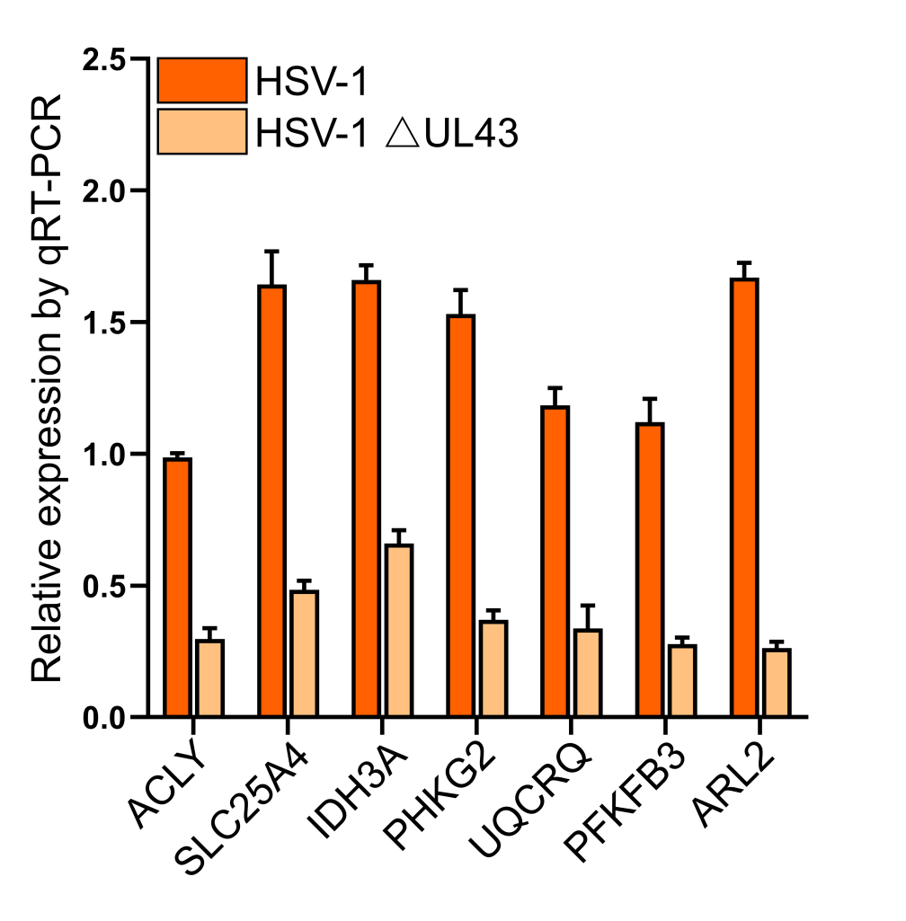

Supplementary Table S3. Peptide Mass of ARL2
The entered protein is: Q19705
The selected enzyme is: Trypsin
Maximum number of missed cleavages (MC): 0
All cysteines in reduced form.
Methionines have not been oxidized.
Displaying peptides with a mass bigger than 500 Dalton.
Using monoisotopic masses of the occurring amino acid residues and giving peptide masses as [M+H]+ .
Chain ADP-ribosylation factor-like protein 2 at positions (Q19705) [Theoretical pI: 6.48 / Mw (average mass): 20868.13 / Mw (monoisotopic mass): 20854.91]
mass | position | peptide sequence
2305.2397 | 127-148 | SDLPGAIDVNSIAQVLDLHS IK
2116.9821 | 79-96 | NYFESTDALIWVVDSSDR
2051.0219 | 36-53 | FLDEPTDTIEPTLGFDIK
1693.8036 | 165-179 | LVQAMTWLCDDVGSR
1519.7539 | 59-71 | DFQLNLWDVGGQK
1171.5234 | 154-164 | IFSCCALSGDR
1171.5234 | 154-164 | IFSCCALSGDR
1169.7252 | 115-126 | LAGASLLVLANK
1126.6830 | 19-29 | ILILGLDNAGK
1062.5499 | 99-107 | LLQCSEELK
716.3937 | 109-114 | LLGEER
694.3419 | 149-153 | SHHWK
631.3562 | 54-58 | TVHFK
620.3654 | 180-184 | LFILD
593.3327 | 30-34 | TTLMK
583.2875 | 75-78 | SYWK
The data in this table on protein profiles come from the UniProtKB/Swiss-Prot database（https://web.expasy.org/cgi-bin/peptide_mass/peptide-mass.pl）
Western blot figures of the manuscript
