Table 1: The structure of the input-output table
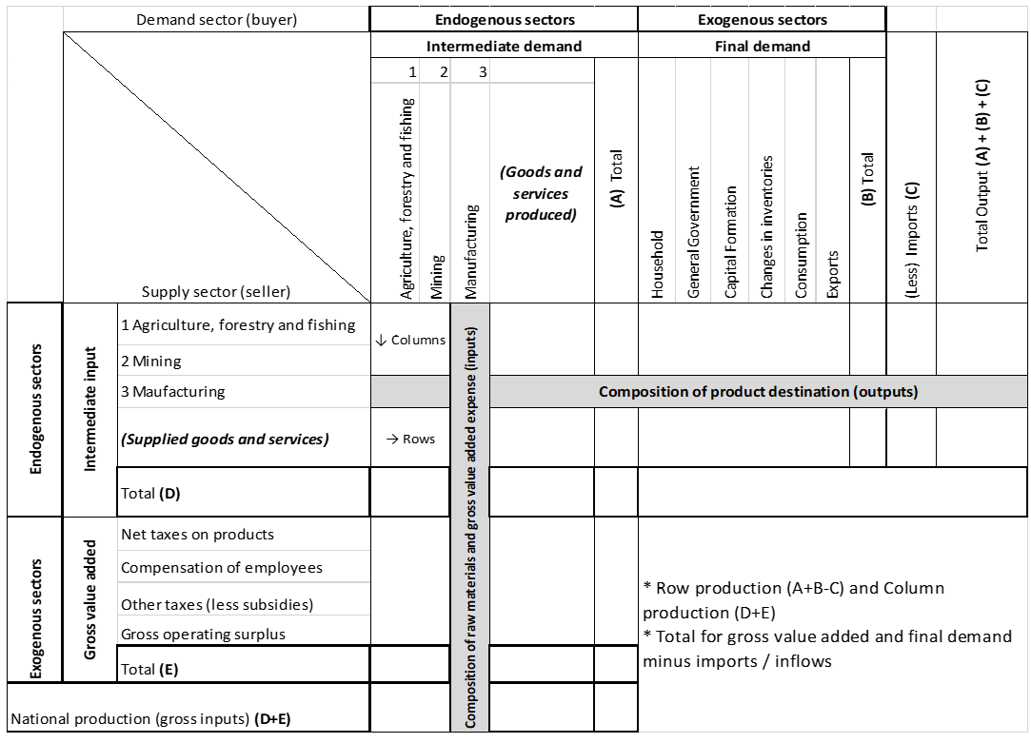
Source: Author’s compilation, Japanese Ministry of economy, trade, and industry (2016)
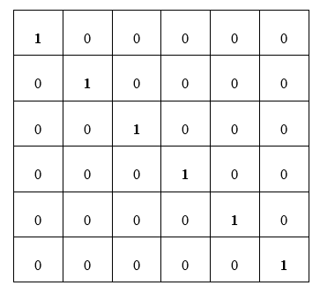
Table2 : Identity matrix and Type I multiplier Leontief inverse
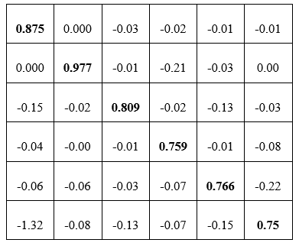

Source: D’Hernoncourt et al., (2011:10)
Table 3: Final Demand Multipliers (Type I)
Multiplier | Definition | Application
Output | Total industry output per R1 change in final demand | Final demand output × final demand multiplier = total gross output impact
Value-added | Total value-added per R1 change in final demand | Final demand output × final demand value-added multiplier = total value-added impact
Earnings | Total household earnings per R1 change in final demand | Final demand output × final demand earnings multiplier = total earnings impact
Employment | Total number of jobs per R1 million change in final demand | Final demand output × final demand employment multiplier = total jobs impact
Source: D’Hernoncourt et al., (2011:11)
  - Table 4: Classifications of the backward and forward linkages’ results
 |  | Forward linkages
 |  | Low (<1) | High (>1)
Backward linkages | Low (<1) | Weak linkages sector (W) | Strong forward linkage sector (F)
Backward linkages | High (>1) | Strong backward linkage sector (B) | Key sector (K)
Source: Temursho (2016:12)
Table 5: 2020 Input-output table of the Nelson Mandela Bay Metropolitan Municipality
Nelson Mandela Bay 2019 financial year | SIC1 | SIC2 | SIC3 | SIC4 | SIC5 | SIC6 | SIC7 | SIC8 | SIC9 | SIC10 | House-hold | General Govern-ment | Capital formation | Changes in invento-ries | Exports | Imports | Total demand
Agriculture [SIC 1] | 0,47 | - | 689,47 | - | 0,01 | 1,31 | 0,01 | 0,45 | 0,24 | 1,27 | 62,66 | - | 17,91 | -0,38 | 36,13 | -21,37 | 788
Mining [SIC 2] | 0,08 | 0,00 | 90,57 | 3,20 | 2,47 | - | - | - | 0,14 | 0,66 | 0,03 | - | 0,01 | -0,00 | 0,02 | -0,01 | 97,17
Manufacturing [SIC 3] | 137 | 10,13 | 27 903 | 126,57 | 3 651 | 2 757 | 2 958 | 3 224 | 689,52 | 1 082 | 23 946 | - | 4 320 | -145,12 | 13 810 | -8 168 | 76 306
Electricity, gas [SIC 4] | 4,82 | 1,49 | 980,07 | 115,76 | 13,14 | 151,63 | 81,91 | 372,62 | 11,25 | 52,95 | 558 | - | 698 | -3,38 | 321,98 | -190,44 | 3 170
Construction [SIC 5] | 0,37 | 0,31 | 816,51 | 17,68 | 335,69 | 498,03 | 893,46 | 636,13 | 87,16 | 260,66 | 5 075 | - | 549 | -30,76 | 2 926 | -1 731 | 10 336
Wholesale and retail trade [SIC 6] | 49,28 | 3,92 | 13 181 | 103,20 | 1 449 | 1 147 | 1 701 | 1 619 | 275,10 | 558,15 | 9 428 | - | 1 606 | -57,14 | 5 437 | -3 216 | 33 287
Transport, storage [SIC 7] | 42,24 | 9,92 | 4 116 | 33,81 | 429,15 | 1 227 | 1 188 | 1 782 | 478,10 | 308,28 | 6 988 | - | 3 746 | -42,35 | 4 030 | -2 383 | 21 955
Finance, insurance [SIC 8] | 23,68 | 4,69 | 3 618 | 48,58 | 840,93 | 3 333 | 1 869 | 7 441 | 657,34 | 1 424 | 14 626 | - | 4 764 | -88,64 | 8 435 | -4 989 | 42 012
General government [SIC 91] | - | - | - | - | - | - | 65,10 | - | 898,29 | 420,83 | 6 630 | 9 973 | 2 784 | -40,18 | 3 823 | -2 261 | 22 295
Community, social services [SIC 92-96, 99] | 24,29 | 0,14 | 430,00 | 7,16 | 5,25 | 89,79 | 638,64 | 2 238 | 283,79 | 258,93 | 4 771 | - | 555 | -28,92 | 2 751 | -1 627 | 10 398
Tax-subs on Products | 47,54 | 6,41 | 4 127 | 236,74 | 527,03 | 2 109 | 1 301 | 2 400 | 1 431 | 625,64 | 4 030 | - | 1 228,08 | - | - | - | 18 072
Employees | 143 | 28,12 | 13 168 | 764,22 | 1 567 | 9 840 | 4 086 | 9 781 | 15 281 | 3 294 | - | - | - | - | - | - | 57 956
Tax-subs on production | 2,38 | 0,67 | 270,92 | 7,87 | 32,48 | 413,06 | 187,76 | 1 164 | 218,23 | 145,91 | - | - | - | - | - | - | 2 444
GOS | 312 | 31,37 | 6 912 | 1 705 | 1 481 | 11 718 | 6 982 | 11 349 | 1 983 | 1 962 | - | - | - | - | - | - | 44 440
Total output | 788 | 97,17 | 76 306 | 3 170 | 10 336 | 33 287 | 21 955 | 42 012 | 22 295 | 10 398 | 76 119 | 9 973,86 | 20 271 | -436 | 41 574 | -24 589

Source: Author’s compilation
Table 6: 2020 Technical coefficients of the Nelson Mandela Metropolitan Municipality
 |  | Agriculture  [SIC 1] | Mining  [SIC 2] | Manufacturing  [SIC 3] | Electricity, gas and water  [SIC 4] | Construc-tion  [SIC 5] | Wholesale and retail trade  [SIC 6] | Transport, storage  [SIC 7] | Finance, insurance, real estate  [SIC 8] | General govern-ment  [SIC 91] | Communi-ty, social services  [SIC 92-96, 99] | Total
A-matrix (Technical coefficients) | Nr | 1 | 2 | 3 | 4 | 5 | 6 | 7 | 8 | 9 | 10
Agriculture [SIC 1] | 1 | 0,001 | 0,000 | 0,009 | 0,000 | 0,000 | 0,000 | 0,000 | 0,000 | 0,000 | 0,000 | 0,010
Mining and quarrying [SIC 2] | 2 | 0,000 | 0,000 | 0,001 | 0,001 | 0,000 | 0,000 | 0,000 | 0,000 | 0,000 | 0,000 | 0,003
Manufacturing [SIC 3] | 3 | 0,175 | 0,104 | 0,366 | 0,040 | 0,353 | 0,083 | 0,135 | 0,077 | 0,031 | 0,104 | 1,468
Electricity, gas and water [SIC 4] | 4 | 0,006 | 0,015 | 0,013 | 0,037 | 0,001 | 0,005 | 0,004 | 0,009 | 0,001 | 0,005 | 0,095
Construction [SIC 5] | 5 | 0,000 | 0,003 | 0,011 | 0,006 | 0,032 | 0,015 | 0,041 | 0,015 | 0,004 | 0,025 | 0,152
Wholesale and retail trade [SIC 6] | 6 | 0,063 | 0,040 | 0,173 | 0,033 | 0,140 | 0,034 | 0,077 | 0,039 | 0,012 | 0,054 | 0,665
Transport and storage [SIC 7] | 7 | 0,054 | 0,102 | 0,054 | 0,011 | 0,042 | 0,037 | 0,054 | 0,042 | 0,021 | 0,030 | 0,446
Finance, insurance [SIC 8] | 8 | 0,030 | 0,048 | 0,047 | 0,015 | 0,081 | 0,100 | 0,085 | 0,177 | 0,029 | 0,137 | 0,751
General government [SIC 91] | 9 | 0,000 | 0,000 | 0,000 | 0,000 | 0,000 | 0,000 | 0,003 | 0,000 | 0,040 | 0,040 | 0,084
Community, social services [SIC 92-96, 99] | 10 | 0,031 | 0,001 | 0,006 | 0,002 | 0,001 | 0,003 | 0,029 | 0,053 | 0,013 | 0,025 | 0,163
Total |  | 0,359 | 0,315 | 0,679 | 0,144 | 0,651 | 0,277 | 0,428 | 0,412 | 0,152 | 0,420 | 3,837

Source: Author’s compilation

Table 7: 2020 Leontief inverse matrix for the Nelson Mandela Bay Metropolitan Municipality
[I-A]⁻¹ matrix - Type I Leontief inverse | [SIC1] | [SIC2] | [SIC3] | [SIC4] | [SIC5] | [SIC6] | [SIC7] | [SIC8] | [SIC9] | [SIC10] | Total input multipliers | Forward linkages
Agriculture, forestry and fishing [SIC 1] | 1,004 | 0,002 | 0,015 | 0,001 | 0,006 | 0,002 | 0,003 | 0,002 | 0,001 | 0,002 | 1,038 | 0,589
Mining and quarrying [SIC 2] | 0,001 | 1,000 | 0,002 | 0,001 | 0,001 | 0,000 | 0,000 | 0,000 | 0,000 | 0,000 | 1,007 | 0,572
Manufacturing [SIC 3] | 0,340 | 0,230 | 1,692 | 0,088 | 0,677 | 0,191 | 0,313 | 0,213 | 0,077 | 0,252 | 4,072 | 2,313
Electricity, gas and water [SIC 4] | 0,013 | 0,021 | 0,026 | 1,040 | 0,014 | 0,009 | 0,011 | 0,016 | 0,002 | 0,012 | 1,165 | 0,662
Construction [SIC 5] | 0,013 | 0,015 | 0,032 | 0,009 | 1,054 | 0,024 | 0,056 | 0,029 | 0,008 | 0,038 | 1,278 | 0,726
Wholesale and retail trade [SIC 6] | 0,141 | 0,101 | 0,327 | 0,056 | 0,292 | 1,086 | 0,161 | 0,104 | 0,034 | 0,123 | 2,425 | 1,378
Transport, storage and communication [SIC 7] | 0,088 | 0,131 | 0,120 | 0,021 | 0,106 | 0,062 | 1,093 | 0,077 | 0,033 | 0,064 | 1,795 | 1,020
Finance, insurance, real estate and business services [SIC 8] | 0,091 | 0,102 | 0,158 | 0,035 | 0,194 | 0,155 | 0,164 | 1,264 | 0,053 | 0,215 | 2,431 | 1,381
General government [SIC 91] | 0,002 | 0,001 | 0,001 | 0,000 | 0,001 | 0,001 | 0,005 | 0,003 | 1,043 | 0,044 | 1,102 | 0,626
Community, social and personal services [SIC 92-96, 99] | 0,042 | 0,013 | 0,023 | 0,006 | 0,019 | 0,015 | 0,044 | 0,073 | 0,018 | 1,042 | 1,294 | 0,735
Total Output Multipliers (Type 1) | 1,734 | 1,616 | 2,397 | 1,258 | 2,365 | 1,544 | 1,851 | 1,780 | 1,269 | 1,793 | 17,607
Backward linkages | 0,985 | 0,918 | 1,361 | 0,714 | 1,343 | 0,877 | 1,051 | 1,011 | 0,721 | 1,018

Source: Own compilation

Table 8: Final demand multiplier analyses: Type I and Type II multipliers for the Nelson Mandela Bay Metro
Final demand multipliers
 |  | Output multipliers |  | Earnings/income multipliers |  | Tax multipliers |  | GVA multipliers |  | Total job multipliers
 |  | Type 1 | Type 2 | Type 1 | Type 2 | Type 1 | Type 2 | Type 1 | Type 2 | Type 1 | Type 2
A-matrix (Technical coefficients) | Nr
Agriculture, forestry and fishing | 1 | 1,73 | 3,70 | 0,34 | 0,81 | 0,11 | 0,25 | 0,90 | 1,79 | 7,92 | 10,44
Mining and quarrying | 2 | 1,62 | 4,05 | 0,42 | 1,00 | 0,11 | 0,28 | 0,90 | 2,00 | 1,83 | 4,95
Manufacturing | 3 | 2,40 | 5,12 | 0,47 | 1,12 | 0,15 | 0,34 | 0,87 | 2,11 | 2,19 | 5,69
Electricity, gas and water | 4 | 1,26 | 2,99 | 0,30 | 0,71 | 0,10 | 0,21 | 0,91 | 1,70 | 0,49 | 2,71
Construction | 5 | 2,36 | 4,91 | 0,44 | 1,05 | 0,14 | 0,32 | 0,87 | 2,03 | 2,93 | 6,20
Wholesale and retail trade, catering and accommodation | 6 | 1,54 | 3,94 | 0,41 | 0,99 | 0,11 | 0,28 | 0,91 | 1,99 | 2,85 | 5,92
Transport, storage and communication | 7 | 1,85 | 4,01 | 0,37 | 0,89 | 0,13 | 0,27 | 0,89 | 1,87 | 1,77 | 4,53
Finance, insurance, real estate and business services | 8 | 1,78 | 4,16 | 0,41 | 0,98 | 0,14 | 0,30 | 0,90 | 1,98 | 2,26 | 5,30
General government | 9 | 1,27 | 5,70 | 0,76 | 1,83 | 0,09 | 0,40 | 0,92 | 2,93 | 2,24 | 7,91
Community, social and personal services | 10 | 1,79 | 4,76 | 0,51 | 1,22 | 0,13 | 0,33 | 0,89 | 2,24 | 5,22 | 9,02
SA weighted national average |  | 1,93 | 4,65 | 0,50 | 1,19 | 0,12 | 0,30 | 0,90 | 2,08 | 4,85 | 8,13

Source: Own compilation

Table 9: The backward and forward linkages for the Nelson Mandela Bay Metropolitan Municipality
 |  | Forward linkages
 |  | Low (<1) | High (>1)
Backward linkages | Low (<1) | Weak linkages sector (W)  (i) Agriculture, forestry and fishing  (ii) Mining and Quarrying  (iii) Electricity, gas and water  (iv) General Government | Strong forward linkage sector (F)  (v) Wholesale and retail trade, catering, and accommodation
Backward linkages | High (>1) | Strong backward linkage sector (B)  (vi) Construction  (vii) Community, social and personal services | Key sector (K)  (viii) Manufacturing  (ix) Transport, storage and communication  (x) Finance, insurance, real estate and business services
Source: Temursho (2016:12)

